Moduldokumentation

Modul Verteilte Systeme (vesys)

Simon Wächter

2017

Inhalt

1 Einleitung 11

1.1 Einleitung 11

1.2 Lernziele 11

1.3 Prüfungen 11

2 Woche 1 12

2.1 Definition of Distributed Systems 12

2.1.1 Definitions 12

2.1.2 Classification 12

2.1.3 Pros and Cons 13

2.1.4 Interaction Models 13

2.1.5 Client/Server Model 14

2.1.6 Communication Models 14

2.1.7 Communication Styles 15

2.2 Challenges of Distributed Systems 16

2.2.1 Heterogeneity 16

2.2.2 Latency 16

2.2.3 Security 16

2.2.4 Scalability 17

2.2.5 Failures 17

2.2.6 Concurrency 18

2.2.7 Consistency 18

2.3 Networking 18

2.3.1 Protocol & Network Levels 18

2.3.2 IP Socket Connections 19

2.3.3 IP Addressing 19

2.3.4 TCP/UDP Common Port Numbers 20

2.3.5 InetAddress 20

2.3.6 Network Interfaces 21

2.4 Sockets 21

2.4.1 Sockets 21

2.4.2 TCP Sockets 22

2.4.3 Java Socket 22

2.4.4 Sample Client (Echo) 23

2.4.5 Sample Client (Mailer) 23

2.4.6 ServerSocket 24

2.4.7 Echo Server 25

2.4.8 Concurrent Echo Server 25

2.4.9 Concurrent Echo Server (Threaded) 26

2.4.10 Concurrent Echo Server (Limitierter Threadpool) 27

2.4.11 Concurrent Echo Server (Dynamischer Threadpool) 28

3 Woche 2 29

3.1 Input and Output Streams 29

3.1.1 OutputStream 29

3.1.2 InputStream 29

3.2 Filter Streams 30

3.2.1 FilterOutputStream 30

3.2.2 DataOutputStream 31

3.2.3 DataOutputStream with writeInt 31

3.2.4 DataOutputStream with writeUTF 31

3.2.5 PrintStream 32

3.2.6 FilterInputStream 32

3.2.7 DataInputStream 32

3.2.8 DataInputStream with readFully 33

3.2.9 Filter Streams 33

3.3 Object Streams & Serialization 33

3.3.1 ObjectStream 33

3.3.2 Serialization with ObjectStream 34

3.3.3 Serial Version Number 35

3.3.4 Serialization Customization 36

3.3.5 Serialization Hints 36

3.4 Sending and Receiving Data 37

3.4.1 Framing 37

3.4.2 Example of Framing 37

3.5 Summary 37

3.5.1 Whole Picture of Input Streams 37

3.5.2 Whole Picture of Output Streams 38

3.5.3 Reading and Writing Text (Unicode Strings) 39

3.5.4 Whole Picture of Reader 39

3.5.5 Whole Picture of Writer 39

3.6 Controlling Socket Behaviors 40

3.6.1 Blocking and Timeouts 40

3.6.2 Send and Receive Buffer Size 41

3.6.3 Package Delay 41

3.7 Closing Connections 41

3.7.1 Closing Connections 41

3.7.2 Example of a Close Test 42

3.7.3 Example of a Compression Server 43

3.8 UDP Sockets 43

3.8.1 UDP (User Datagram Protocol) 43

3.8.2 Java Classes for Datagram 44

3.8.3 DatagramSocket 44

3.8.4 DatagramPacket 45

3.8.5 Example of a UDP Server and Client 46

3.8.6 UDP Implementation 46

3.8.7 Reliable UDP 47

4 Woche 3 48

4.1 HTTP Protocol 48

4.1.1 IETF RFC 48

4.1.2 HTTP Protocol 48

4.1.3 HTTP Request 48

4.1.4 HTTP Response 49

4.1.5 HTTP Protocol 49

4.1.6 HTTP Sample 49

4.1.7 HTTP 1.0 Request Methods 51

4.1.8 HTTP Response Codes 51

4.1.9 HTTP Request Headers 51

4.1.10 HTTP Response Headers 52

4.1.11 MIME Types 52

4.1.12 HTTP Request/Response Sample 53

4.1.13 HTTP 1.1 Enhancements 53

4.2 HTTP Web Server 54

4.2.1 A simple Web Server 54

4.2.2 Java internal Web Server 56

4.3 HTML Forms & URL Encoding 57

4.3.1 HTML GET Form 57

4.3.2 URL Encoding 58

4.3.3 HTML POST Form 58

4.4 HTTP Requests from Java 59

4.4.1 URL 59

4.4.2 Sending GET Requests from within Java 59

4.4.3 URLConnection 59

4.4.4 URLConnection Tips & Tricks 60

4.4.5 Sample 1: URLConnection GET 60

4.4.6 Sample 2: URLConnection POST 61

4.4.7 Sample 3: Currency Converter 61

4.4.8 Other Libraries 63

5 Woche 4 64

5.1 Servlets 64

5.1.1 Dynamic Content 64

5.1.2 Servlets 64

5.1.3 Servlet Packages 64

5.1.4 Servlet Life-Cycle Methods 65

5.1.5 HttpServlet 65

5.1.6 HttpServletRequest 66

5.1.7 HttpServletResponse 66

5.1.8 Servlet Example 66

5.1.9 Webapplication Structure 67

5.1.10 Annotation WebServlet 68

5.1.11 Webapplication Structure 68

5.2 Tomcat Servlet Server 69

5.2.1 Tomcat 69

5.2.2 Tomcat Directory Structure 69

5.2.3 Tomcat Scripts 69

5.2.4 Tomcat Startup Screen 70

5.2.5 Tomcat Managers 70

5.2.6 Debugging 70

5.2.7 Tomcat Architecture 71

5.2.8 Configuration of a Host 71

5.2.9 Configuration of a Context 72

5.2.10 Deployment while development 73

5.2.11 Eclipse and Servlets (JEE Eclipse Version) 73

6 Woche 5 75

6.1 Motivation XML-RPX 75

6.1.1 Services over HTTP (Currency Converter) 75

6.1.2 XML-Remote Procedure Calls 76

6.2 SOAP und JAX-WS 76

6.2.1 SOAP 76

6.2.2 JAX-WS 77

6.2.3 JAX-WS HTTP Request 83

6.2.4 JAX-WS HTTP Response 83

6.2.5 SOAP Message Structure 84

6.2.6 Tools for SOAP 84

6.3 WSDL 85

6.3.1 WSDL 85

6.3.2 WSDL Examples 85

6.3.3 WSDL Structure 85

6.3.4 WSDL Definitions 86

6.3.5 Message Exchange Patterns (MEP) 87

6.3.6 WSDL Definitions 87

6.3.7 Web Service Styles 88

6.3.8 RPC/Encoded 89

6.3.9 RPC/Literal 90

6.3.10 Document/Literal/Bare 91

6.3.11 Document/Literal/Wrapped 92

6.3.12 Web Service Styles 93

6.4 Resources 93

7 Woche 6 94

7.1 REST Concepts 94

7.1.1 Representational State Transfer (REST) 94

7.1.2 REST Principles 94

7.1.3 REST Short Primer 96

7.1.4 SOAP versus REST 96

7.1.5 REST Common Patterns 96

7.1.6 Example Doodle 97

7.1.7 REST versus SOAP 98

7.1.8 Client Side 98

7.1.9 Web Client Plugins 98

7.1.10 Client Side via curl 99

7.2 REST Server Implementations 99

7.2.1 Server Side 99

7.2.2 JAX-RS Services 100

7.2.3 JAX-RS HTTP Methods 100

7.2.4 JAX-RS Injection 100

7.2.5 JAX-RS Content Negotoation 102

7.2.6 JAX-RS Content Handlers 103

7.2.7 JAX-RS Responses 103

7.2.8 JAX-RS Conditional GET 104

7.2.9 JAX-RS Cache Control 105

7.2.10 JAX-RS Optimistic Locking 106

7.2.11 JAX-RS Deployment 106

7.2.12 Deploy Stand Alone via Jersey 107

7.3 REST Clients 108

7.3.1 JAX-RS Client API 108

7.4 Resources 110

8 Woche 7 111

8.1 REST Data Binding 111

8.1.1 JAX-RS Data Binding 111

8.1.2 XStream Provider (Reader) 111

8.1.3 XStream Provider (Writer) 111

8.1.4 XStream Example 112

8.2 Java Spark 113

8.2.1 Java Spark 113

8.3 JAXB 115

8.3.1 JAXB Java Architecture for XML Binding 115

8.3.2 XML Schema 116

8.3.3 Schema Compiler & Generator 116

8.3.4 JAXB Marshaller 117

8.3.5 JAXB Unmarshaller 117

8.4 REST API Description Languages 117

8.4.1 Swagger 117

8.4.2 Swagger Doodle 118

8.4.3 Swagger Java Annotations 119

8.4.4 Swagger GUI 119

8.5 REST Easy Client Proxy Framework 119

8.5.1 RestEasy Client Proxy Framework 119

8.5.2 RestEasy Example 120

8.6 Resources 120

9 Woche 8 121

9.1 RMI Overview 121

9.1.1 Communication Technologies 121

9.1.2 Communication Architectures 121

9.1.3 Excursion: Proxy Pattern 121

9.1.4 Proxy Layer Stub and Skeleton 122

9.2 RMI Step by Step 122

9.2.1 Using RMI 122

9.2.2 1.) Remote Interfaces 122

9.2.3 2.) Implementation 123

9.2.4 2.) Example 123

9.2.5 3.) Create Stubs and Skeletons (Deprecated) 123

9.2.6 3.) Dynamic Stubs since Java 1.5 124

9.2.7 4.) Server 124

9.2.8 4.) Example 124

9.2.9 4.) and 5.) Naming/Registry 125

9.2.10 5.) Example 125

9.2.11 6.) Start of RMI Registry & Server 125

9.2.12 6.) Example 126

9.2.13 Example: List of all registered objects 126

9.3 RMI Marshalling 127

9.3.1 Marshalling 127

9.3.2 RMI Stubs 127

9.3.3 Remote Reference Applications 128

9.3.4 Callback 128

9.3.5 Example: Quote Server 128

9.4 RMI Architecture 129

9.4.1 Summary of the RMI Architecture 129

9.4.2 Remote Reference Layer 129

9.4.3 Transport Layer 130

9.4.4 RMI Server Properties 130

9.4.5 Client behind a Router/NAT 130

9.4.6 Conclusion 131

10 Woche 9 132

10.1 UnicastRemoteObject & Proxies 132

10.1.1 RMI Object Implmentation Revisited 132

10.1.2 FileRef Server 133

10.1.3 FileRef Client 133

10.2 Export and Unexport 134

10.2.1 Exporting and Unexporting 134

10.2.2 Migrating Objects 134

10.3 RMI & Threading 136

10.3.1 RMI & Threads 136

10.4 Remote Class Loading 136

10.4.1 Dynamically Loaded Classes 136

10.5 Socket Factories 137

10.5.1 Socket Factories 137

10.5.2 Example of a Socket Factory 137

10.5.3 Example of an XOR encoding 138

10.5.4 RMI over SSL 141

10.5.5 RMI over SSL in JSE 5.0 141

10.5.6 Example of a SSLClientSocketFactory 142

10.5.7 Example of a SSLServerSocketFactory 142

11 Woche 10 143

12 Woche 11 144

13 Woche 12 145

13.1 Asynchronous Communication 145

13.1.1 Asynchronous Communication 145

13.2 Java Message Service 146

13.2.1 Java Message Service API 146

13.2.2 Point to Point Messaging Domain 147

13.2.3 Publish/Subscribe Messaging Domain 147

13.2.4 JMS Destinations 147

13.2.5 JMS Architecture 148

13.2.6 JMS API: Destinations 148

13.2.7 JMS API: Overview & Programming Model 149

13.2.8 JMS API: JMSContext 149

13.2.9 JMS API: Producers & Consumers 150

13.2.10 Message Consumption 150

13.2.11 JMS API: Messages 151

13.2.12 Message Sending 152

13.2.13 JMS API: Overview & Programming Model 152

13.2.14 Simple Example Sender 153

13.2.15 Simple Example Receiver 153

13.2.16 Sending & Receiving a Message 153

13.3 HornetQ & Echo Example 154

13.3.1 HornetQ 154

13.3.2 Example: Echo 154

13.3.3 Echo Client 155

13.3.4 Echo Server 155

13.4 Guaranteed Messaging and Transactions 156

13.4.1 QoS Properties: Delivery Mode 156

13.4.2 QoS Properties: TTL and Delay 156

13.4.3 QoS Properties: Priority 156

13.4.4 Message Selection 157

13.4.5 Durable Consumers 157

13.4.6 Message Acknowledgement: Transacted 158

13.4.7 Message Acknowledgement: Manually 158

13.5 References 158

14 Woche 13 159

14.1 WebSockets Specification 159

14.1.1 Web: Bidirectional Communication 159

14.1.2 WebSockets Specification 159

14.1.3 WebSockets Subprotocols 162

14.2 WebSockets in Java 163

14.2.1 JSR 356 163

14.2.2 Java WebSockets Server 163

14.2.3 Java WebSockets Client 164

14.2.4 Java WebSockets 164

14.2.5 Sending Messages (JSR 356) 165

14.2.6 Annotations (JSR 356) 165

14.2.7 Attributes for Annotation @ServerEndpoint 165

14.2.8 Java WebSocket Server 166

14.2.9 Java WebSocket Client 166

14.2.10 Receiving Messages (JSR 356) 167

14.3 WebSockets in JavaScript 167

14.3.1 JavaScript Client Interface 167

14.3.2 JavaScript Echo Example 168

15 Woche 14 169

15.1 Actor Model 169

15.1.1 Communication in Actor Systems 169

15.1.2 Anatomy of an Actor 169

15.1.3 Actor Model 169

15.1.4 Programming with Actors 170

15.1.5 Actor versus JMS 170

15.2 Akka 171

15.2.1 Simple Actor 171

15.2.2 Creating an Actor Instance 171

15.2.3 Sending Messages (Fire-Forget) 172

15.2.4 Receiving Messages (Actor Methods) 172

15.2.5 Example: Chat Program 173

15.3 Akka and Fault Tolerance 173

15.3.1 Actor System Hierarchies 173

15.3.2 Actor Lookup 174

15.3.3 Exceptions 175

15.3.4 Definition of a Supervisor Strategy 176

15.3.5 Guardian Supervisor Strategy 177

15.3.6 Actor Lifecycle 177

16 Woche 15 178

17 Woche 16 179

# Einleitung

## Einleitung

Dieses Dokument stellt die Moduldokumentation für das Modul vesys dar. Allfällige Unterlagen sind im Modulordner zu finden.

## Lernziele

Das Modul beinhaltet folgende Lernziele:

* Erstellen einer Verbindung zwischen zwei Rechnern mittels Sockets
* Wissen über http Protokoll und Webserver
* Implementieren einfacher Servlets
* Prinzipien und Programmierung von RMI
* Prinzipien von Webservices und Programmierung mittels JAXWS
* Verwendung von Webservices mittels WSDL
* Prinzipien und Programmierung von REST und deren Unterschiede zu SOA und ROA
* Prinzipien der asynchronen Programmierung mittels JMS und Akka
* Entscheidung, welche der Technologien für eine Situation geeignet ist

## Prüfungen

Die Modulnote setzt sich aus einer Semesterprüfung zu 50% und einer Modulschlussprüfung zu 50% zusammen. Zusätzlich müssen 4 von 8 Übungen erfüllt werden.

# Woche 1

## Definition of Distributed Systems

### Definitions

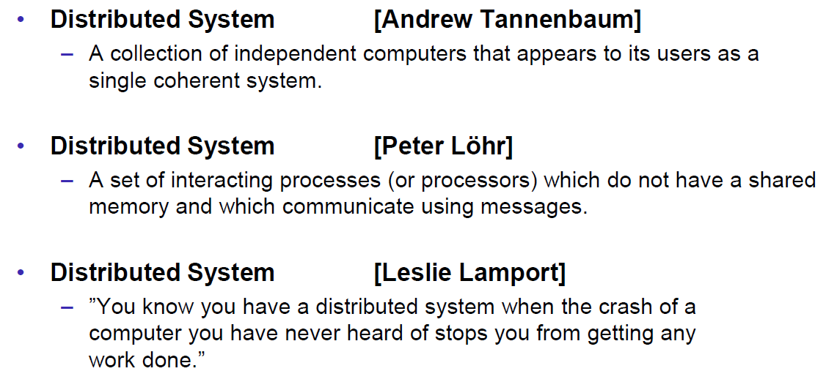

### Classification

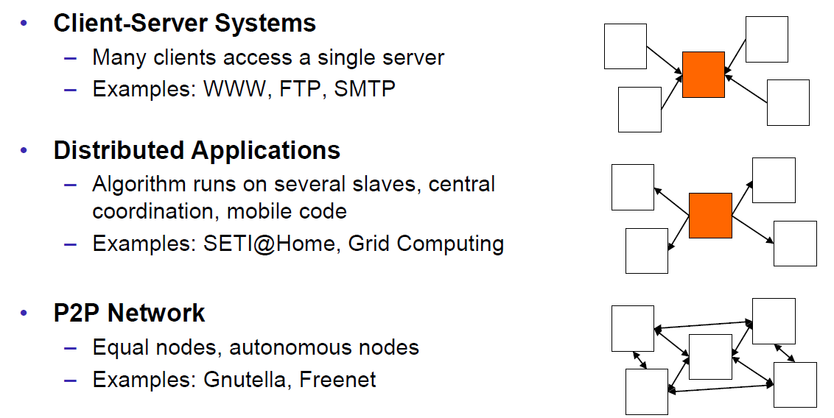

### Pros and Cons

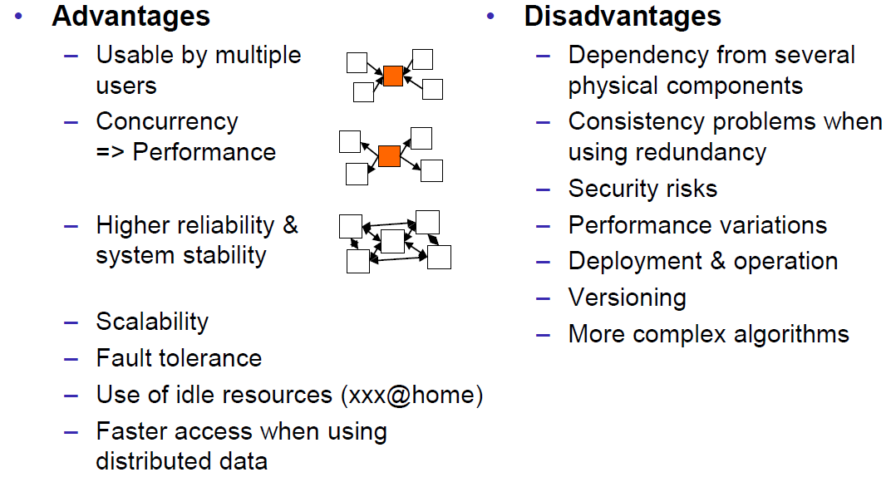

### Interaction Models

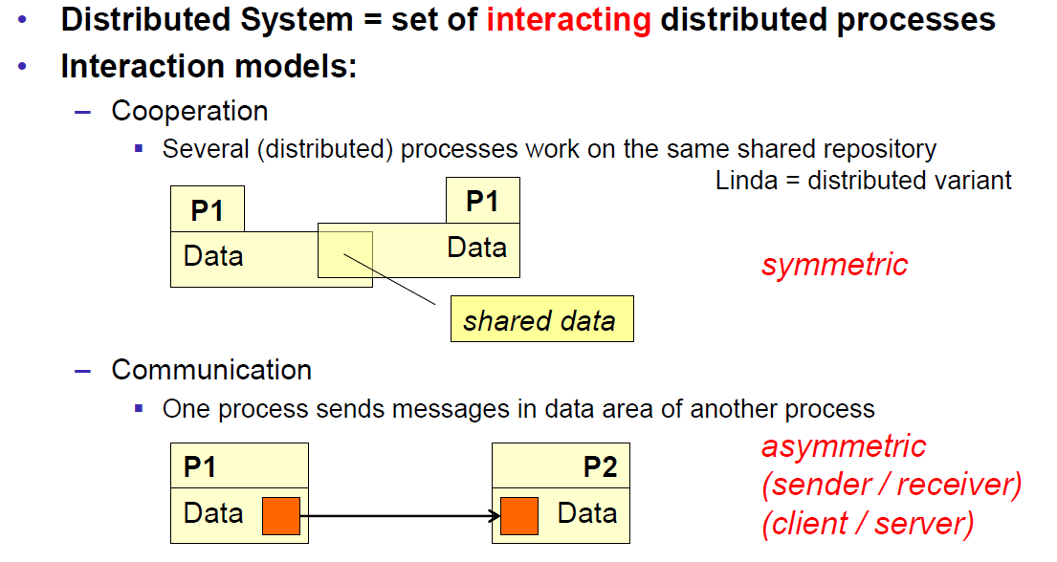

### Client/Server Model

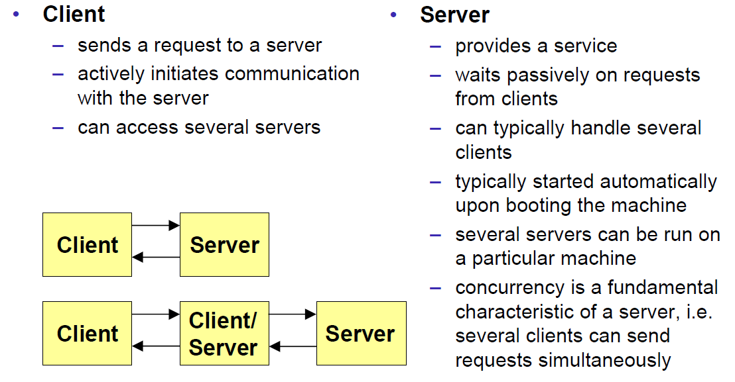

### Communication Models

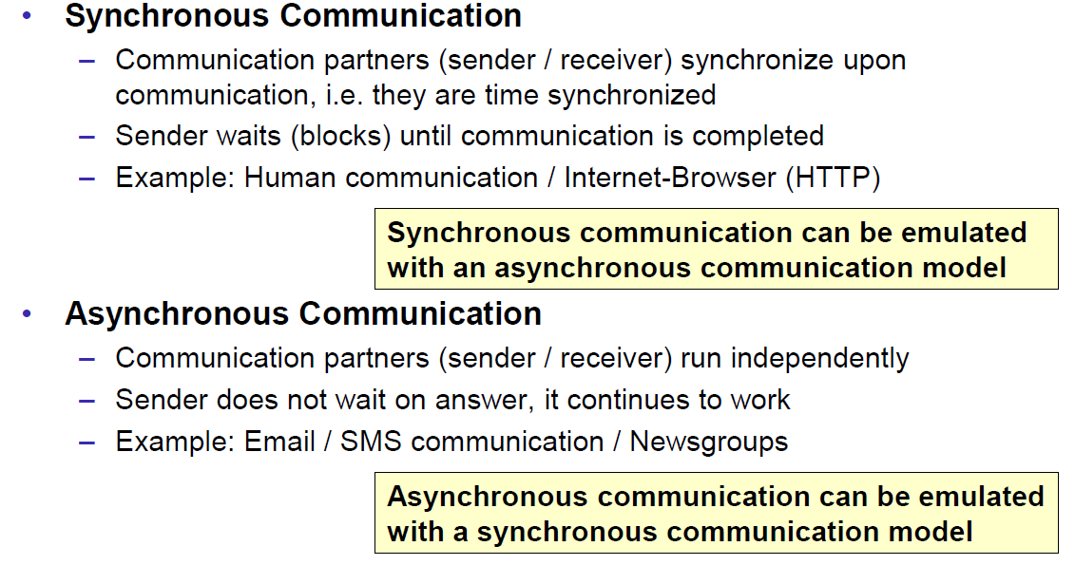

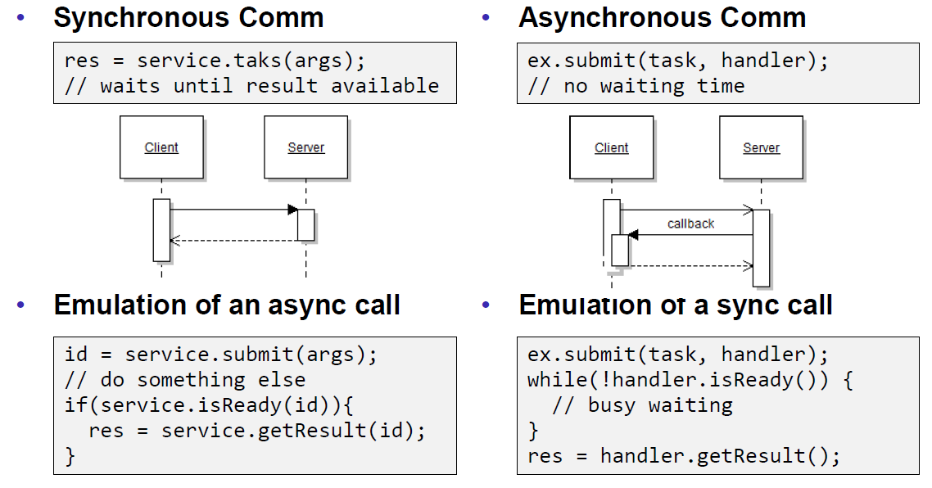

### Communication Styles

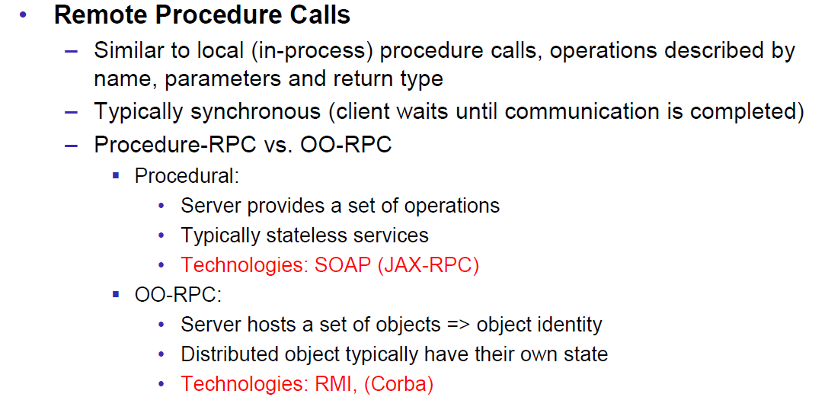

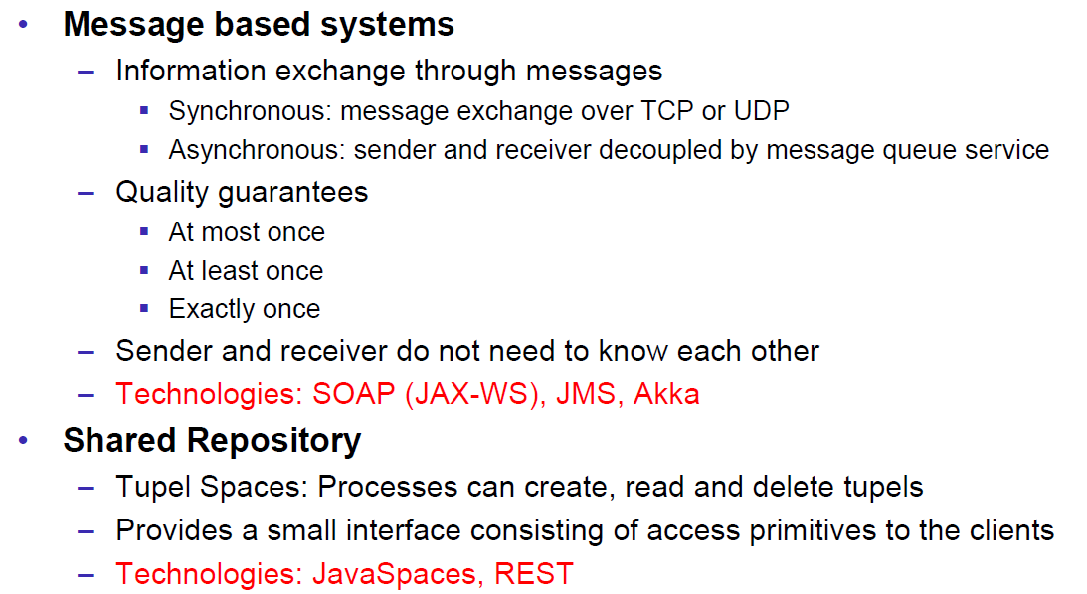

## Challenges of Distributed Systems

### Heterogeneity

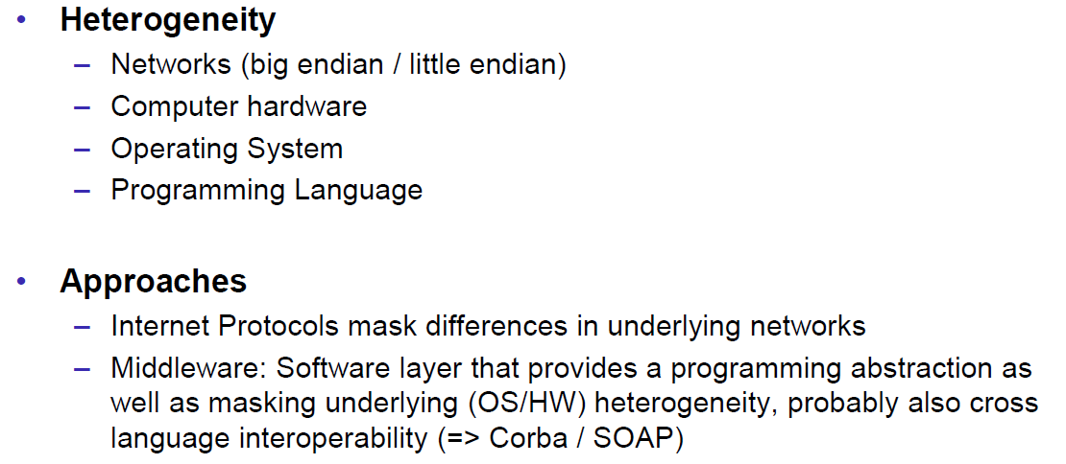

### Latency

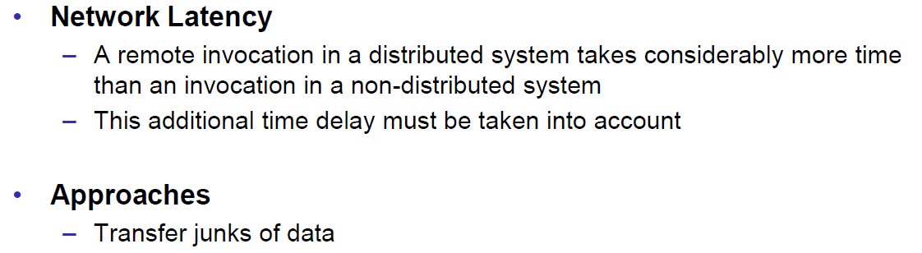

### Security

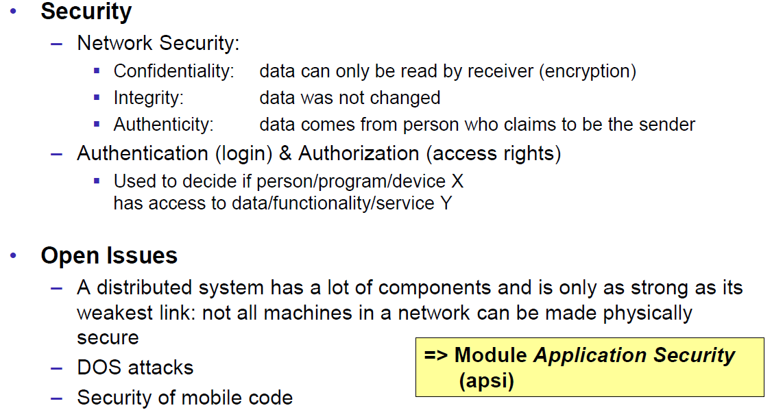

### Scalability

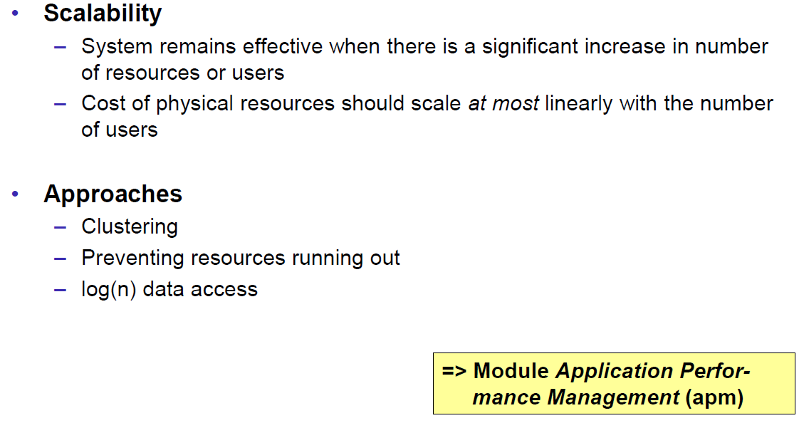

### Failures

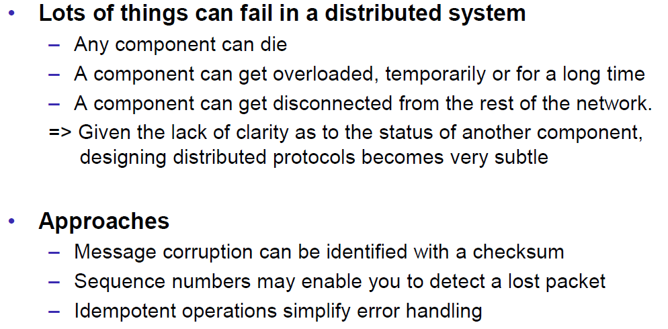

### Concurrency

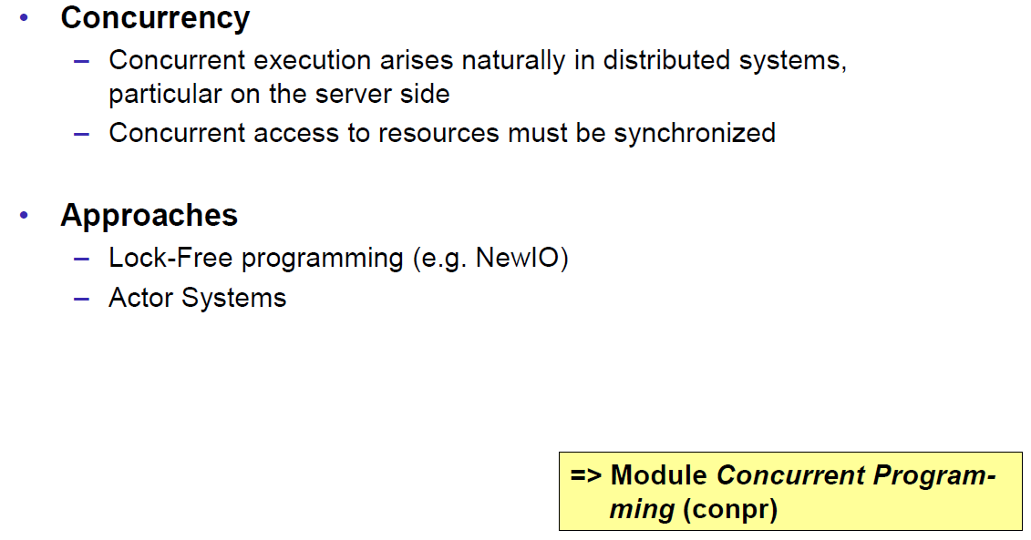

### Consistency

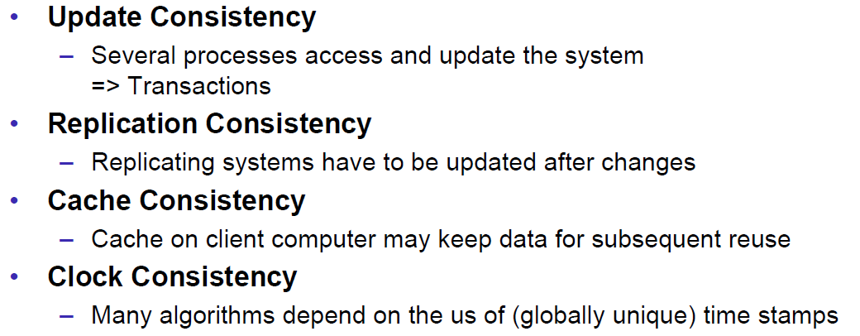

## Networking

### Protocol & Network Levels

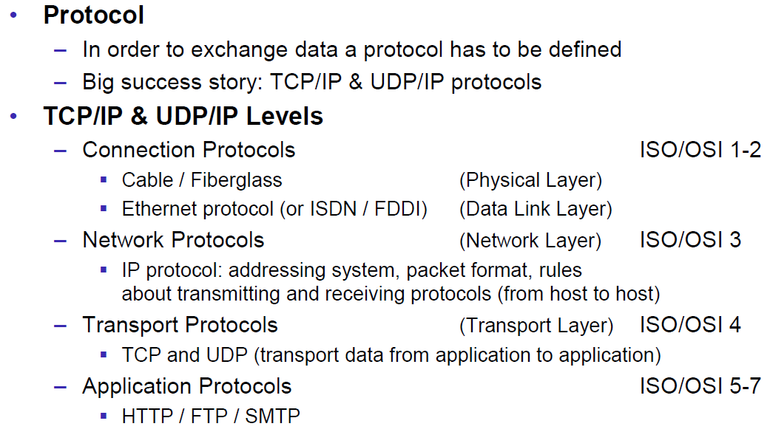

### IP Socket Connections

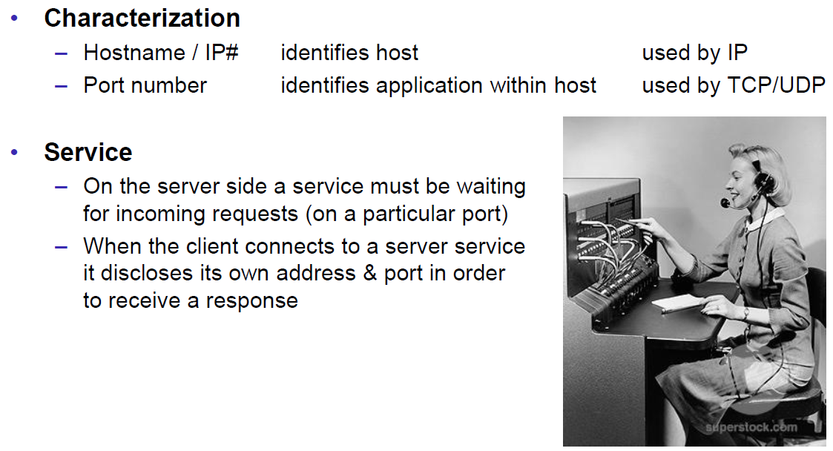

### IP Addressing

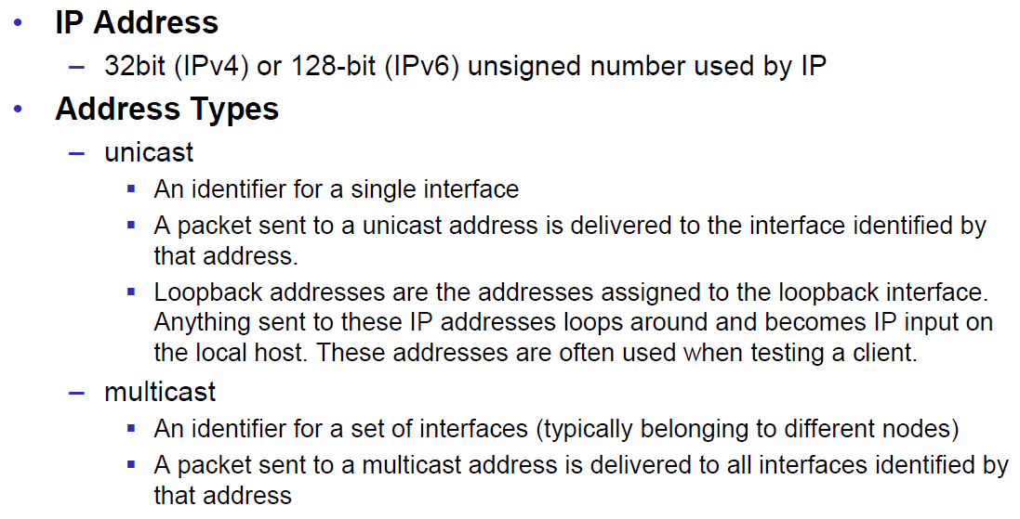

### TCP/UDP Common Port Numbers

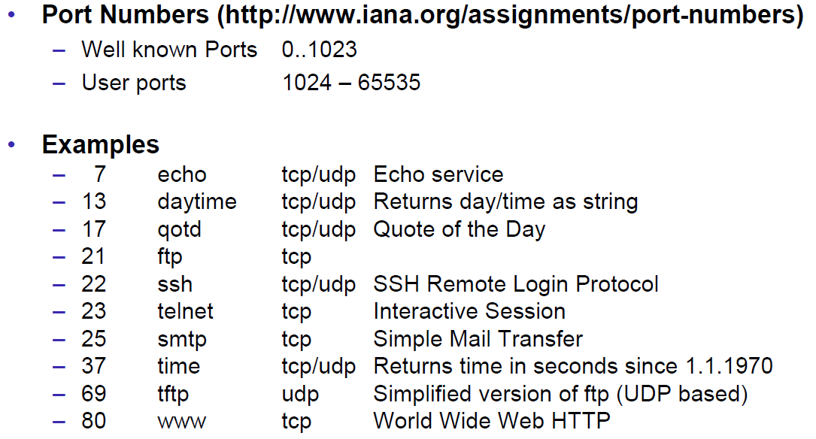

### InetAddress

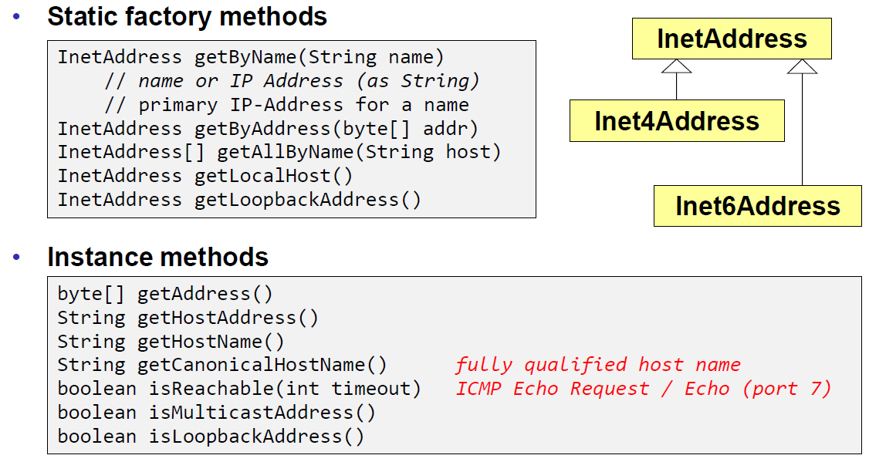

### Network Interfaces

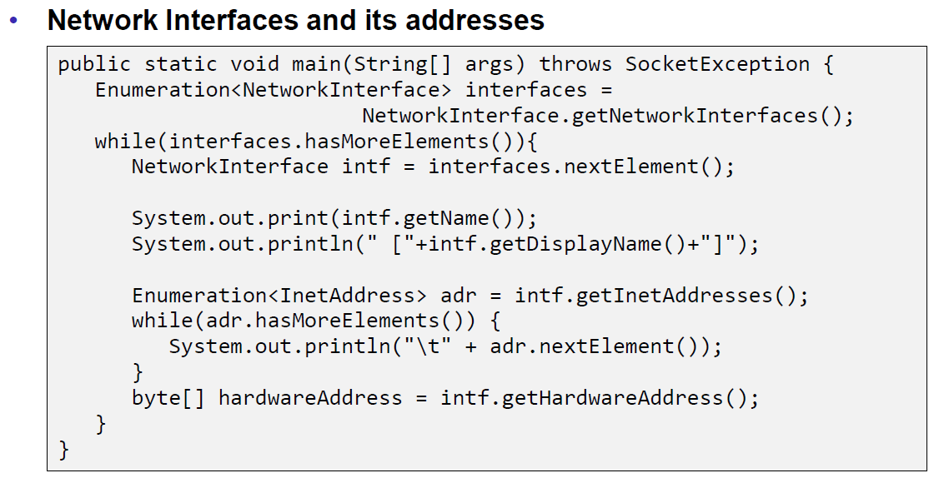

## Sockets

### Sockets

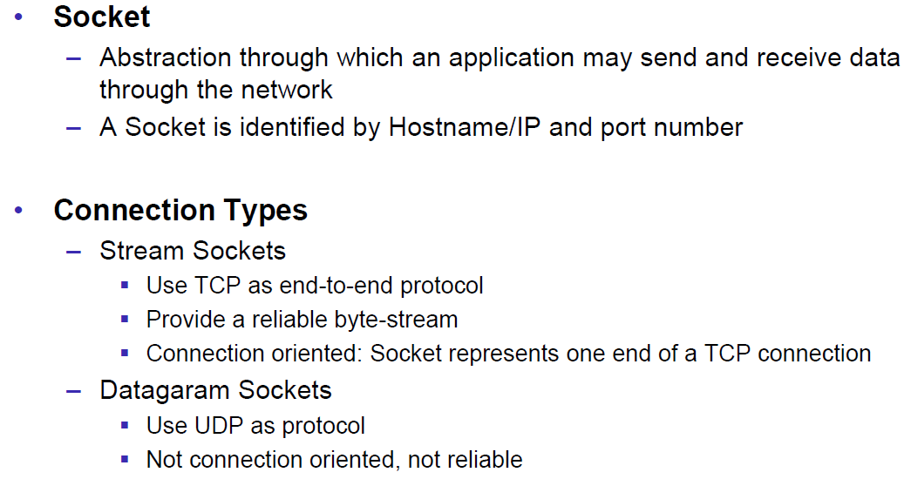

### TCP Sockets

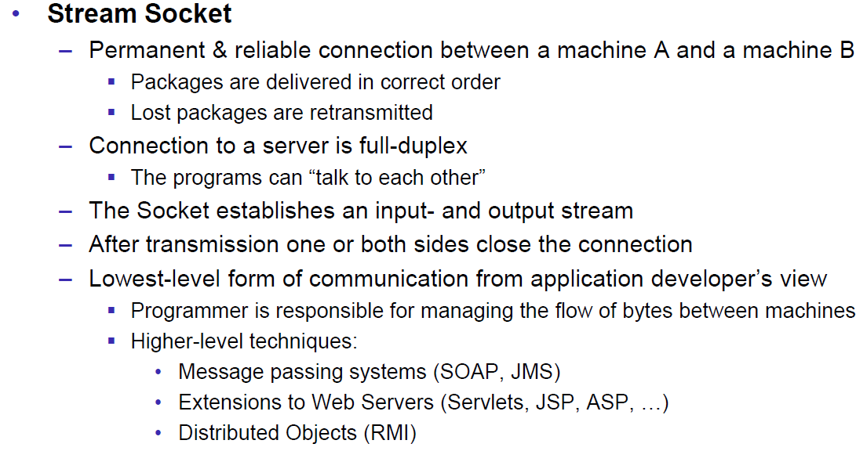

### Java Socket

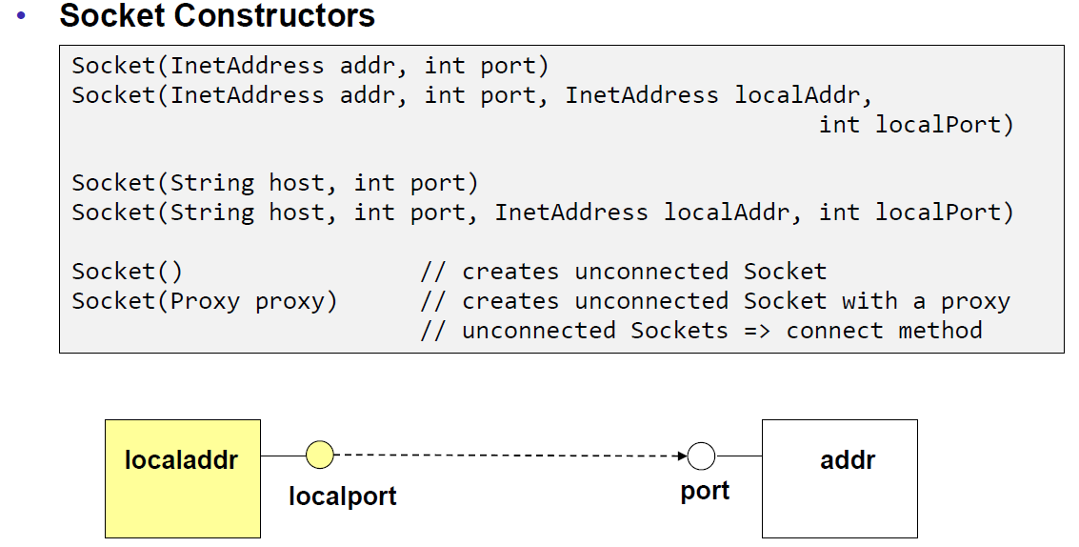

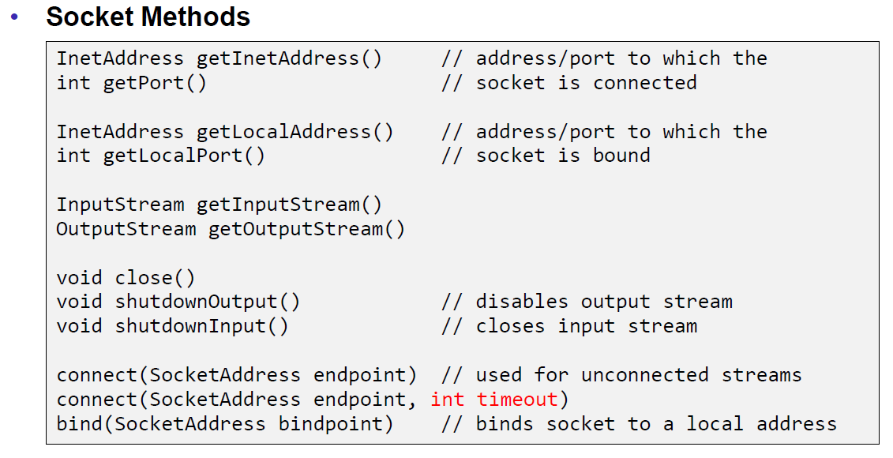

### Sample Client (Echo)

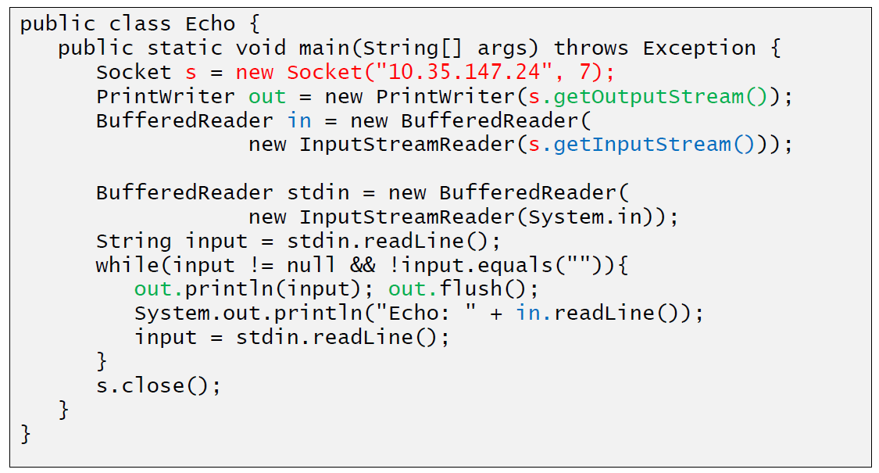

### Sample Client (Mailer)

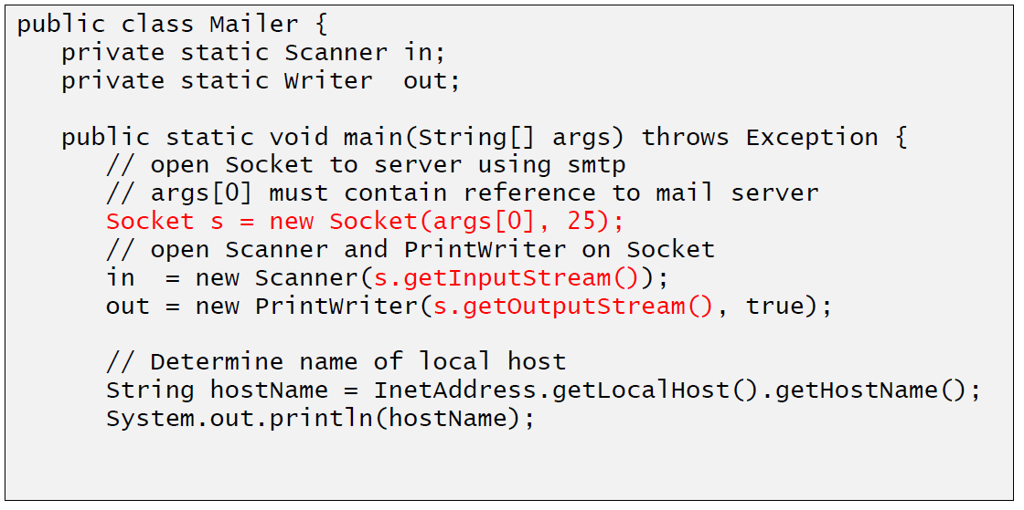

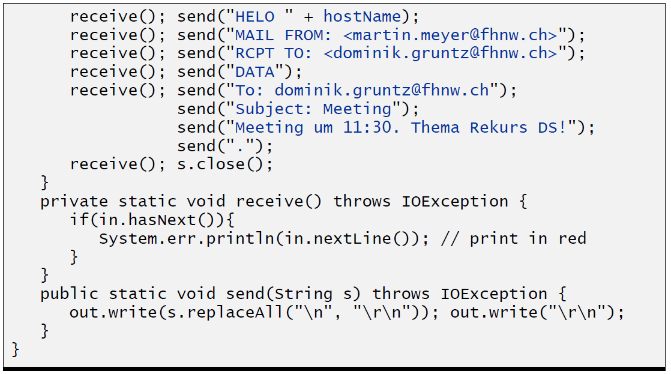

### ServerSocket

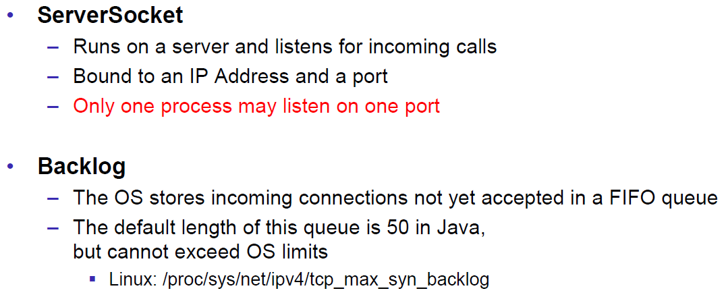

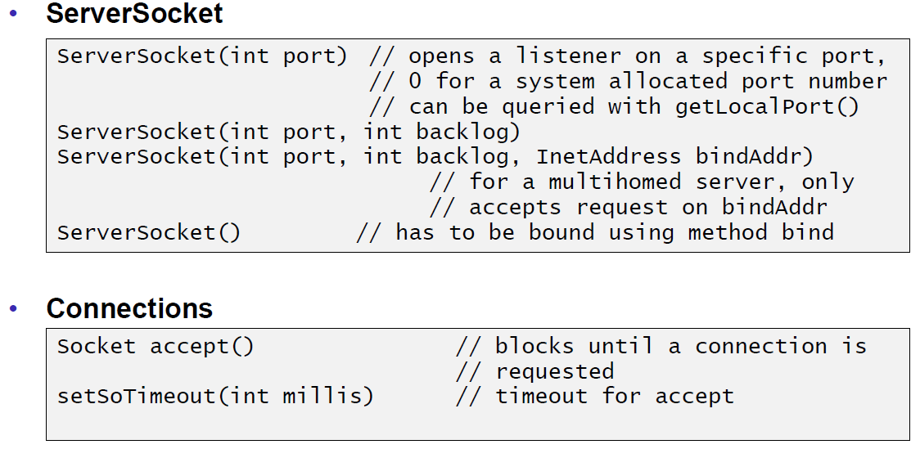

### Echo Server

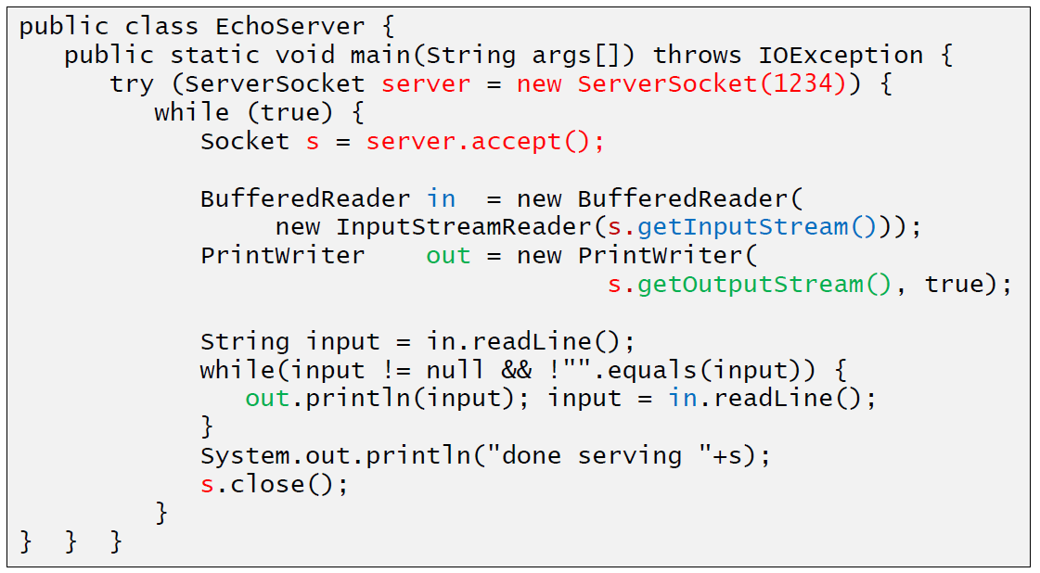

### Concurrent Echo Server

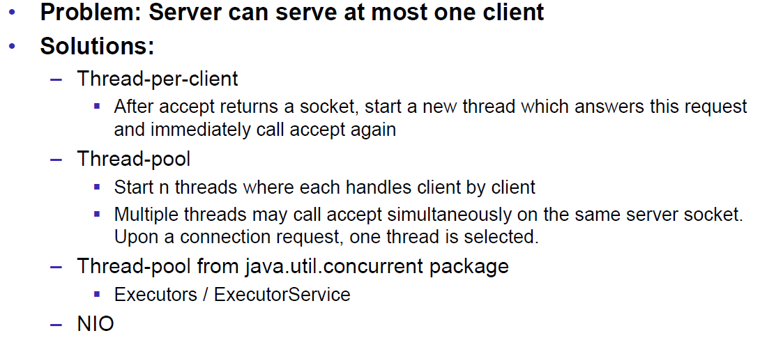

### Concurrent Echo Server (Threaded)

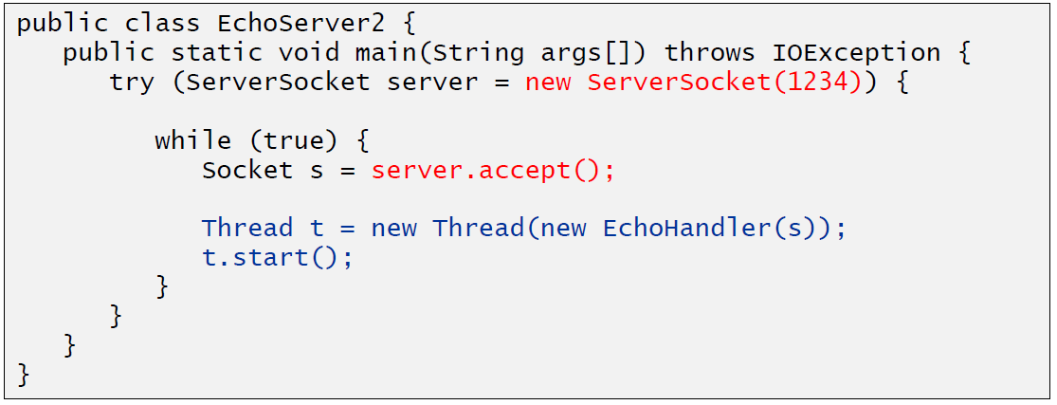

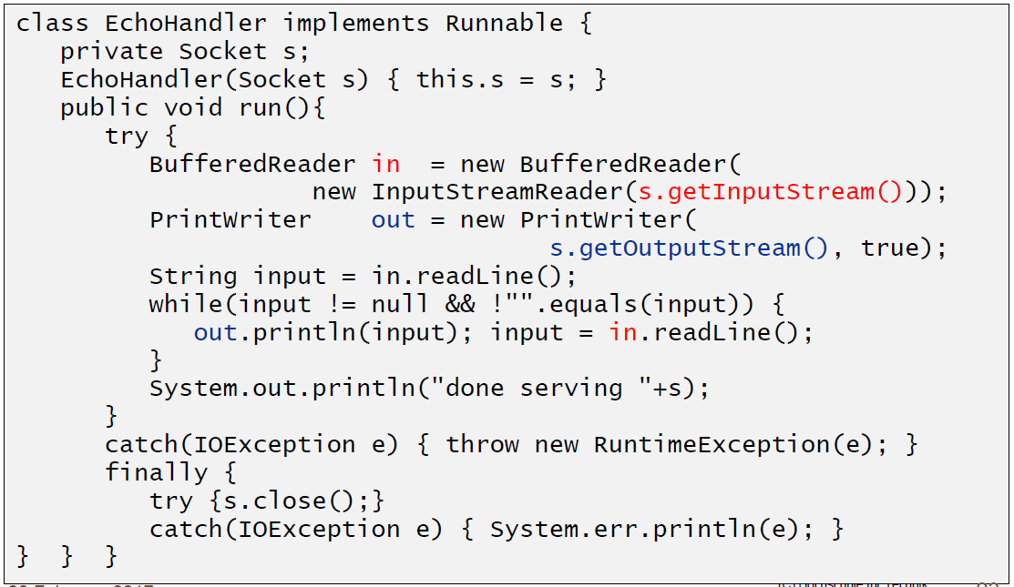

### Concurrent Echo Server (Limitierter Threadpool)

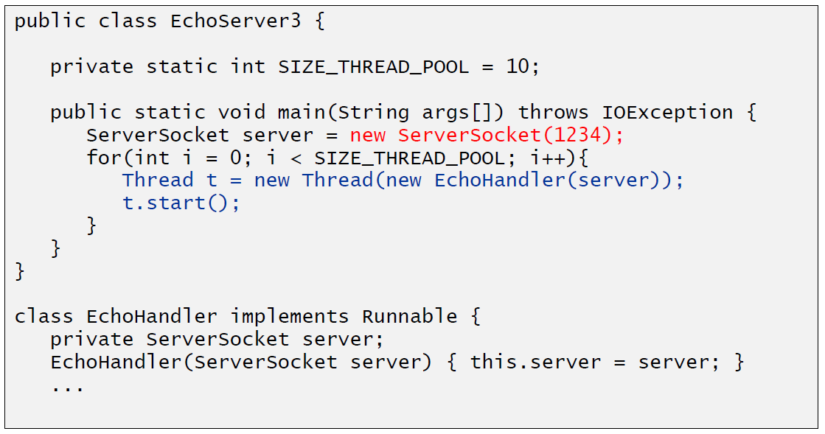

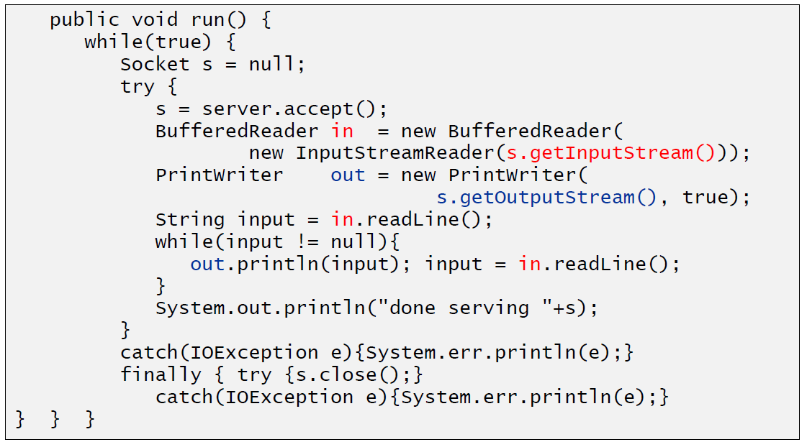

### Concurrent Echo Server (Dynamischer Threadpool)

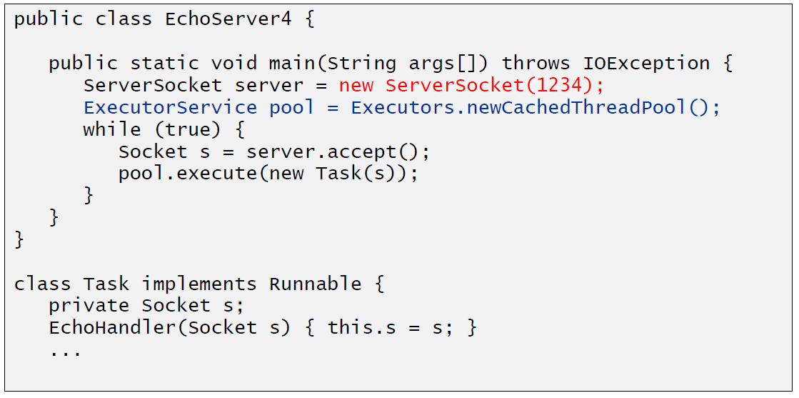

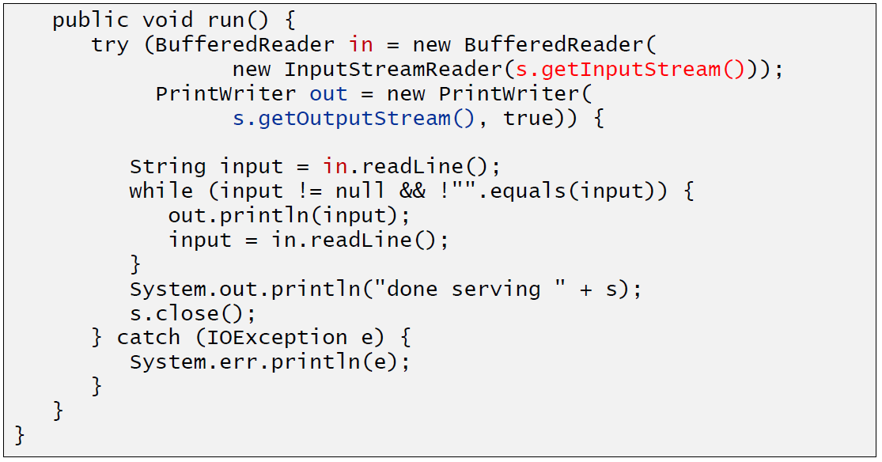

# Woche 2

## Input and Output Streams

### OutputStream

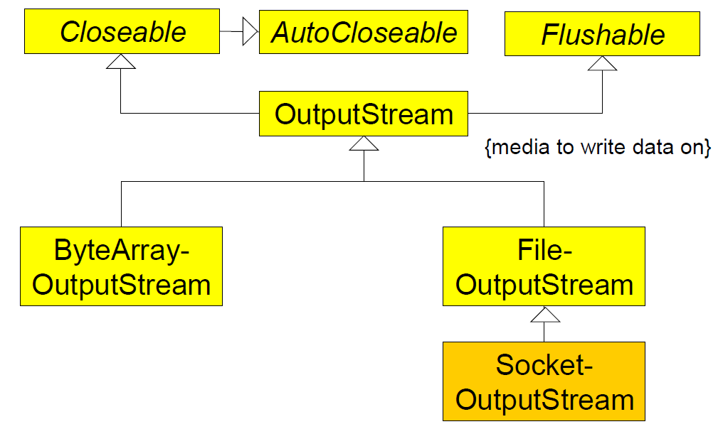

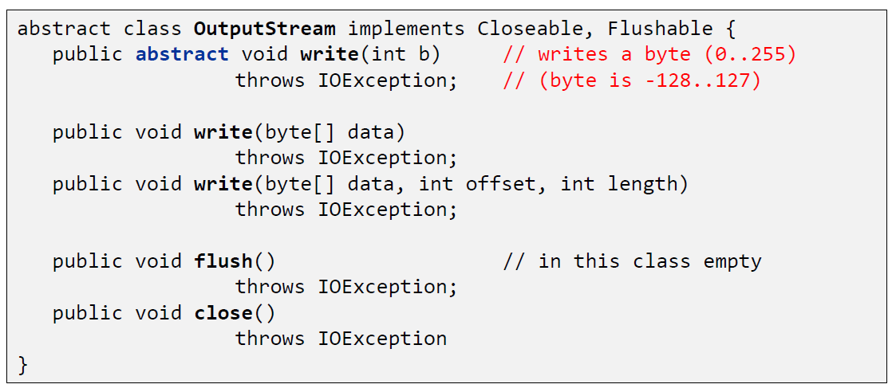

### InputStream

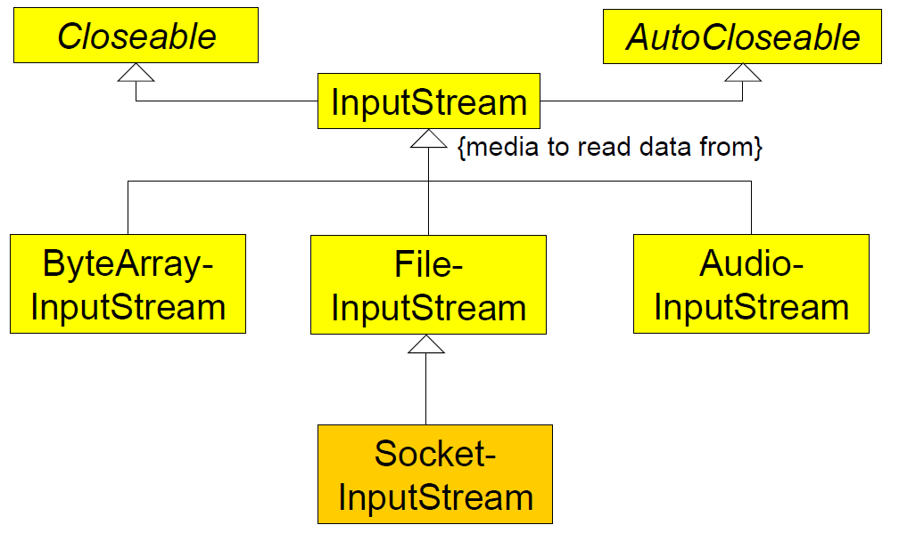

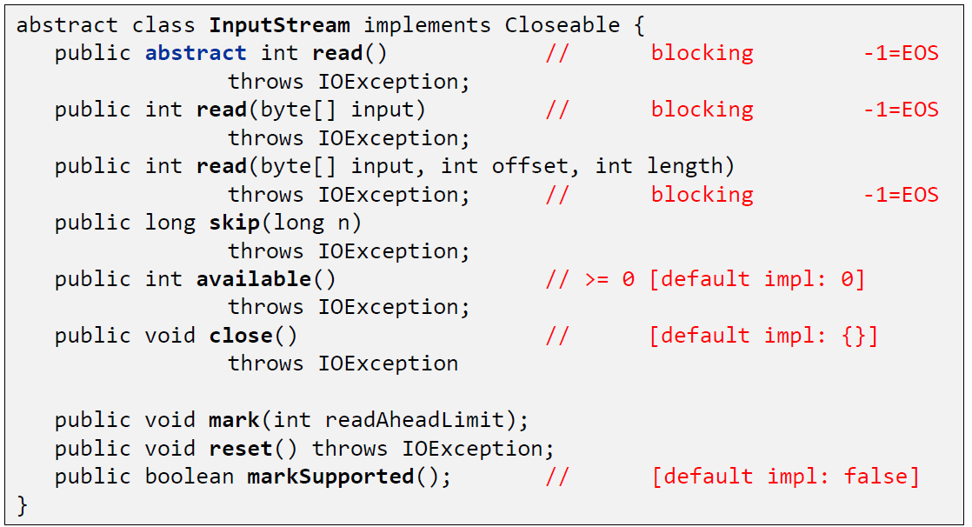

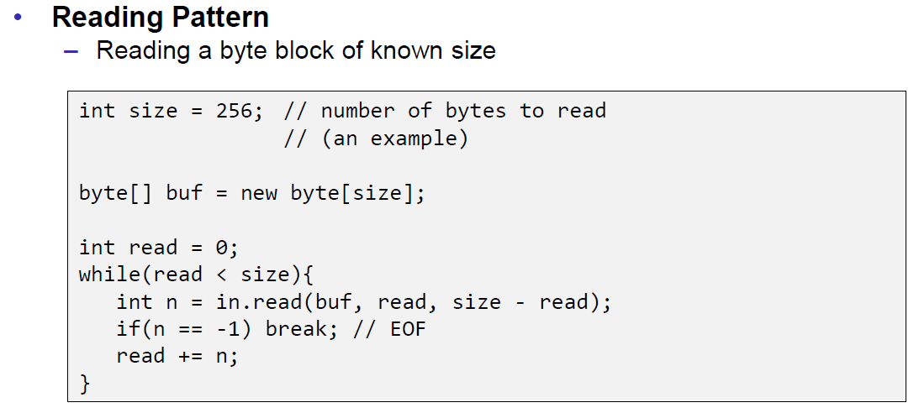

## Filter Streams

### FilterOutputStream

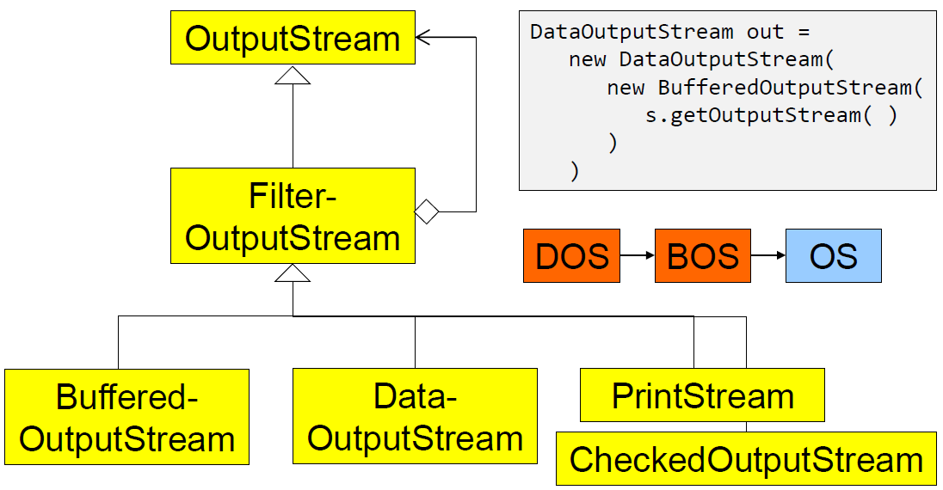

### DataOutputStream

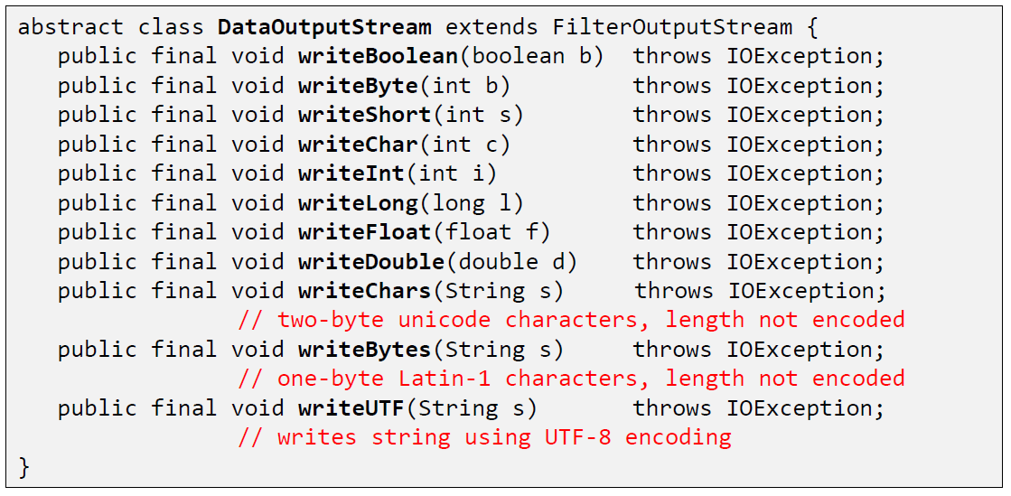

### DataOutputStream with writeInt

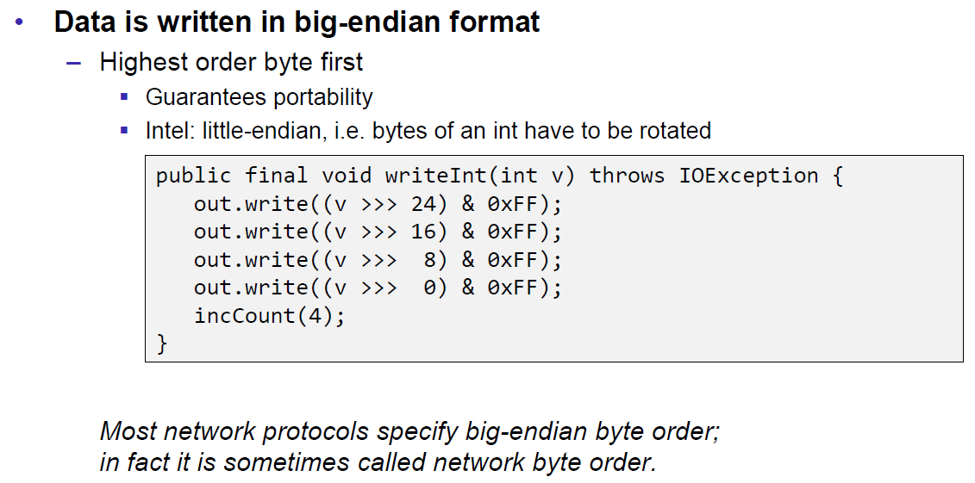

### DataOutputStream with writeUTF

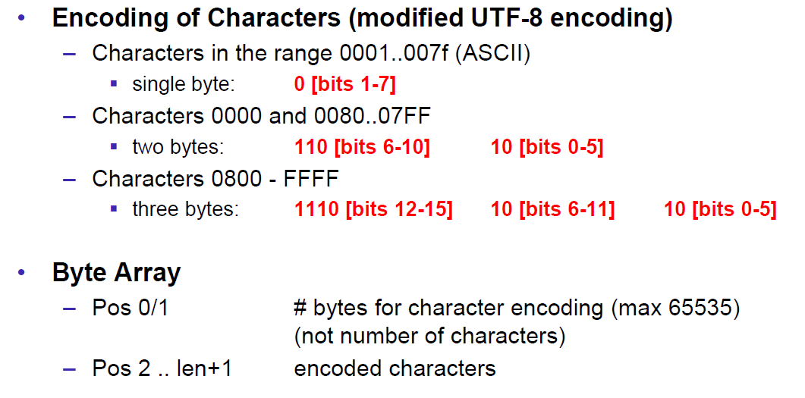

### PrintStream

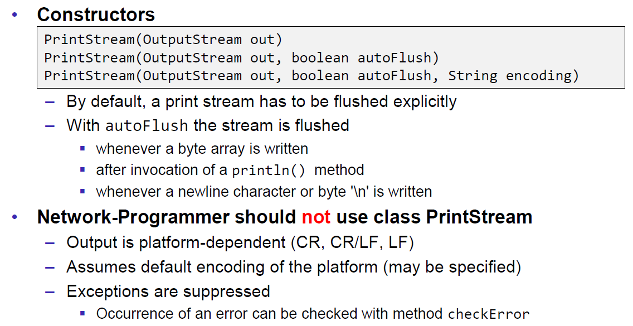

### FilterInputStream

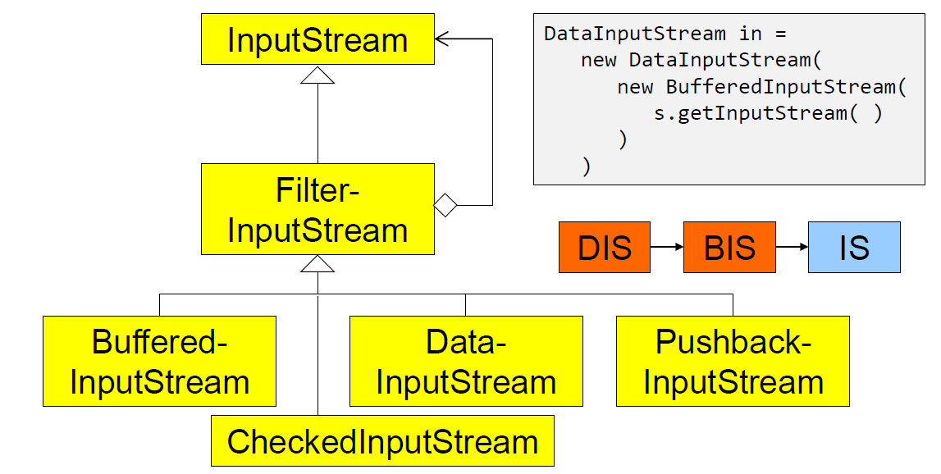

### DataInputStream

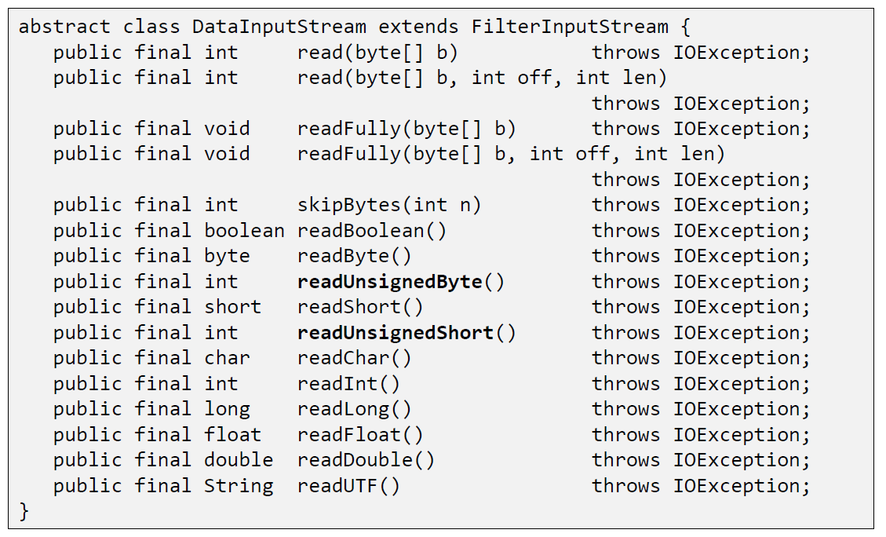

### DataInputStream with readFully

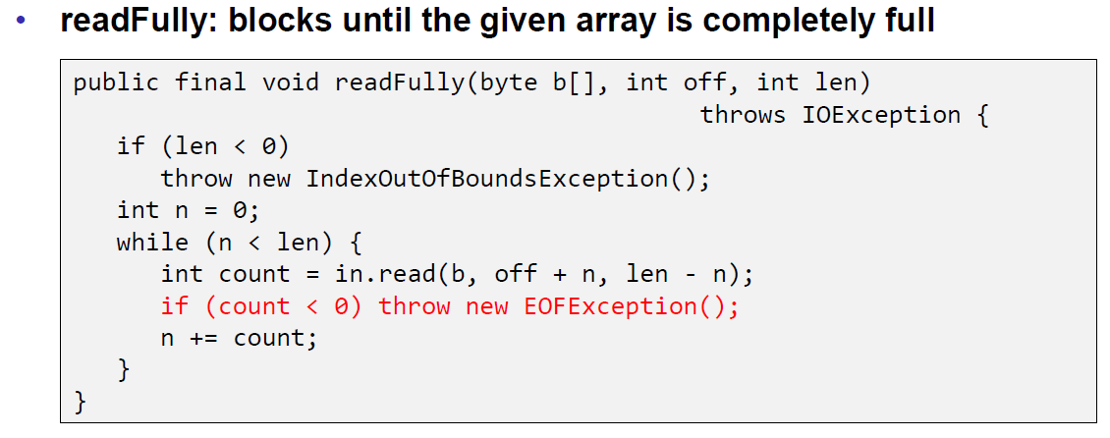

### Filter Streams

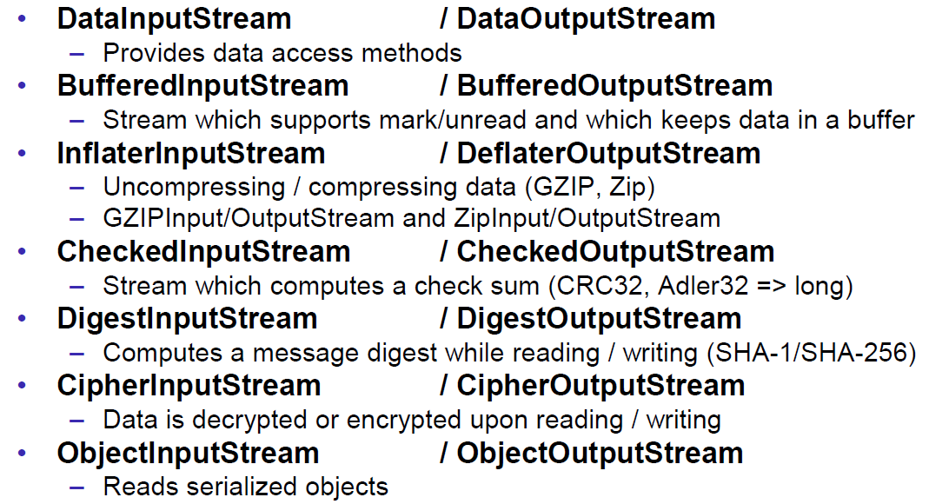

## Object Streams & Serialization

### ObjectStream

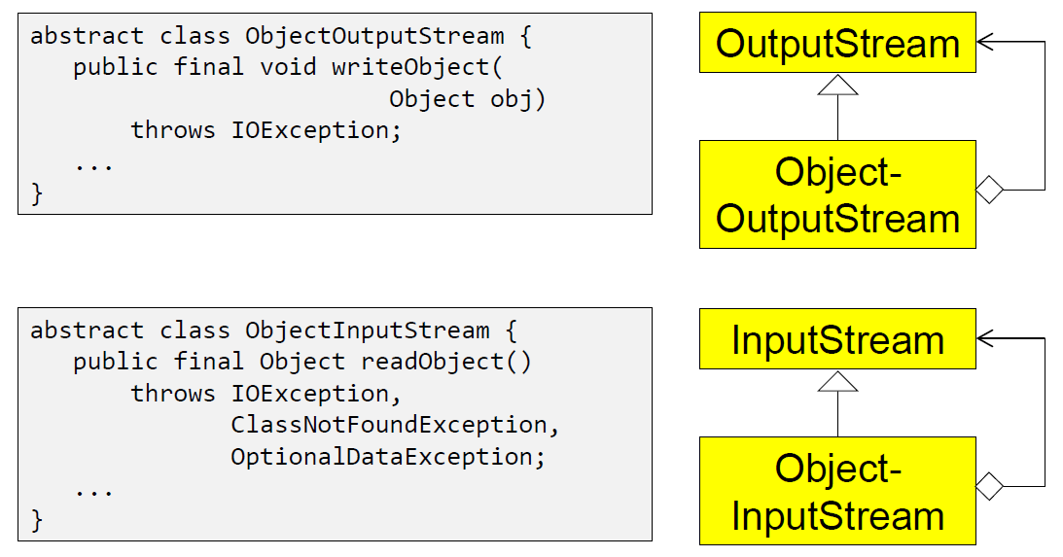

### Serialization with ObjectStream

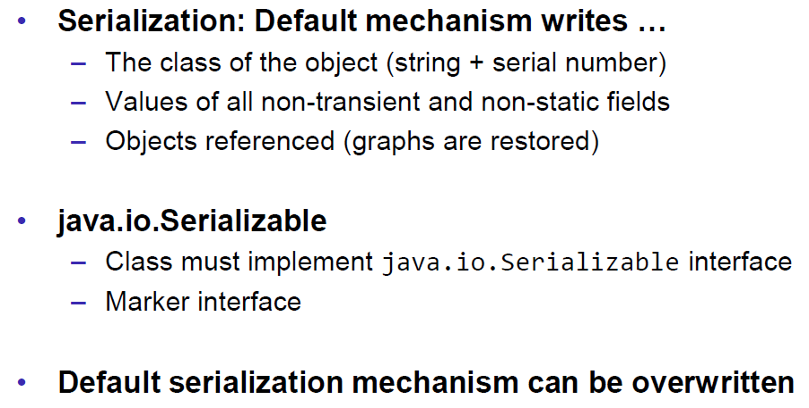

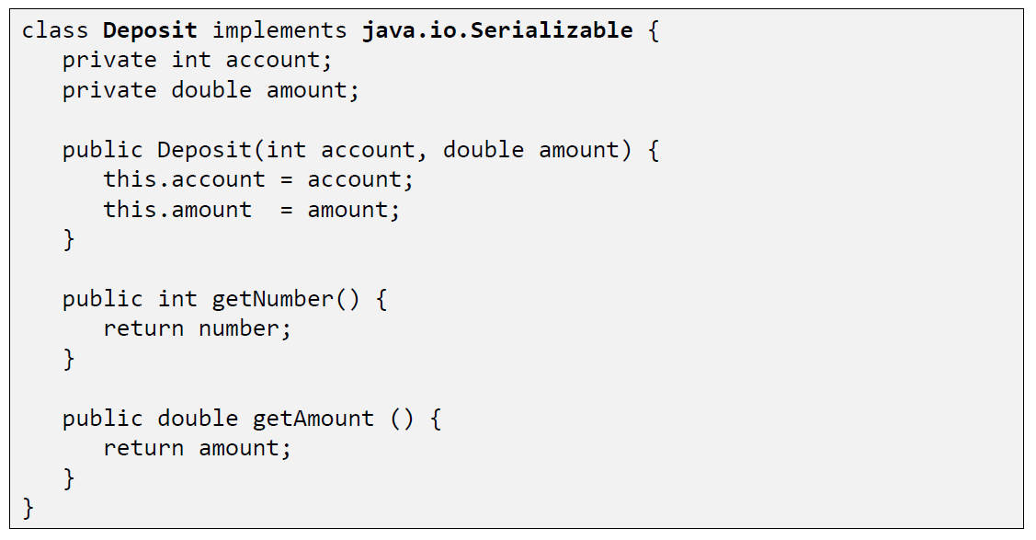

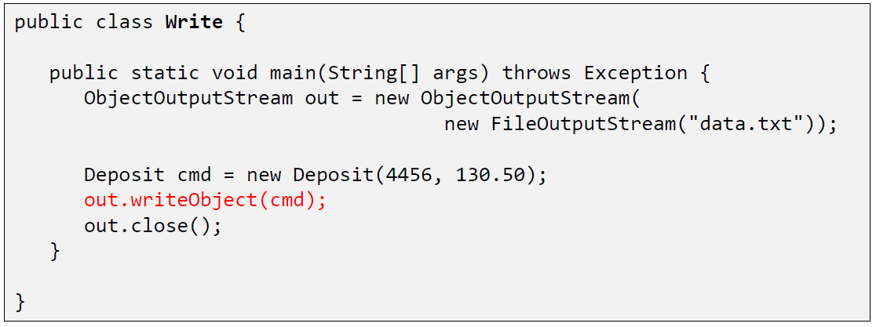

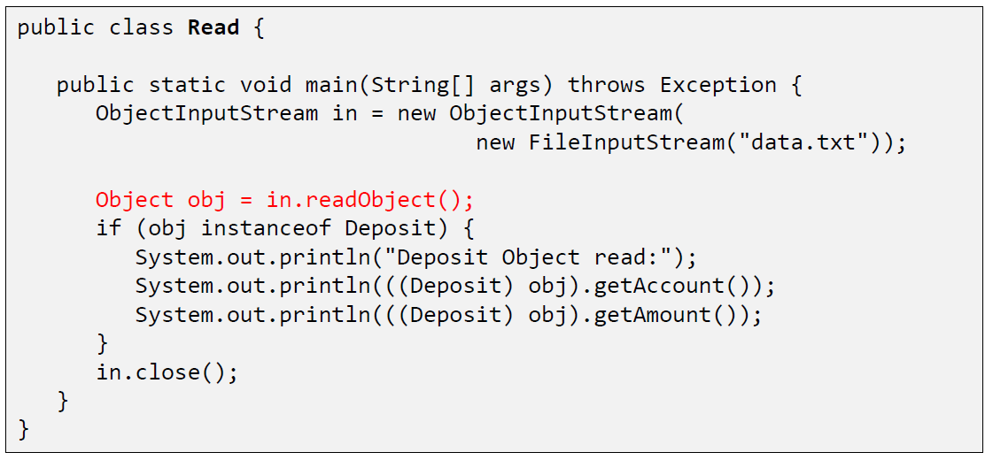

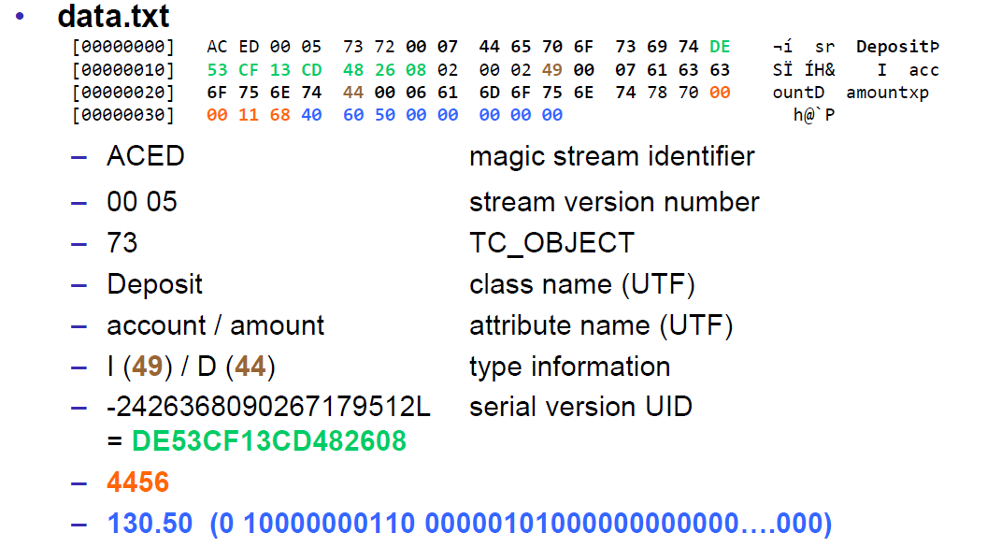

### Serial Version Number

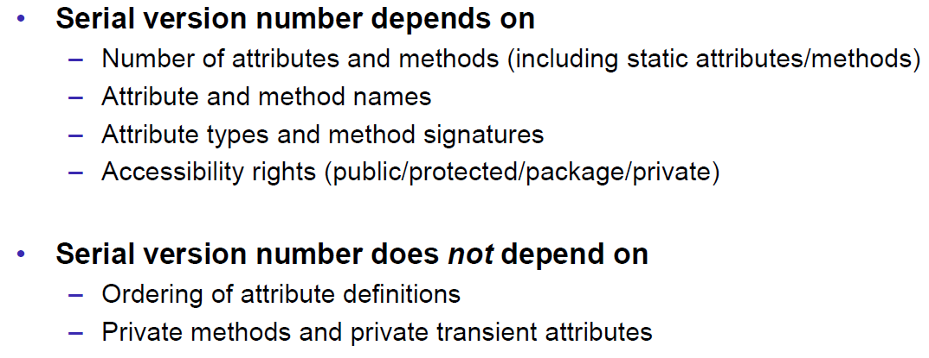

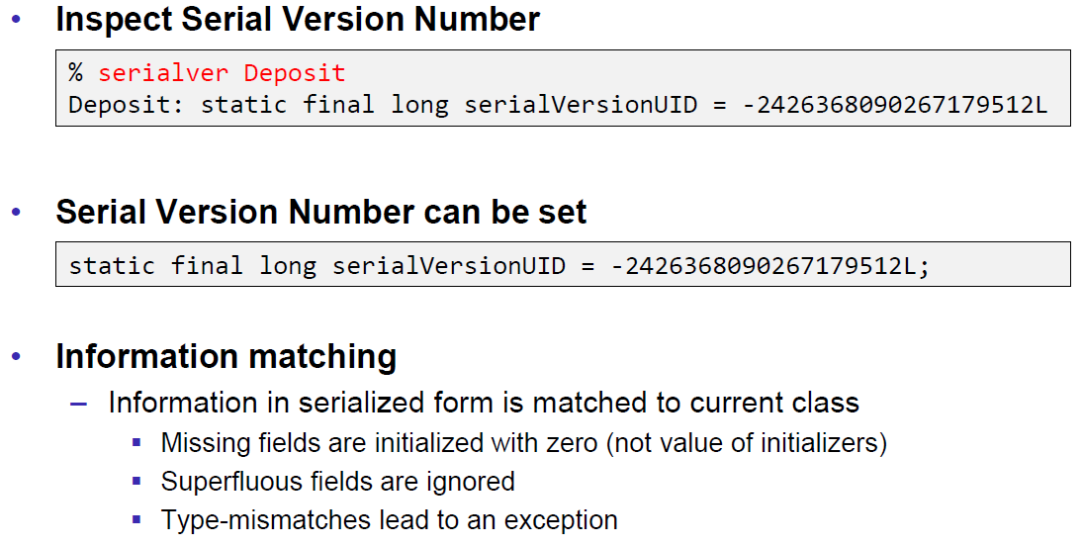

### Serialization Customization

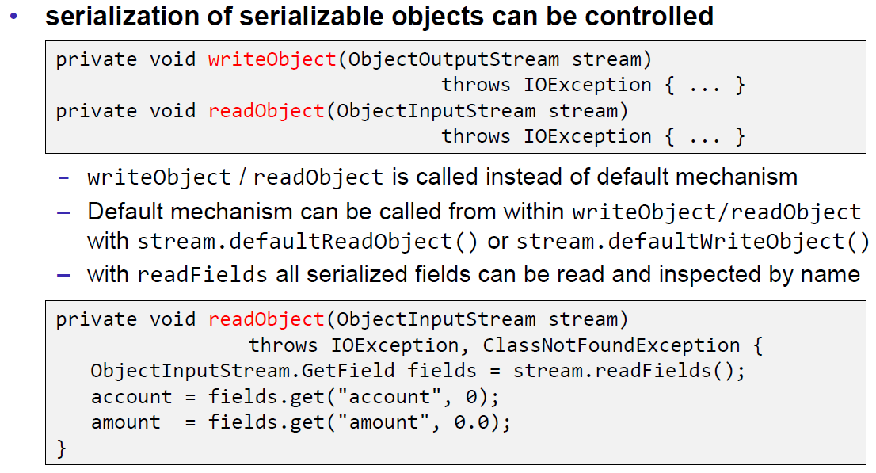

### Serialization Hints

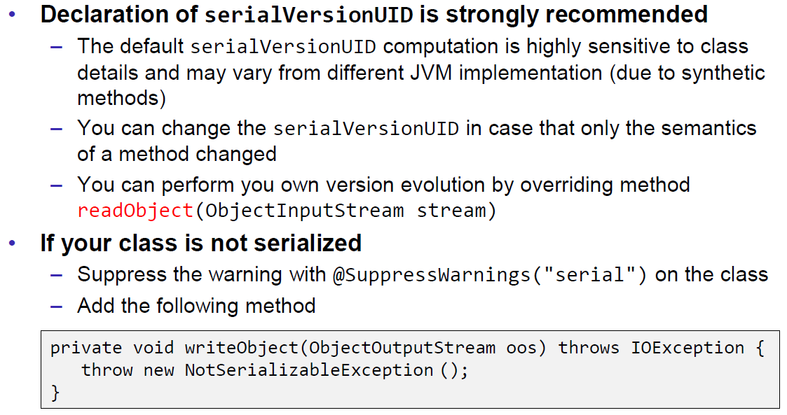

## Sending and Receiving Data

### Framing

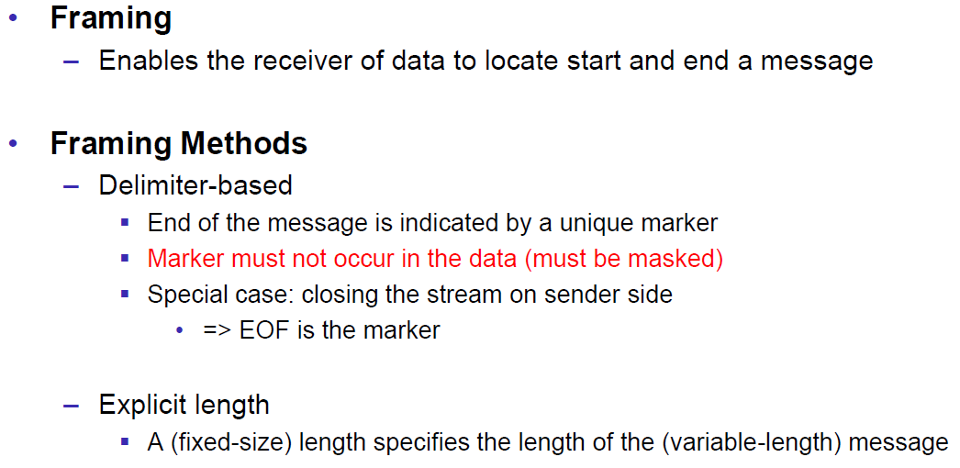

### Example of Framing

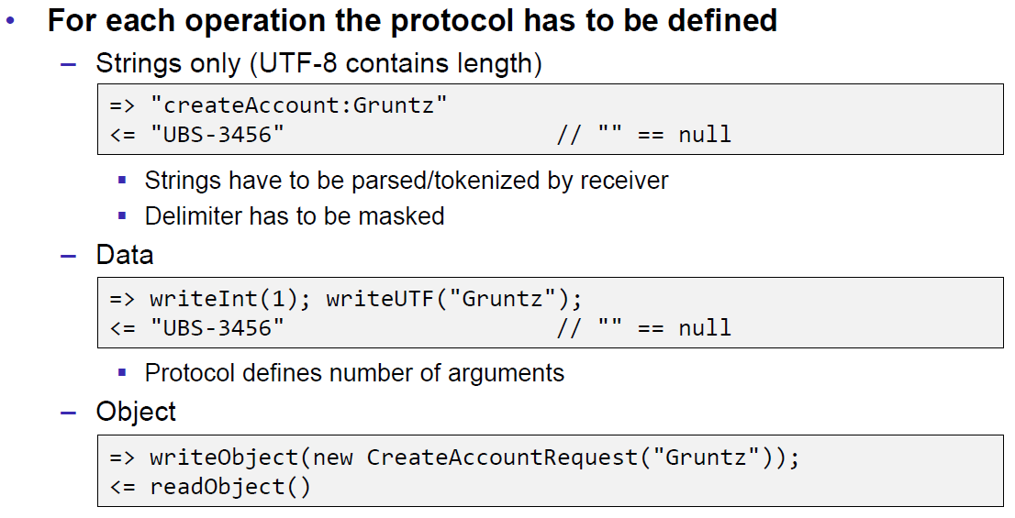

## Summary

### Whole Picture of Input Streams

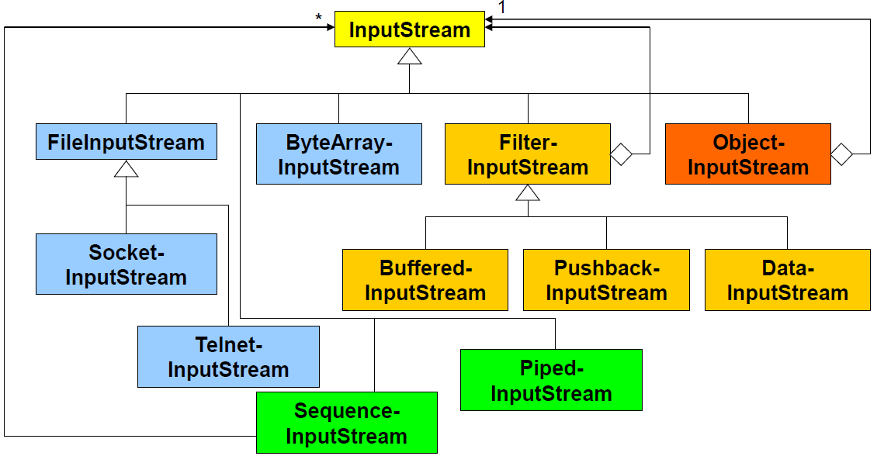

### Whole Picture of Output Streams

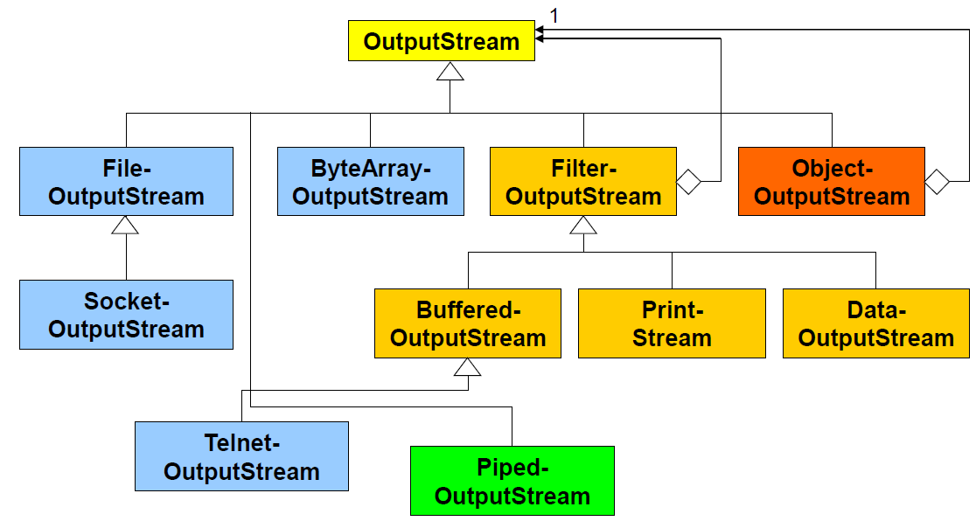

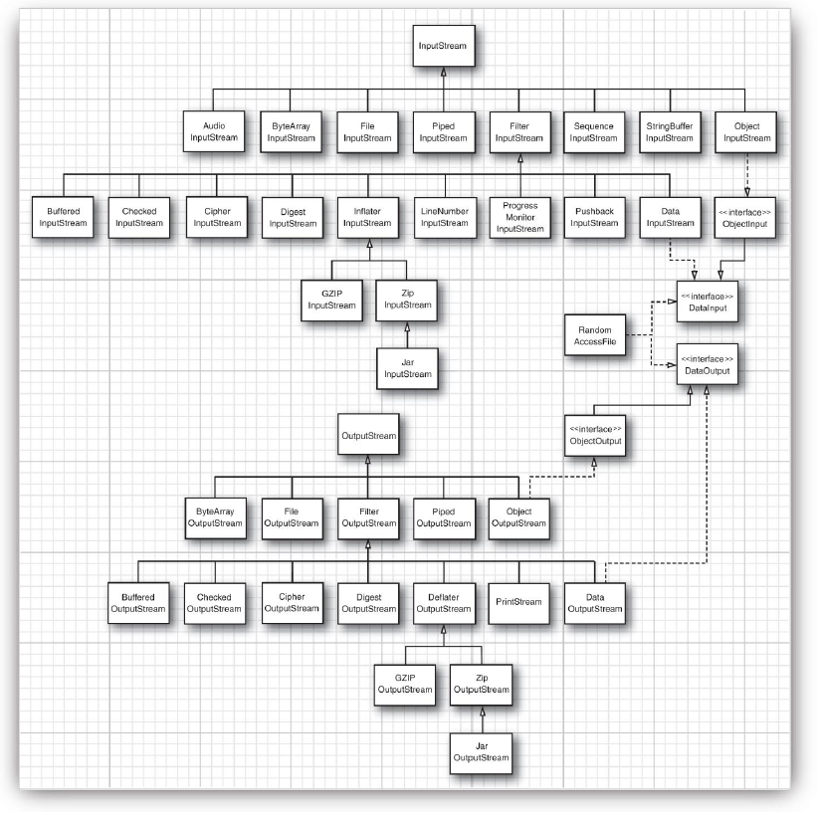

### Reading and Writing Text (Unicode Strings)

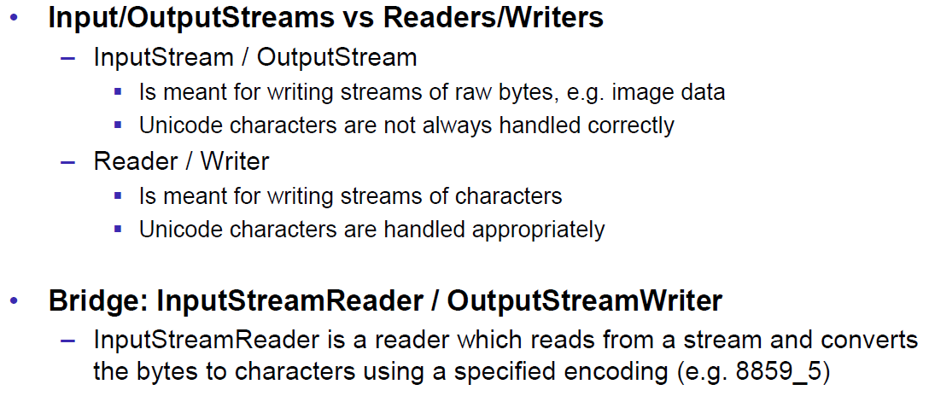

### Whole Picture of Reader

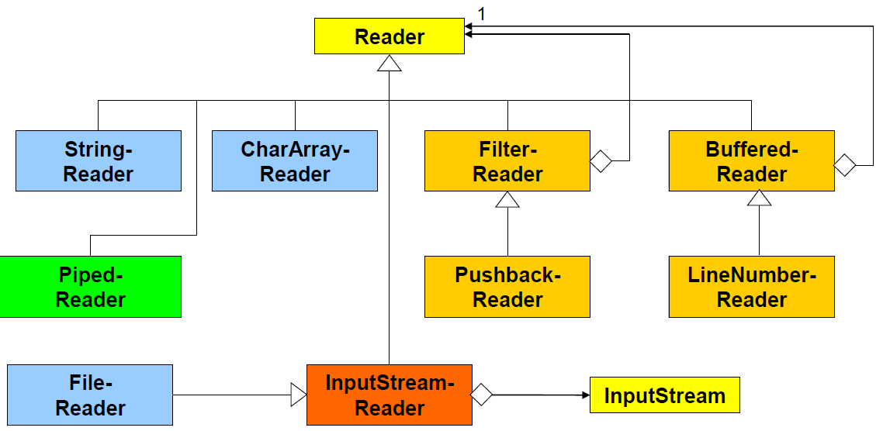

### Whole Picture of Writer

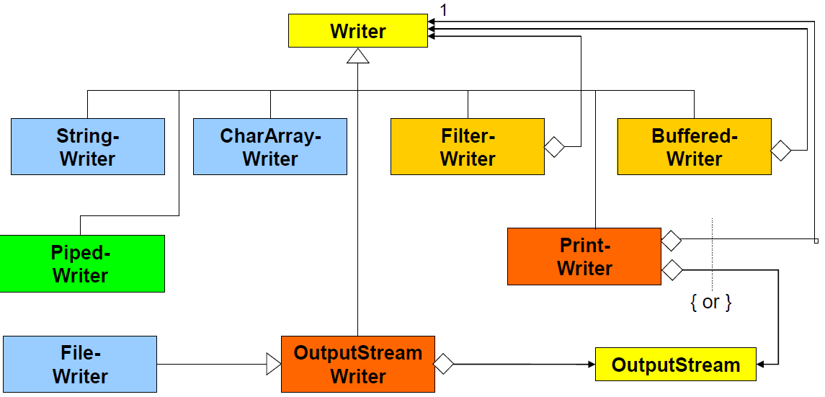

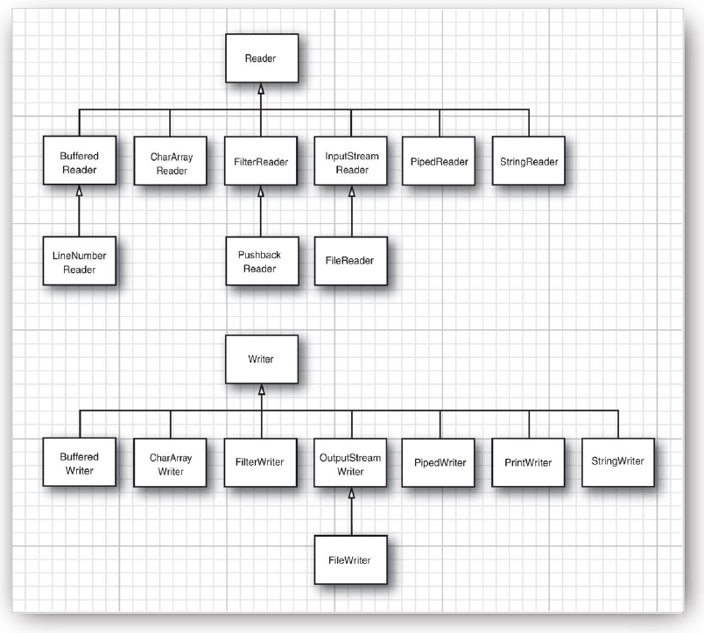

## Controlling Socket Behaviors

### Blocking and Timeouts

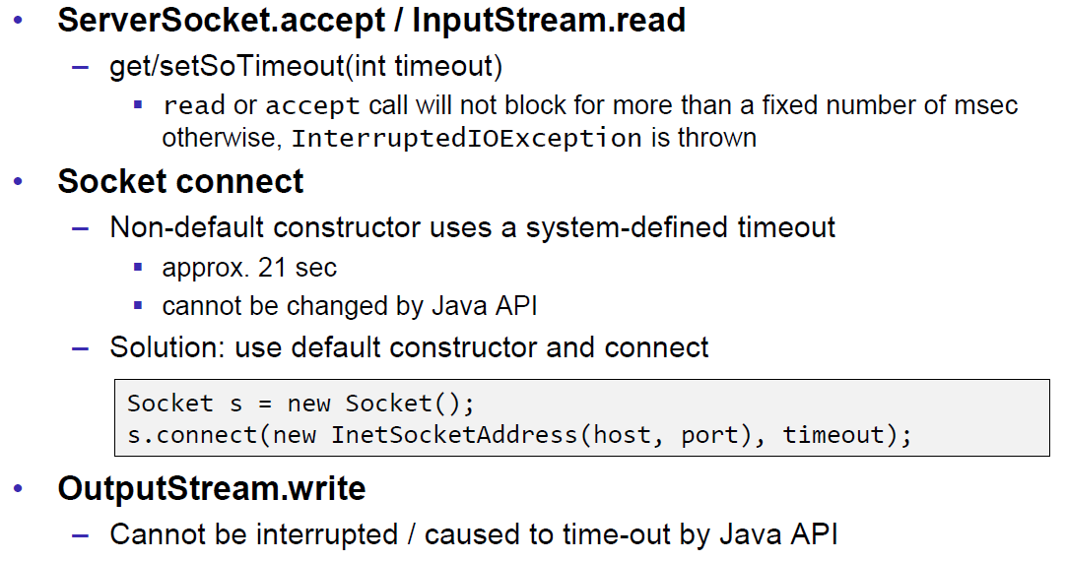

### Send and Receive Buffer Size

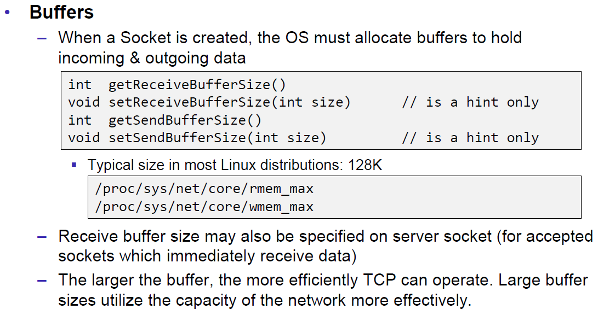

### Package Delay

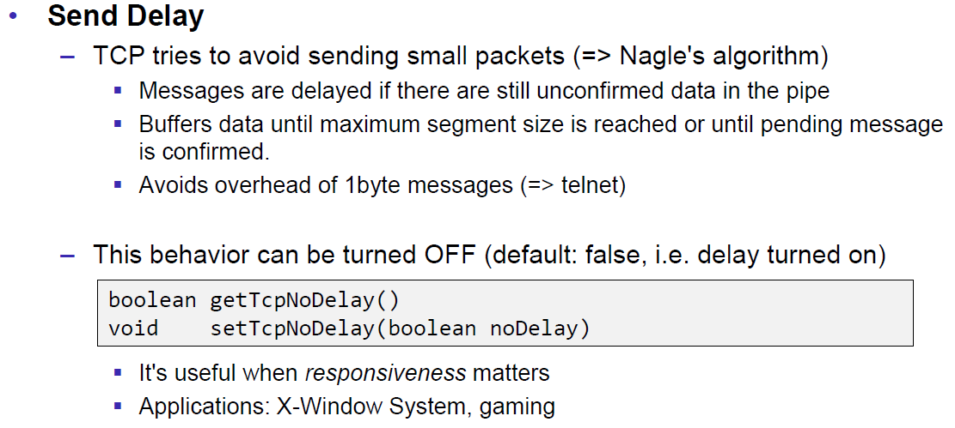

## Closing Connections

### Closing Connections

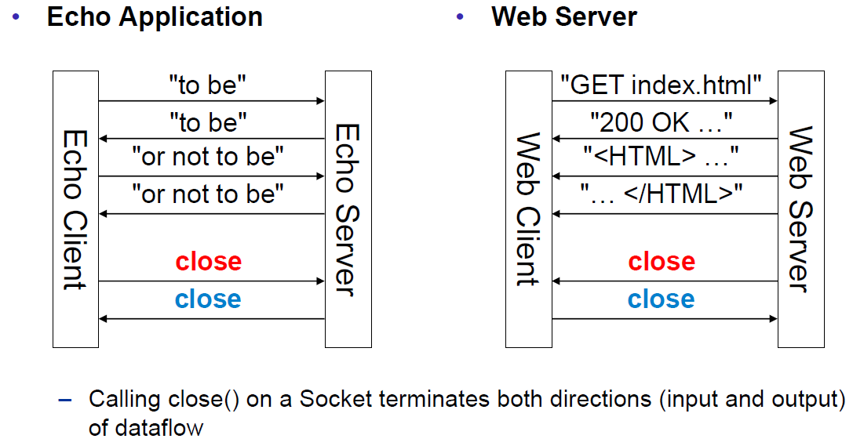

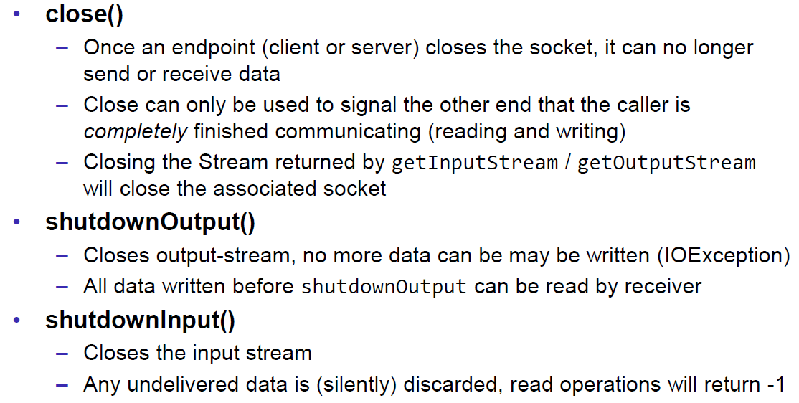

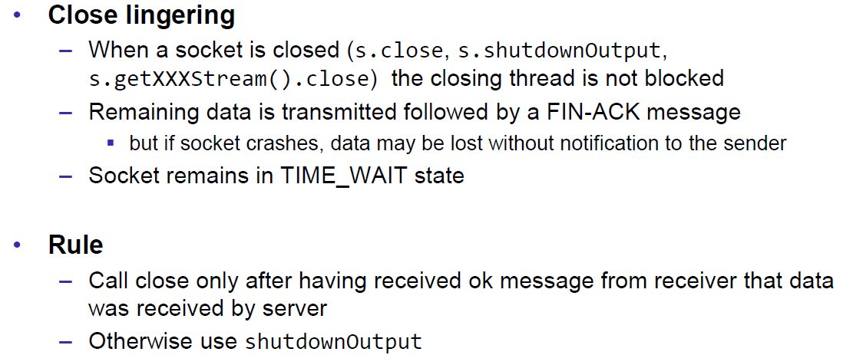

### Example of a Close Test

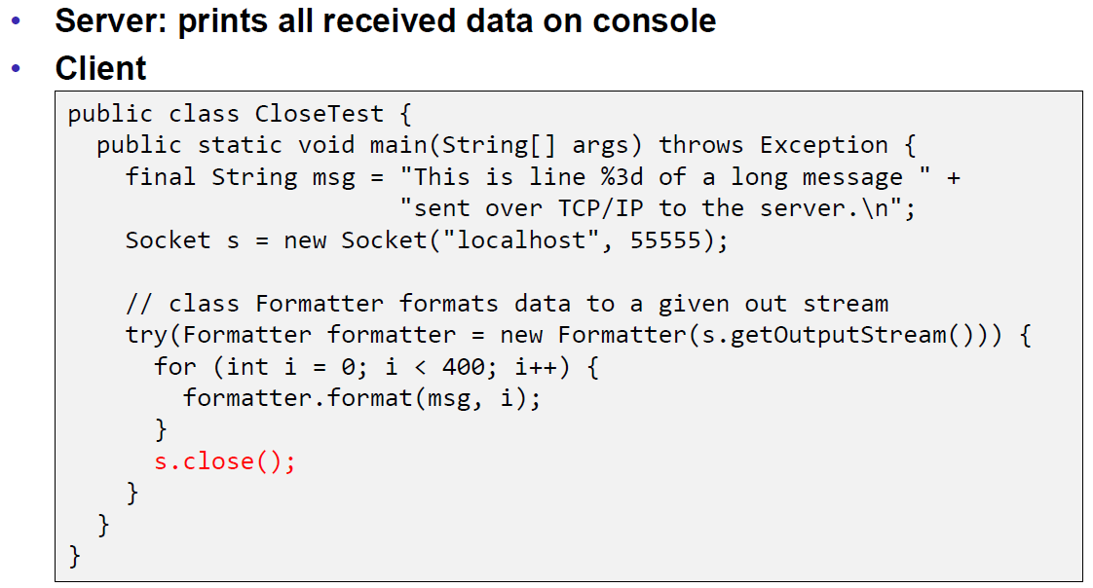

Problem: Some content of the formatter is not received by the server.

Solution: Flush the formatter before you close the socket, otherwise the buffer of the formatter won’t be sent.

### Example of a Compression Server

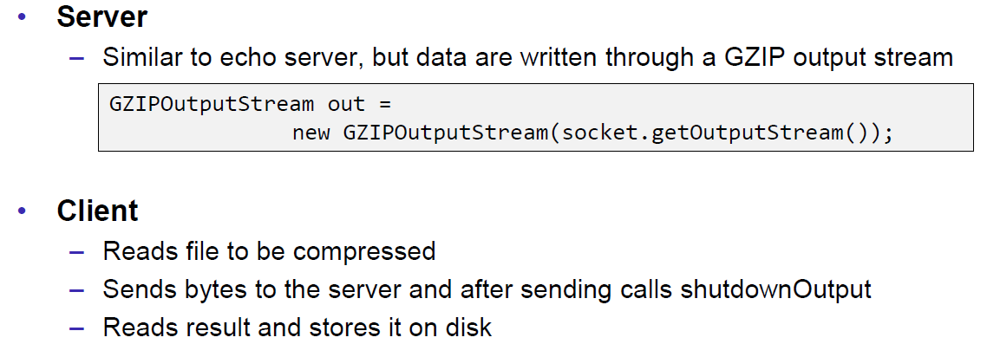

Problem: At some point, the server hangs up and doesn’t reply anymore.

Solution: Don’t send all content before you start reading. Otherwise you will fill up the outgoing (sending) cache of the server (because no one is reading it) and the write process of the server becomes blocking (this prevents a data loss because the outgoing buffer is full). A solution to this problem is to write and read block by block or to start the send process in a separate thread (Both happens in the client), so the client is able to immediately read the result and prevents a full sender buffer of the server.

## UDP Sockets

### UDP (User Datagram Protocol)

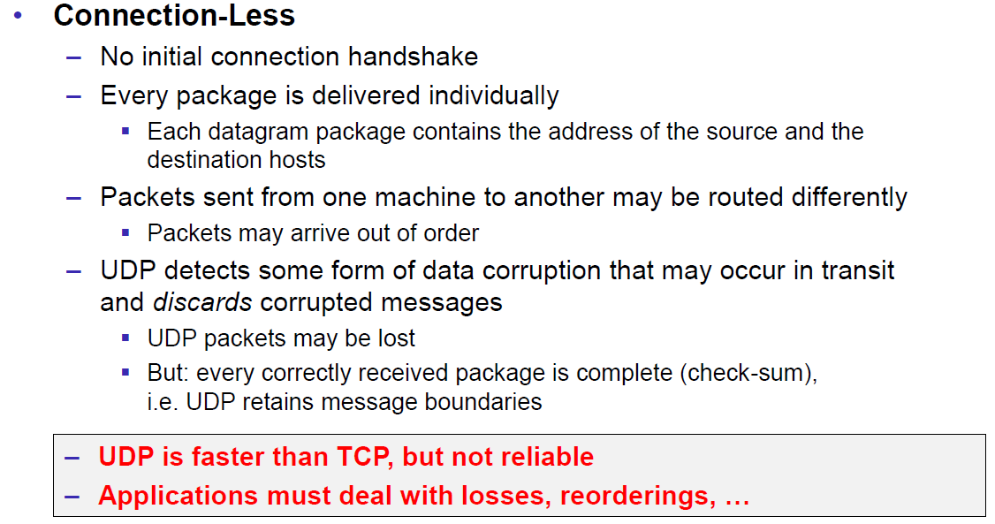

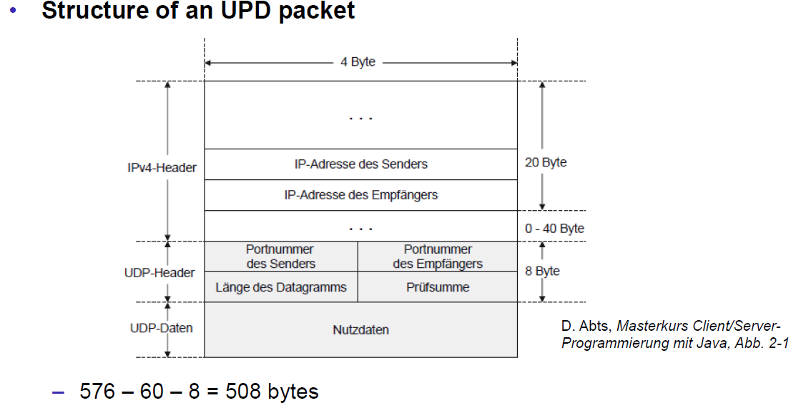

### Java Classes for Datagram

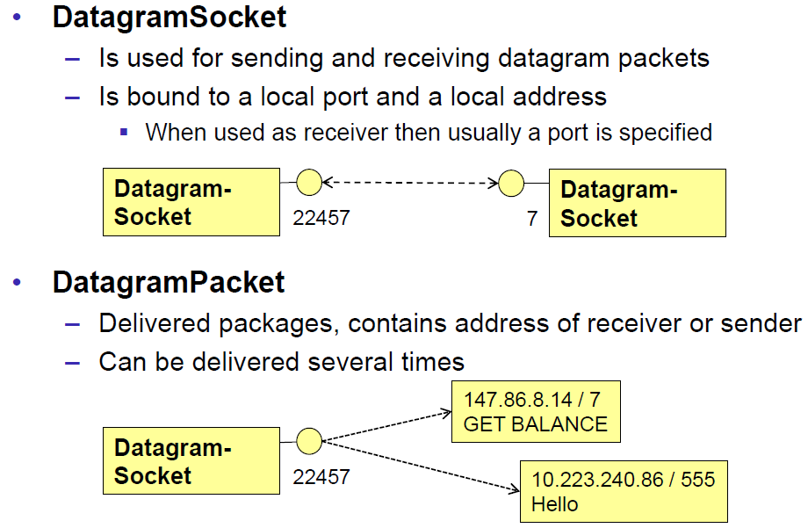

### DatagramSocket

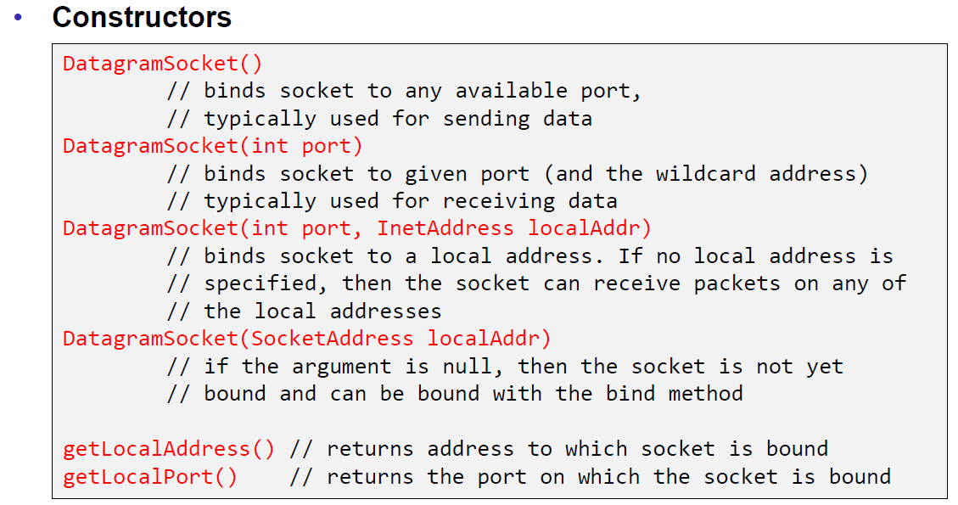

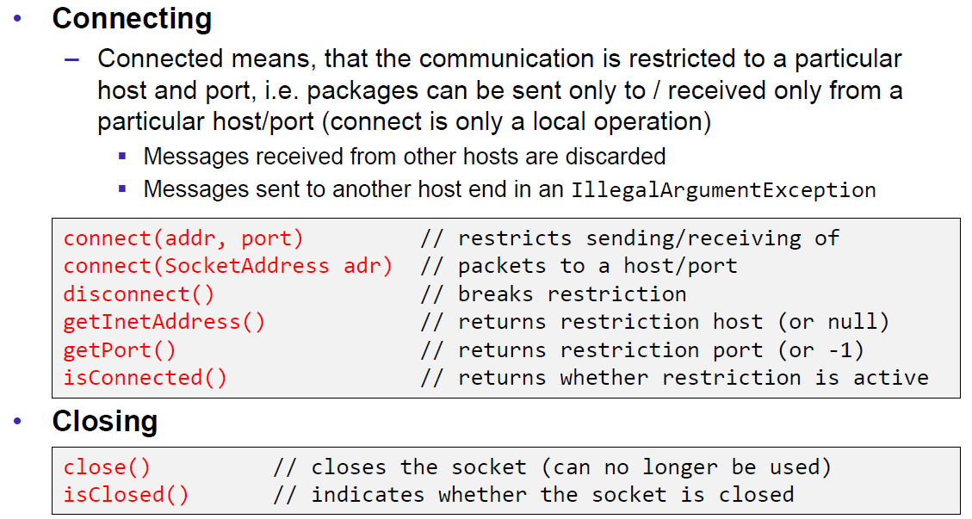

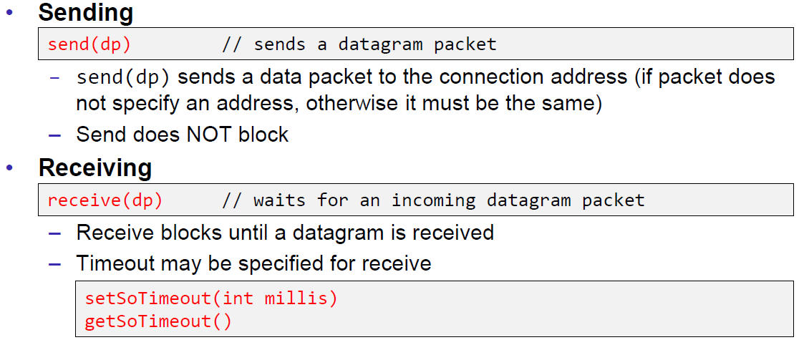

### DatagramPacket

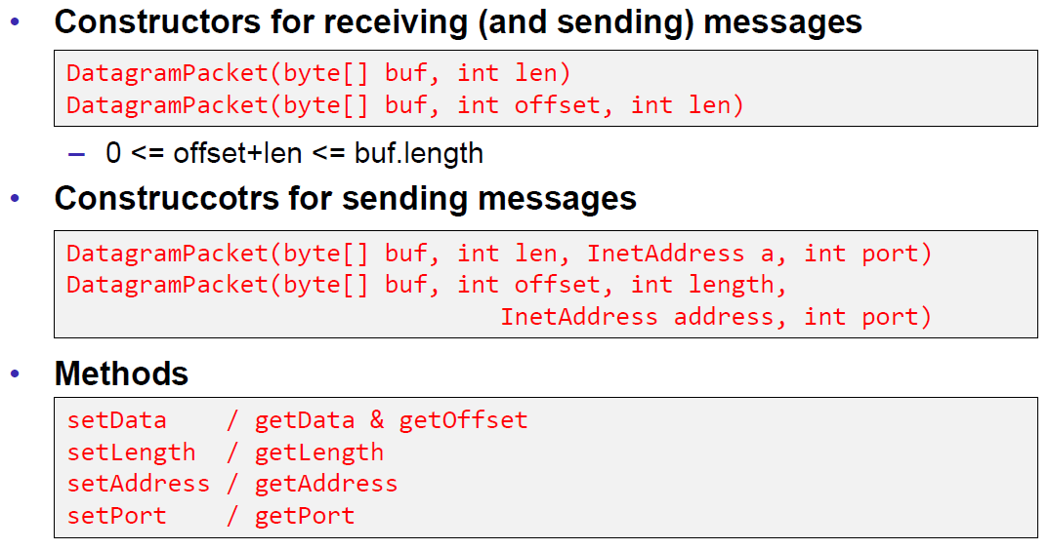

### Example of a UDP Server and Client

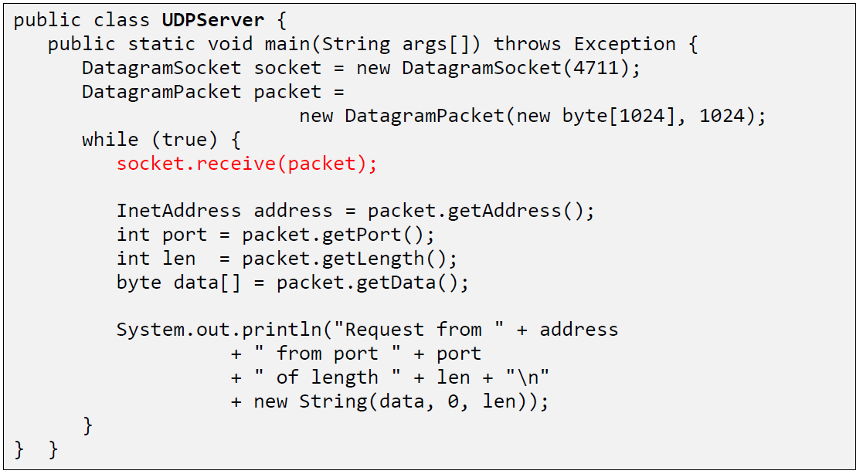

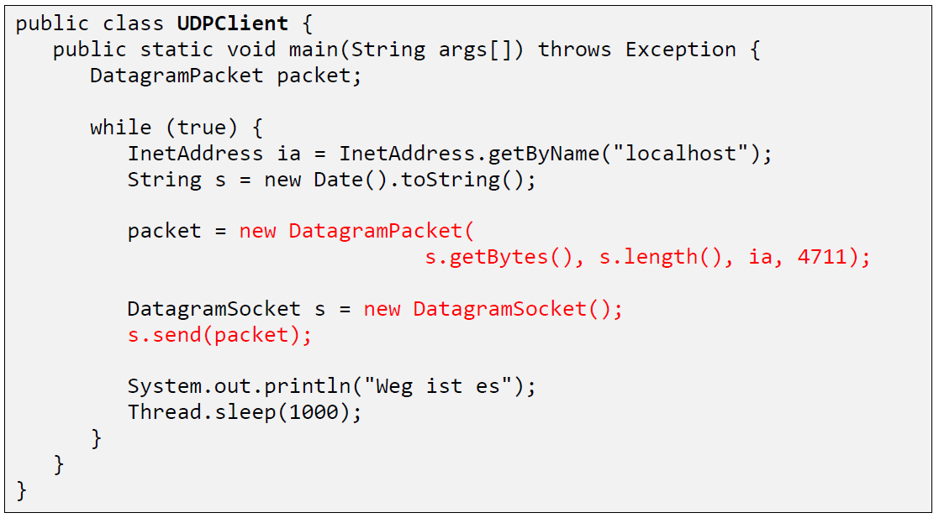

### UDP Implementation

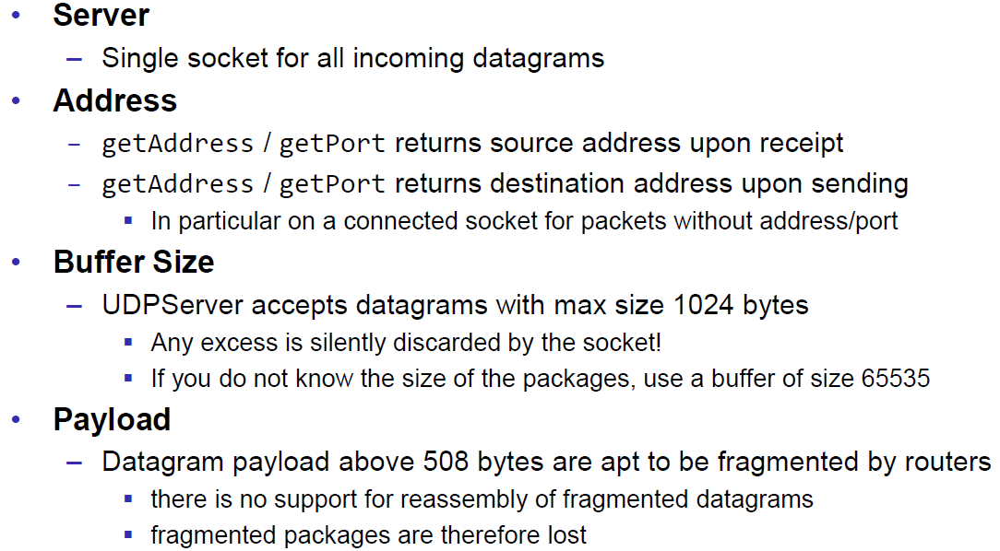

### Reliable UDP

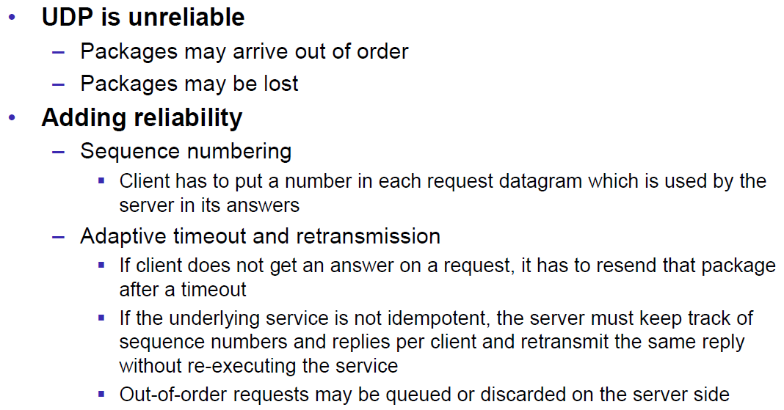

# Woche 3

## HTTP Protocol

### IETF RFC

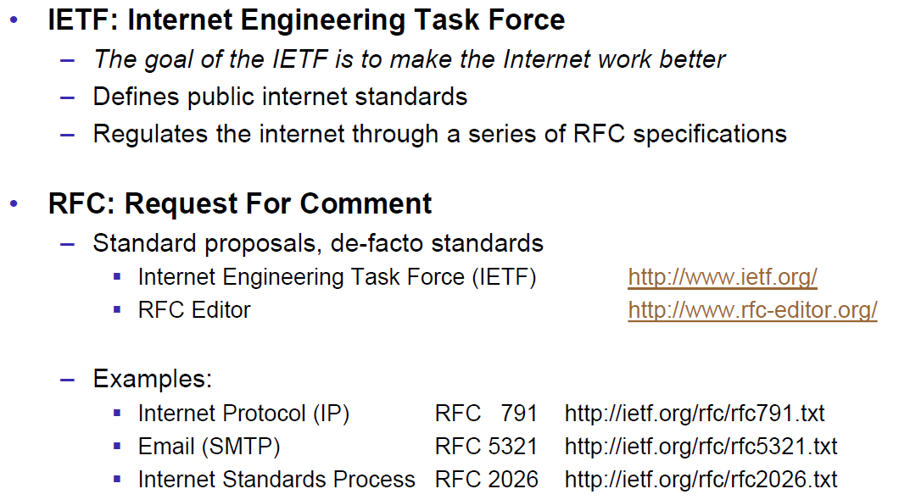

### HTTP Protocol

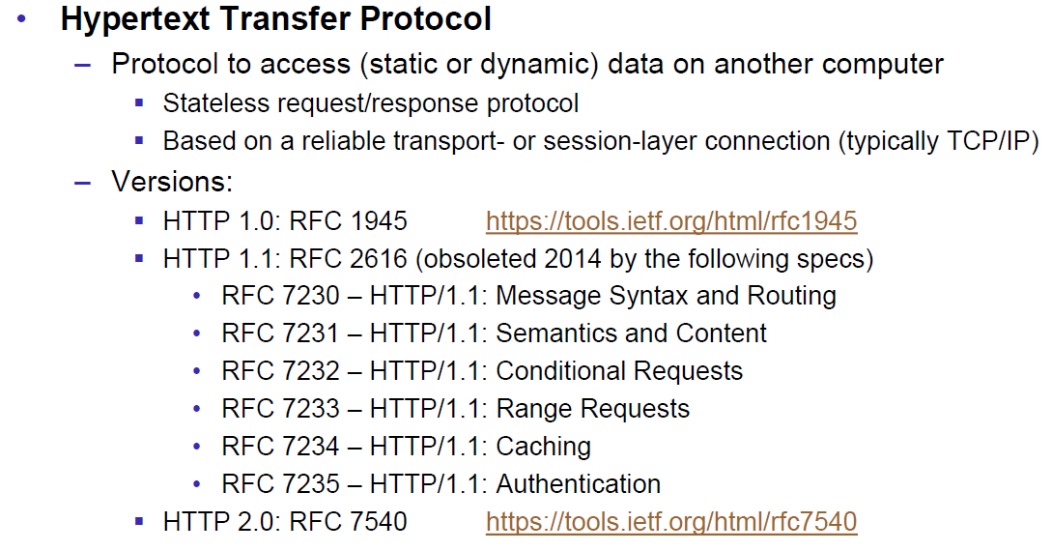

### HTTP Request

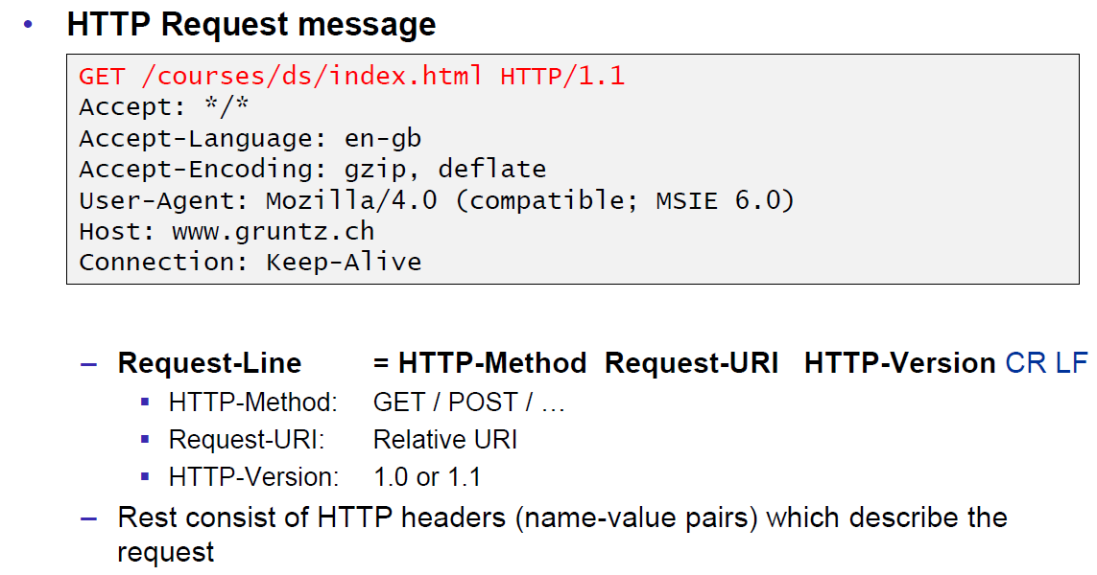

### HTTP Response

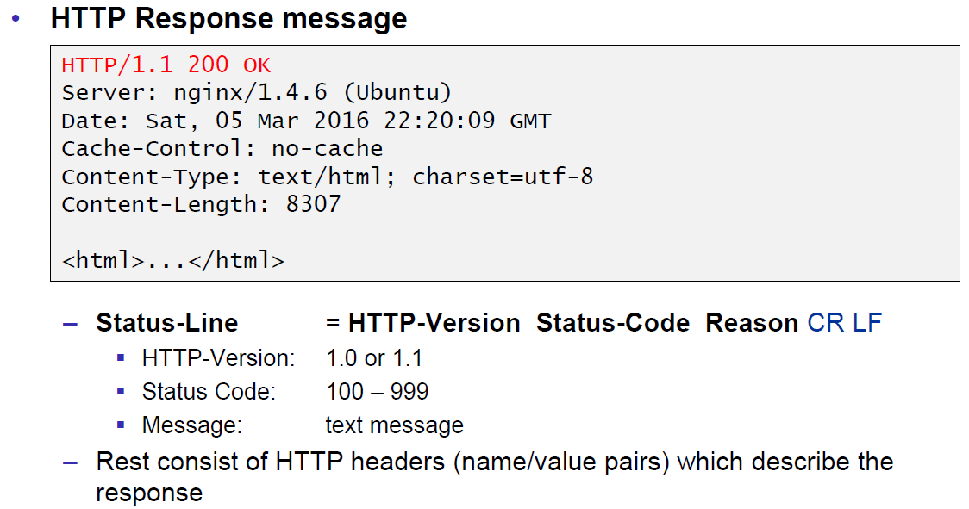

### HTTP Protocol

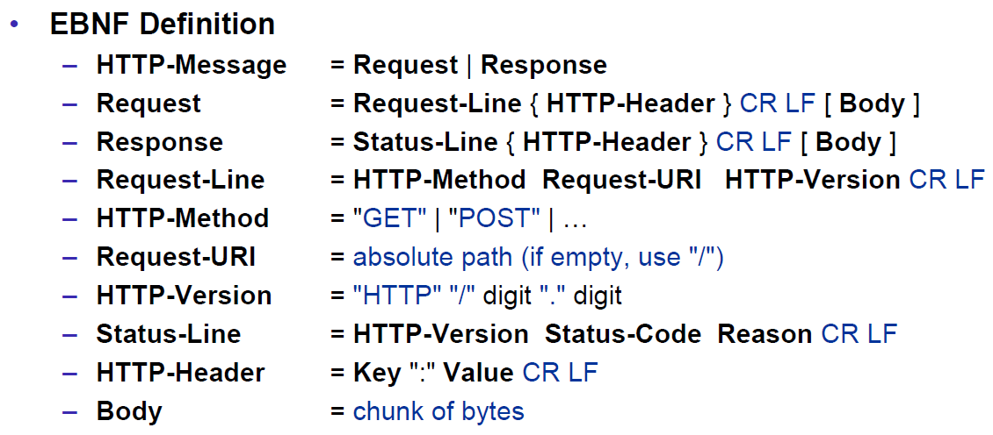

### HTTP Sample

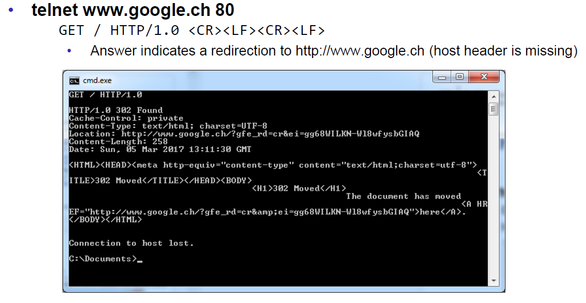

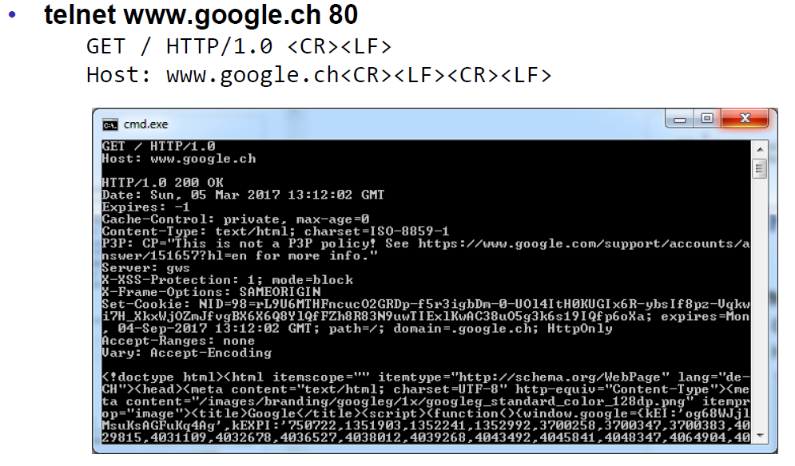

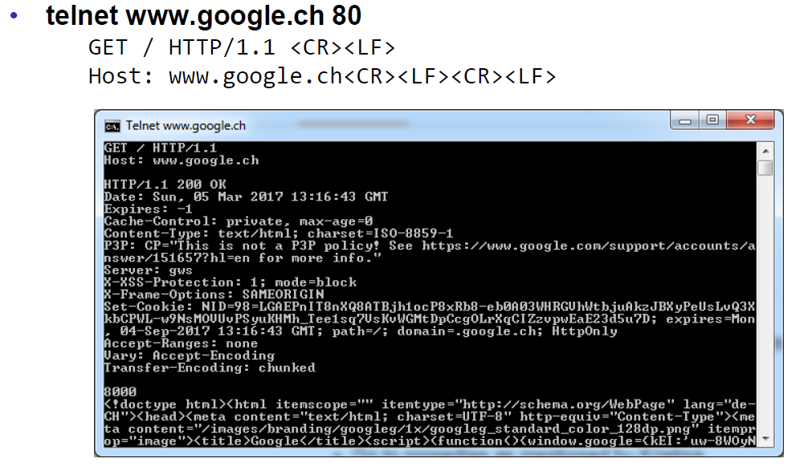

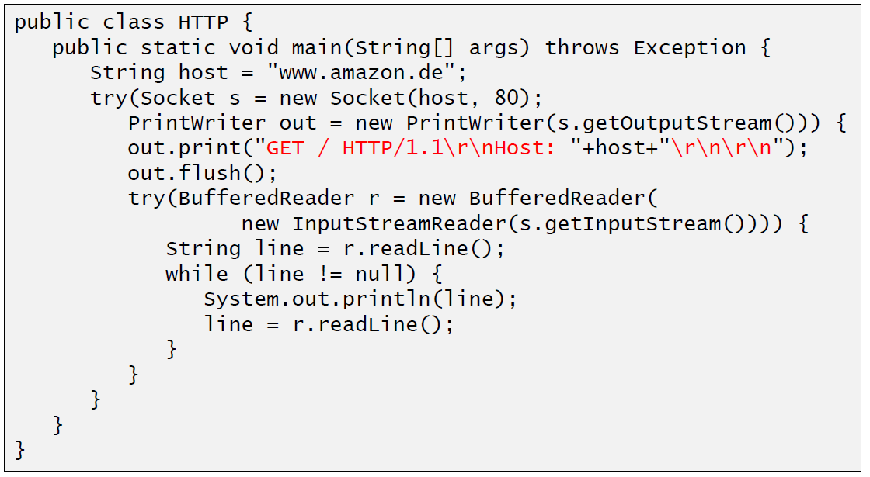

### HTTP 1.0 Request Methods

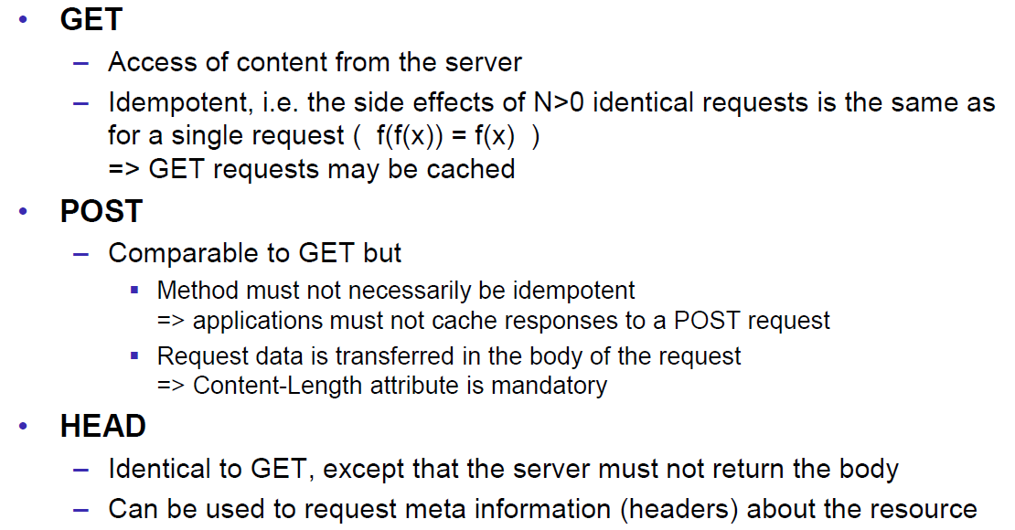

### HTTP Response Codes

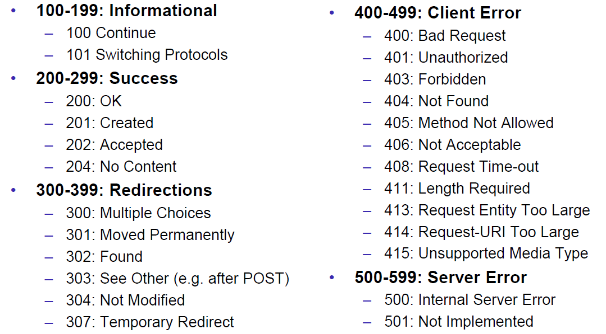

### HTTP Request Headers

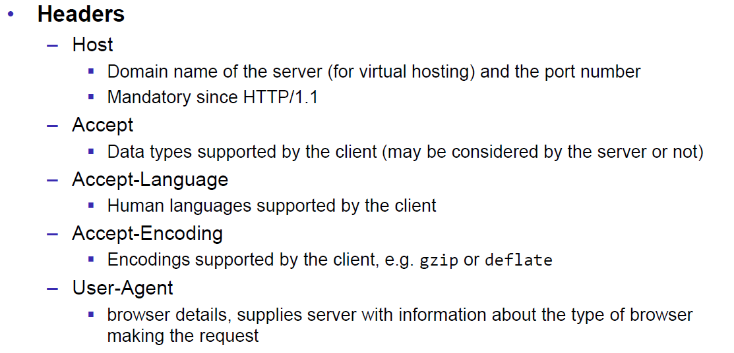

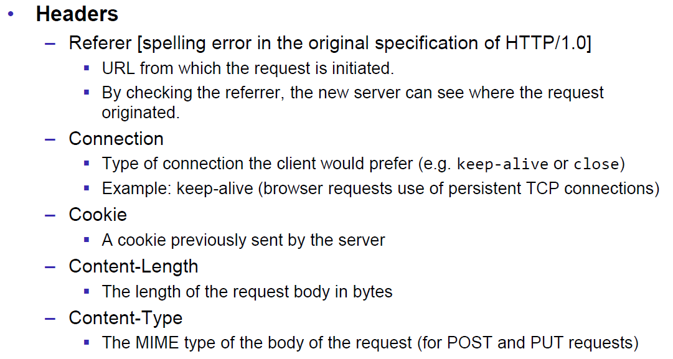

### HTTP Response Headers

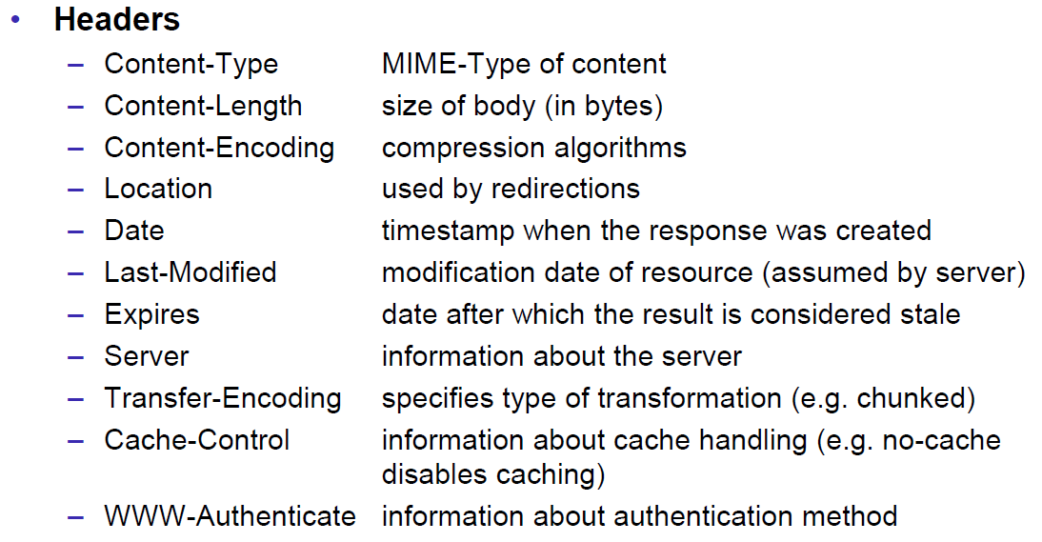

### MIME Types

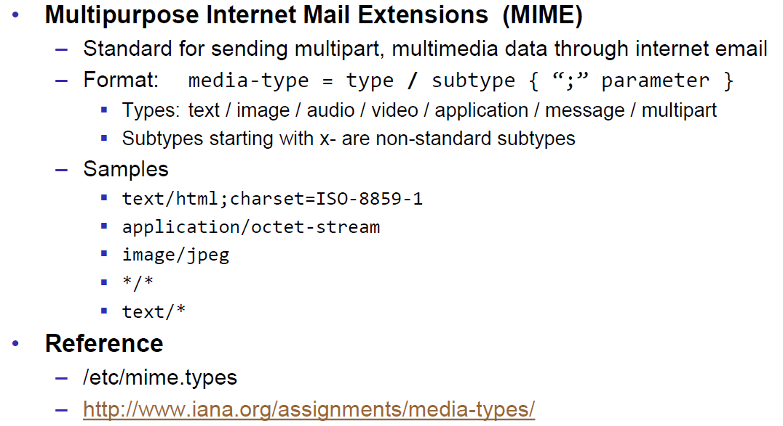

### HTTP Request/Response Sample

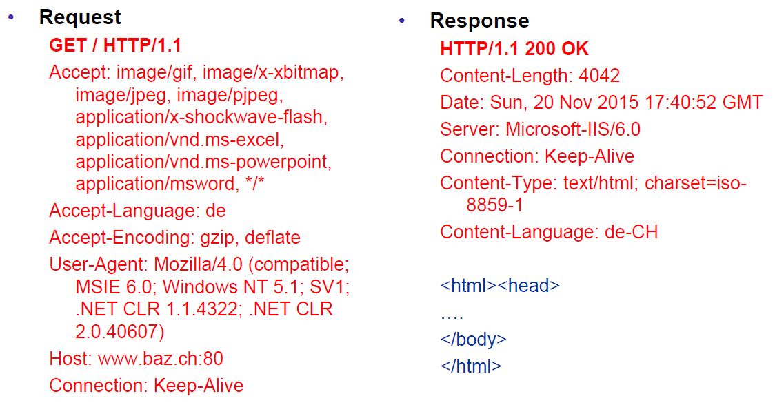

### HTTP 1.1 Enhancements

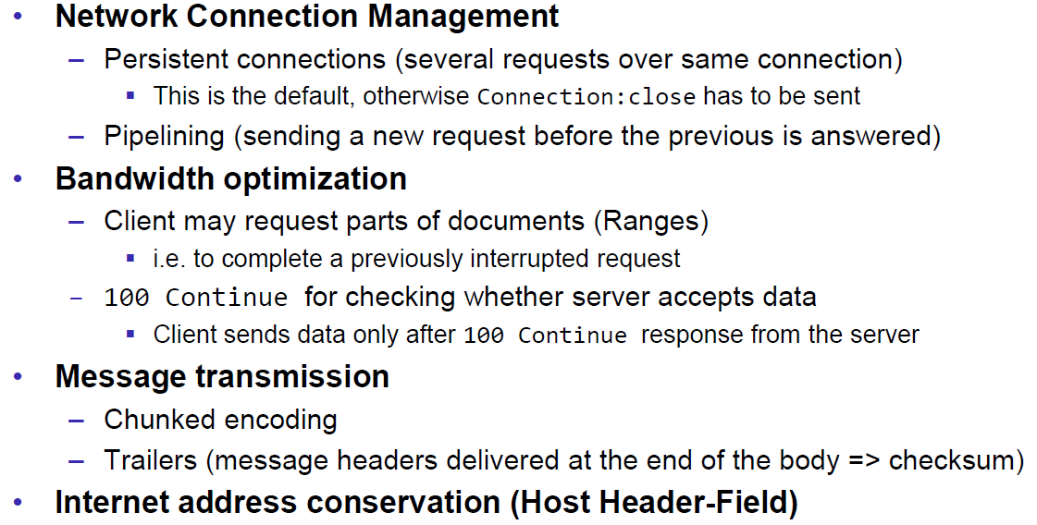

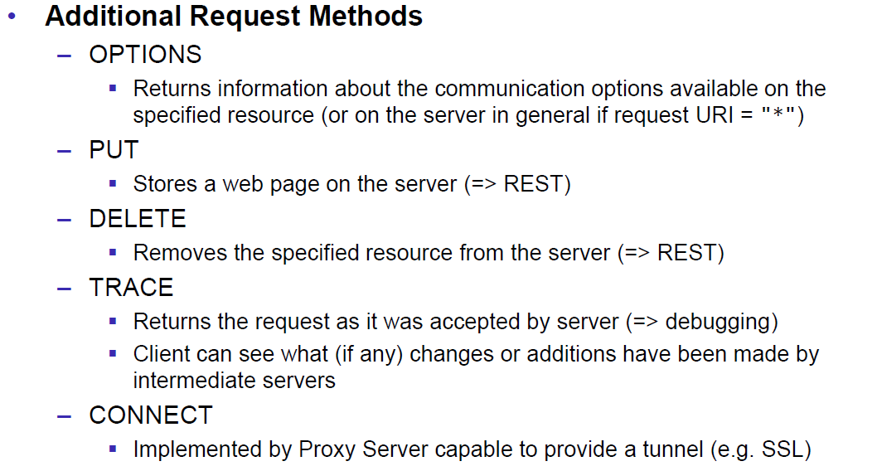

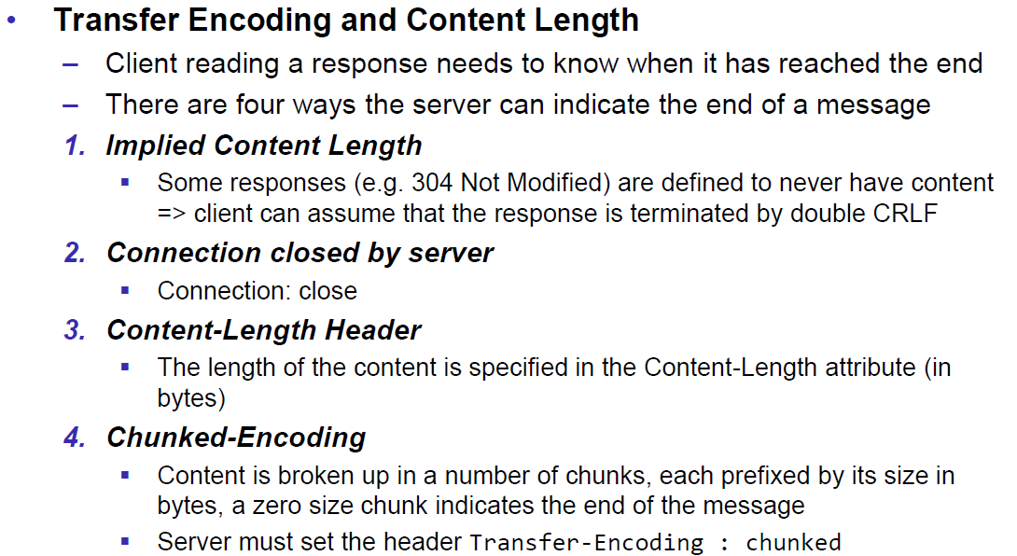

## HTTP Web Server

### A simple Web Server

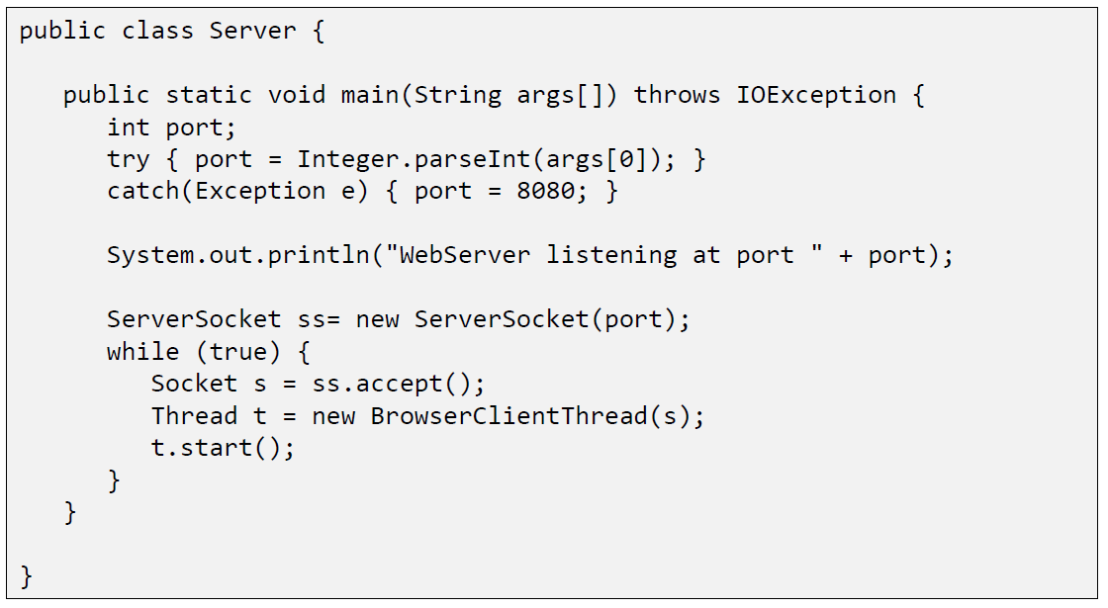

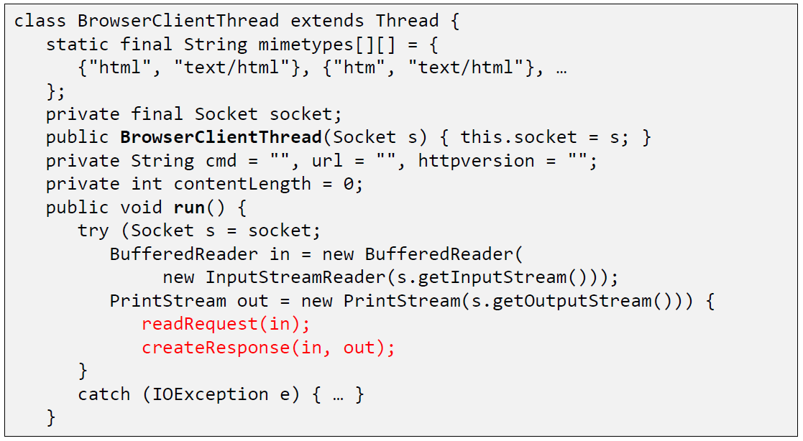

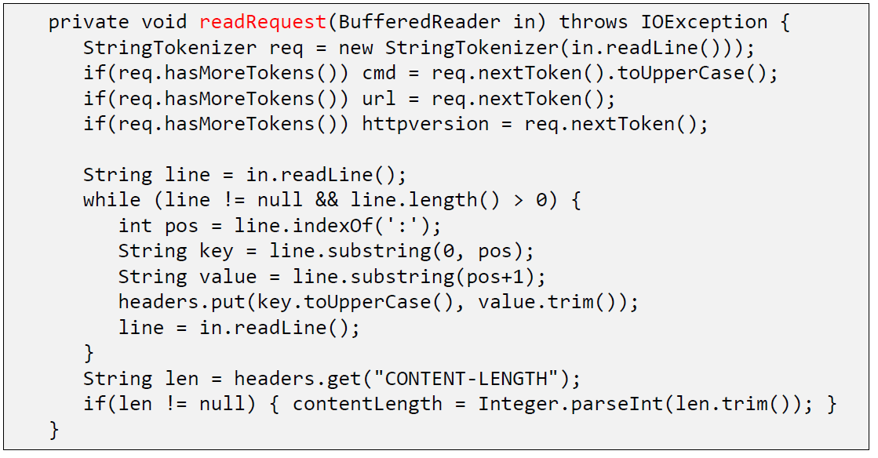

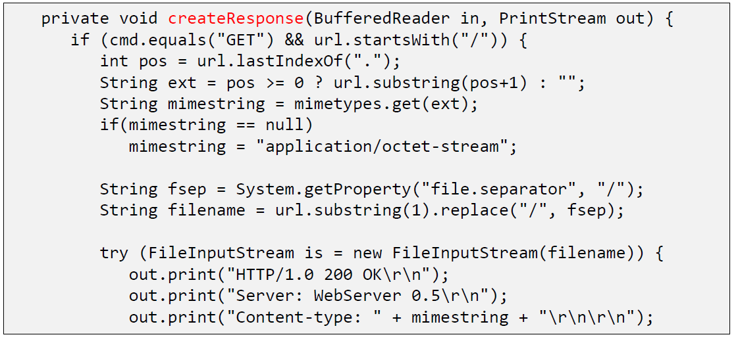

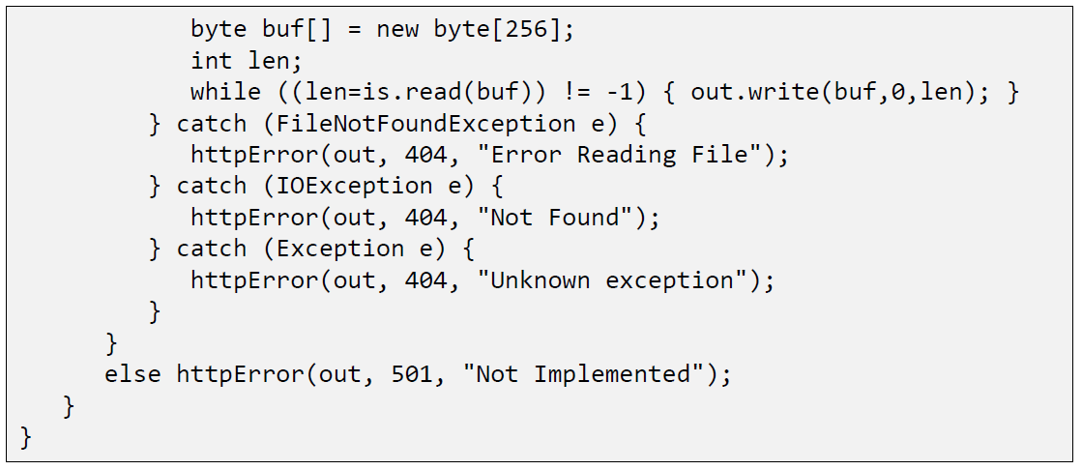

### Java internal Web Server

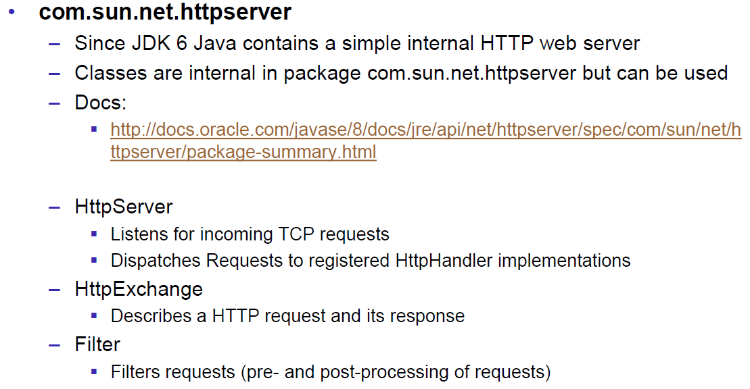

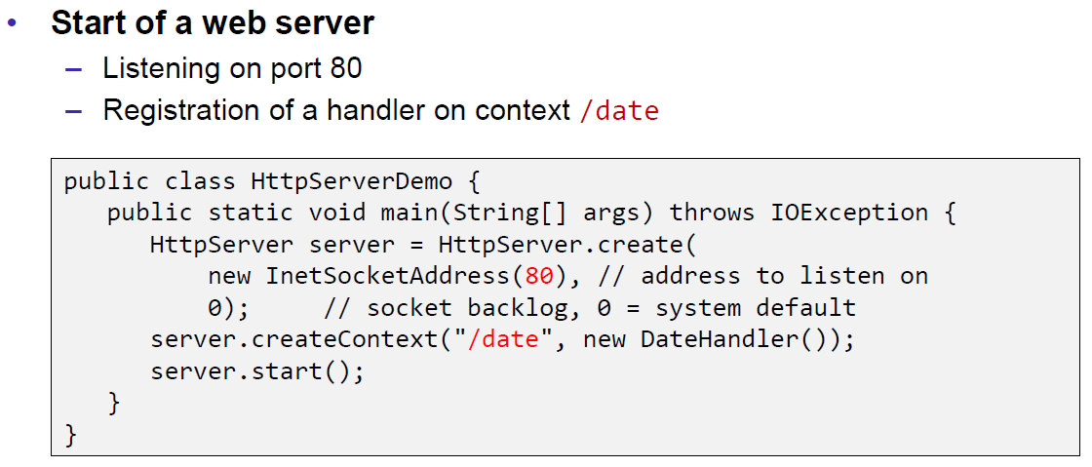

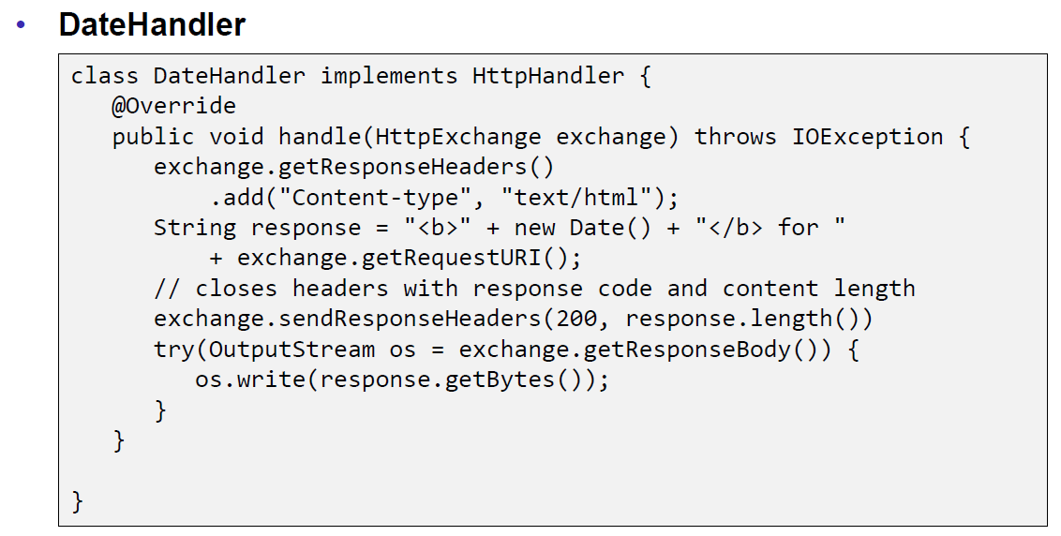

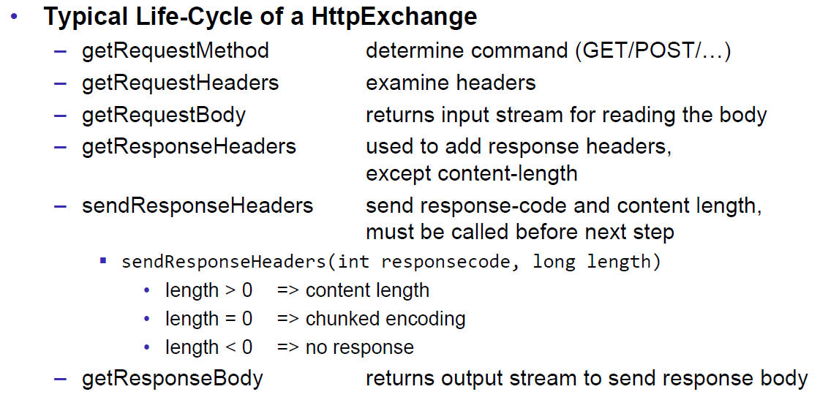

## HTML Forms & URL Encoding

### HTML GET Form

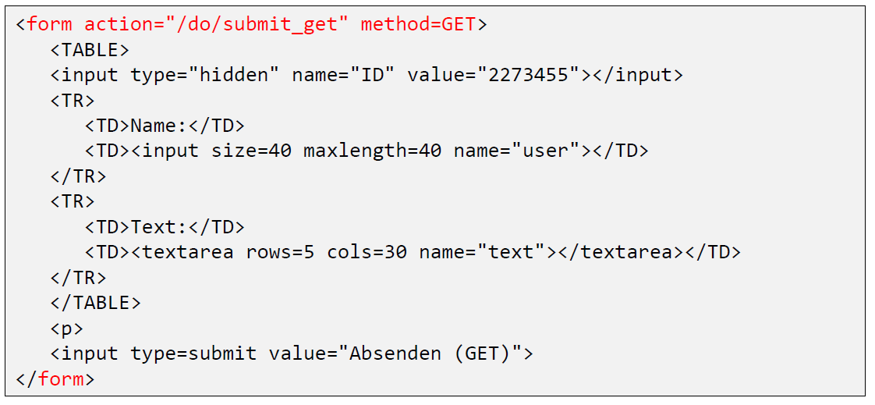

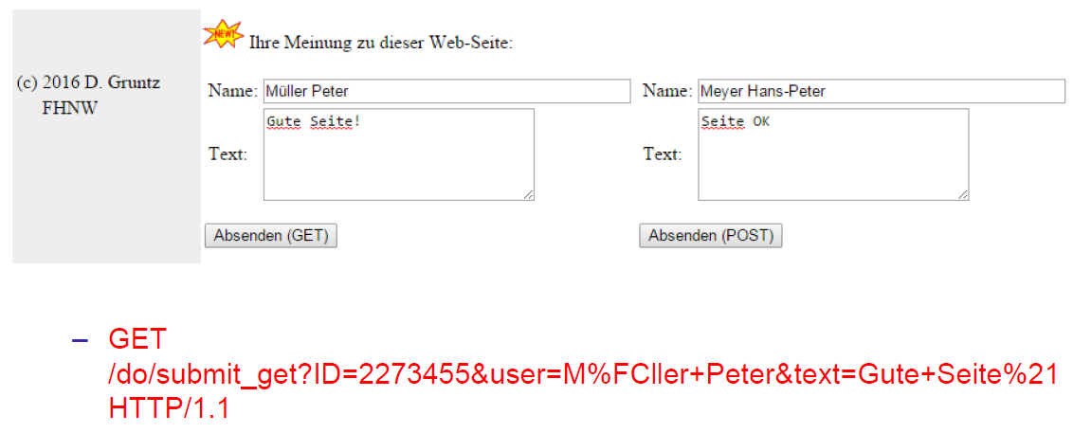

### URL Encoding

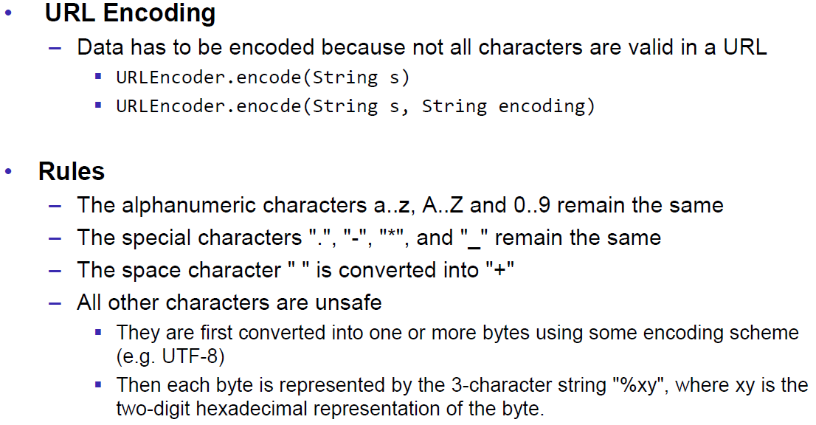

### HTML POST Form

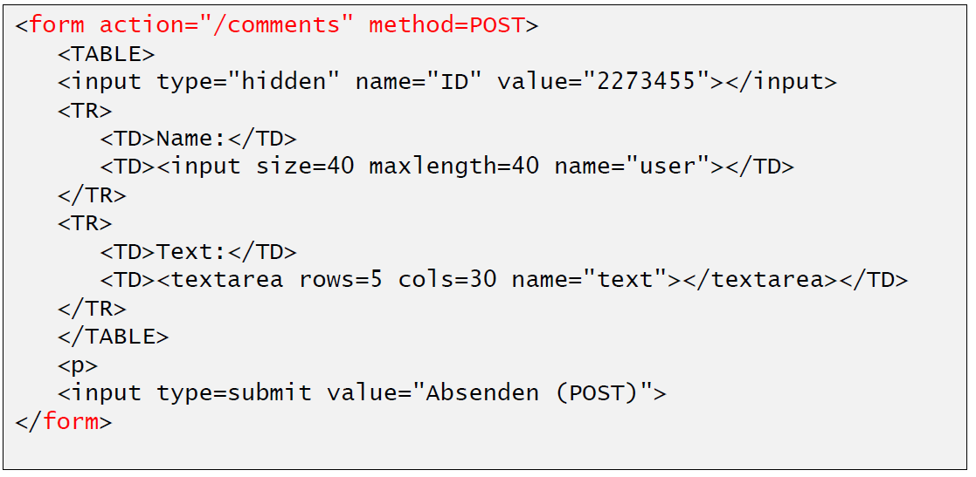

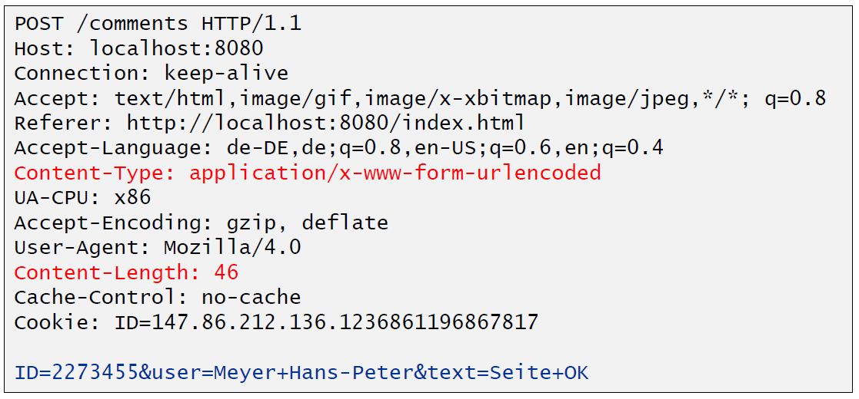

## HTTP Requests from Java

### URL

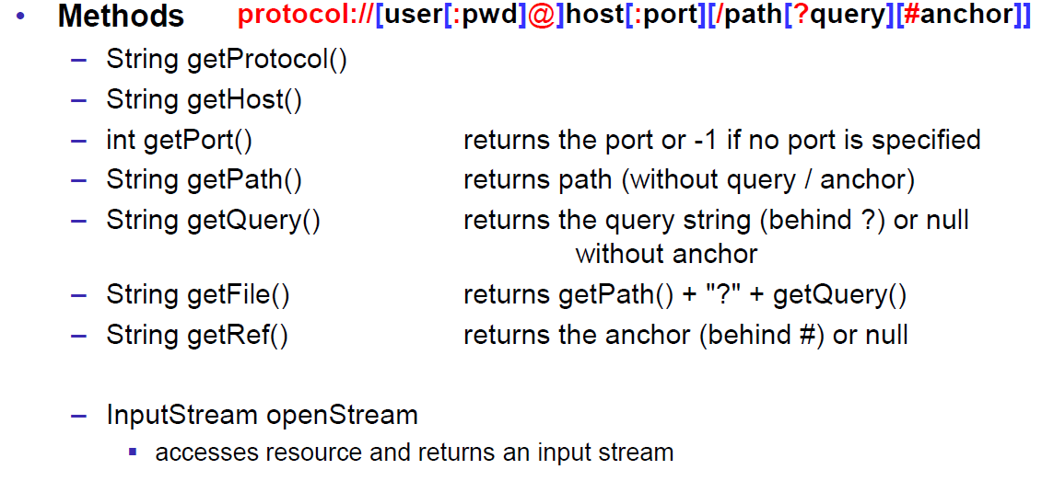

### Sending GET Requests from within Java

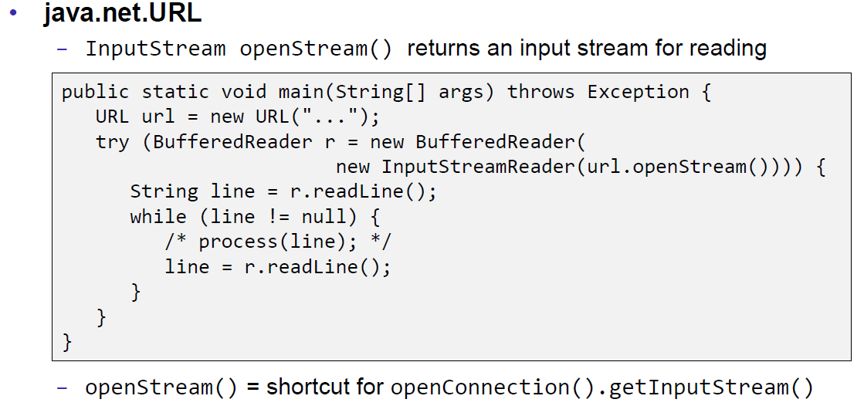

### URLConnection

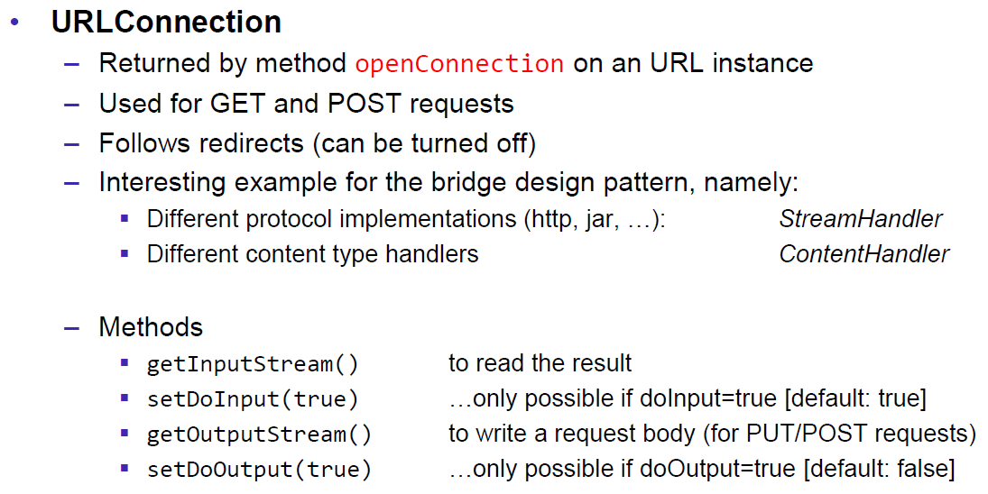

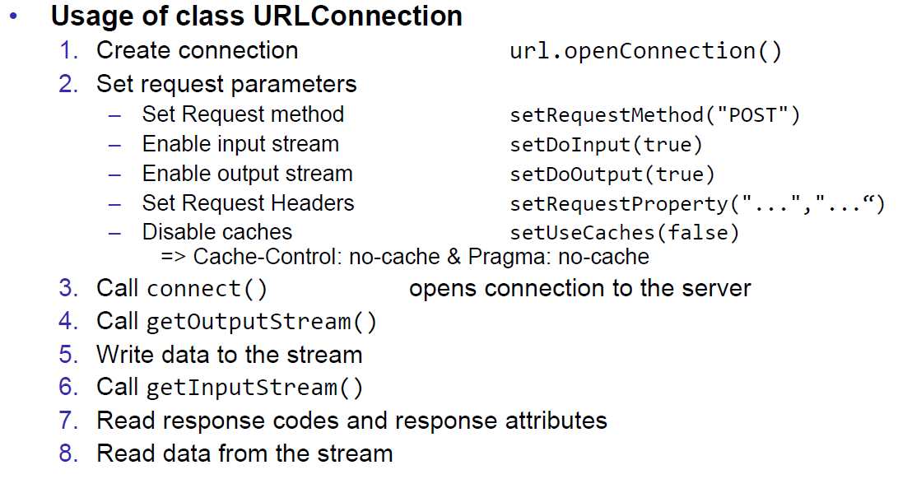

### URLConnection Tips & Tricks

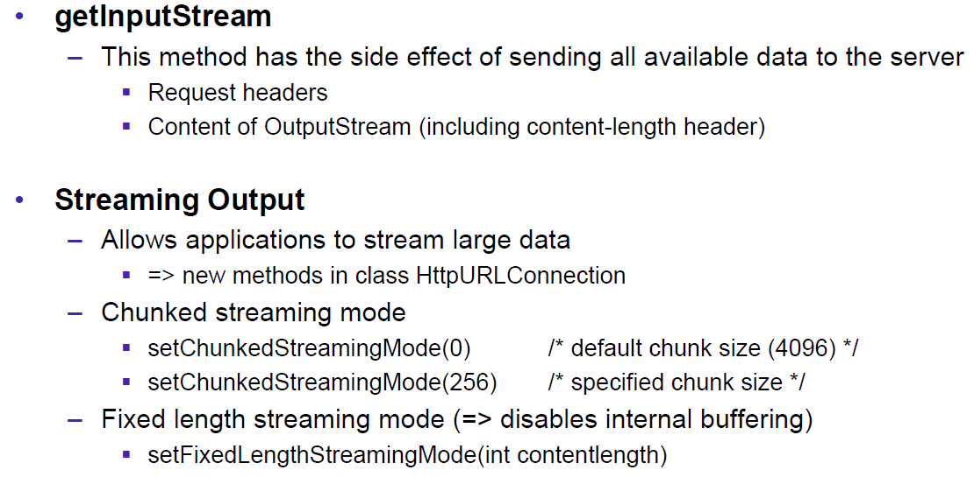

### Sample 1: URLConnection GET

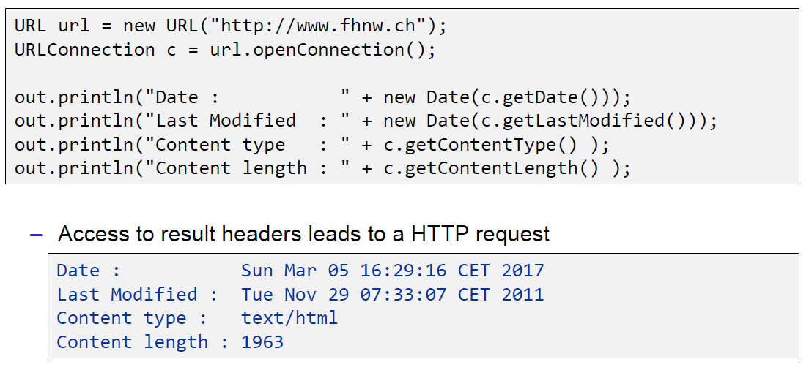

### Sample 2: URLConnection POST

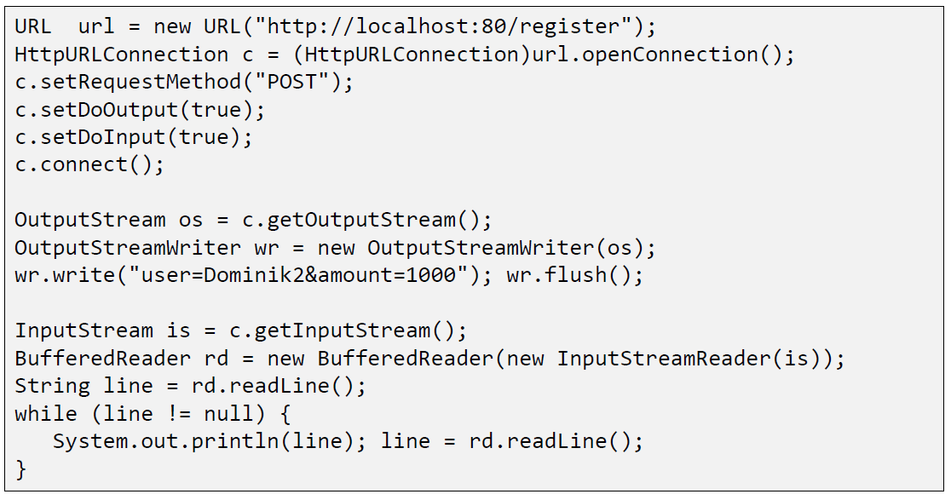

### Sample 3: Currency Converter

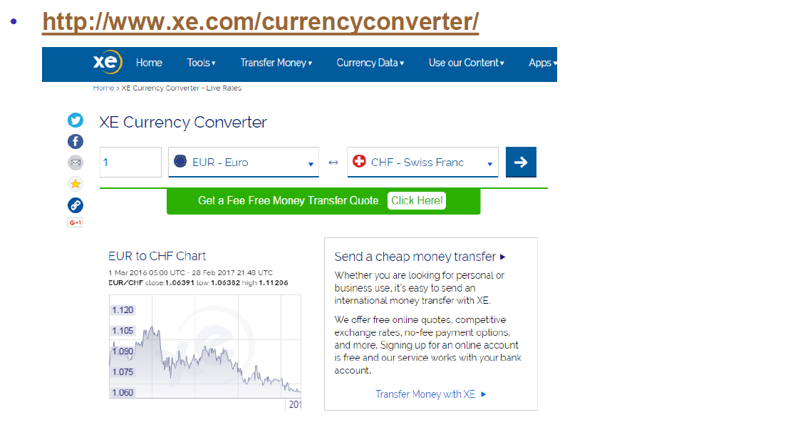

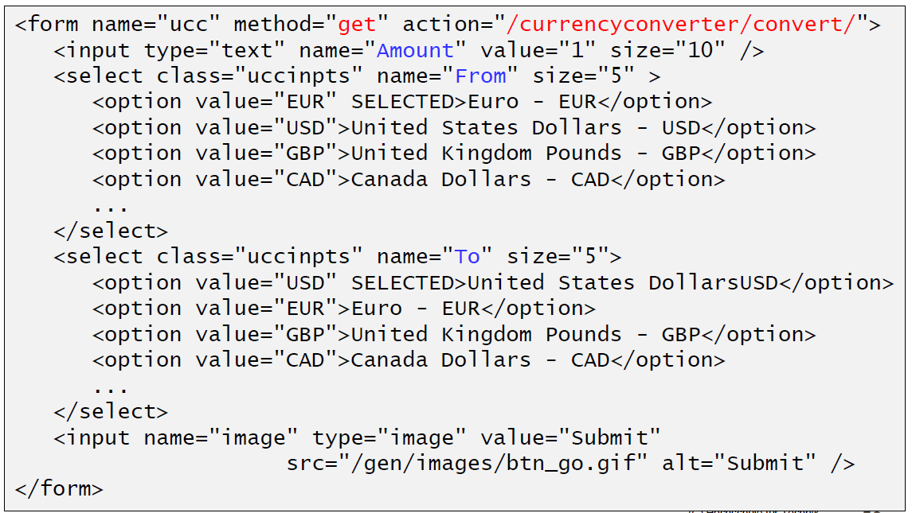

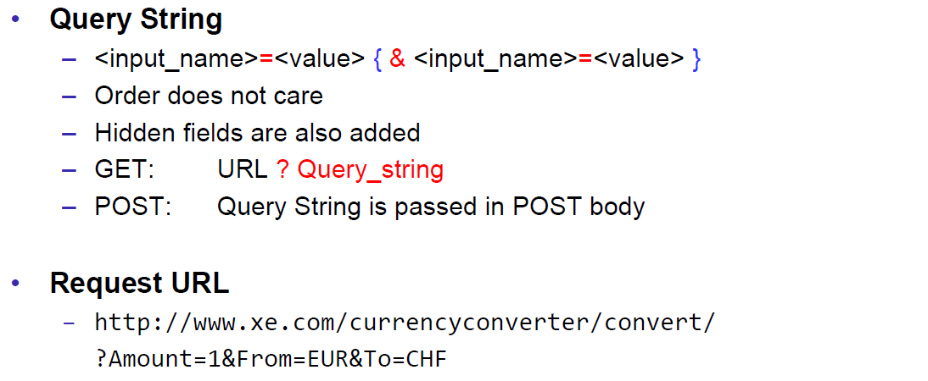

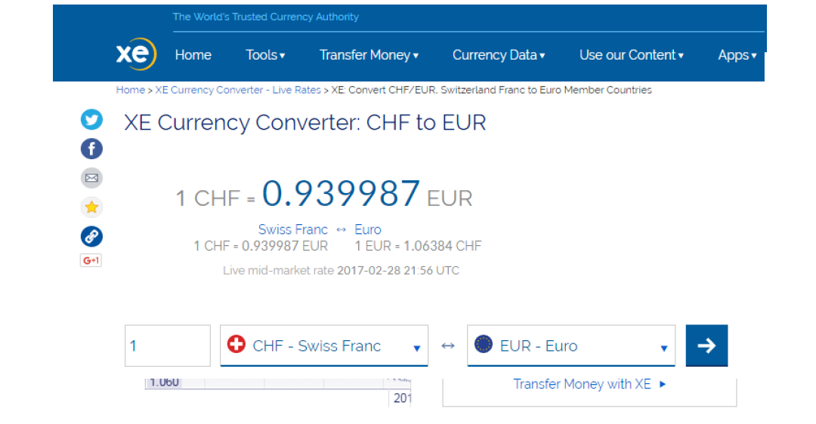

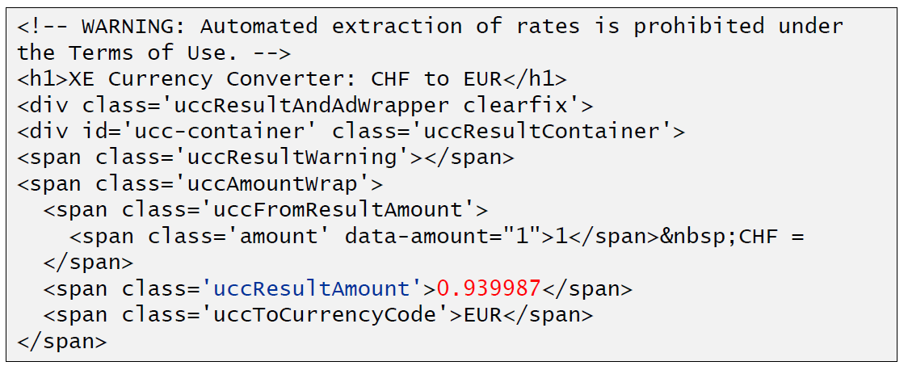

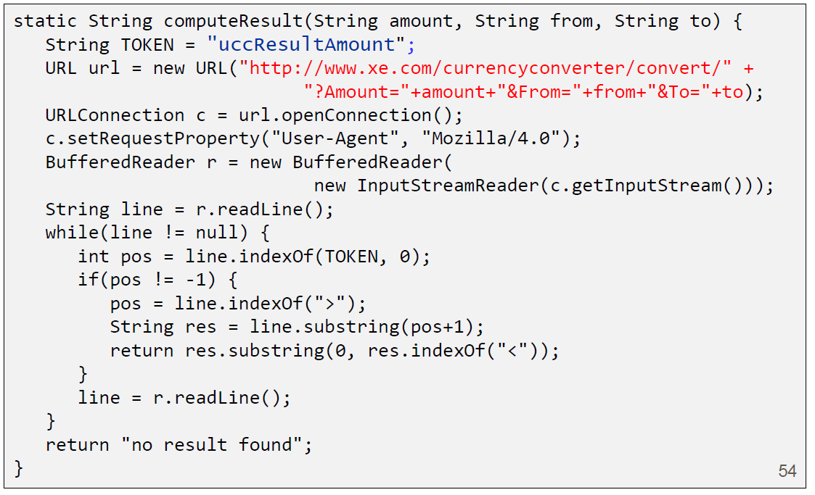

### Other Libraries

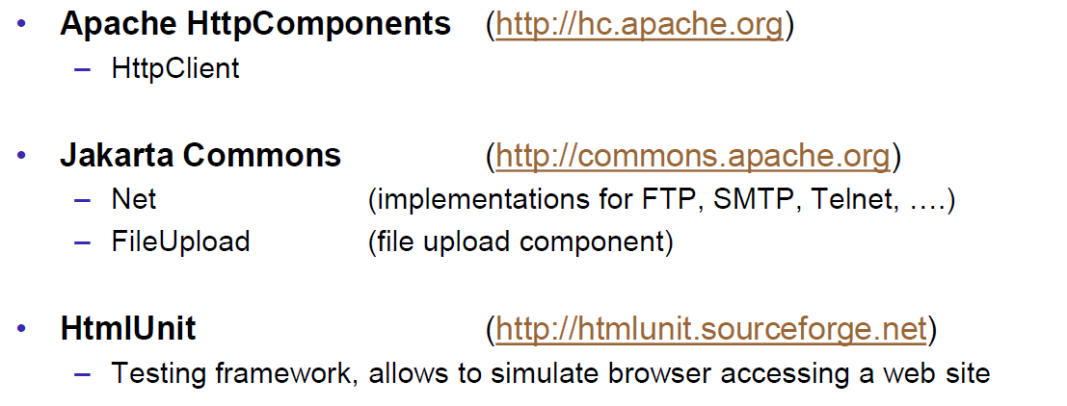

# Woche 4

## Servlets

### Dynamic Content

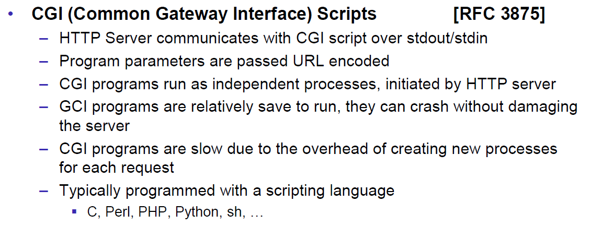

### Servlets

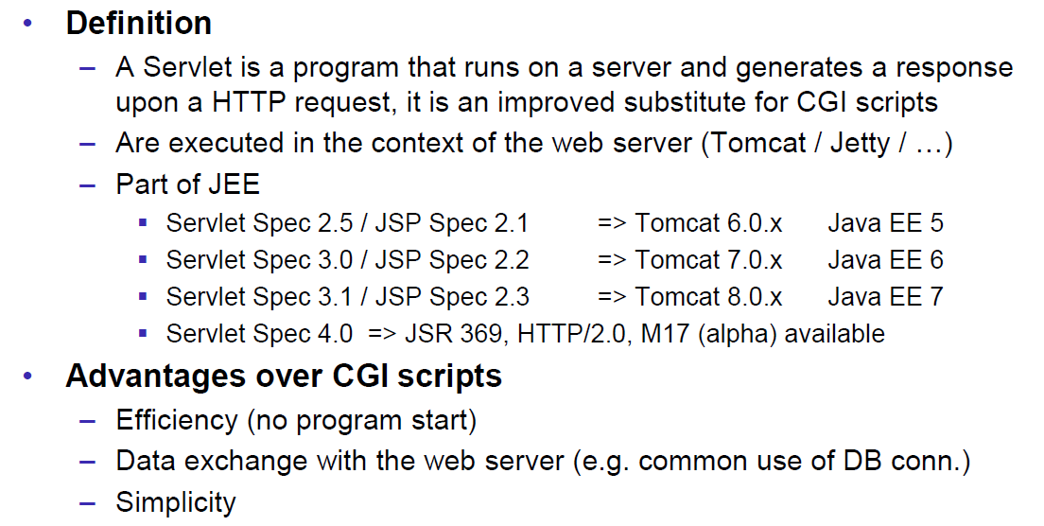

### Servlet Packages

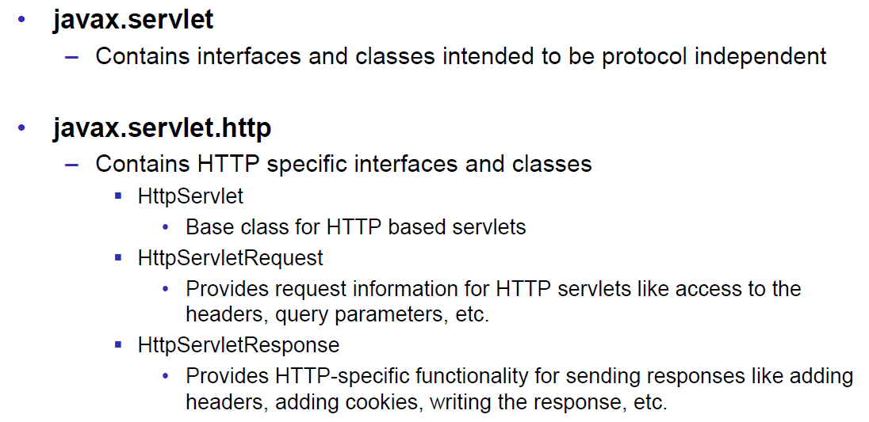

### Servlet Life-Cycle Methods

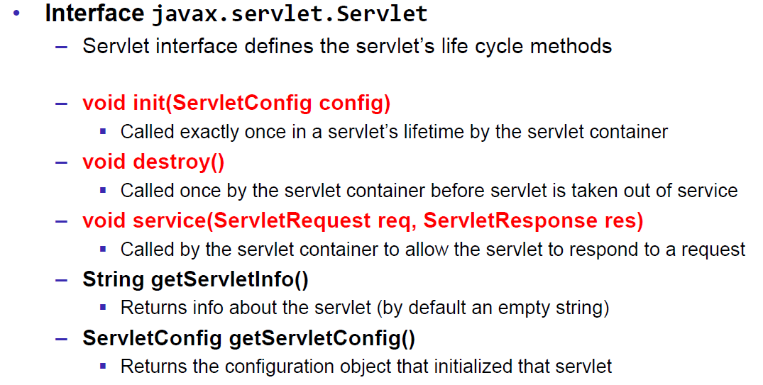

### HttpServlet

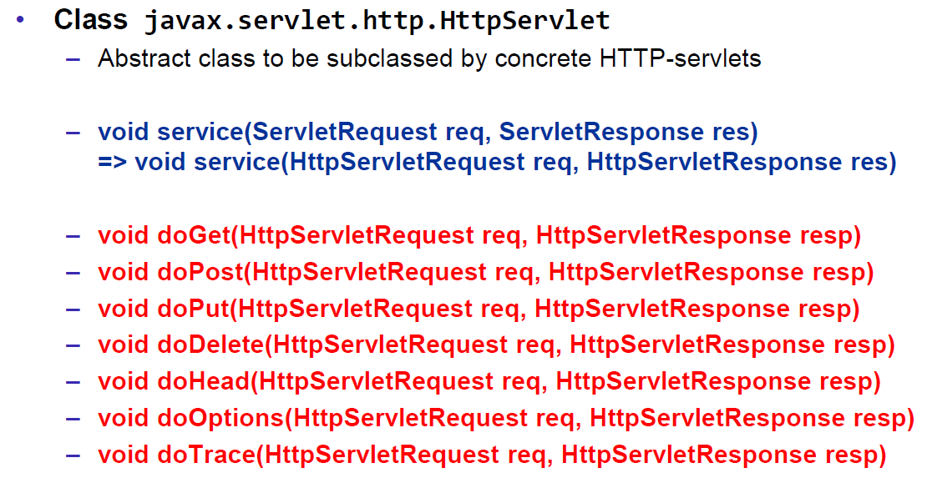

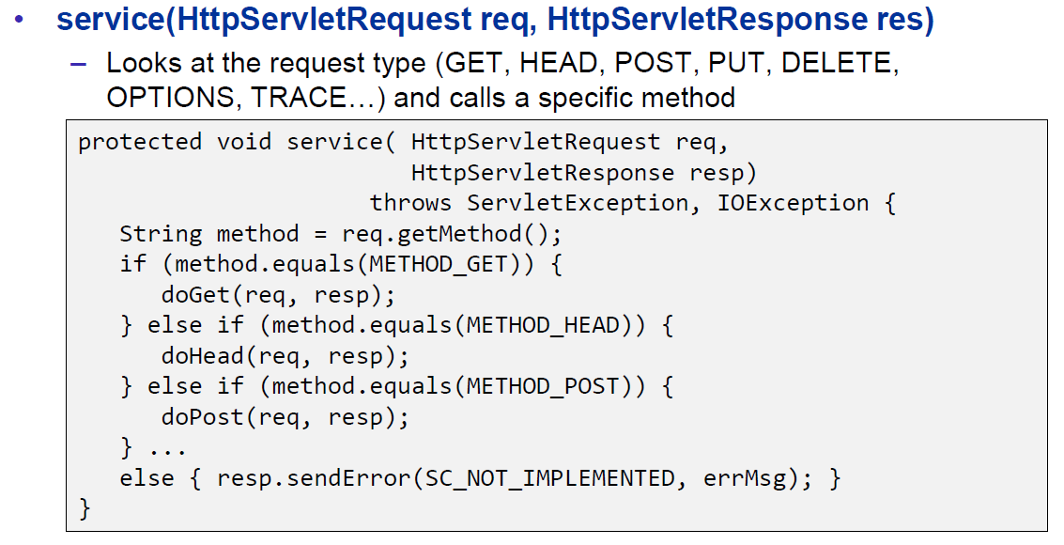

### HttpServletRequest

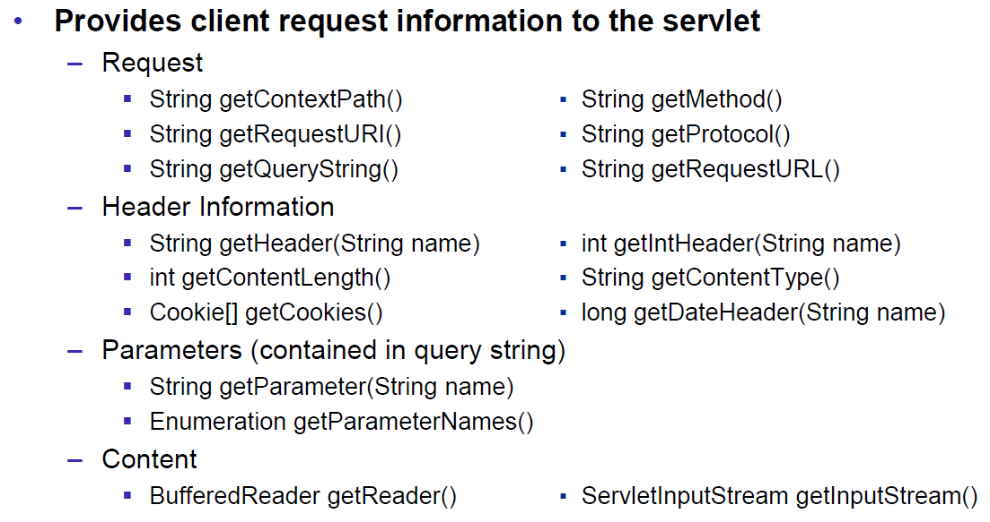

### HttpServletResponse

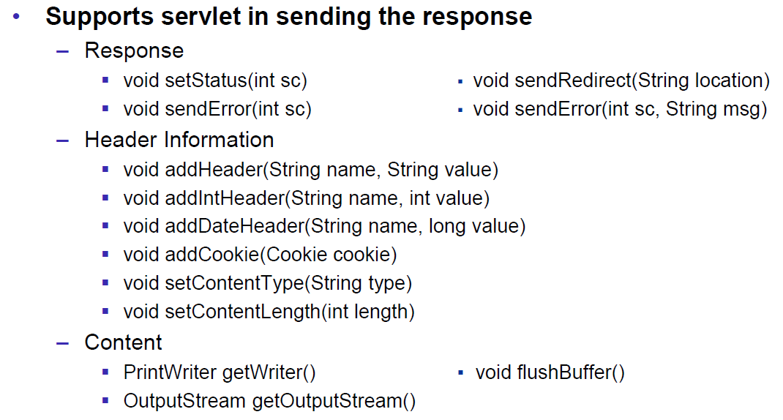

### Servlet Example

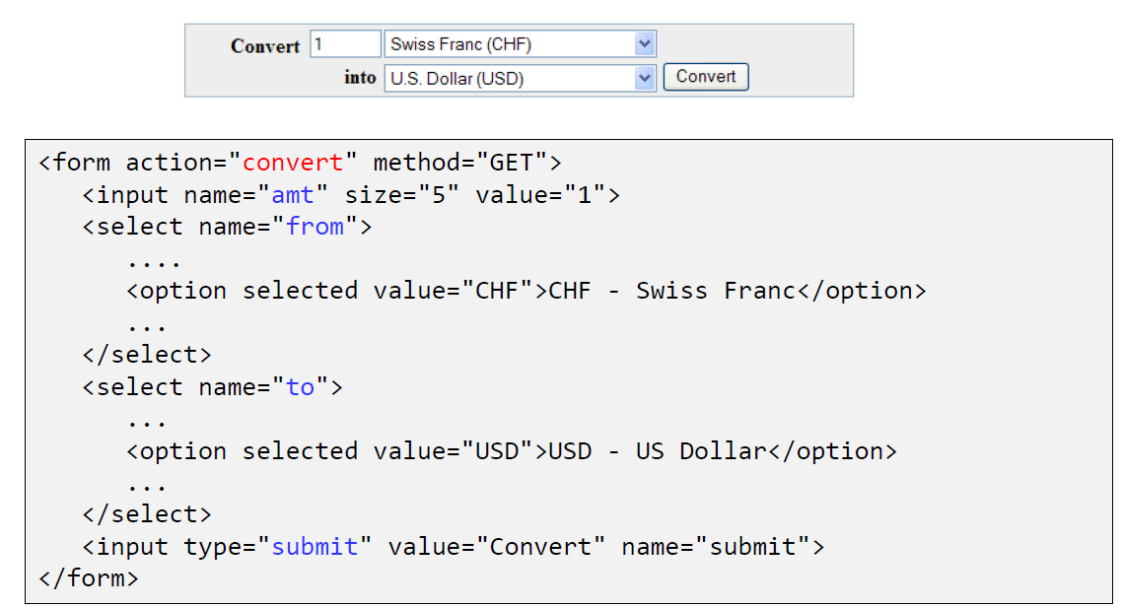

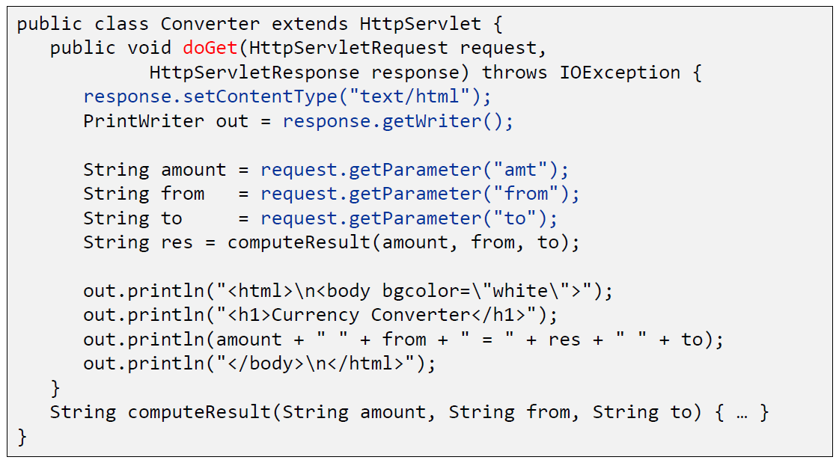

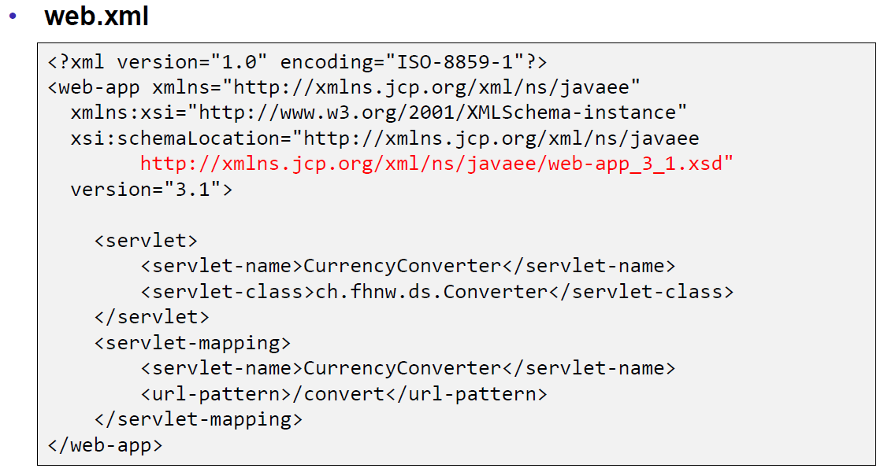

### Webapplication Structure

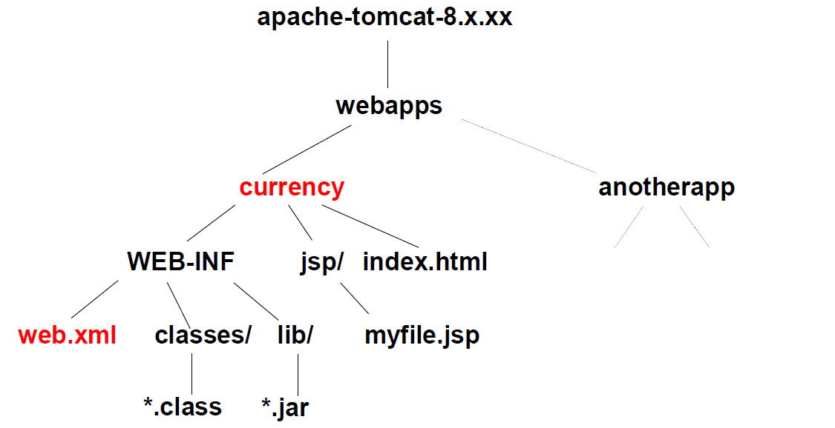

### Annotation WebServlet

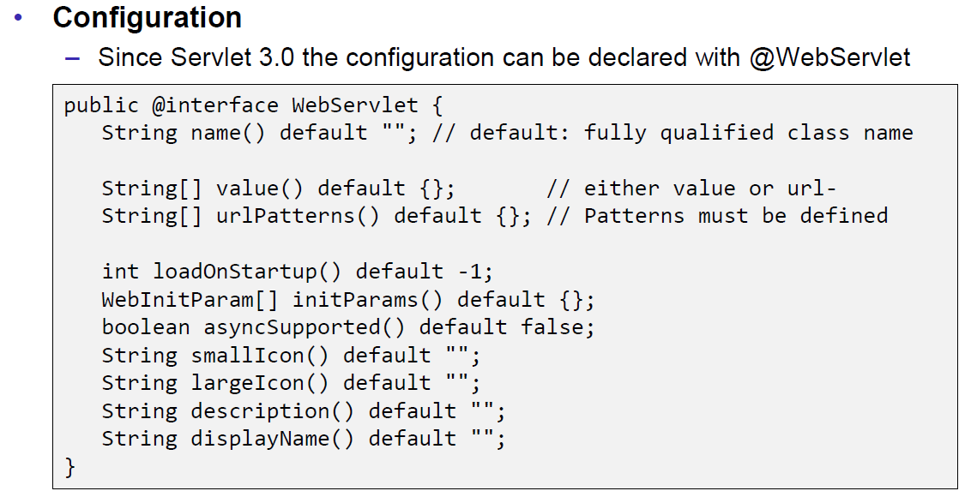

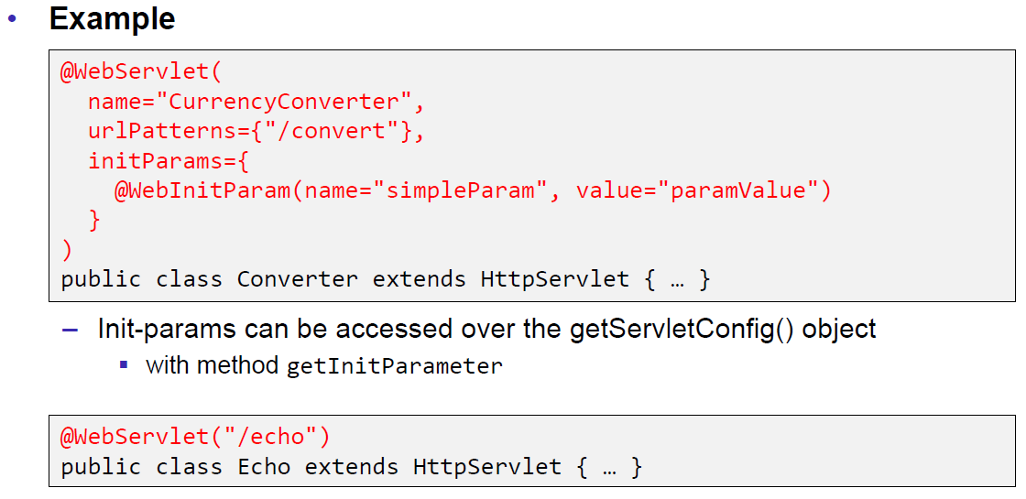

### Webapplication Structure

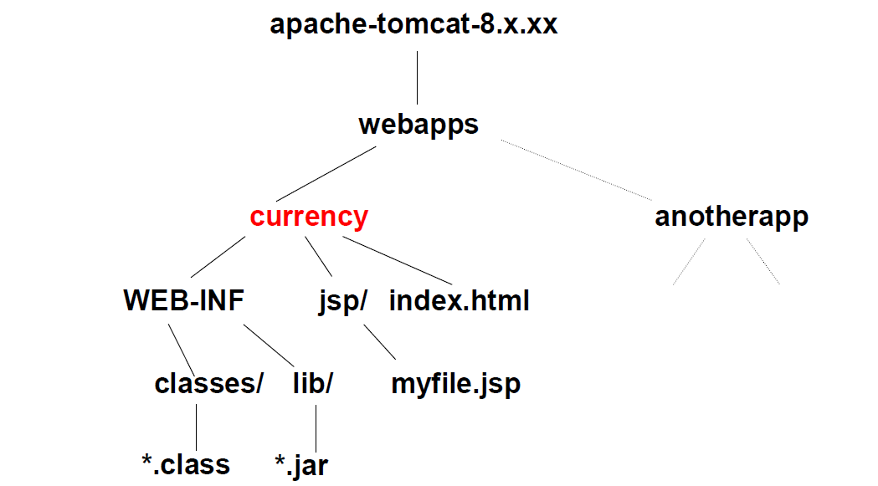

## Tomcat Servlet Server

### Tomcat

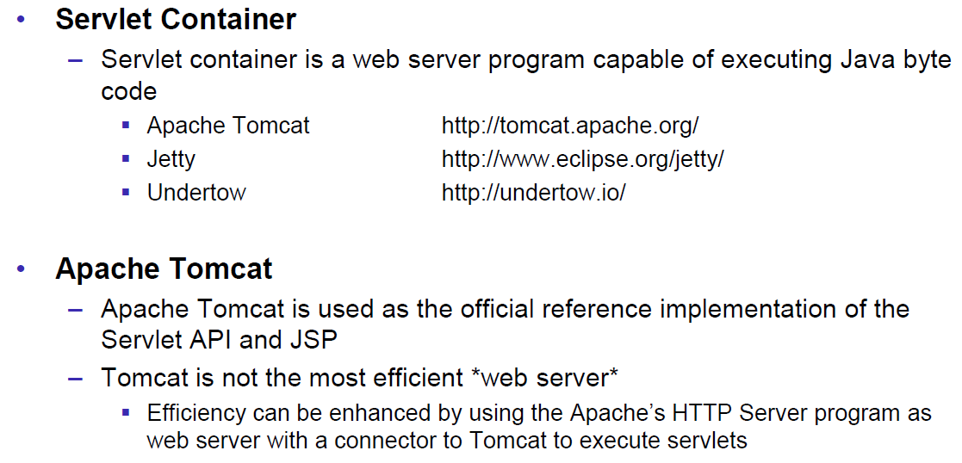

### Tomcat Directory Structure

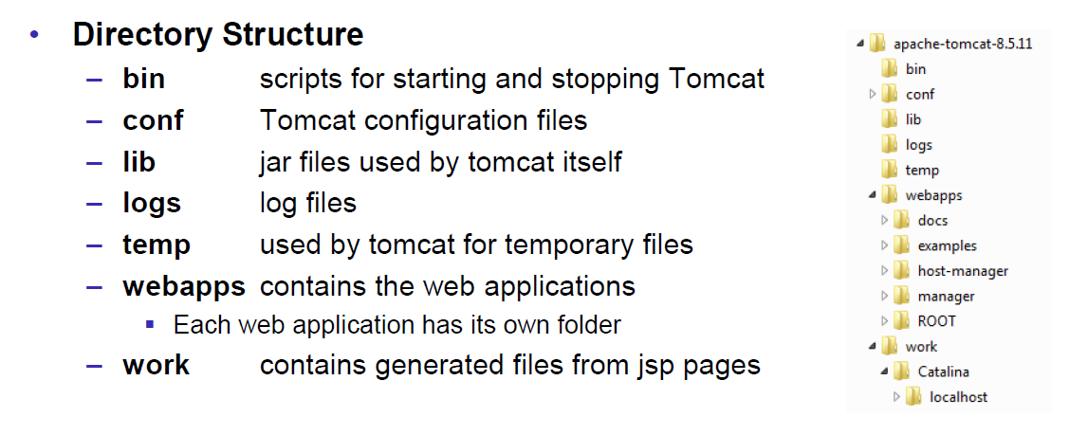

### Tomcat Scripts

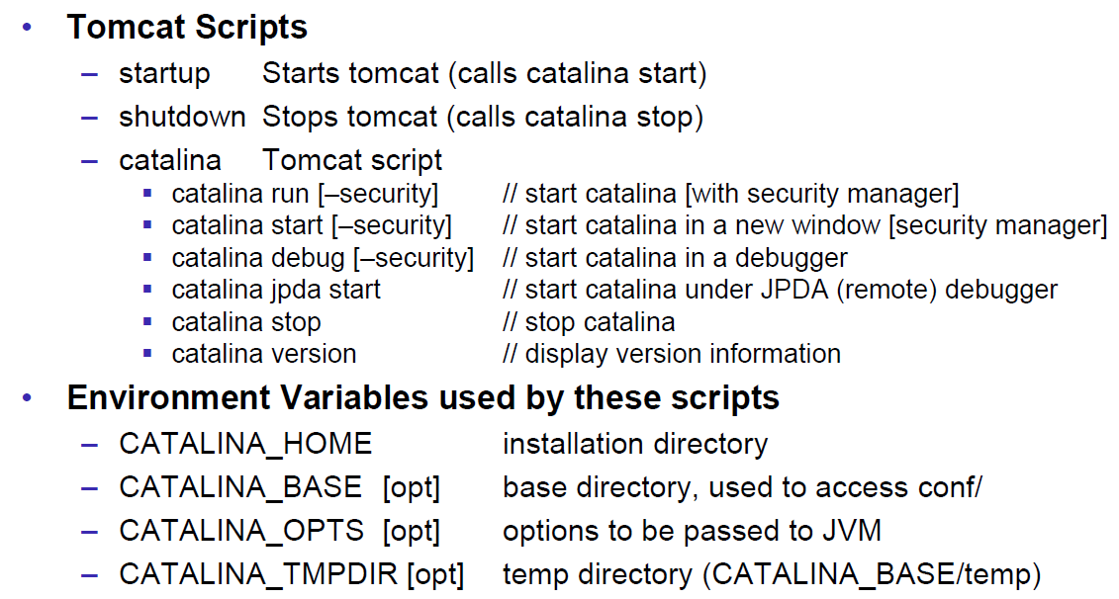

### Tomcat Startup Screen

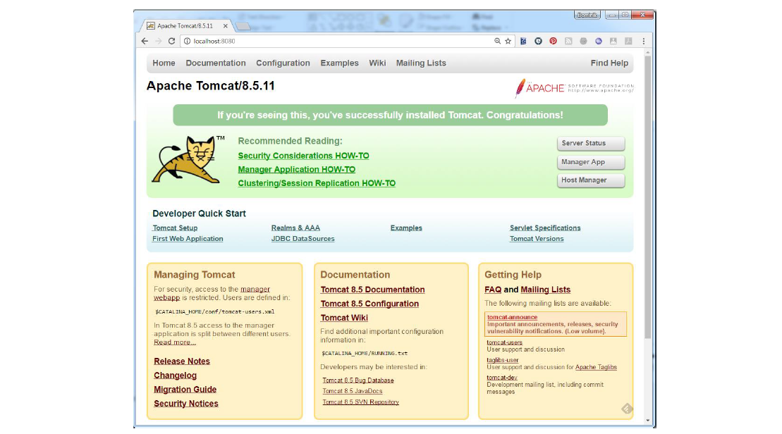

### Tomcat Managers

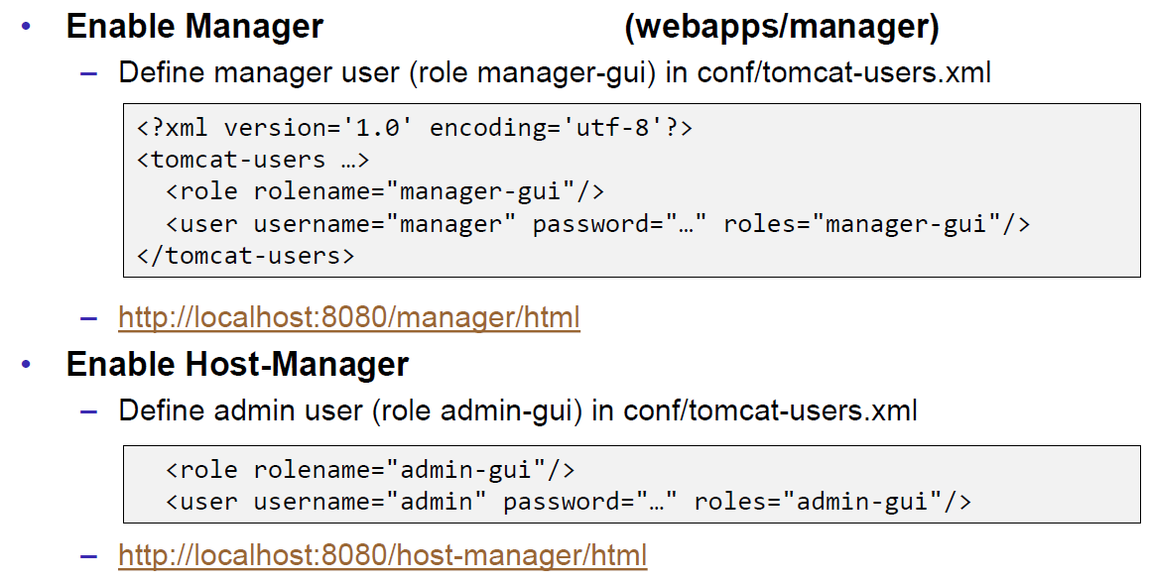

### Debugging

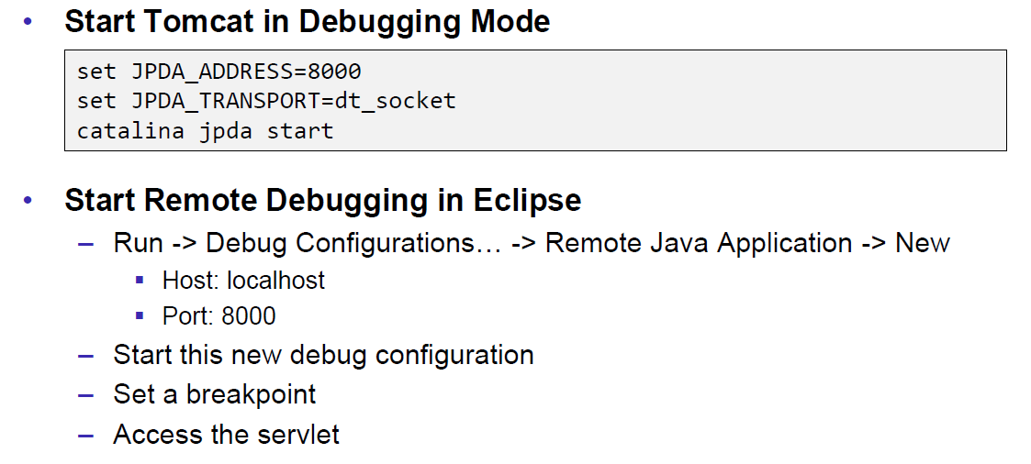

### Tomcat Architecture

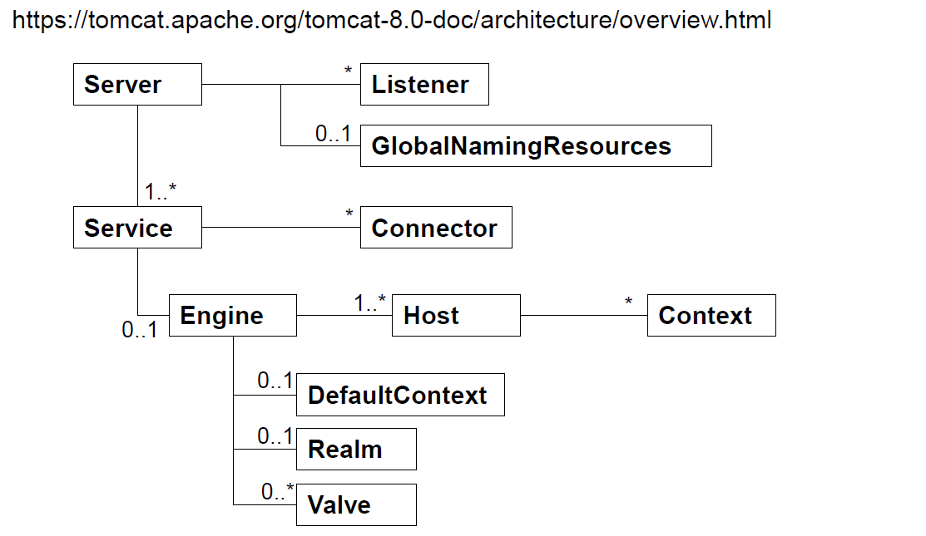

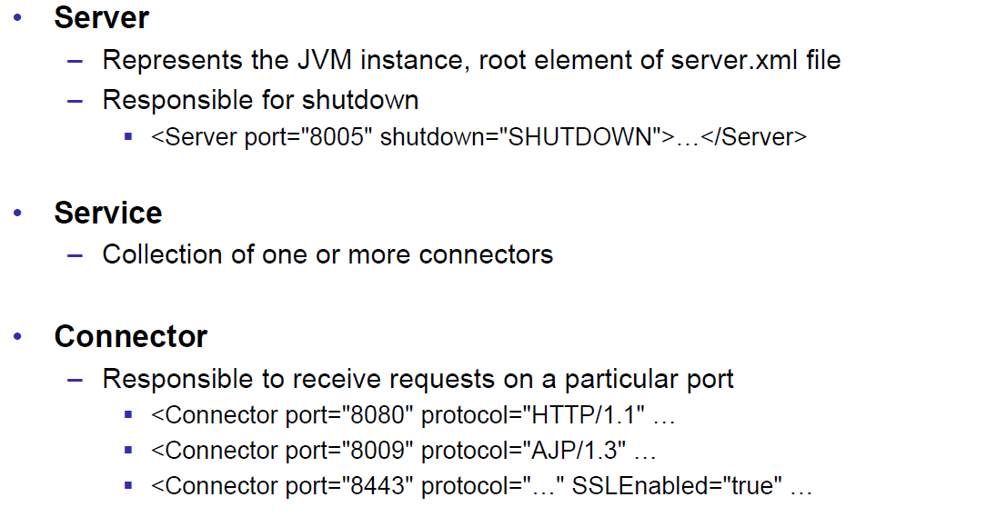

### Configuration of a Host

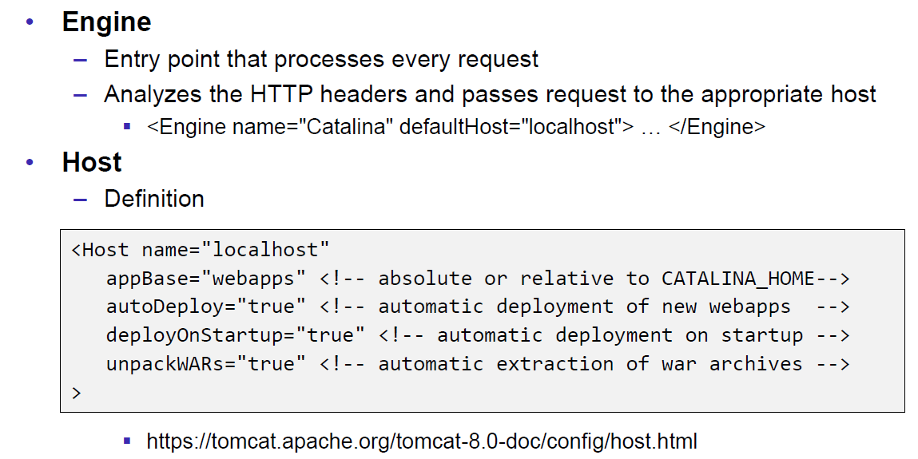

### Configuration of a Context

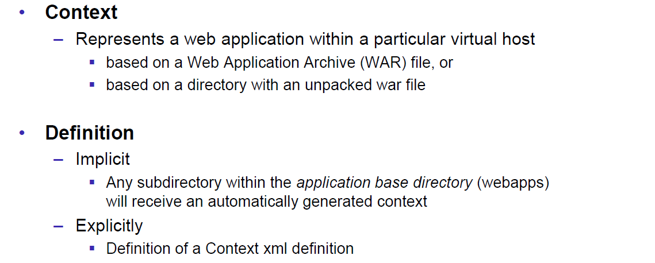

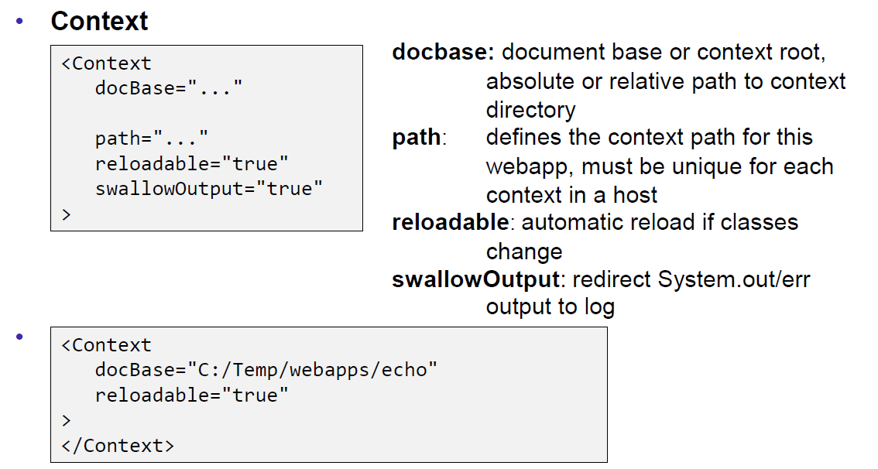

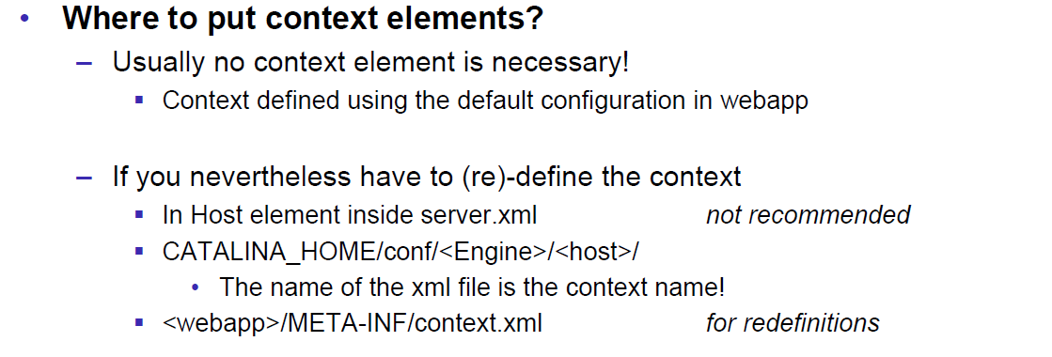

### Deployment while development

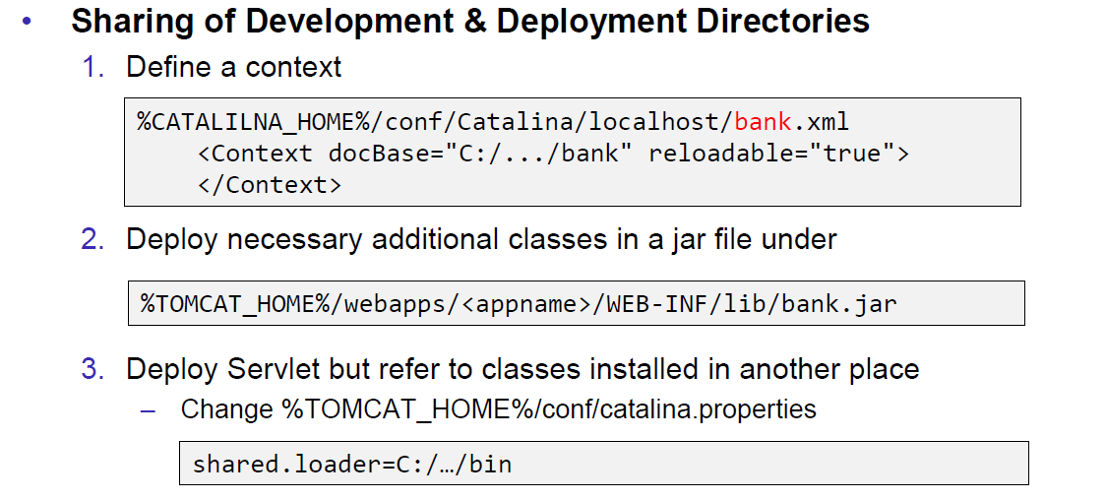

### Eclipse and Servlets (JEE Eclipse Version)

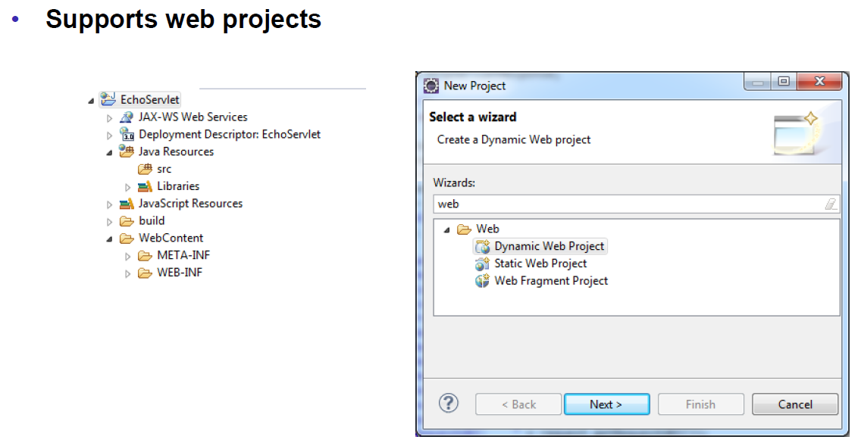

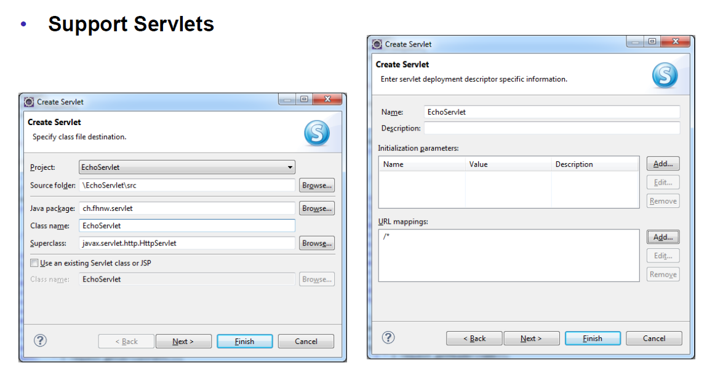

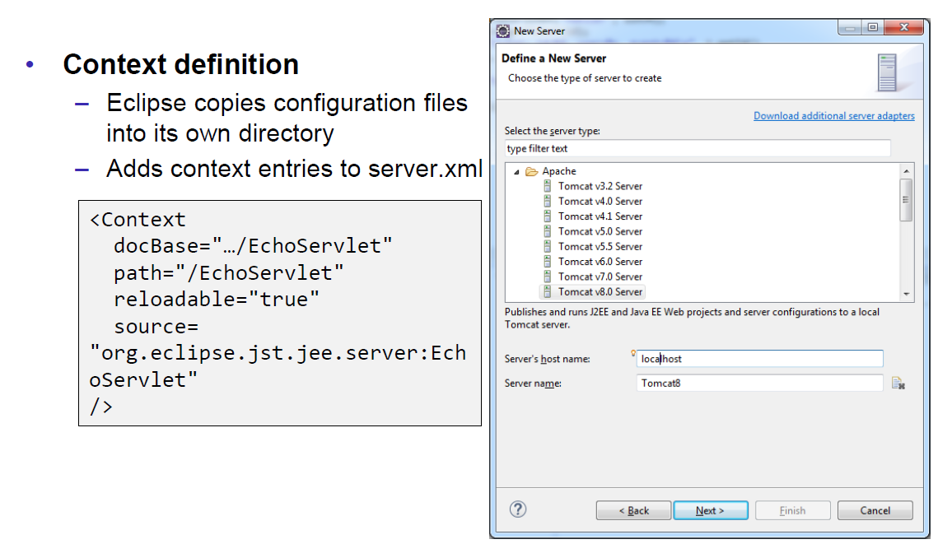

# Woche 5

## Motivation XML-RPX

### Services over HTTP (Currency Converter)

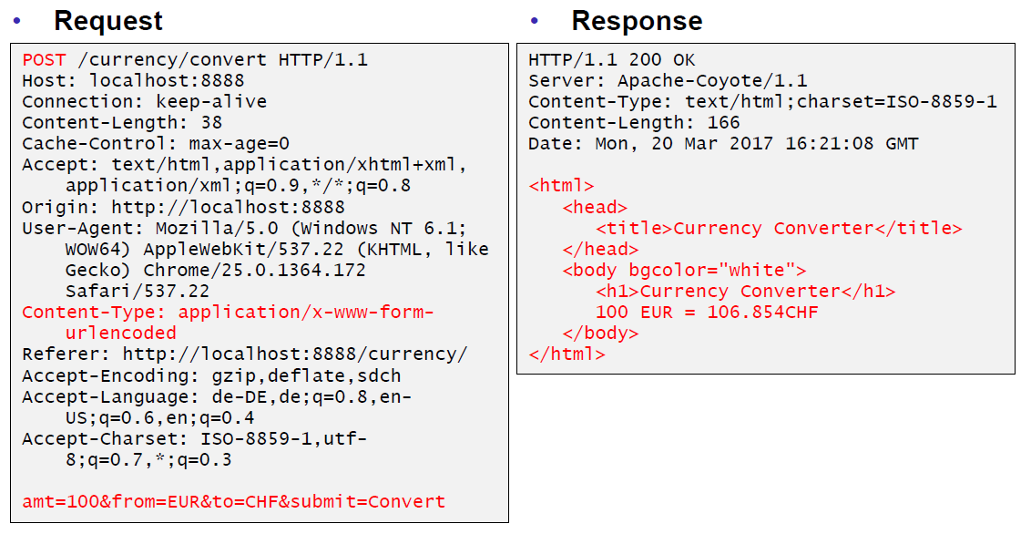

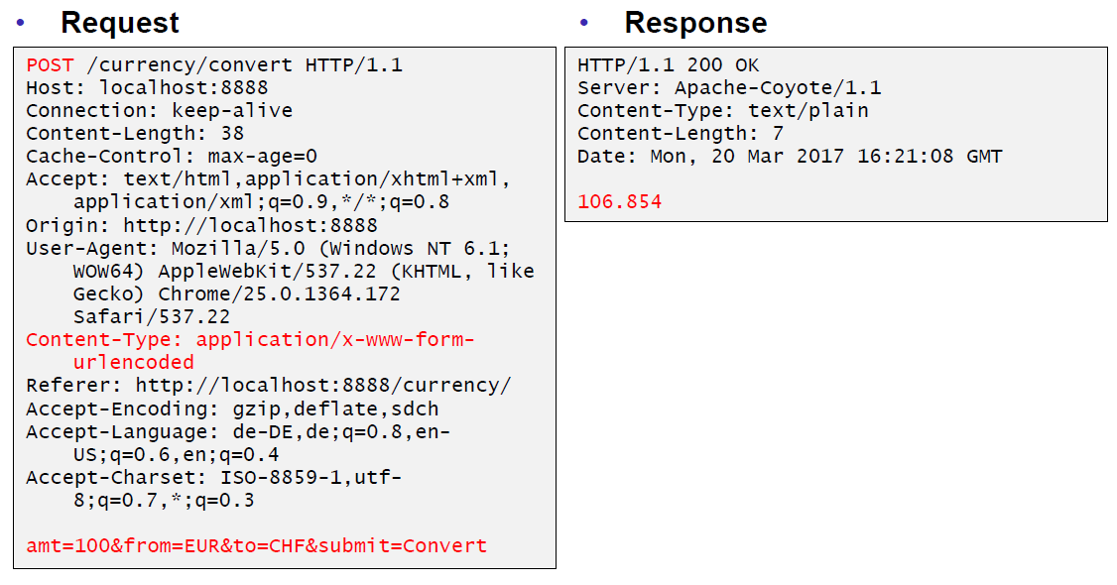

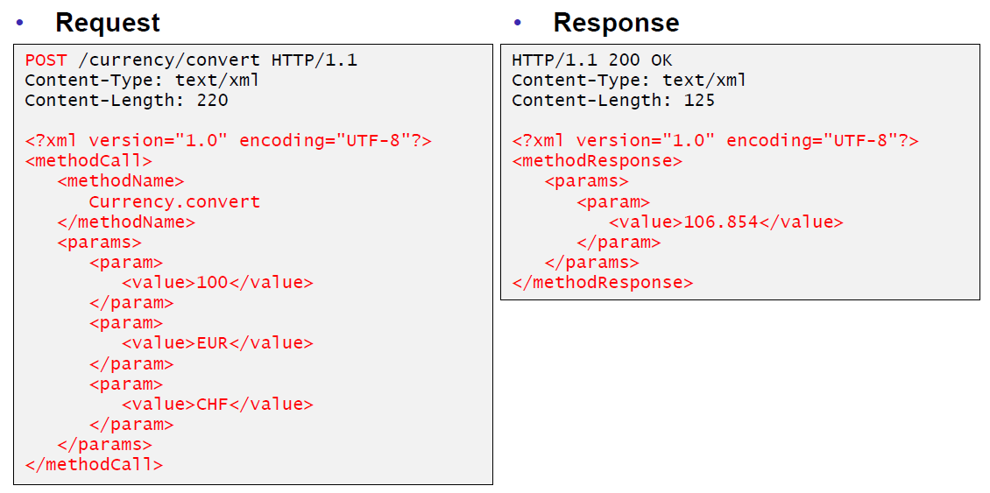

### XML-Remote Procedure Calls

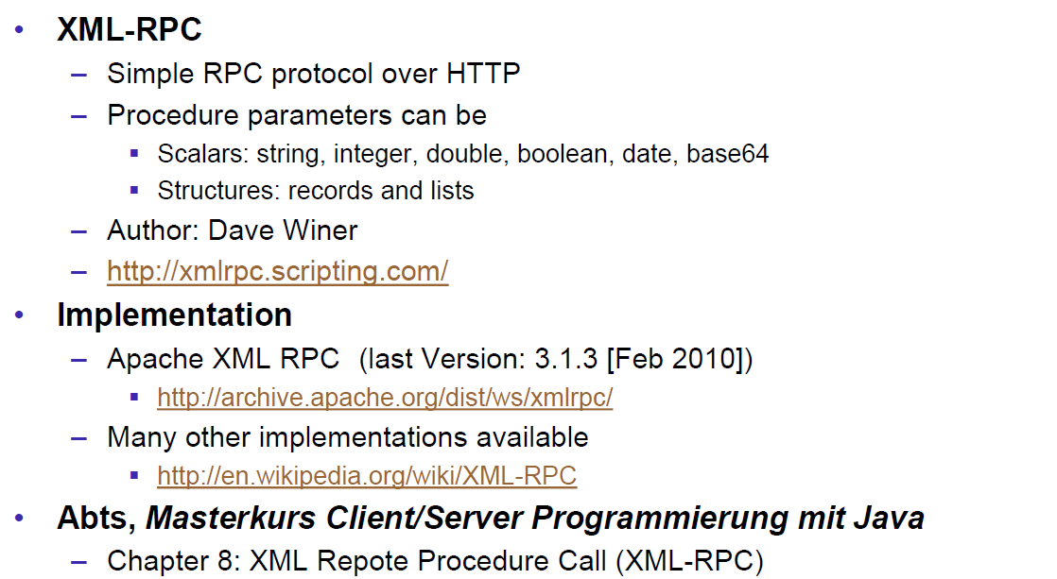

## SOAP und JAX-WS

### SOAP

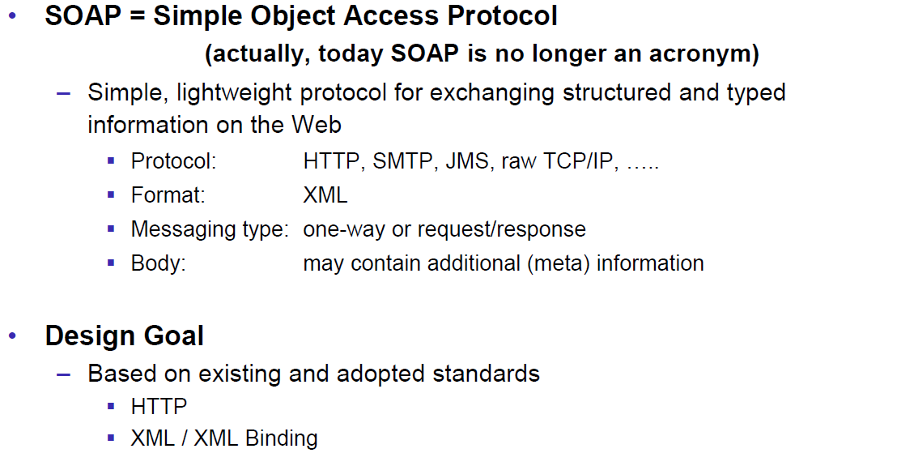

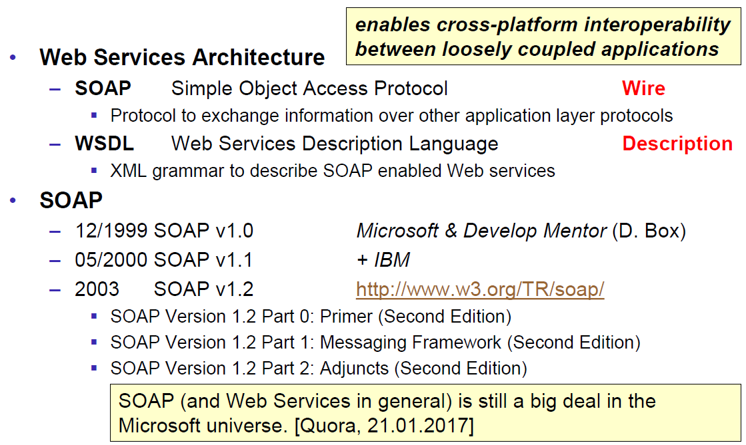

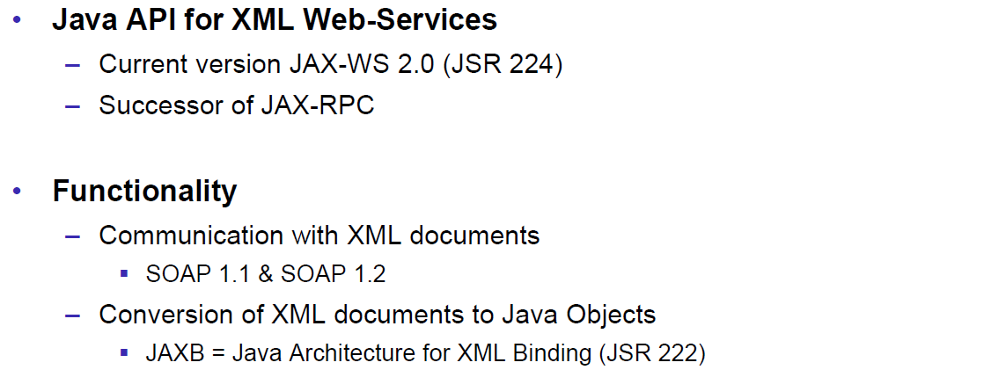

### JAX-WS

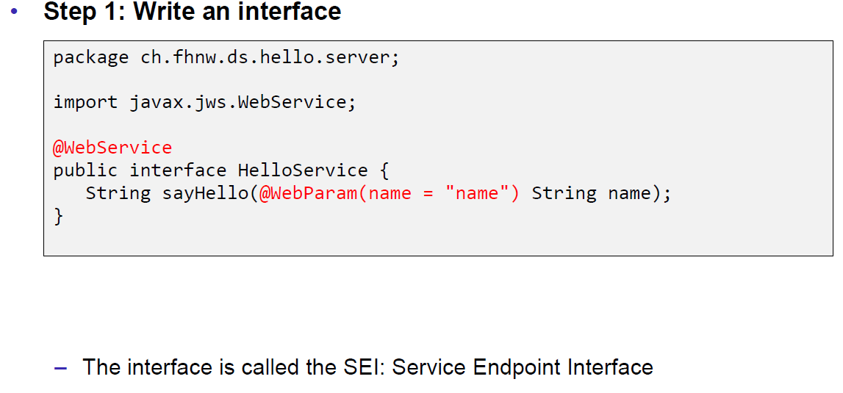

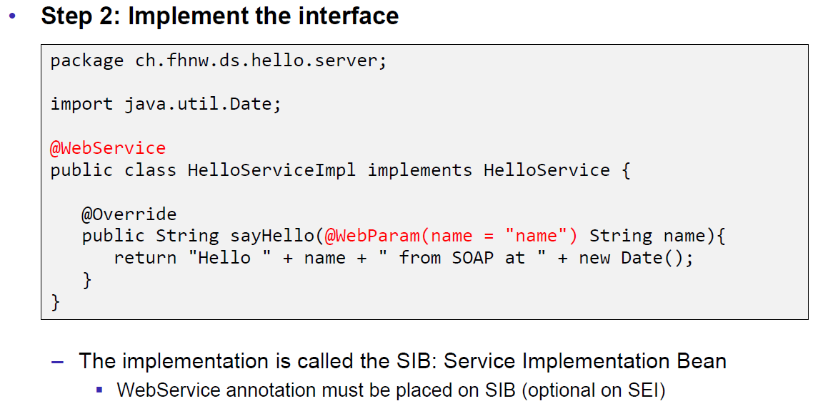

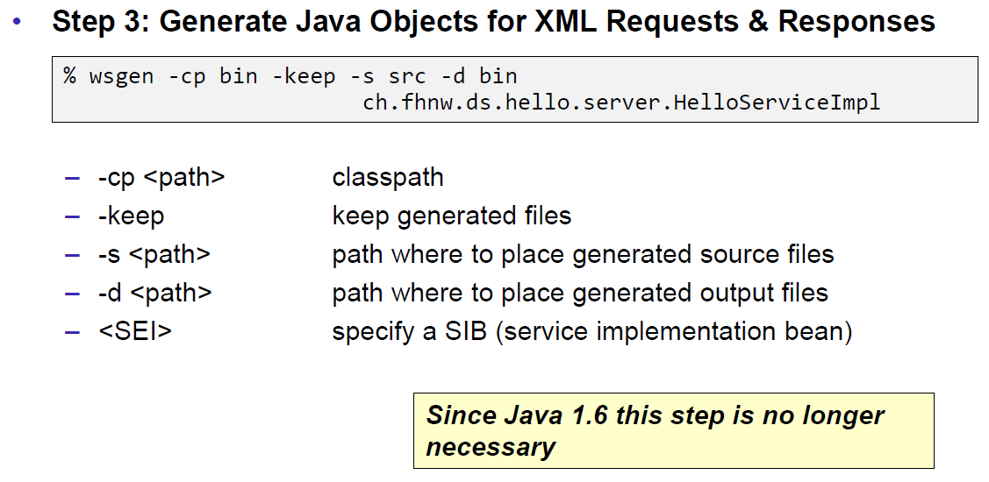

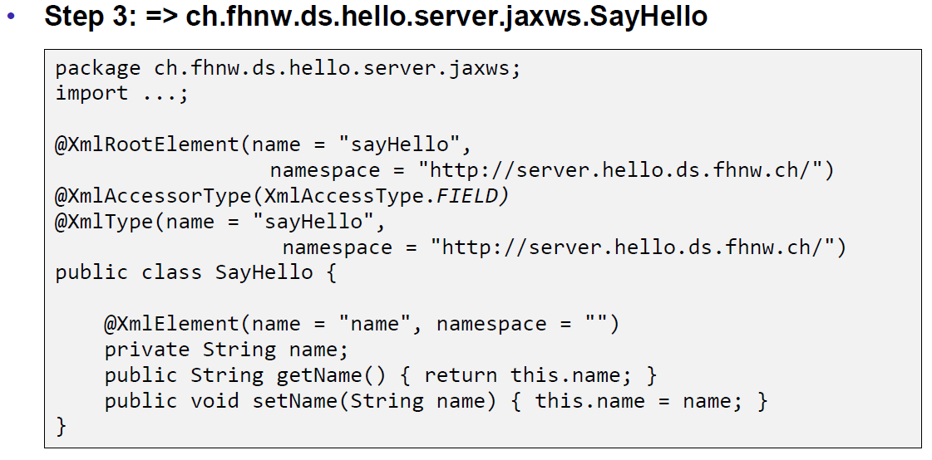

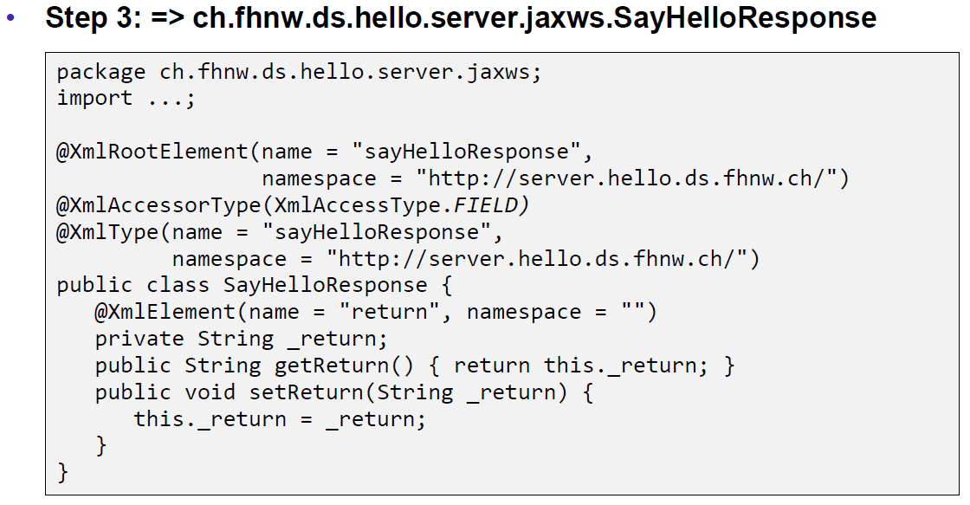

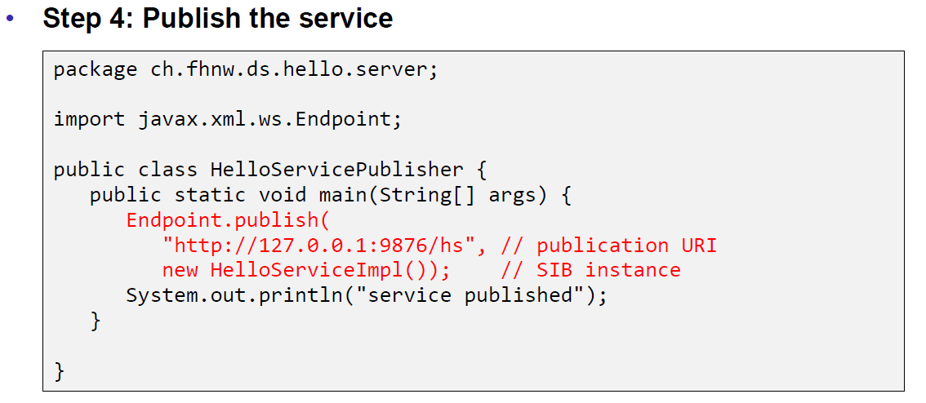

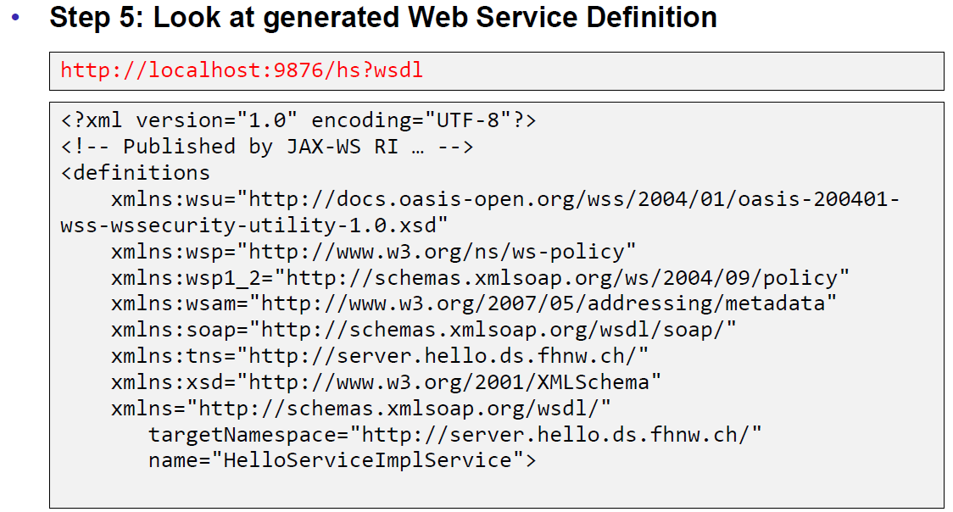

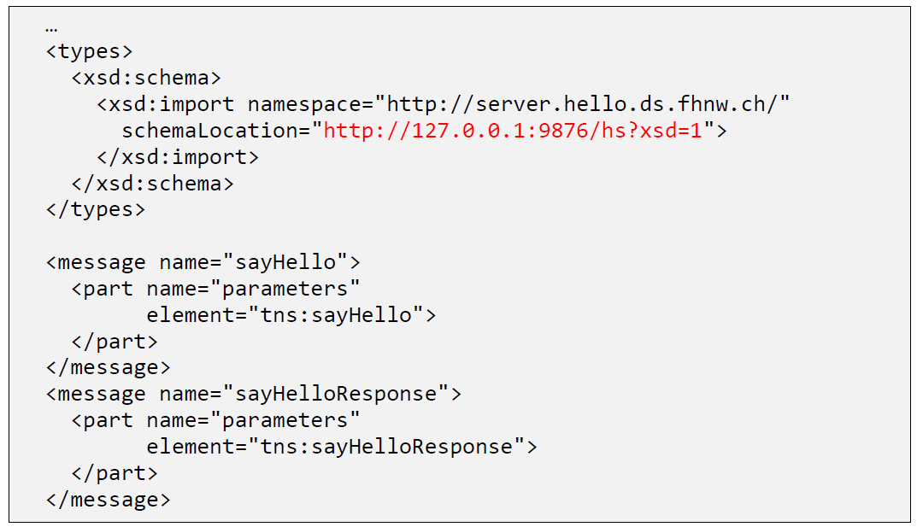

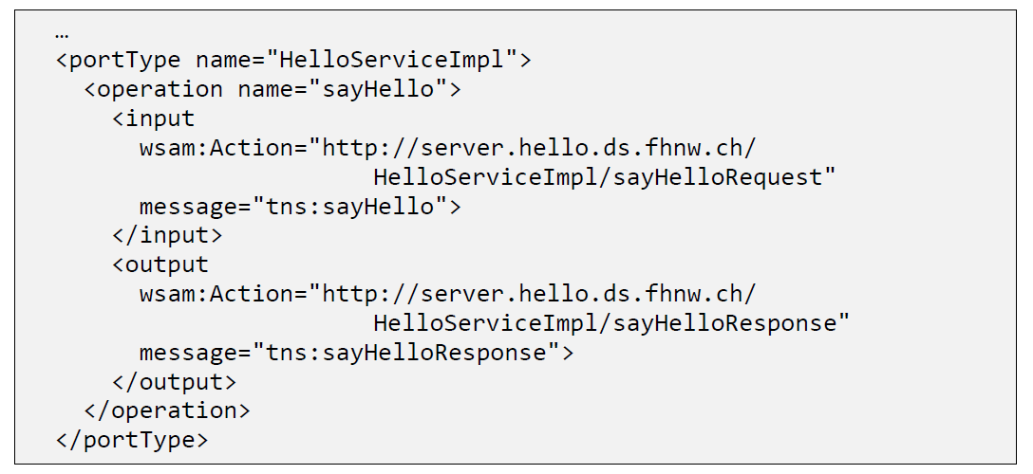

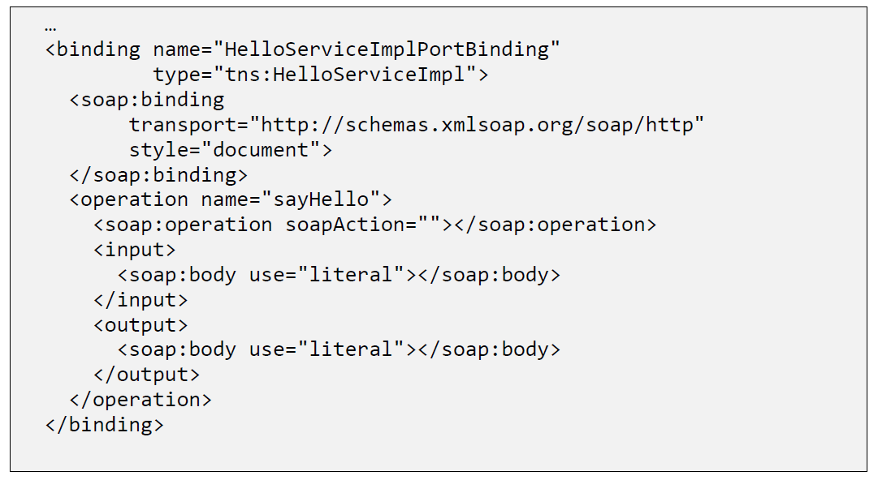

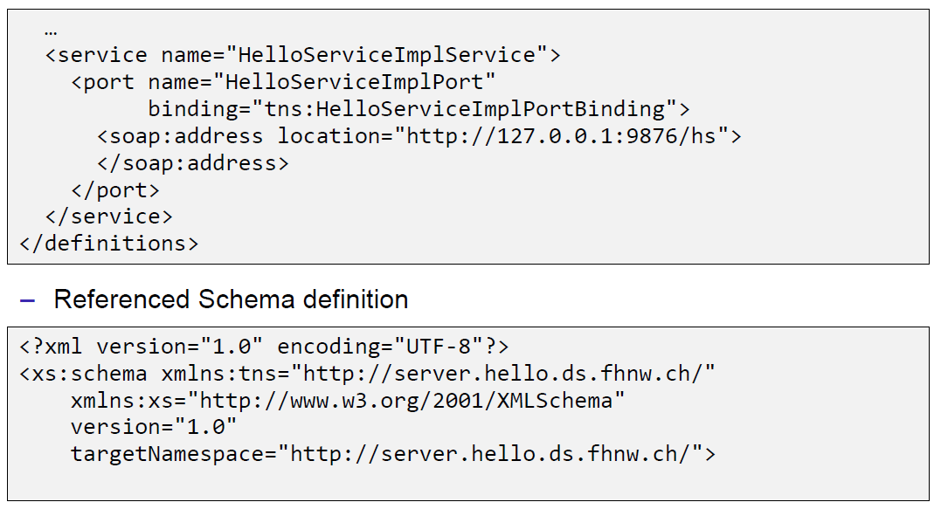

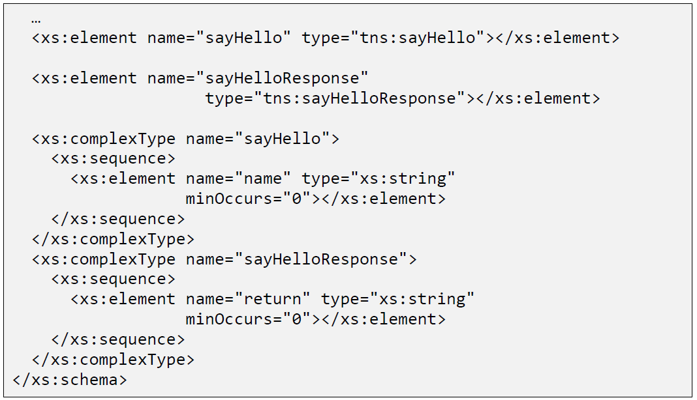

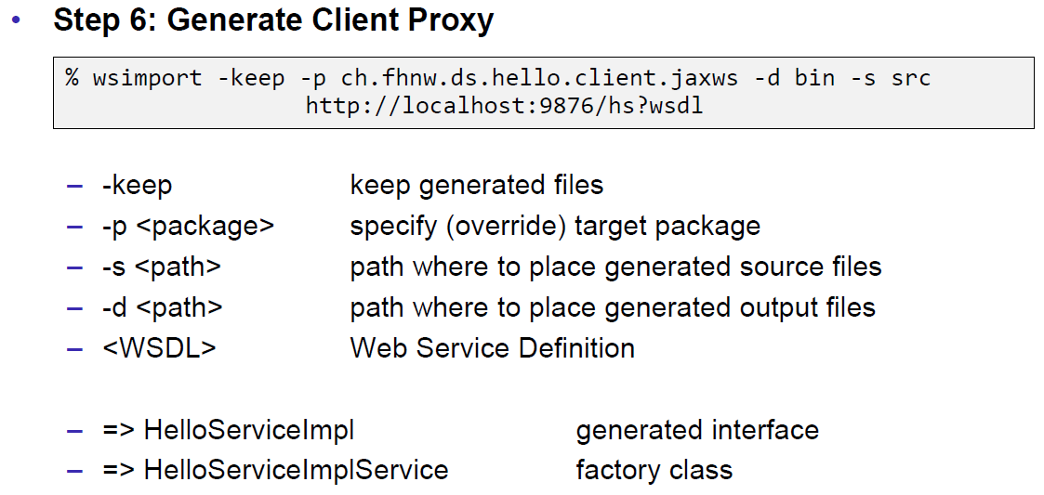

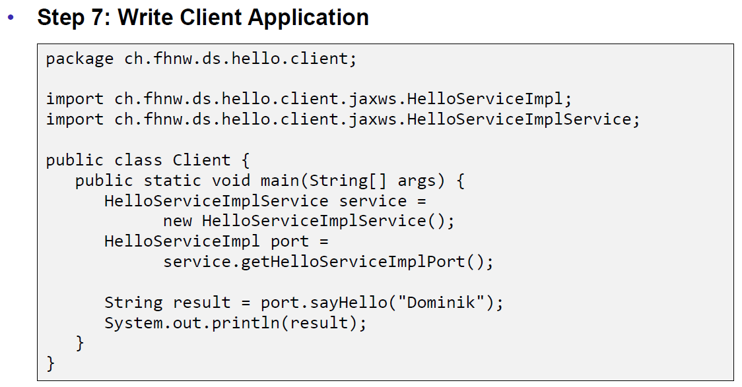

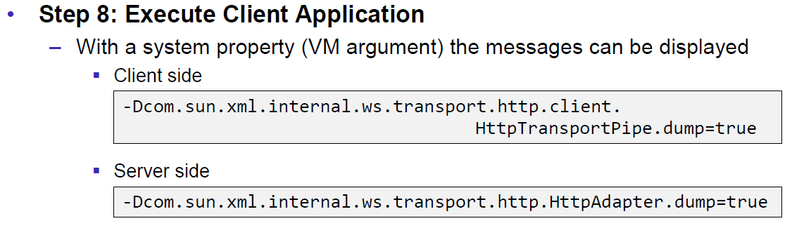

### JAX-WS HTTP Request

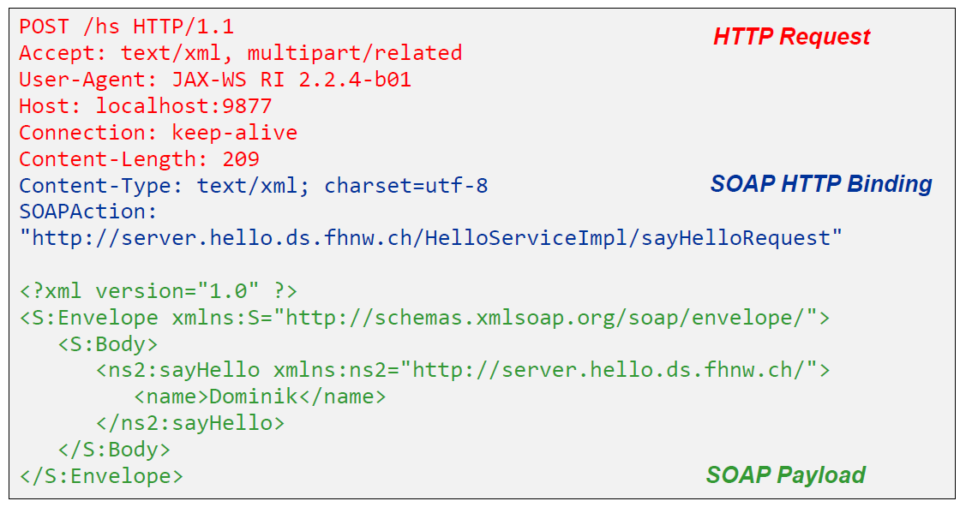

### JAX-WS HTTP Response

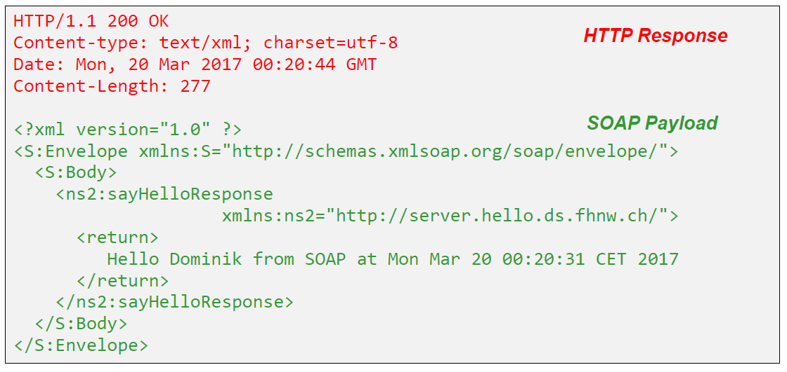

### SOAP Message Structure

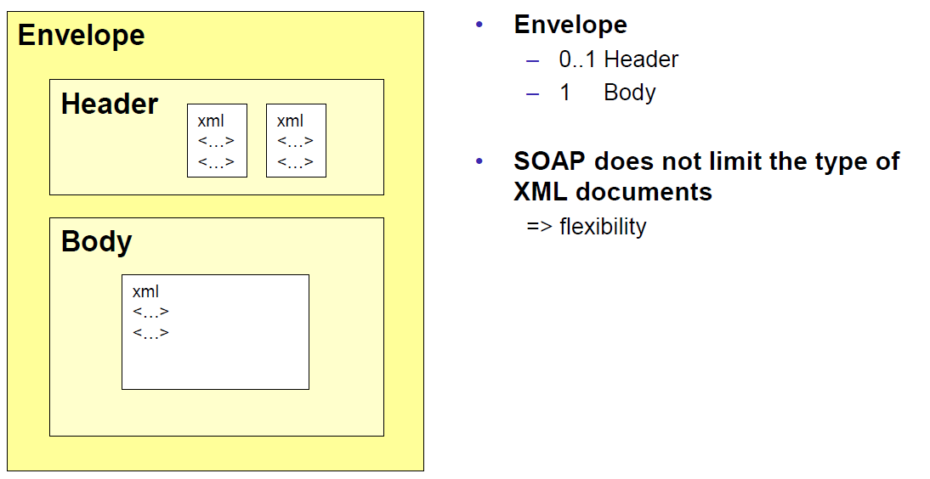

### Tools for SOAP

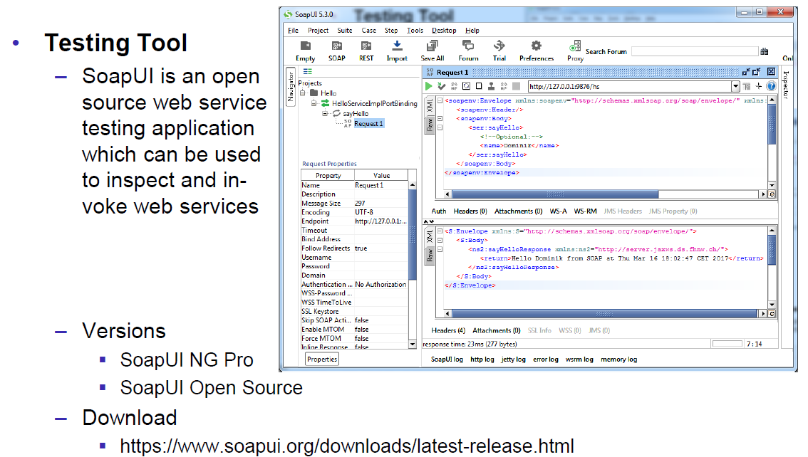

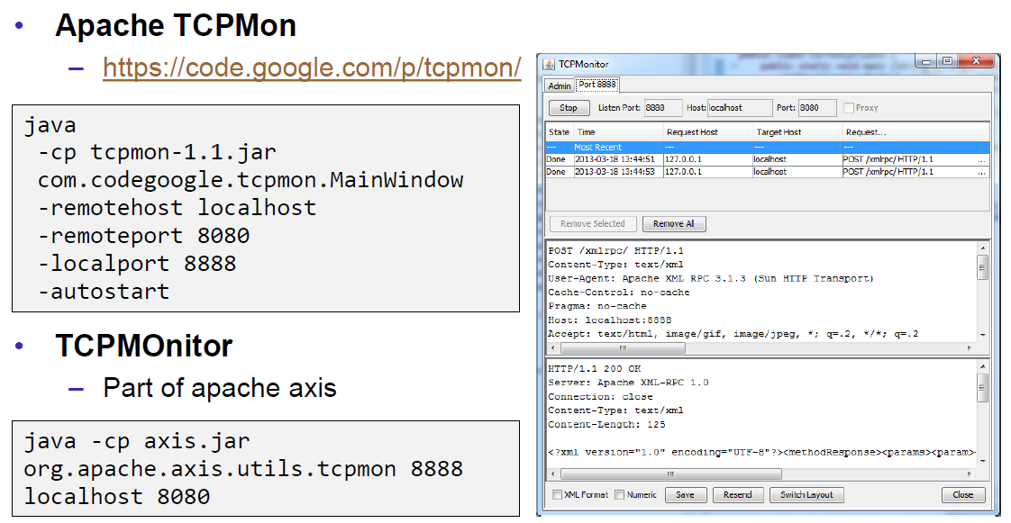

## WSDL

### WSDL

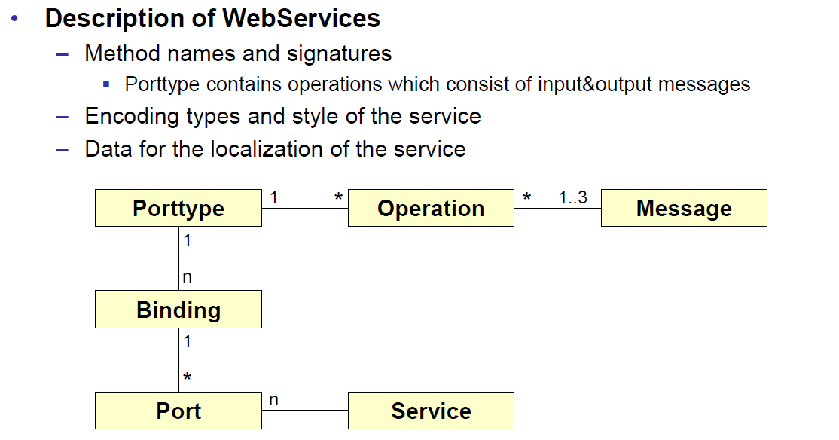

### WSDL Examples

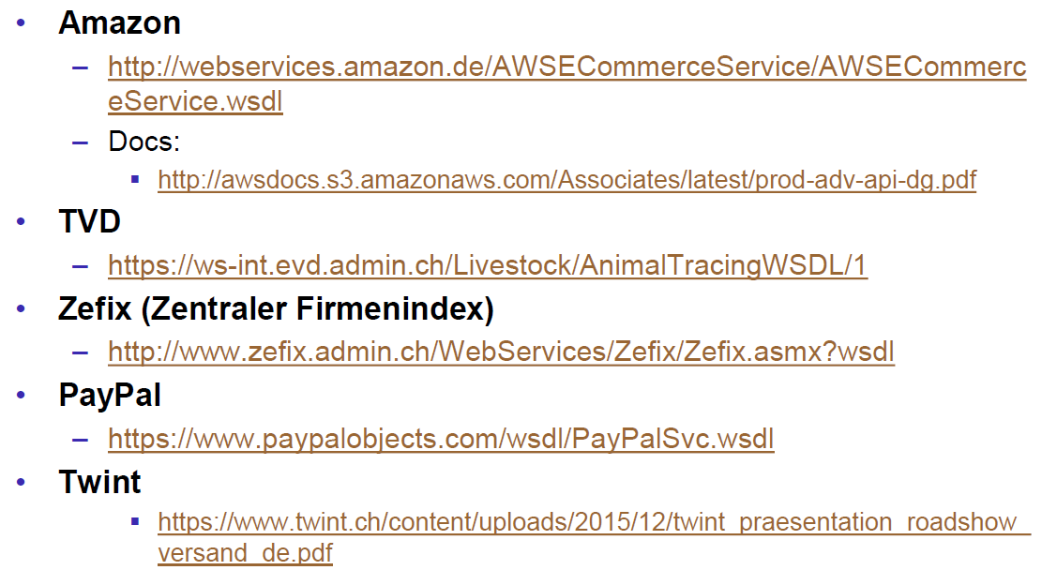

### WSDL Structure

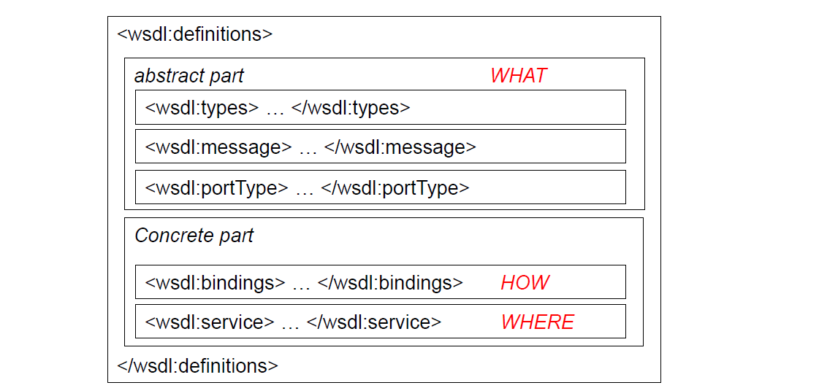

### WSDL Definitions

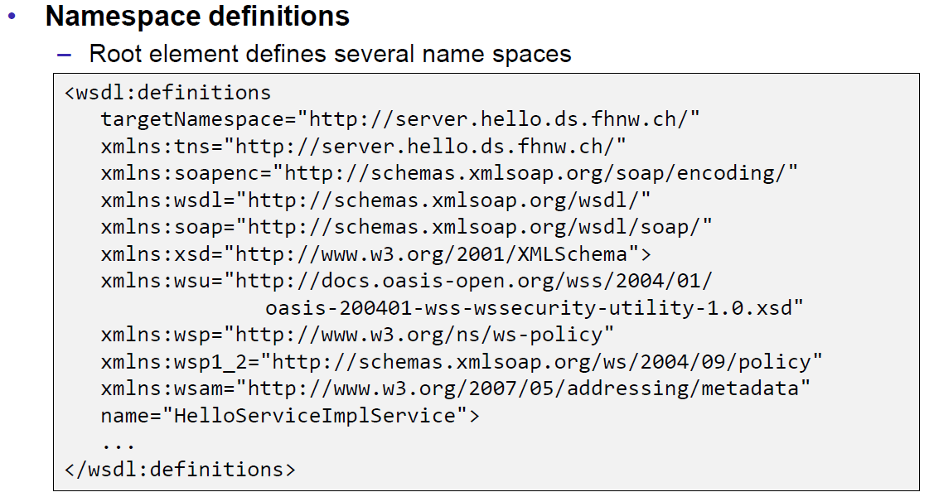

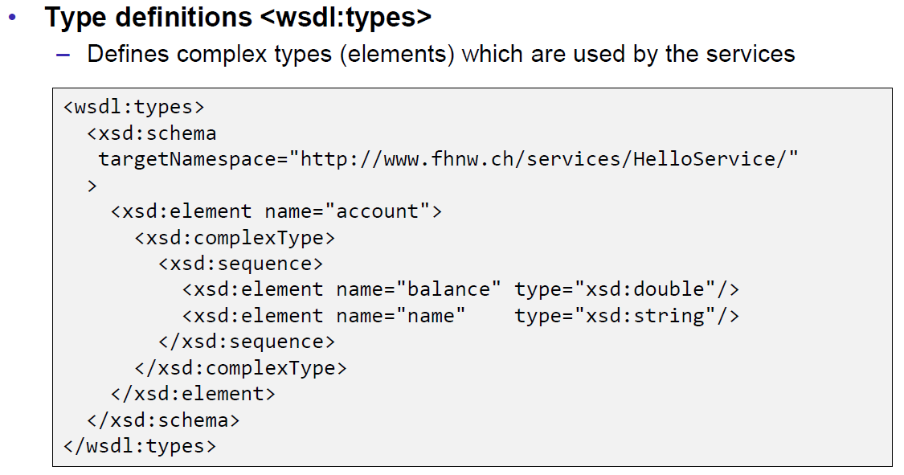

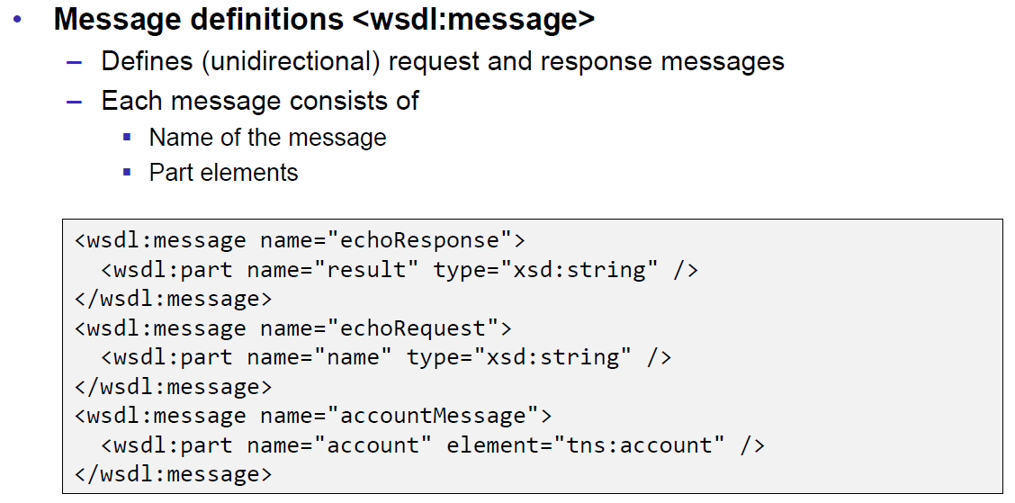

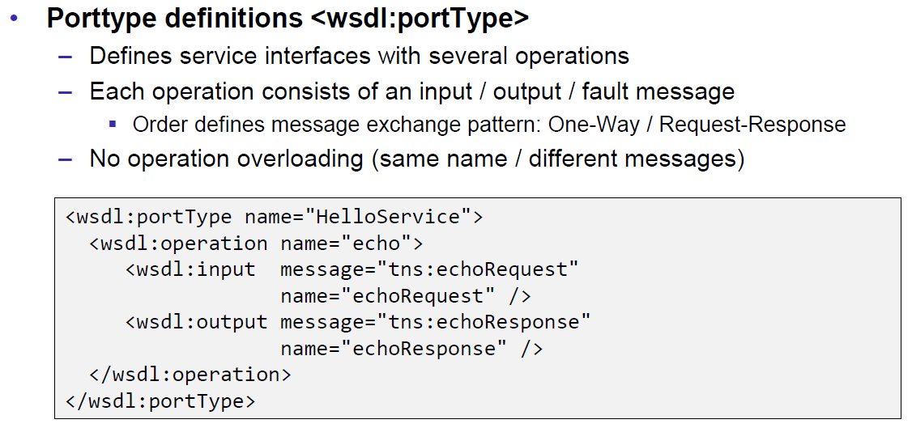

### Message Exchange Patterns (MEP)

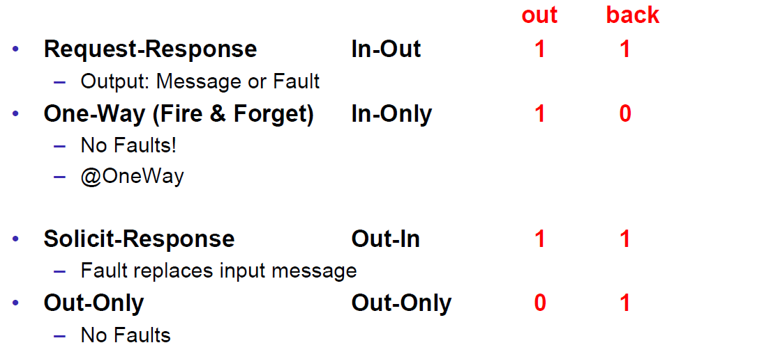

### WSDL Definitions

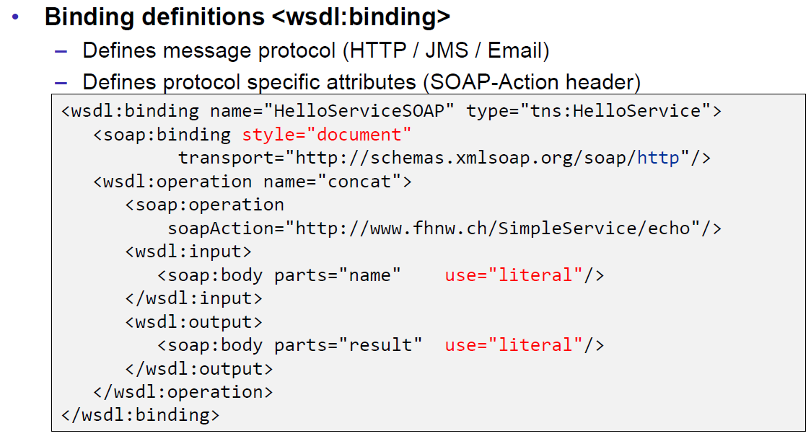

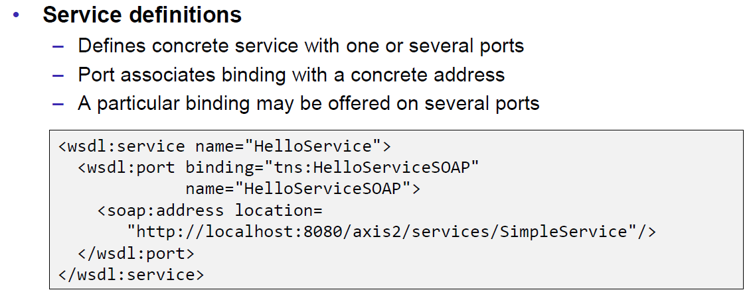

### Web Service Styles

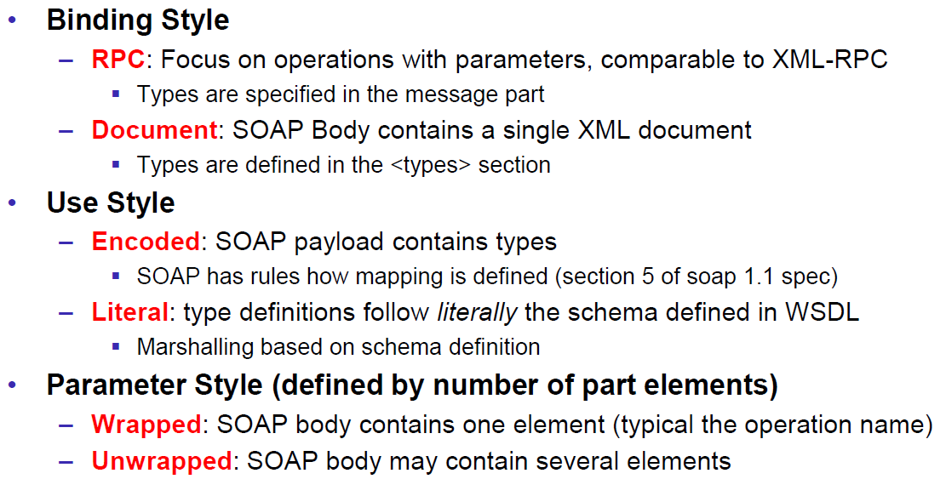

### RPC/Encoded

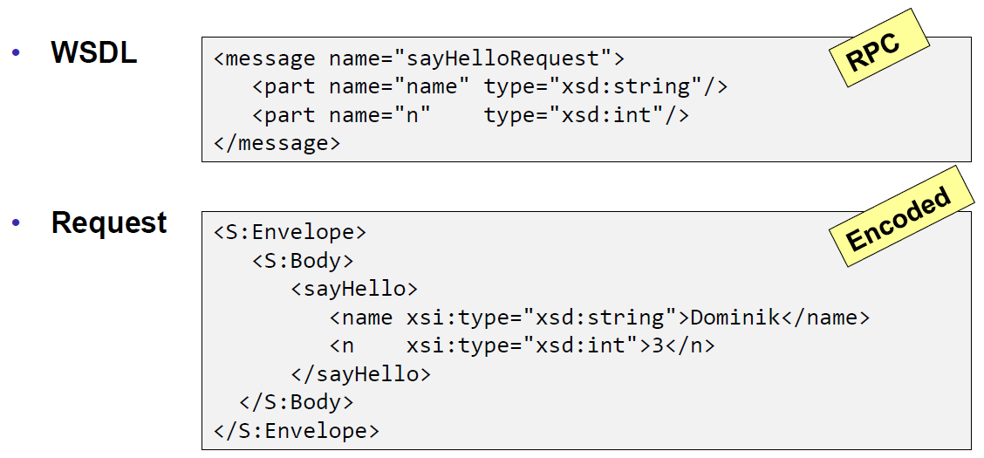

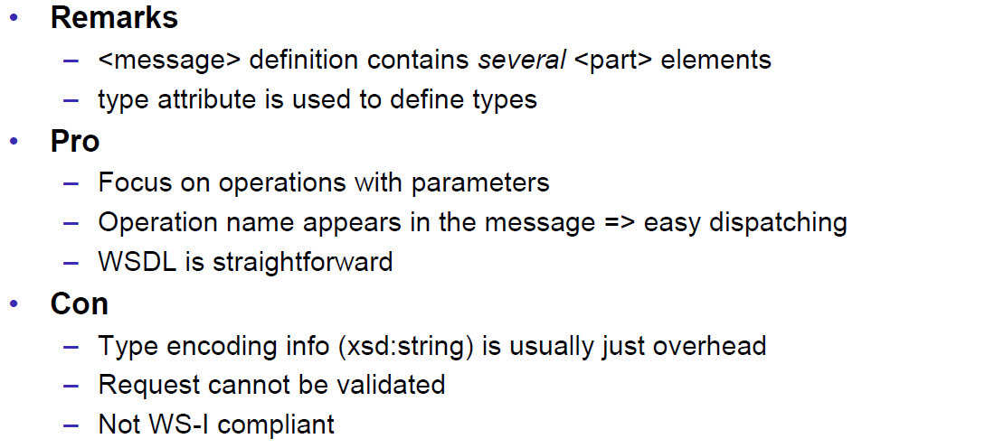

### RPC/Literal

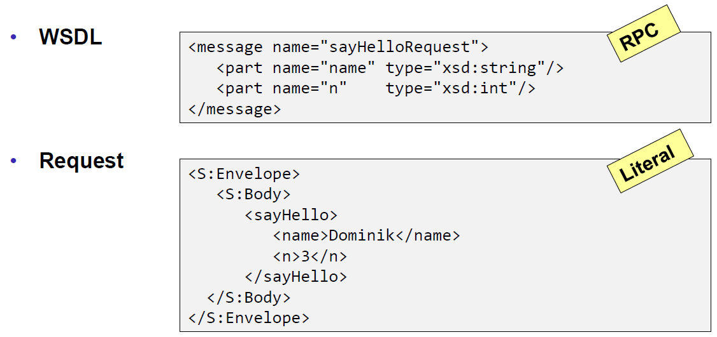

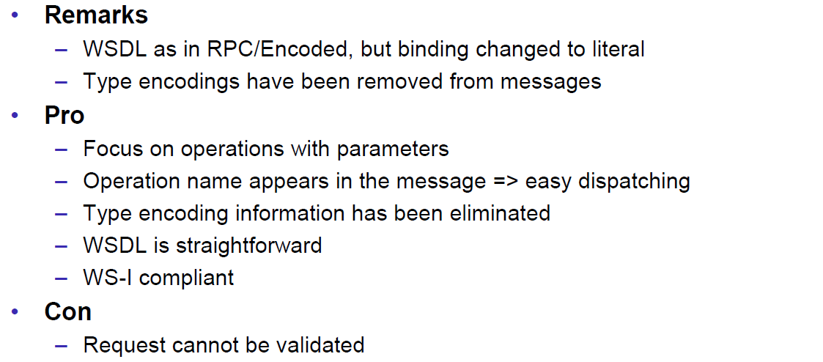

### Document/Literal/Bare

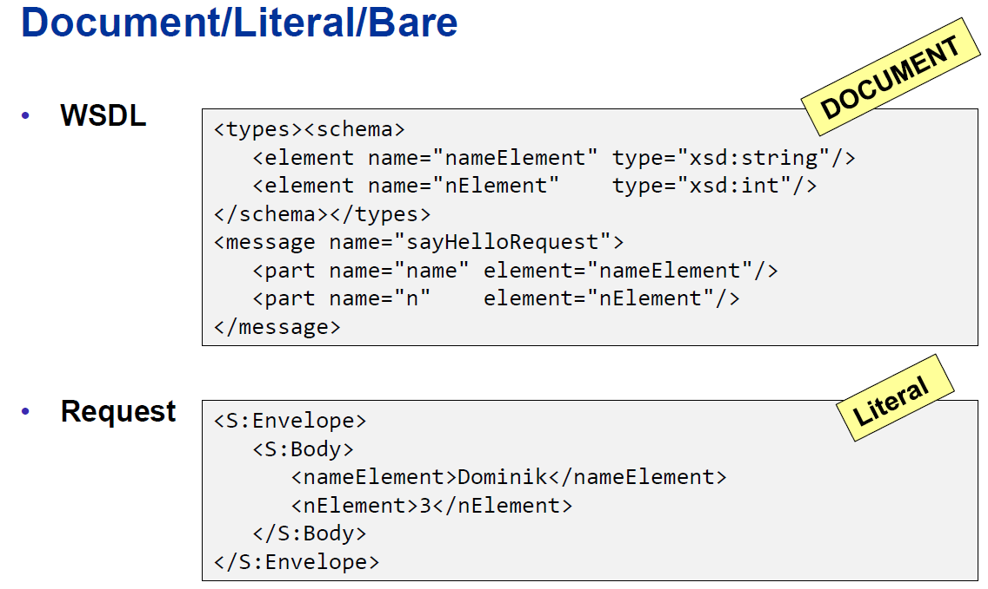

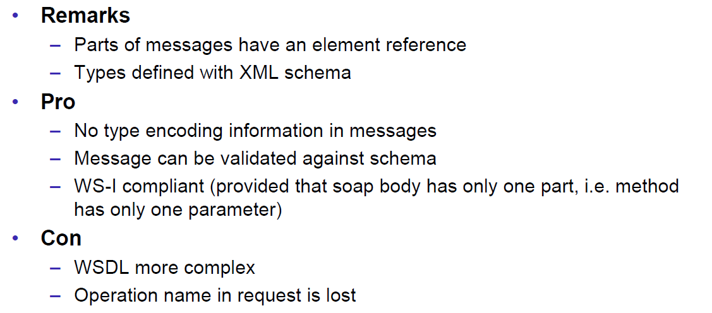

### Document/Literal/Wrapped

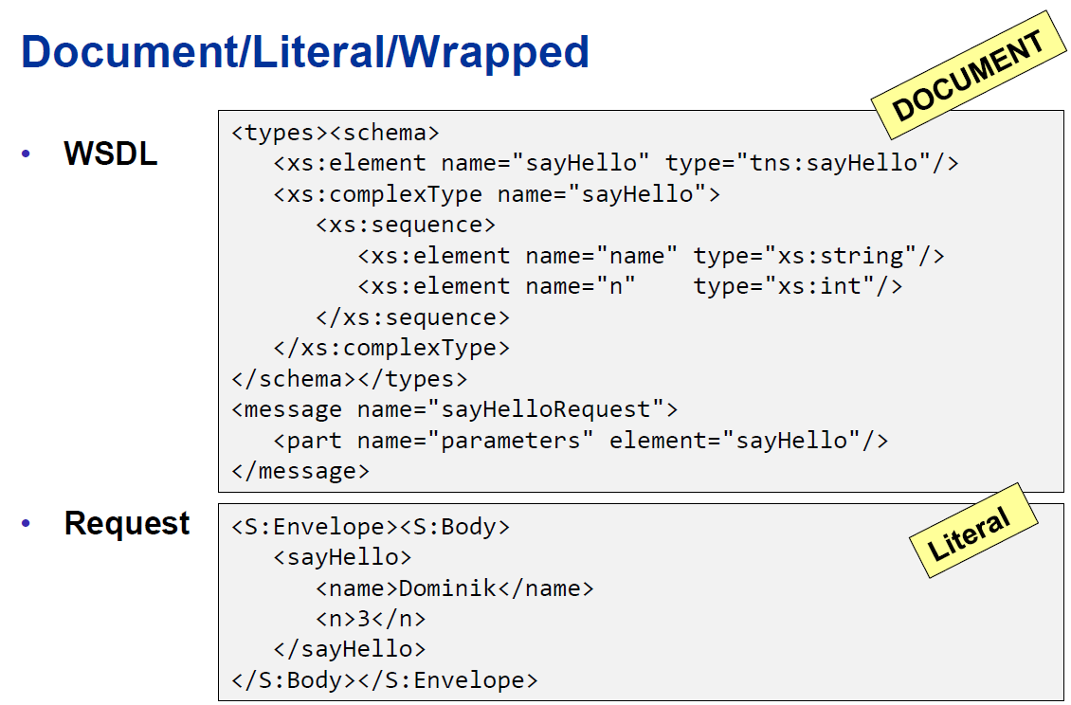

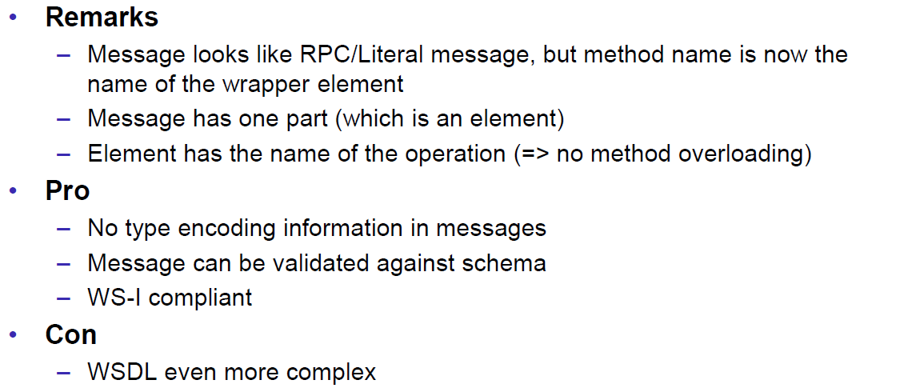

### Web Service Styles

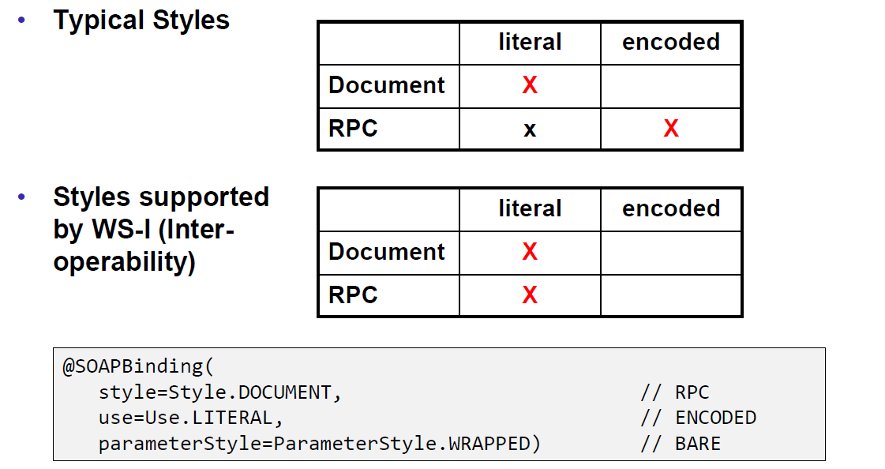

## Resources

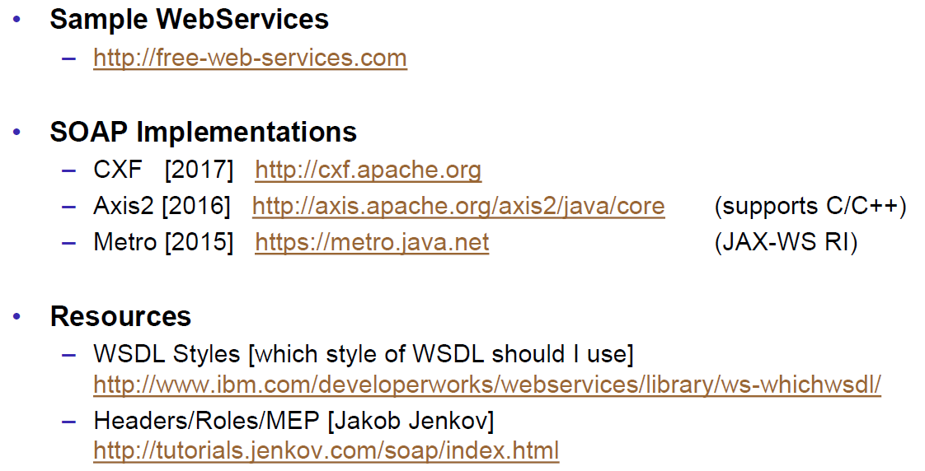

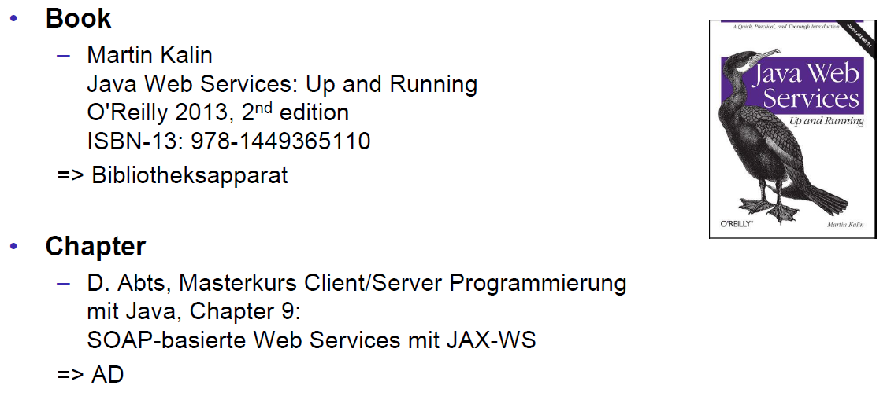

# Woche 6

## REST Concepts

### Representational State Transfer (REST)

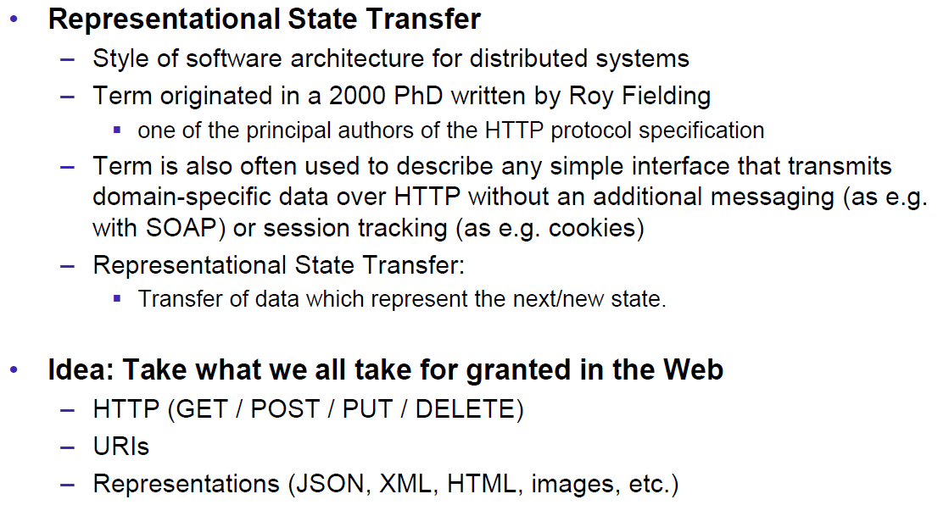

### REST Principles

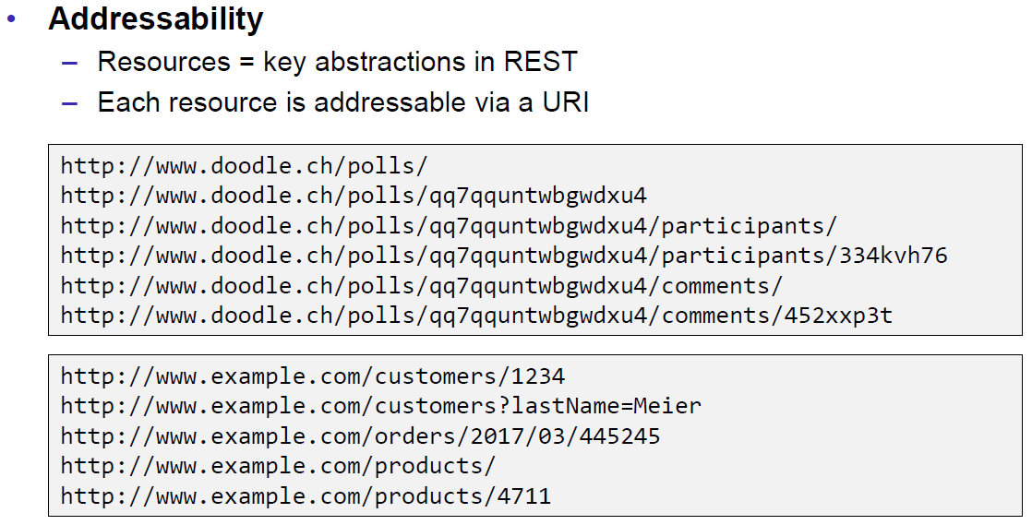

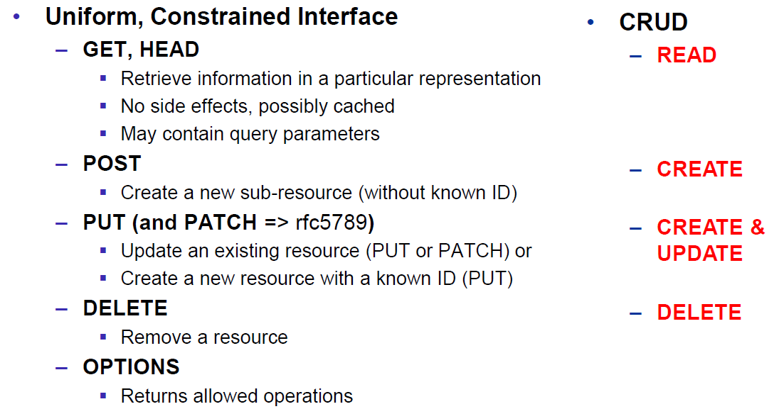

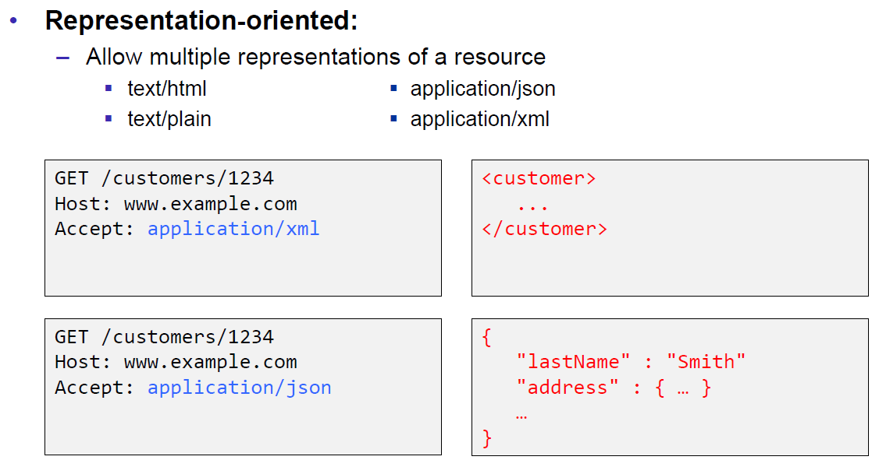

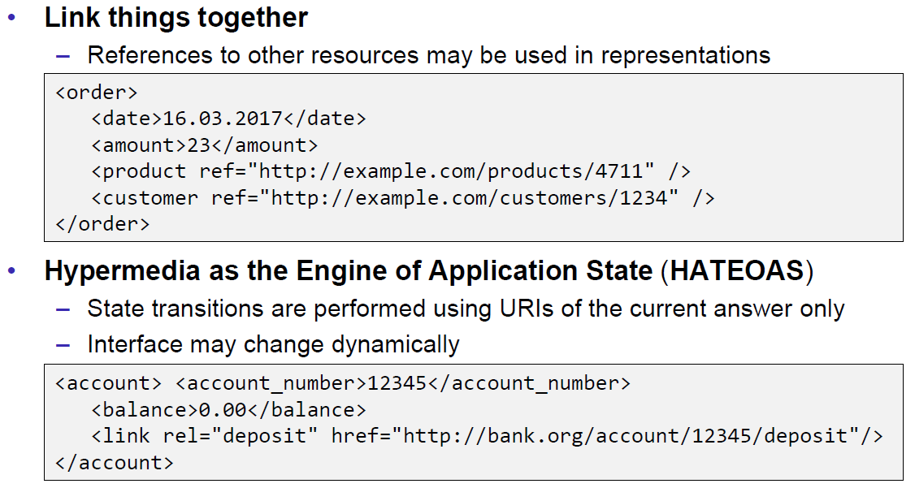

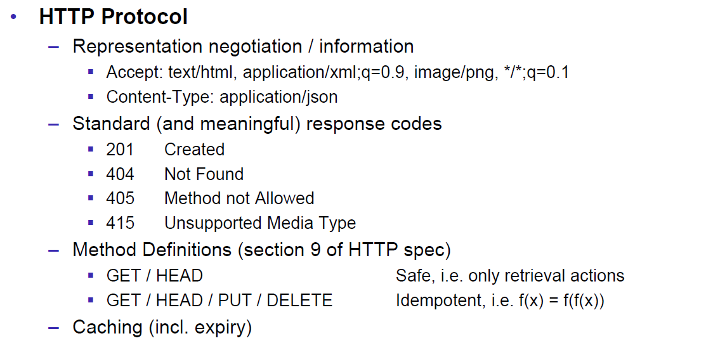

### REST Short Primer

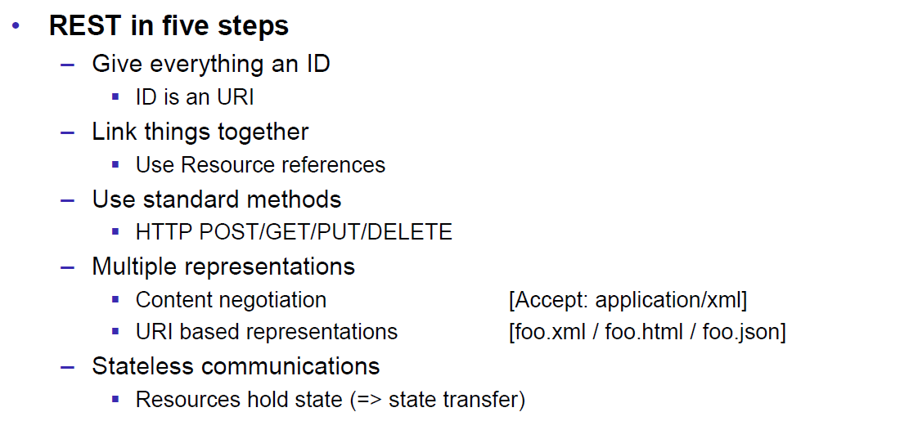

### SOAP versus REST

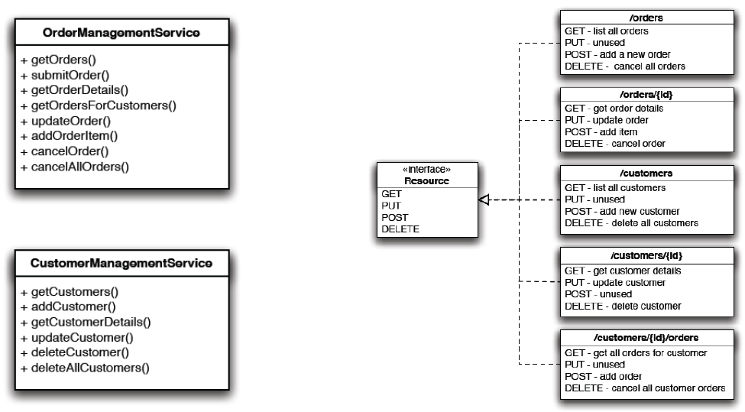

### REST Common Patterns

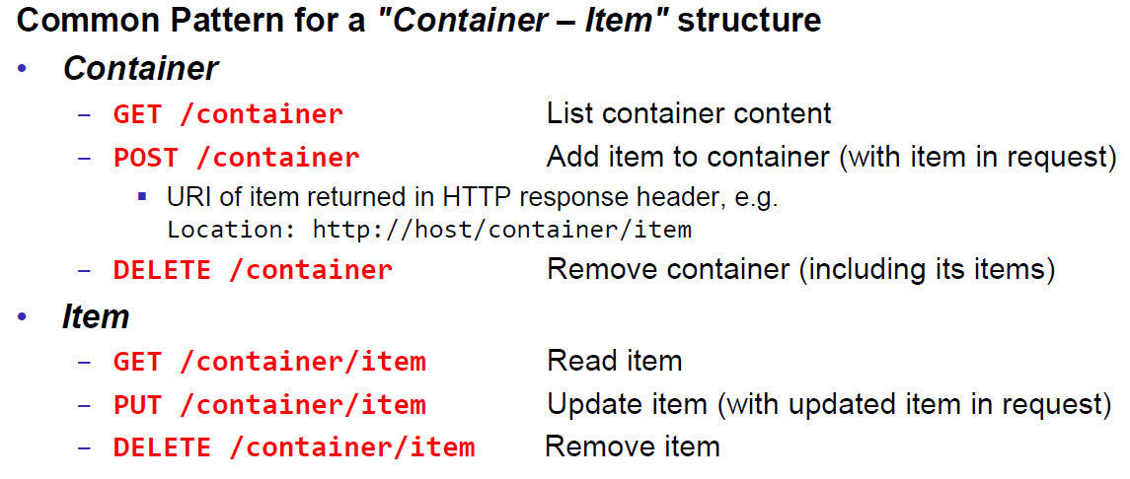

### Example Doodle

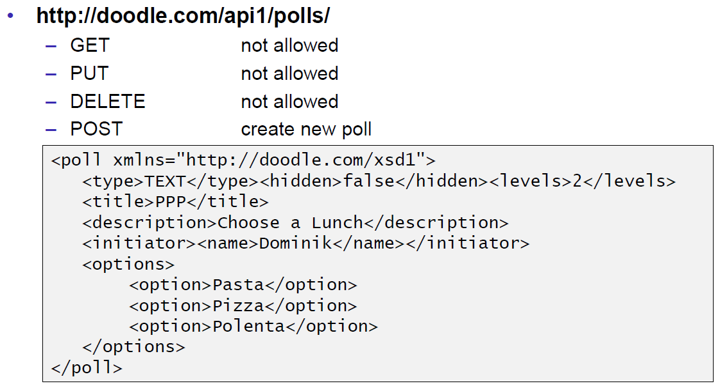

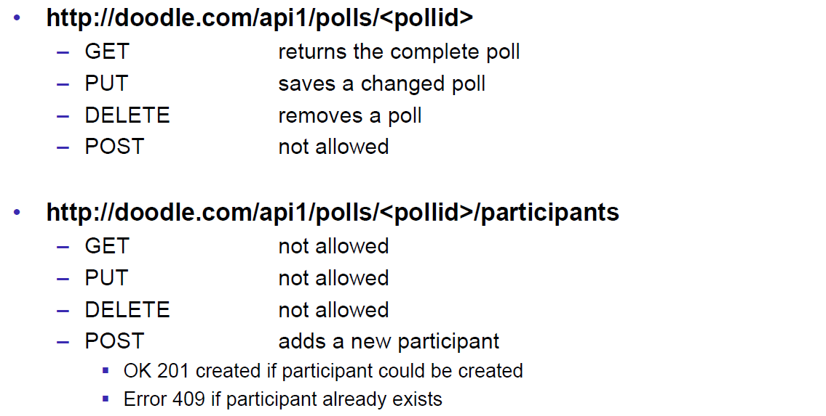

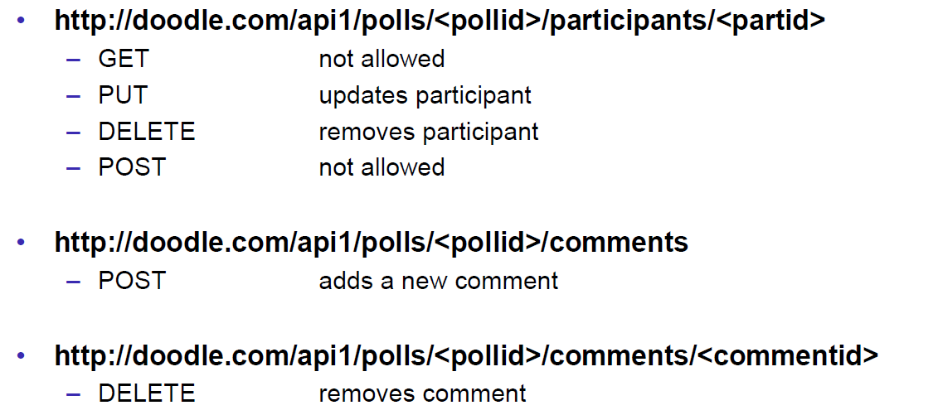

### REST versus SOAP

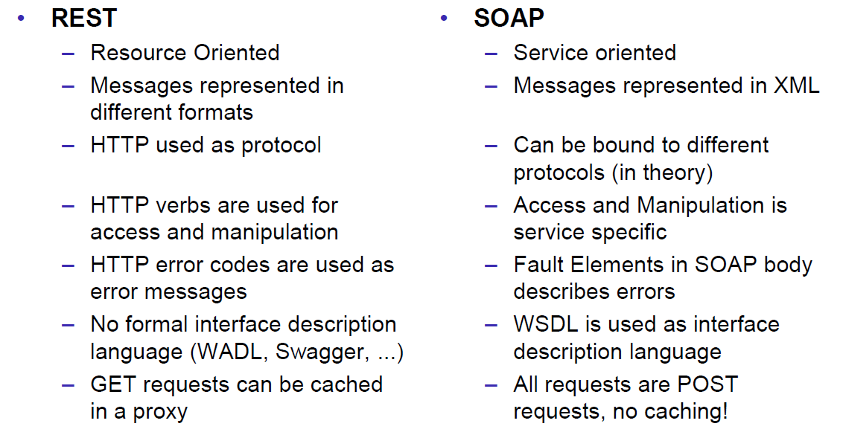

### Client Side

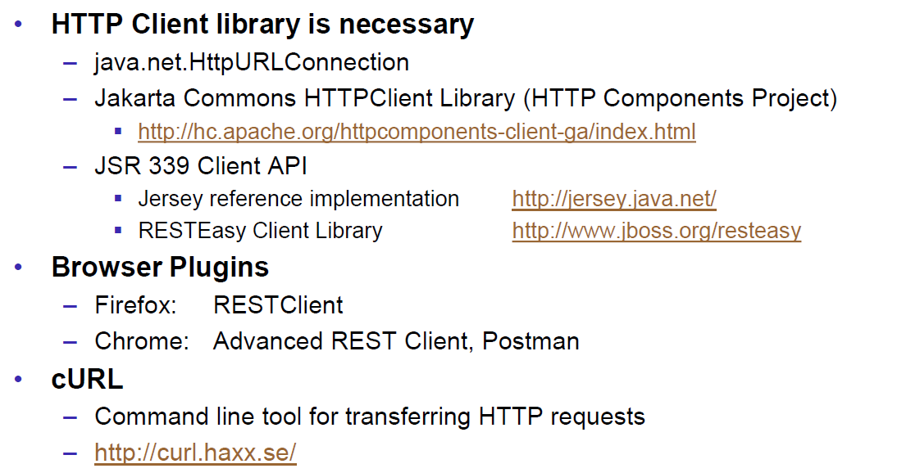

### Web Client Plugins

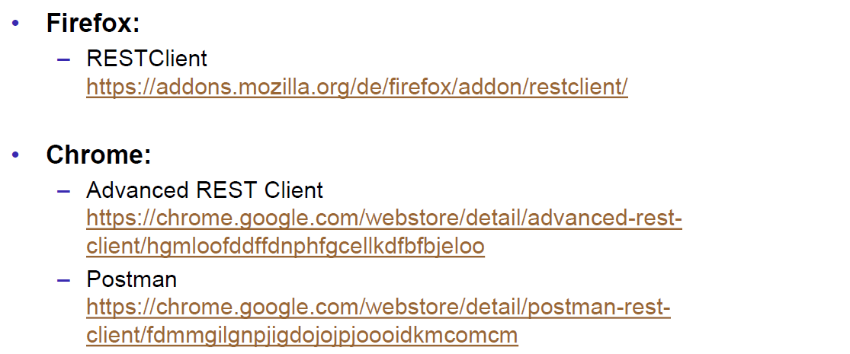

### Client Side via curl

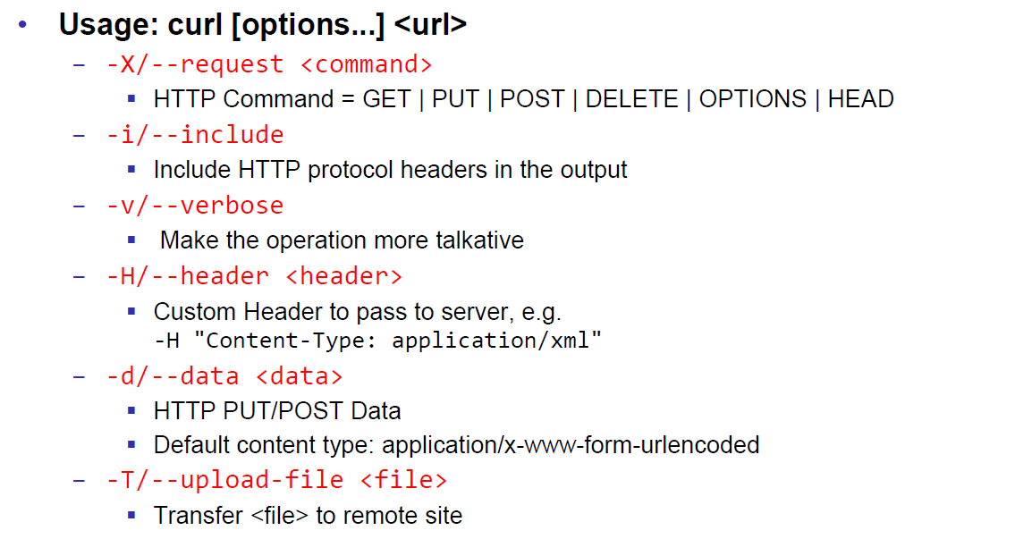

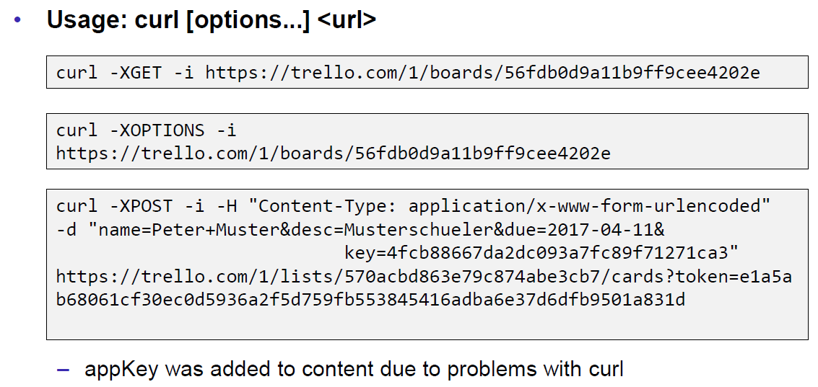

## REST Server Implementations

### Server Side

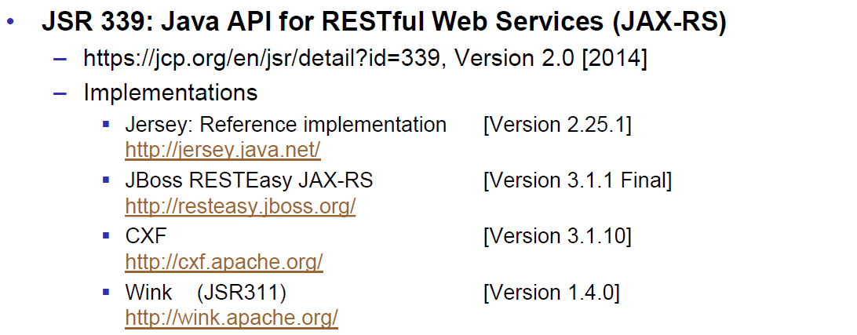

### JAX-RS Services

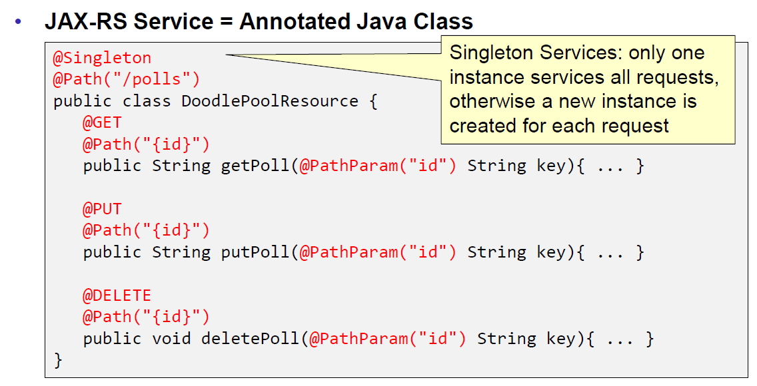

### JAX-RS HTTP Methods

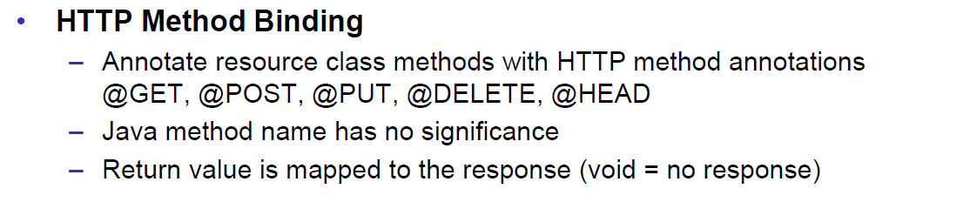

### JAX-RS Injection

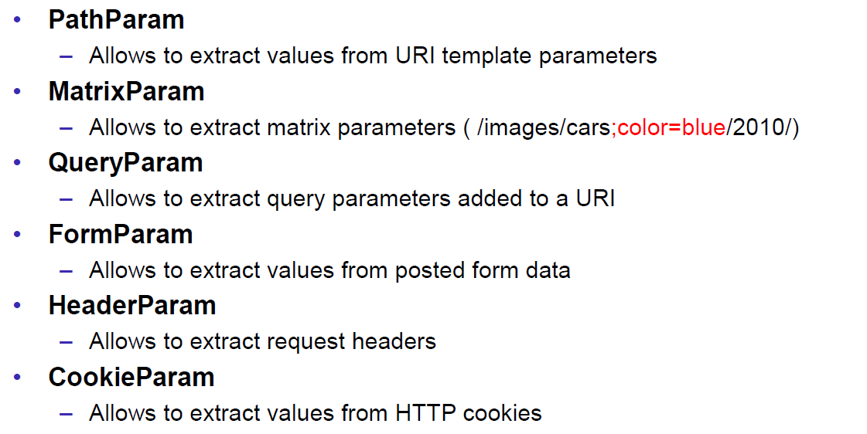

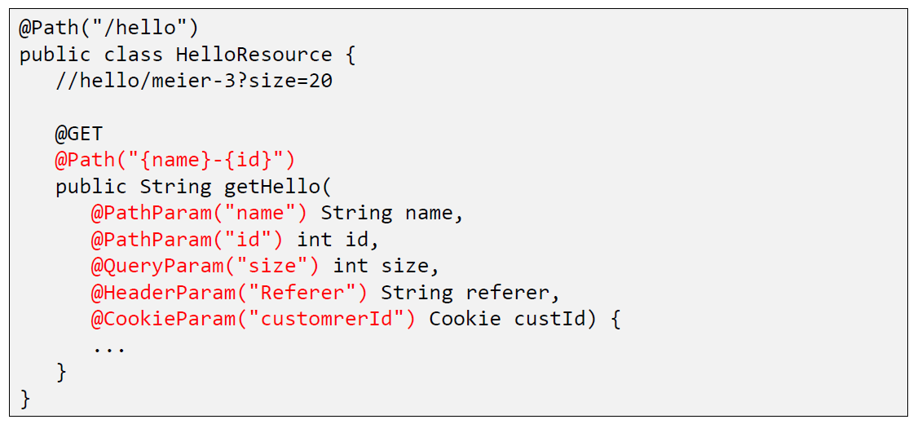

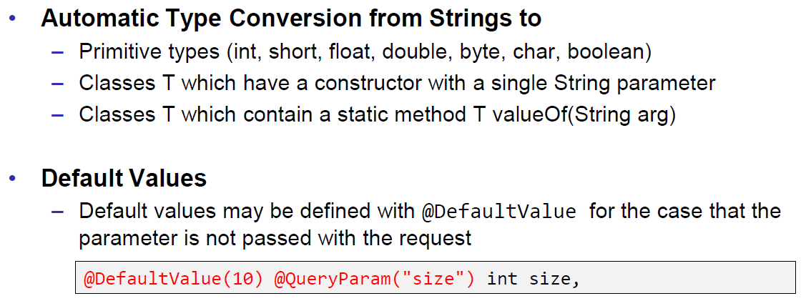

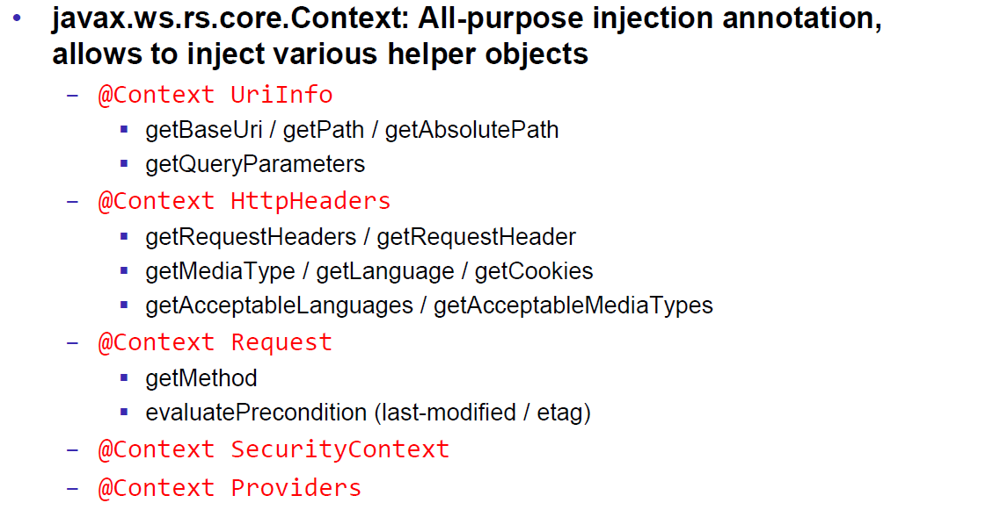

### JAX-RS Content Negotoation

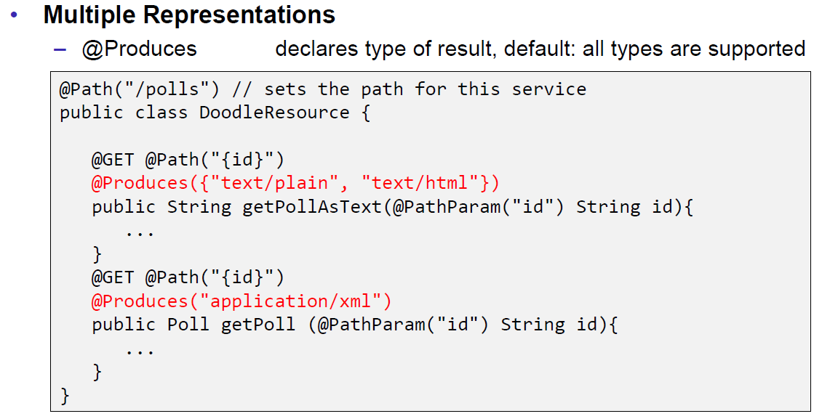

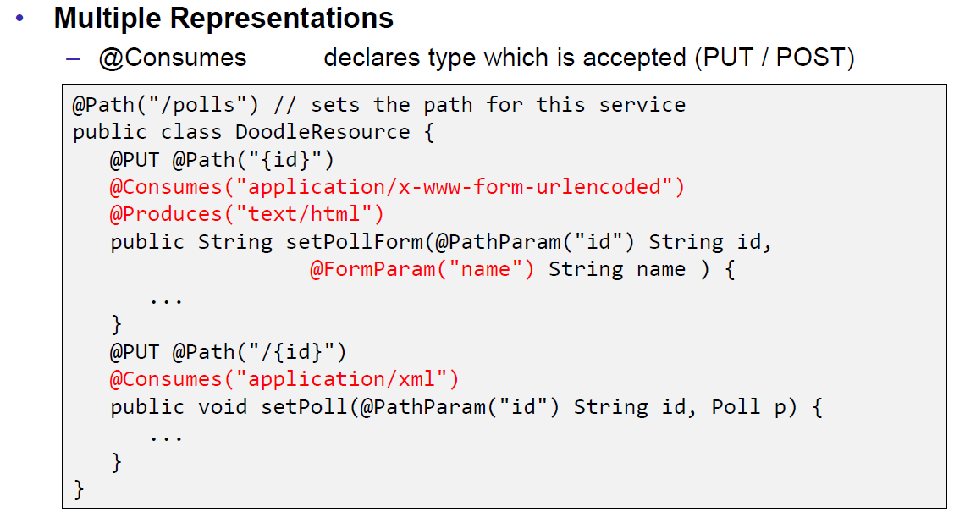

### JAX-RS Content Handlers

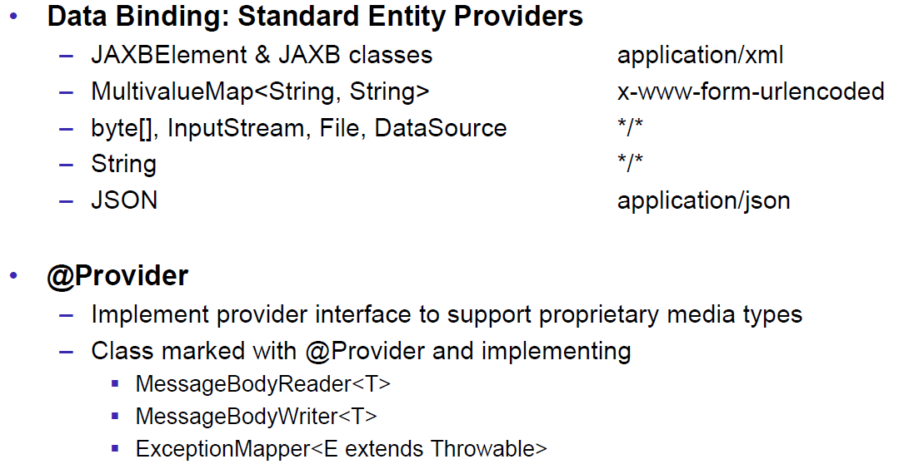

### JAX-RS Responses

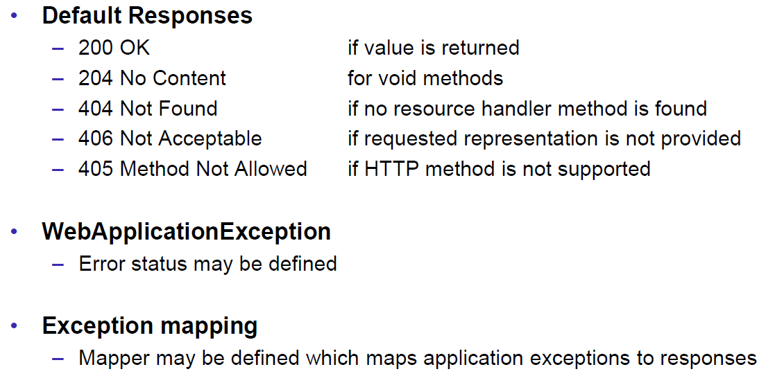

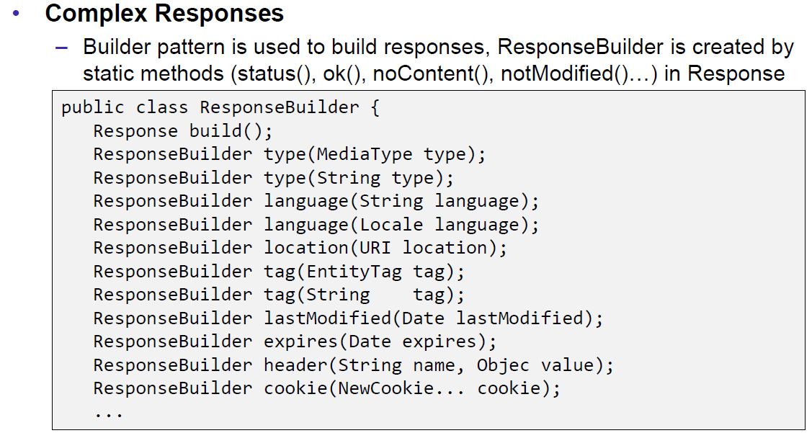

### JAX-RS Conditional GET

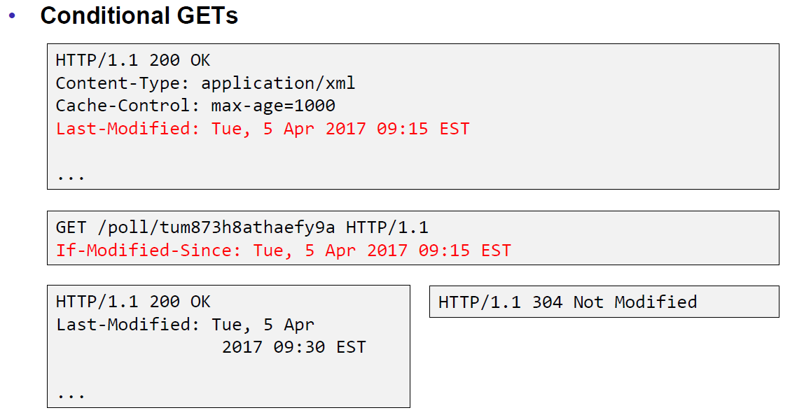

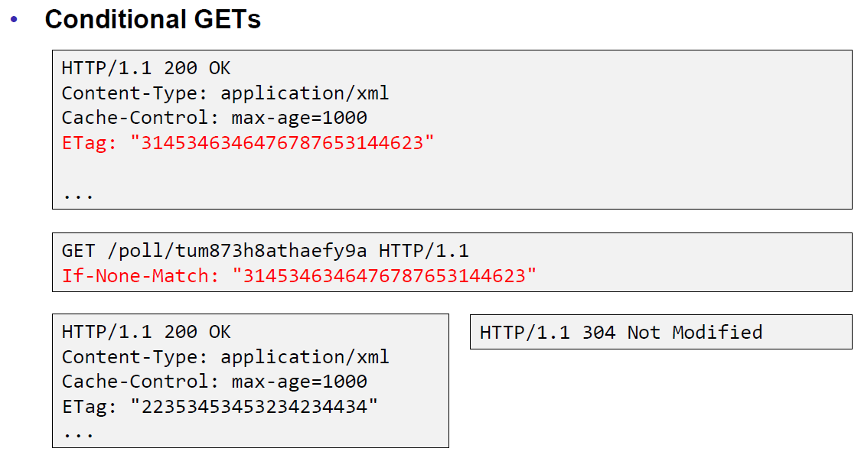

### JAX-RS Cache Control

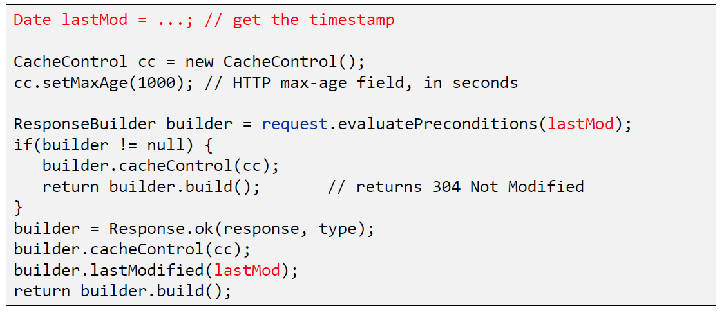

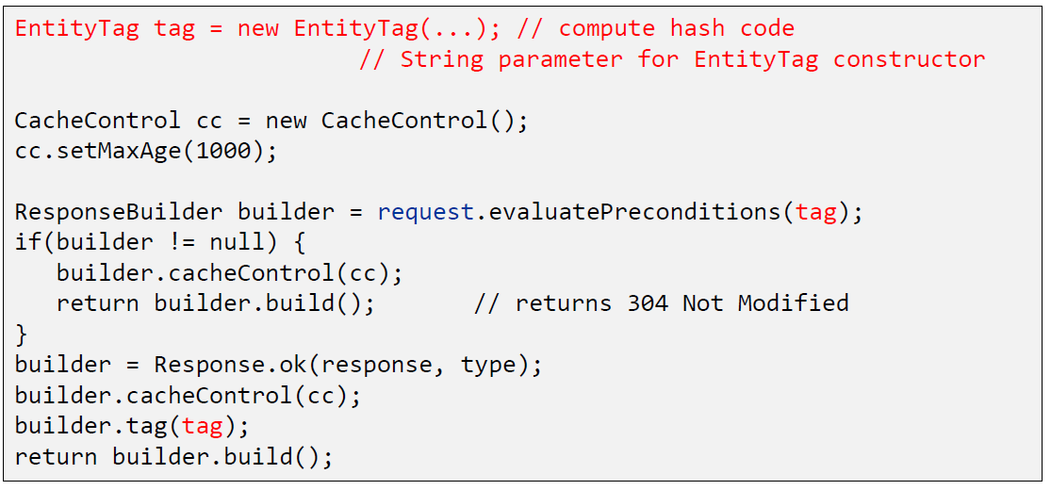

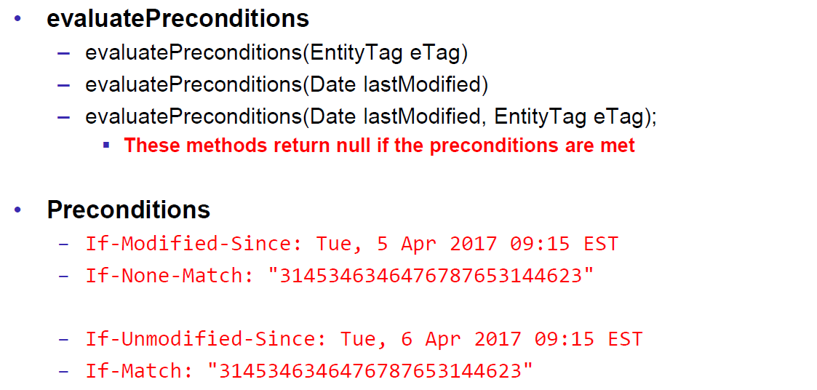

### JAX-RS Optimistic Locking

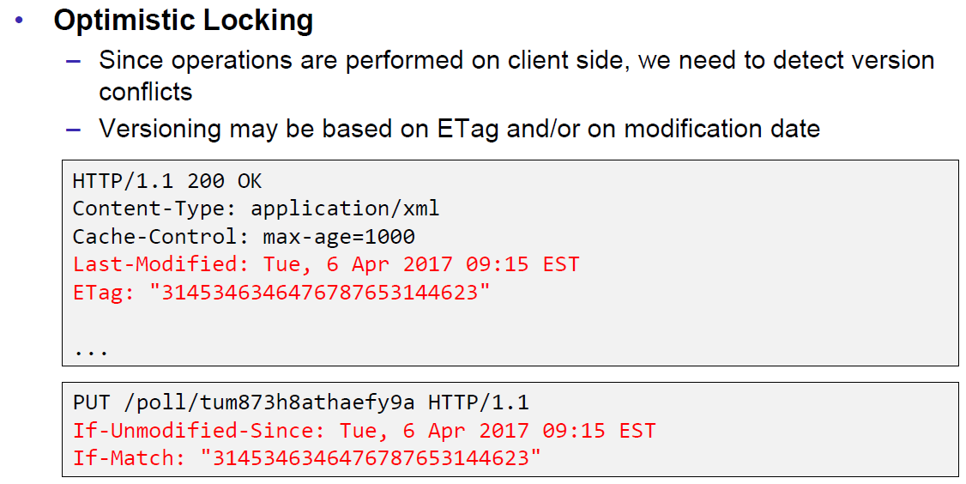

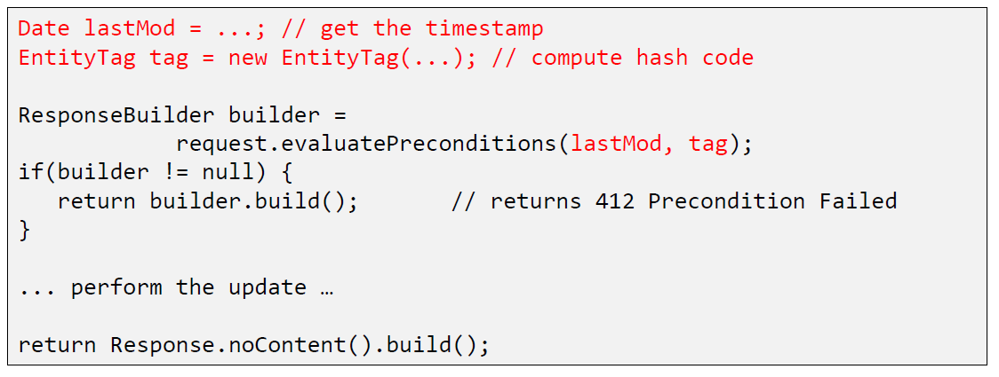

### JAX-RS Deployment

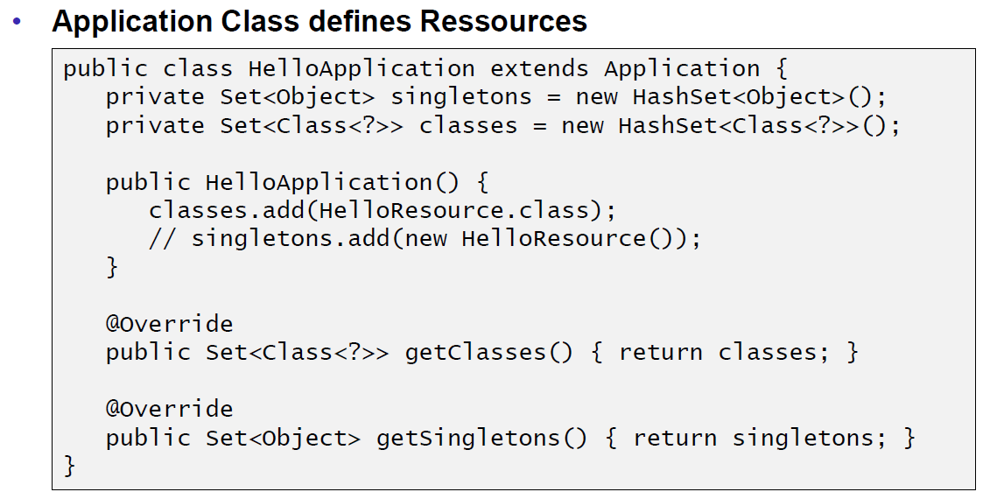

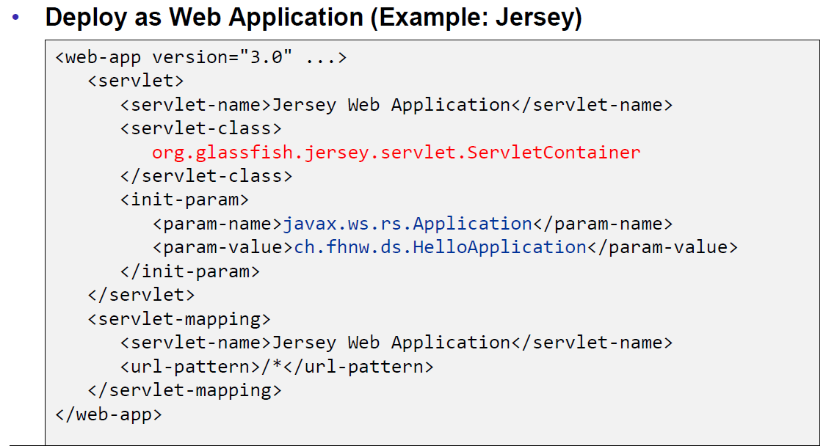

### Deploy Stand Alone via Jersey

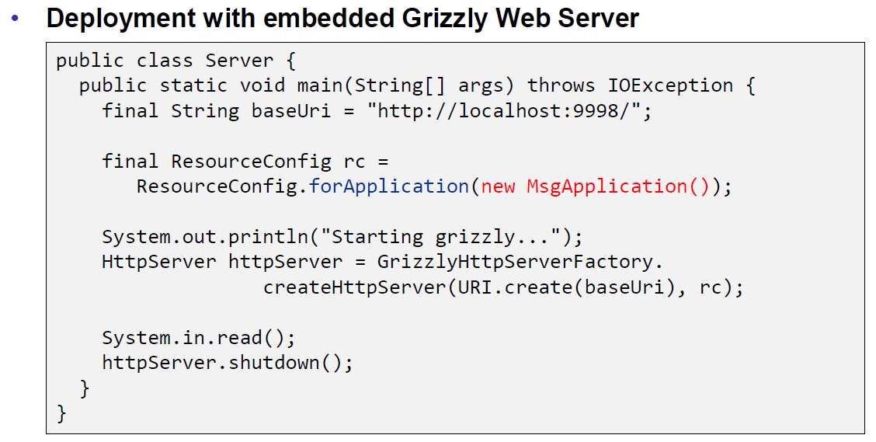

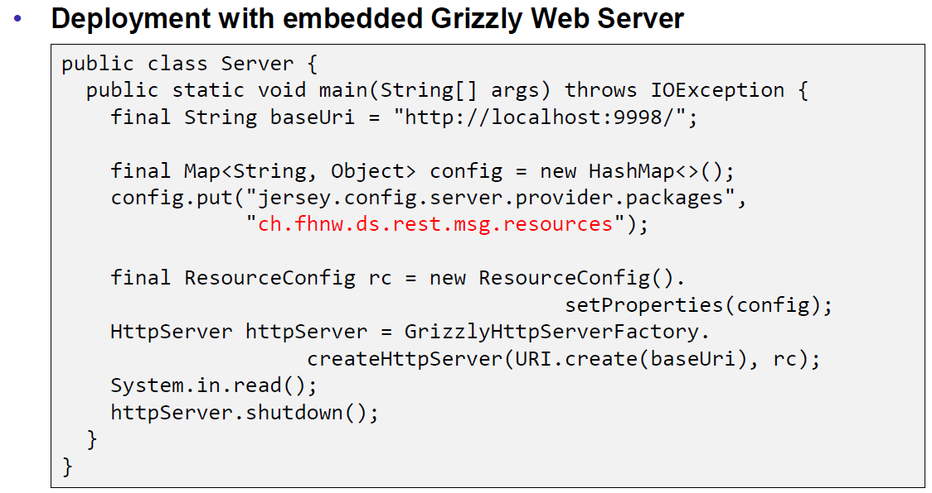

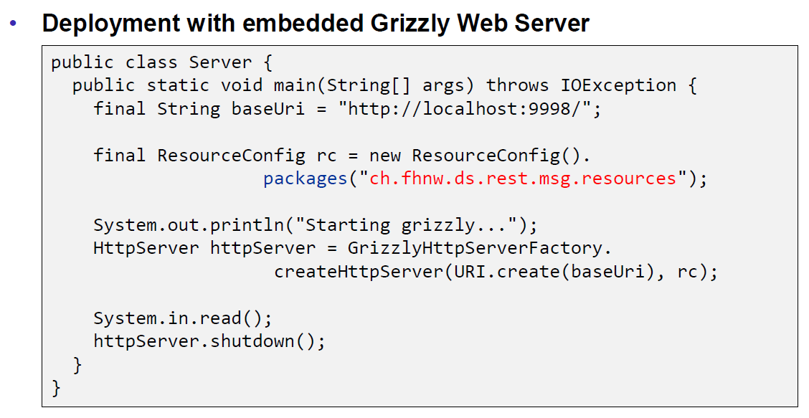

## REST Clients

### JAX-RS Client API

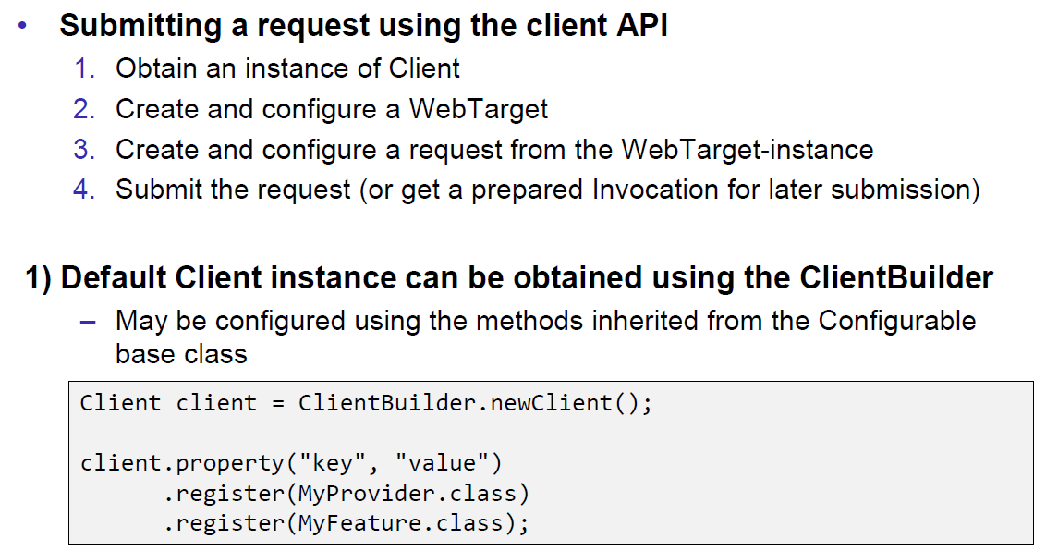

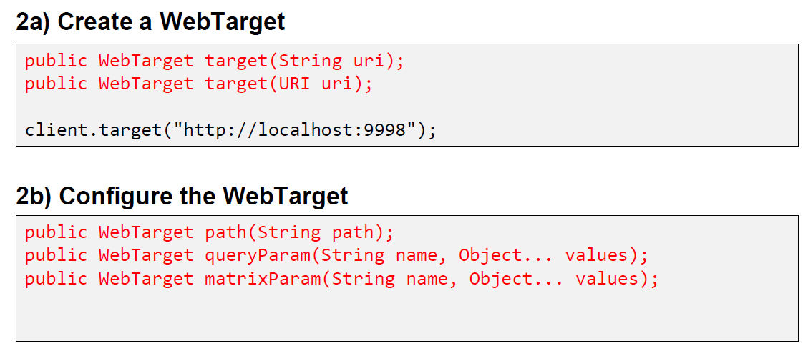

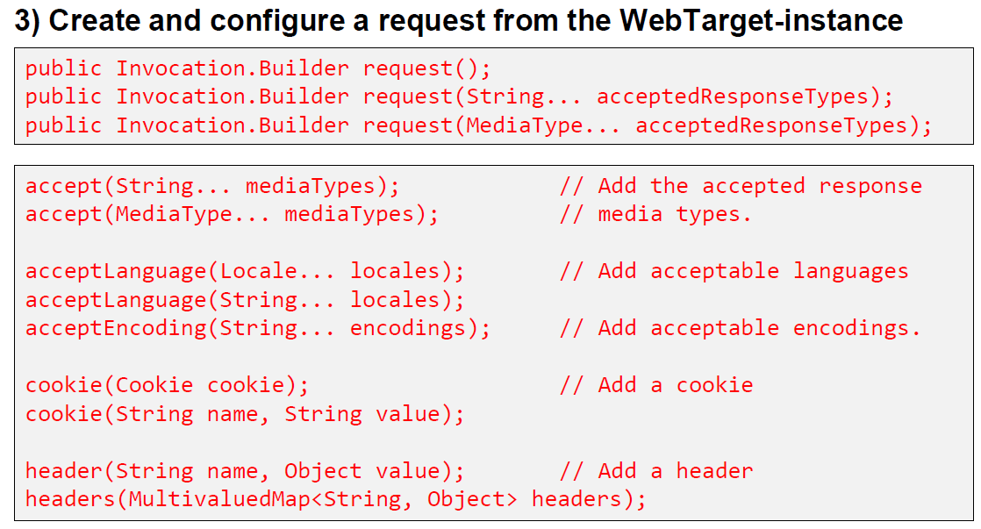

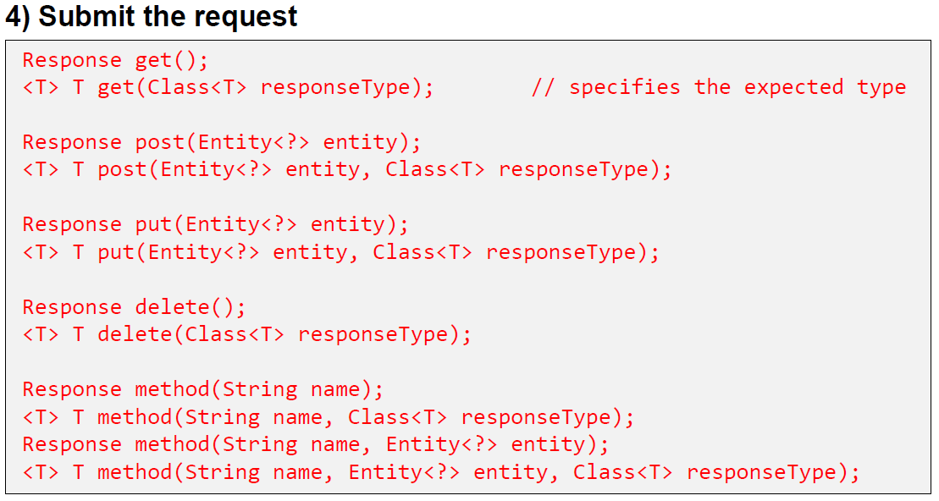

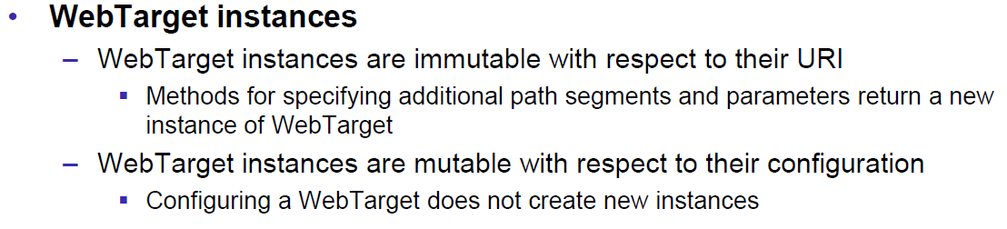

## Resources

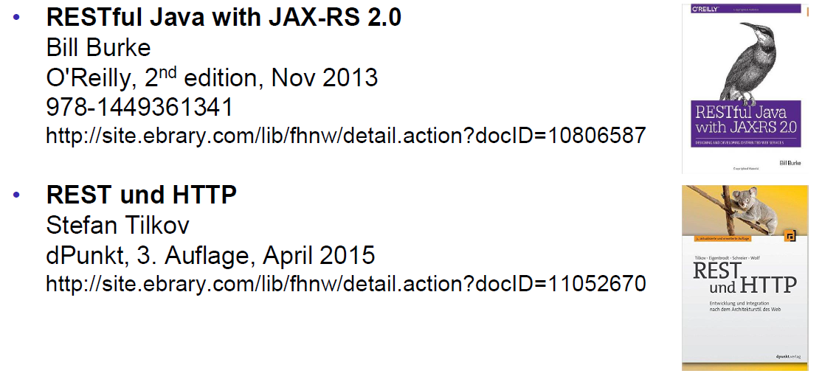

# Woche 7

## REST Data Binding

### JAX-RS Data Binding

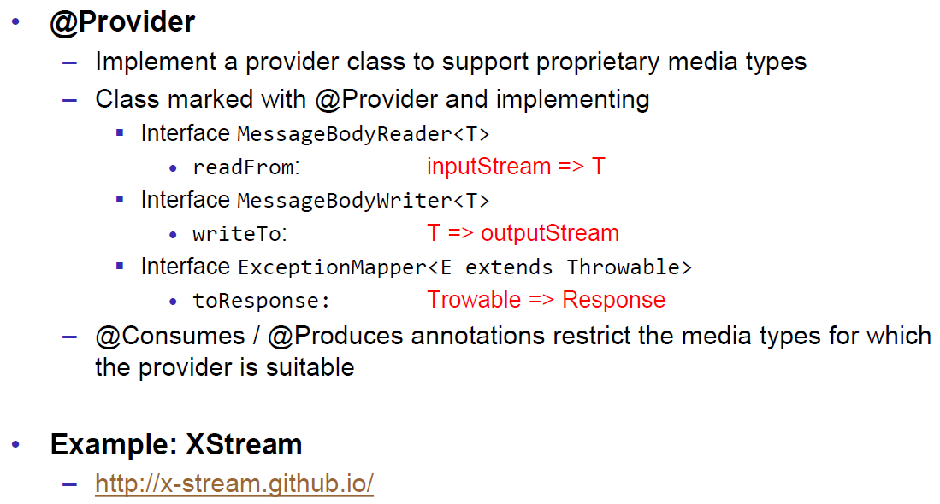

### XStream Provider (Reader)

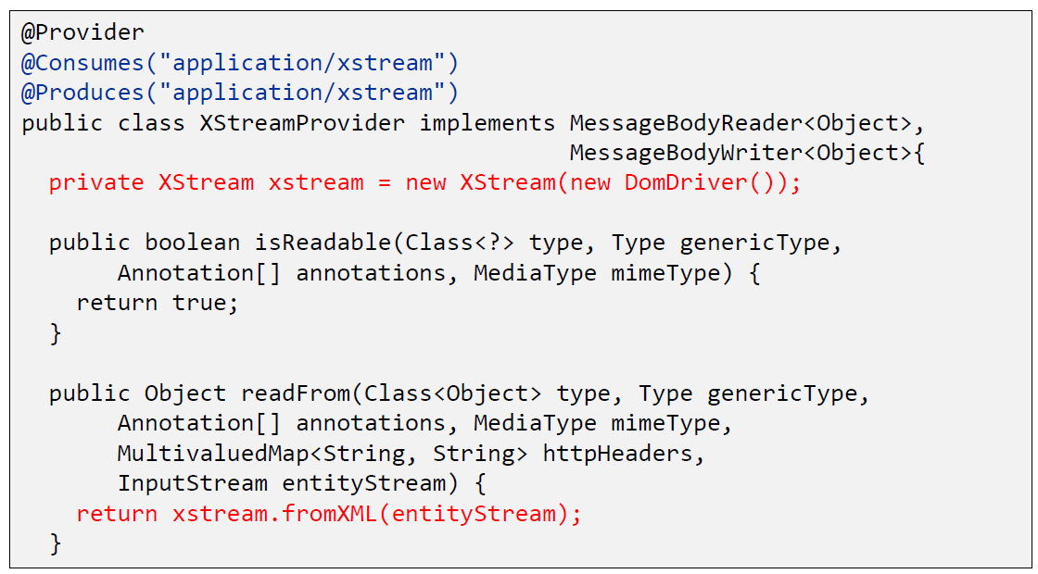

### XStream Provider (Writer)

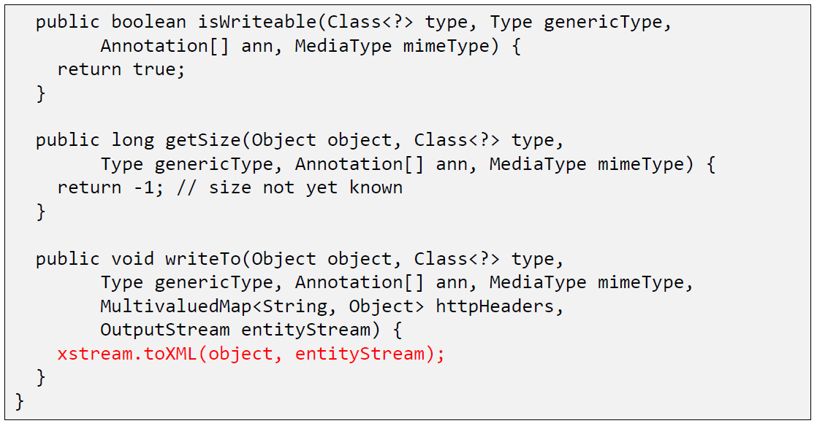

### XStream Example

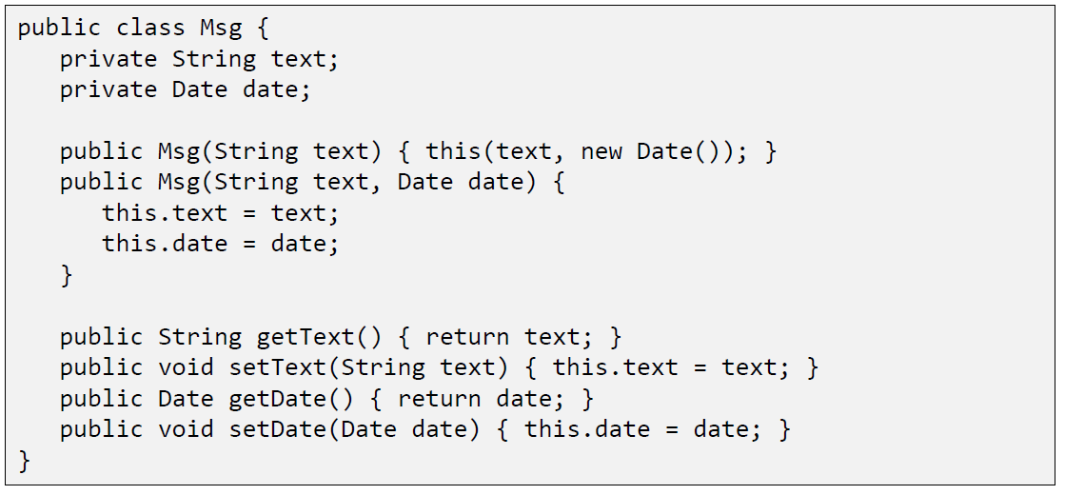

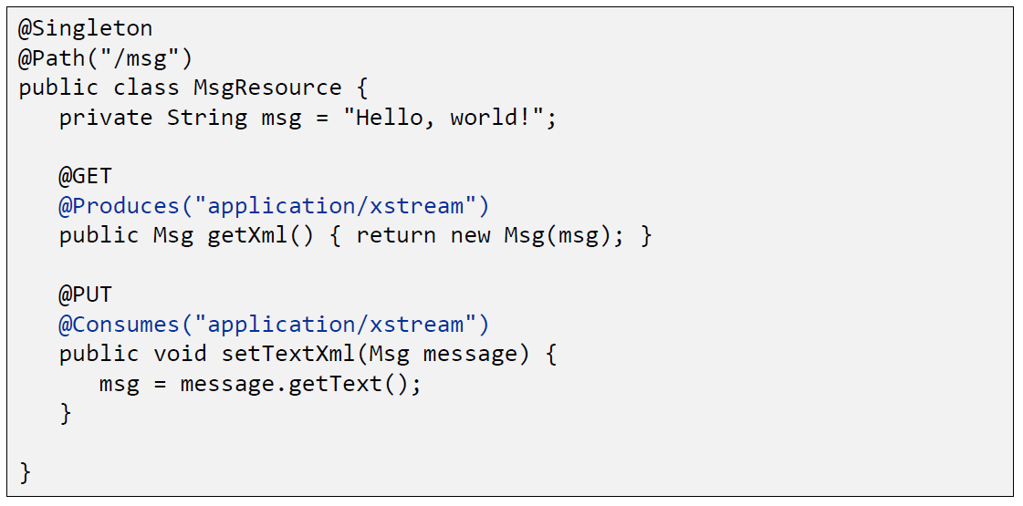

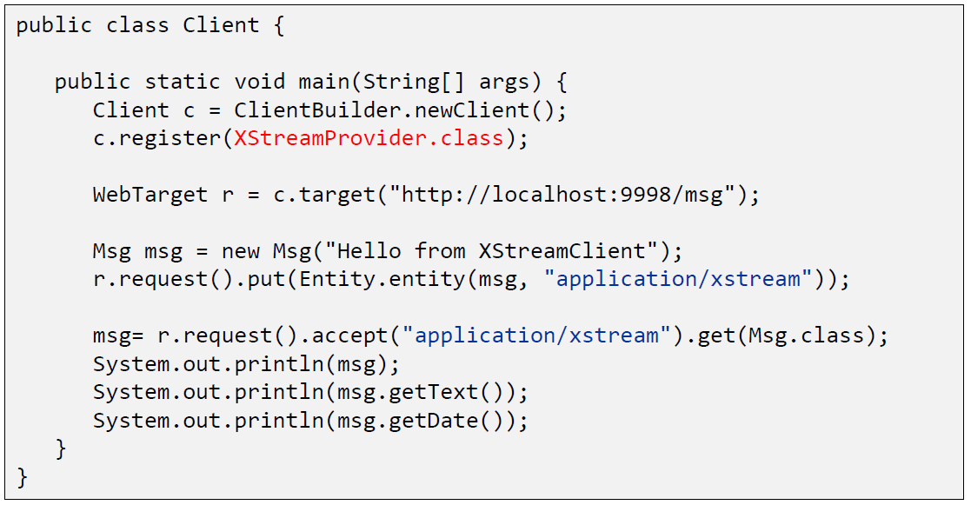

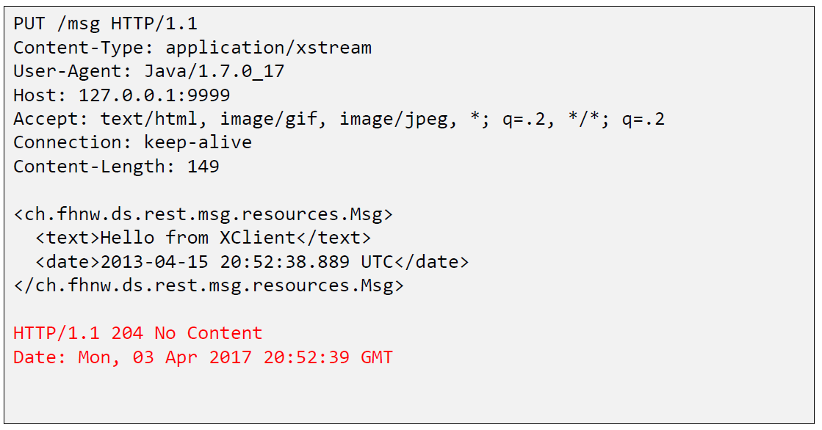

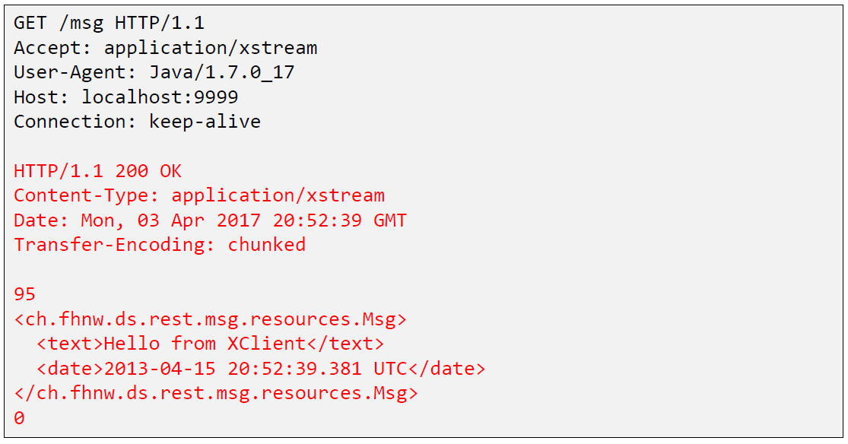

## Java Spark

### Java Spark

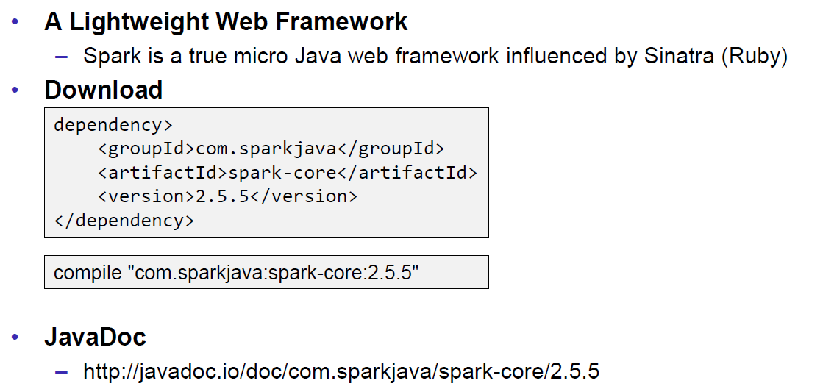

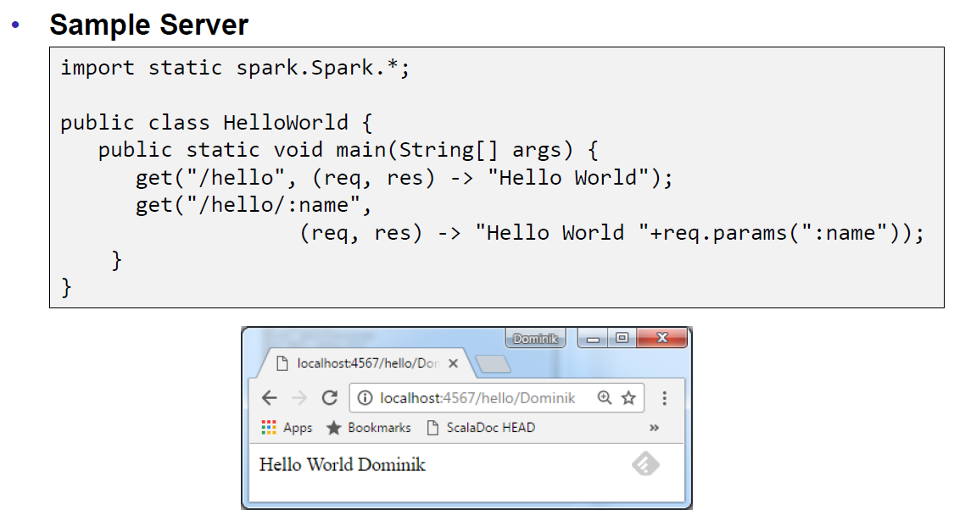

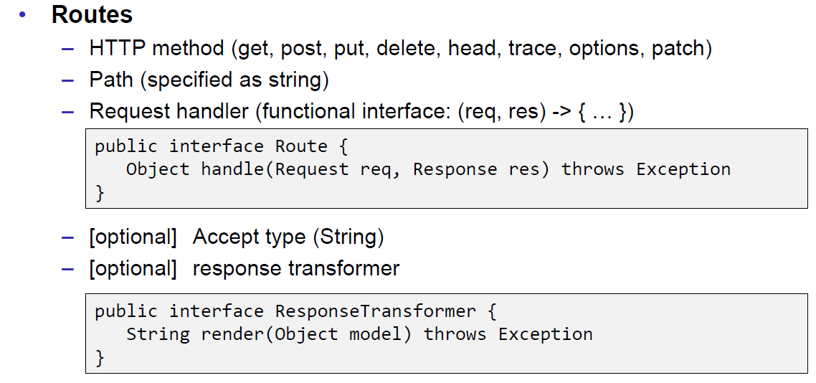

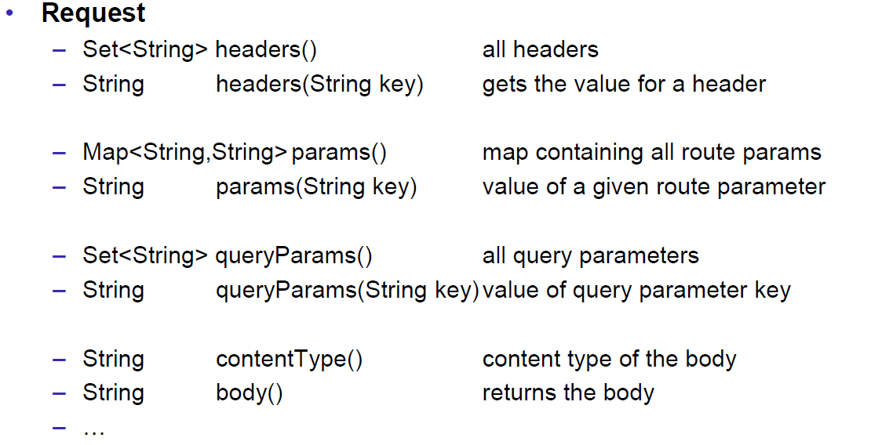

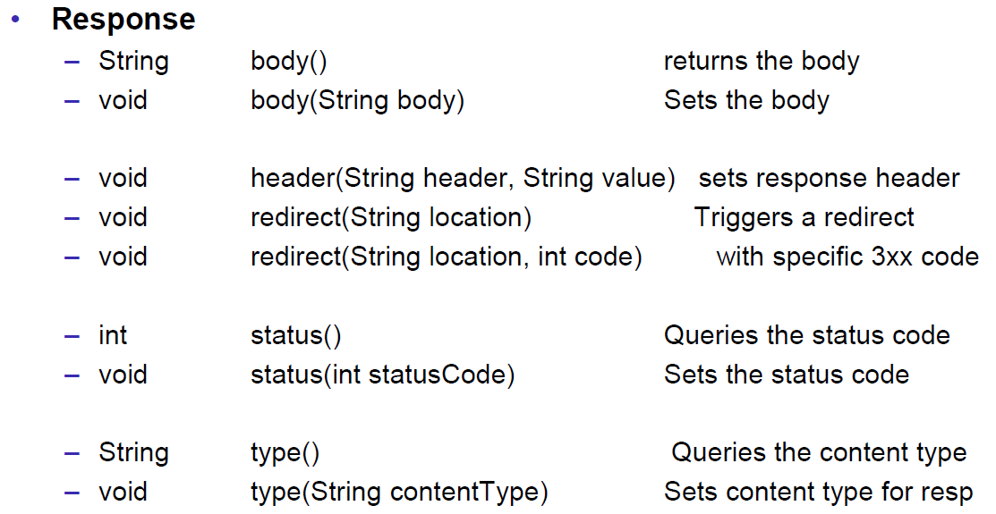

## JAXB

### JAXB Java Architecture for XML Binding

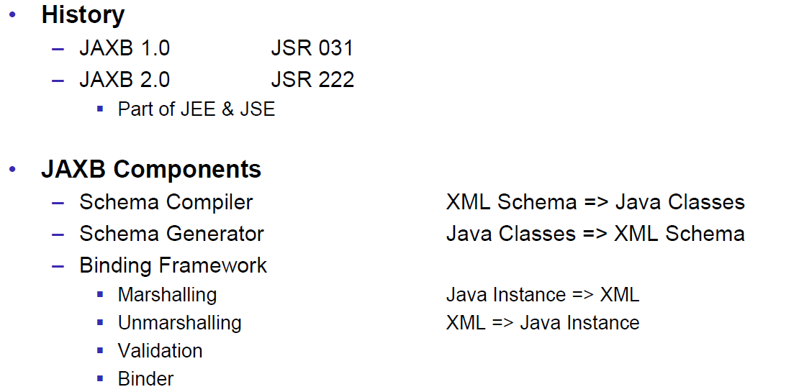

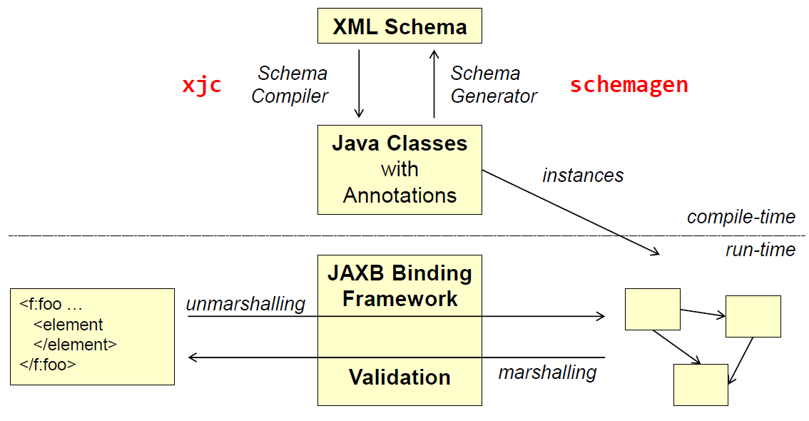

### XML Schema

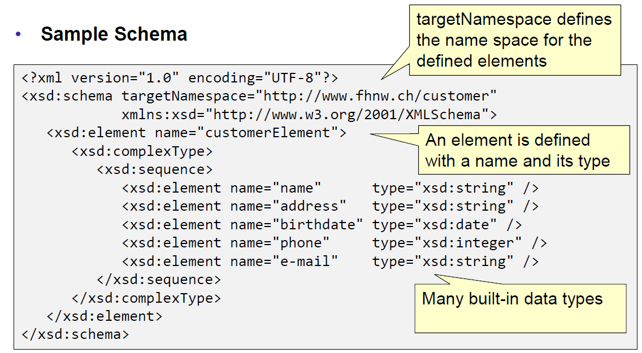

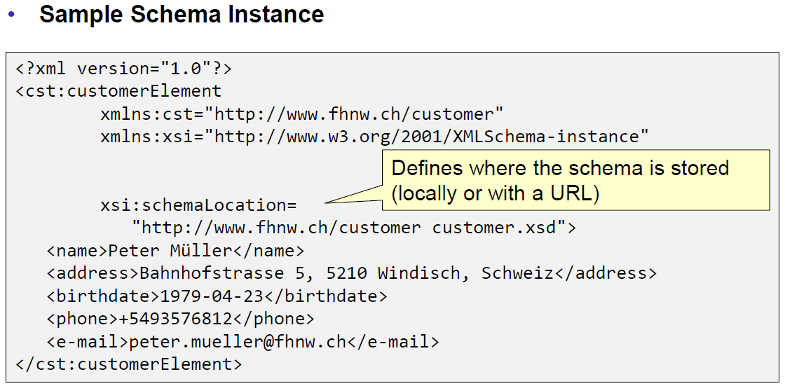

### Schema Compiler & Generator

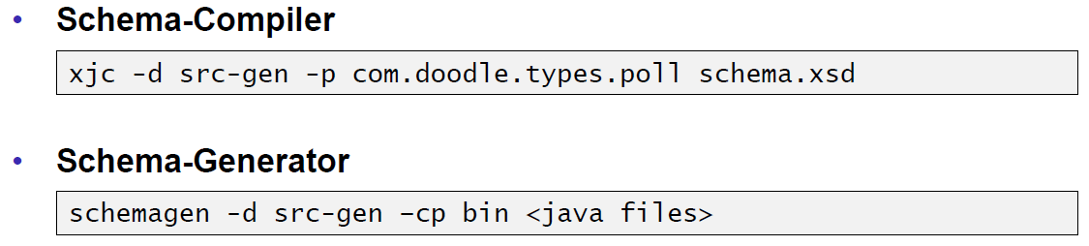

### JAXB Marshaller

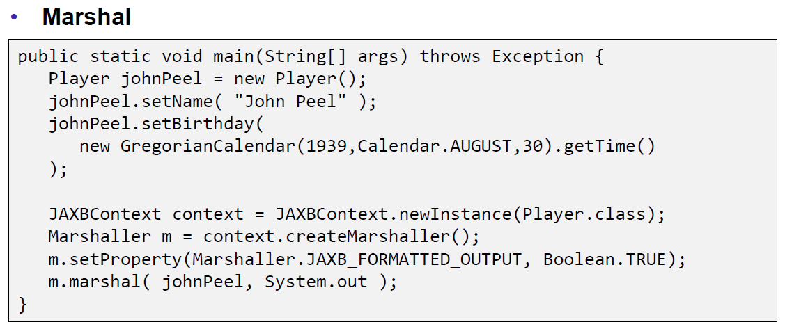

### JAXB Unmarshaller

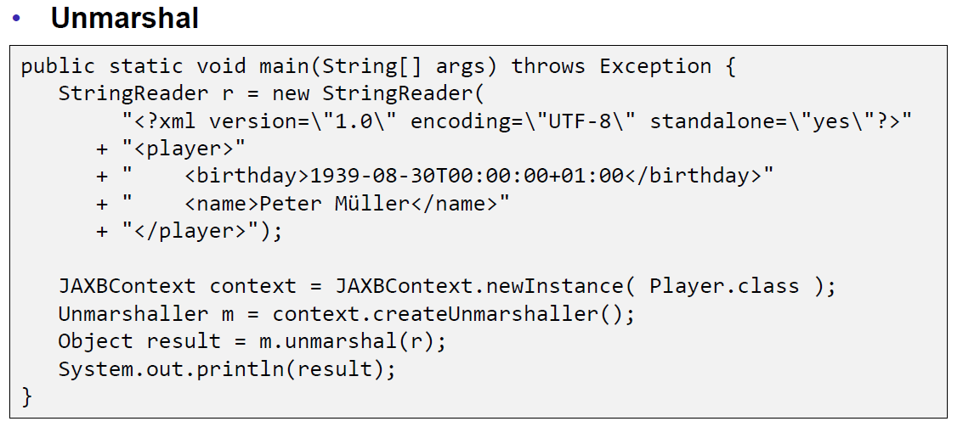

## REST API Description Languages

### Swagger

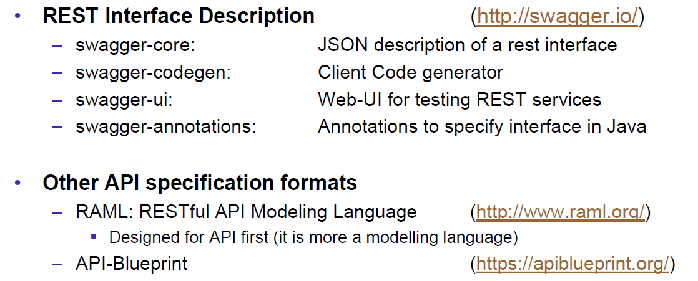

### Swagger Doodle

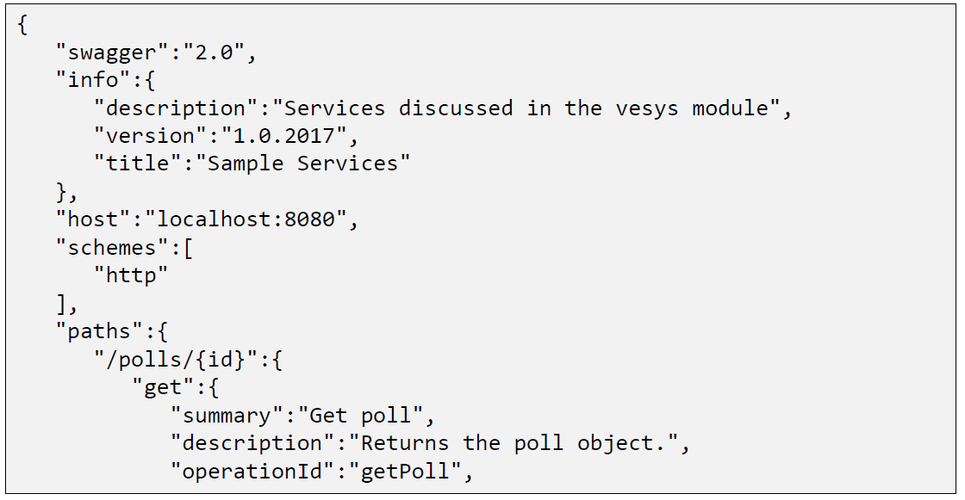

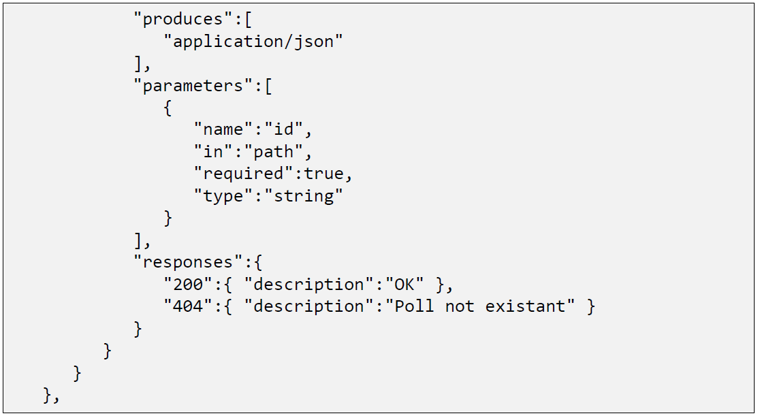

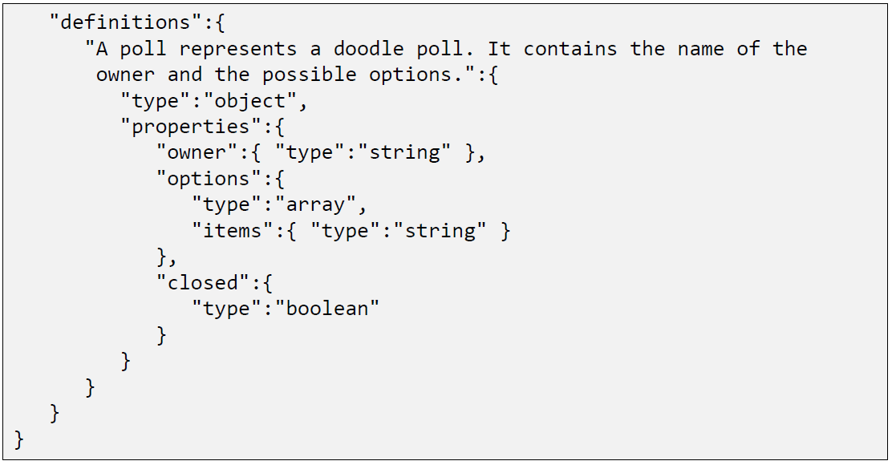

### Swagger Java Annotations

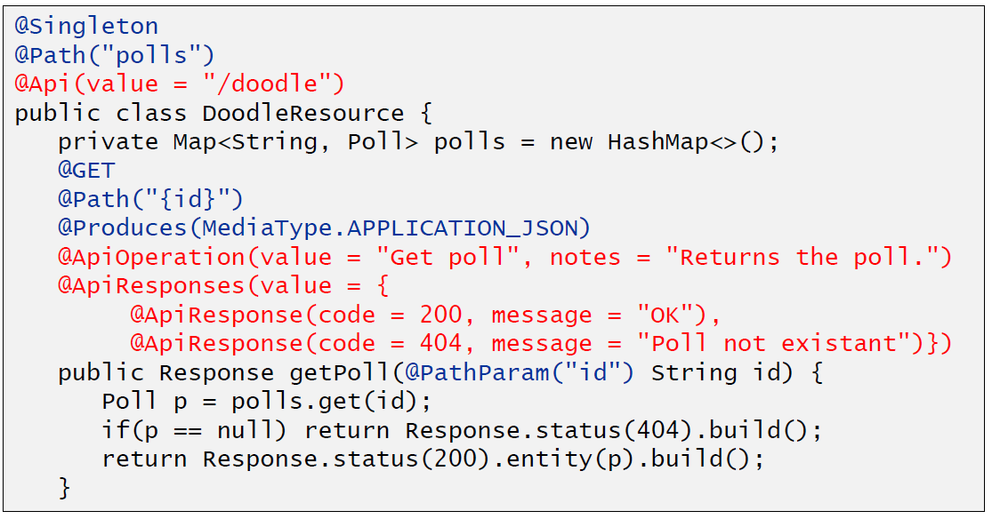

### Swagger GUI

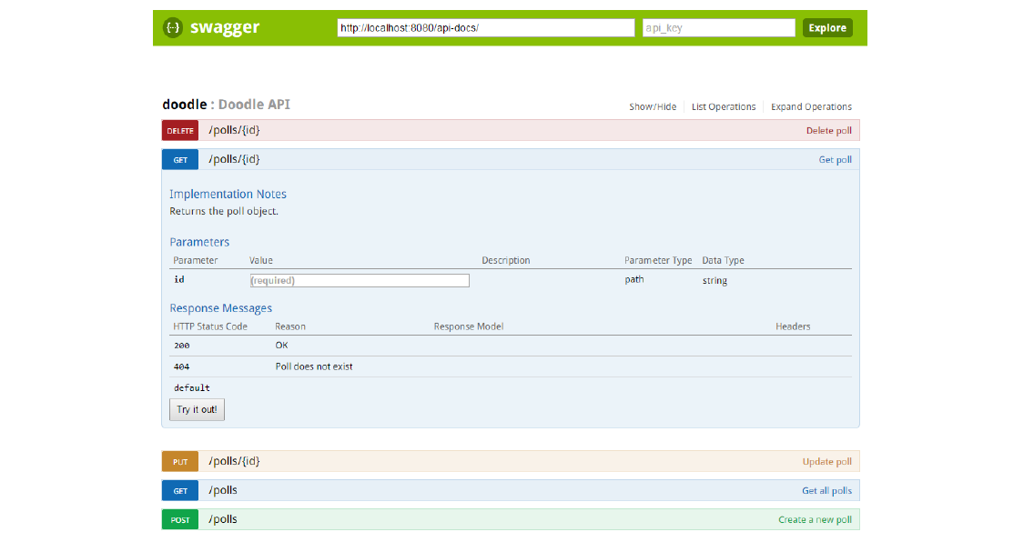

## REST Easy Client Proxy Framework

### RestEasy Client Proxy Framework

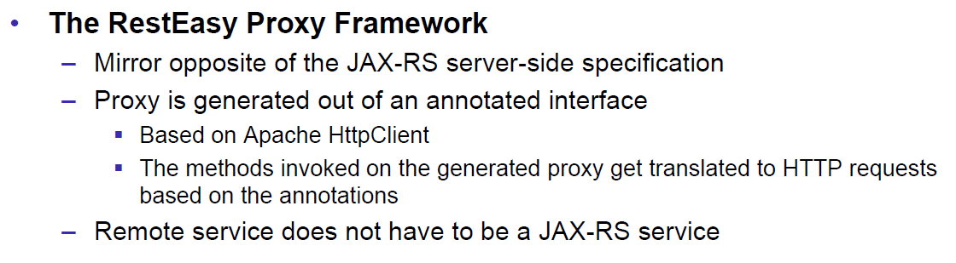

### RestEasy Example

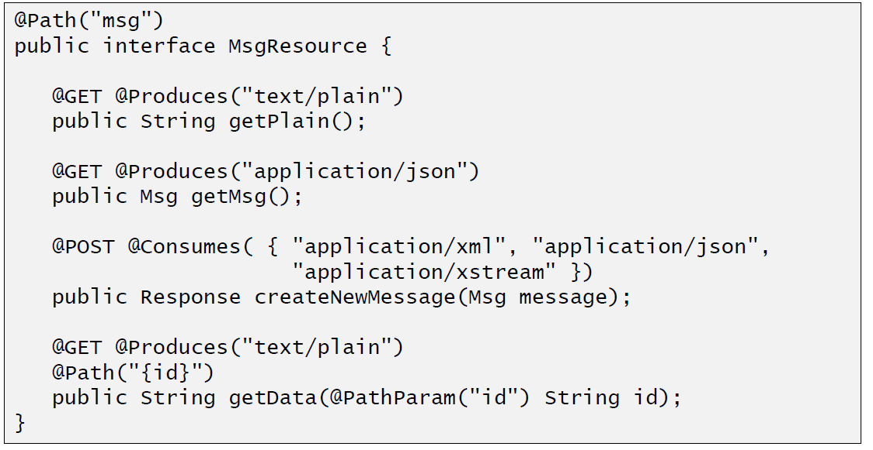

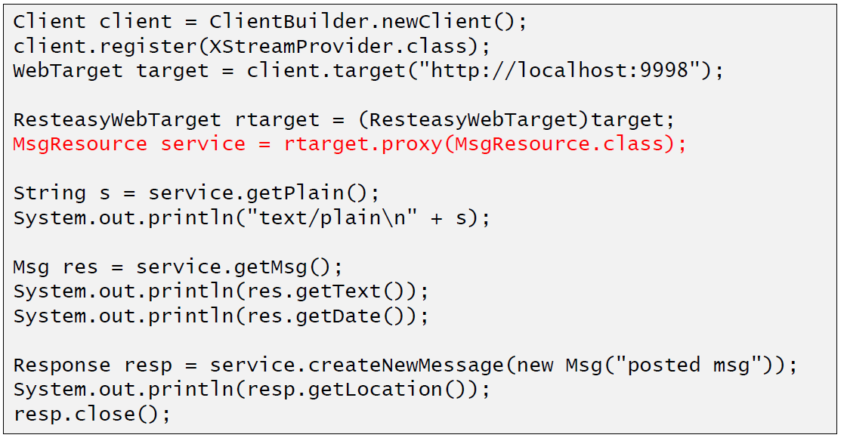

## Resources

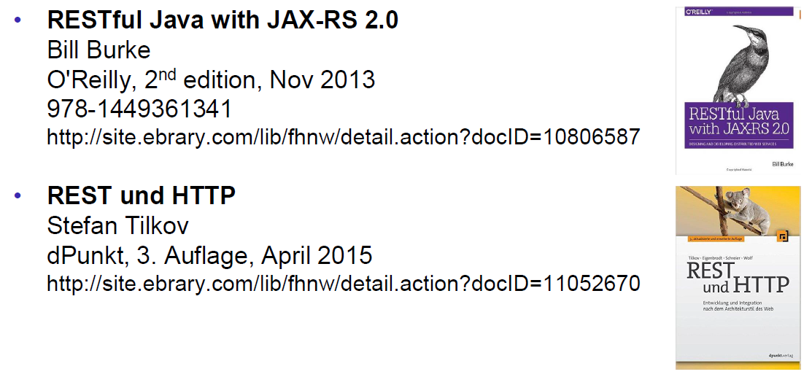

# Woche 8

## RMI Overview

### Communication Technologies

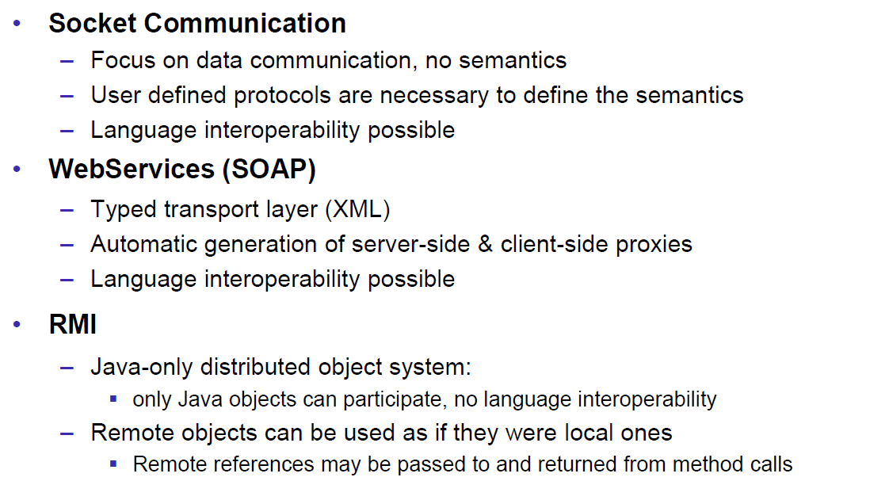

### Communication Architectures

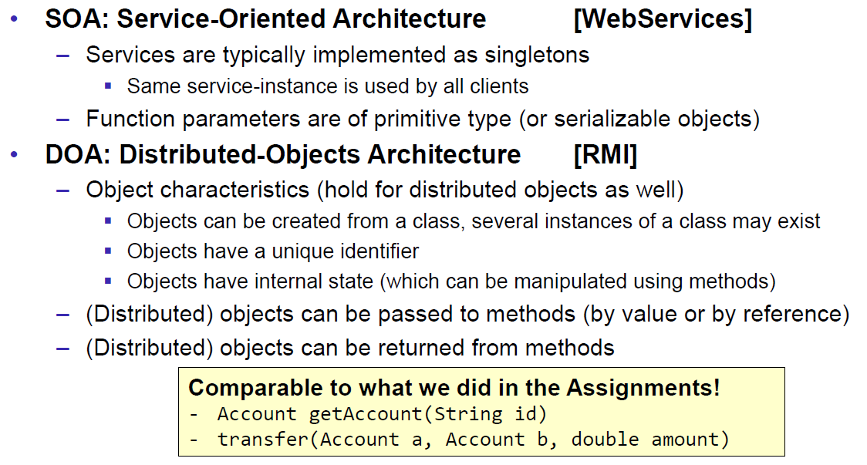

### Excursion: Proxy Pattern

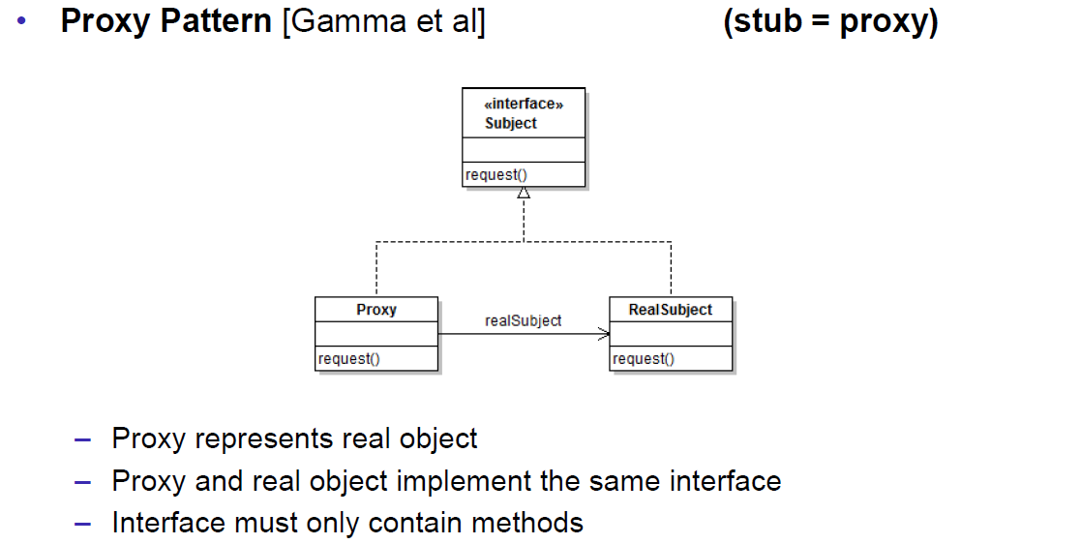

### Proxy Layer Stub and Skeleton

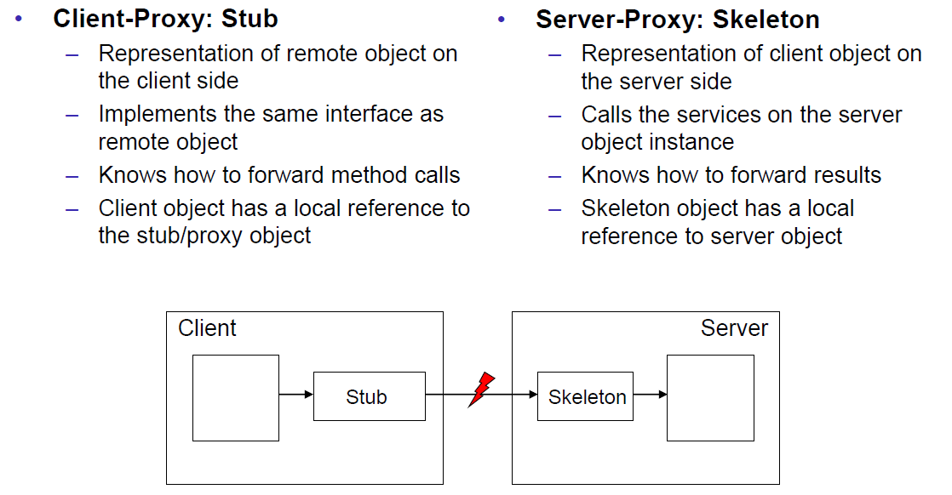

## RMI Step by Step

### Using RMI

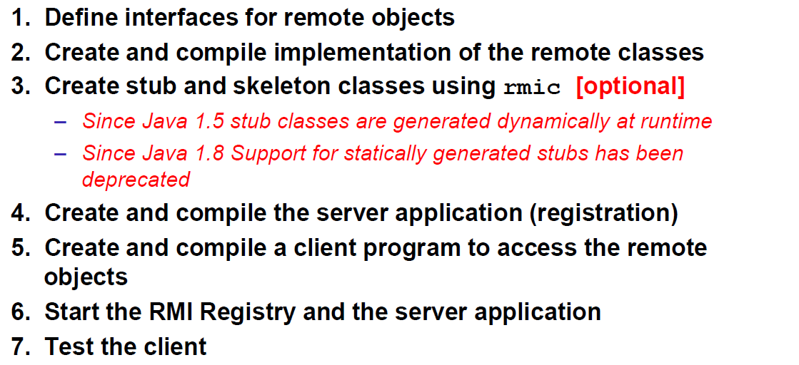

### 1.) Remote Interfaces

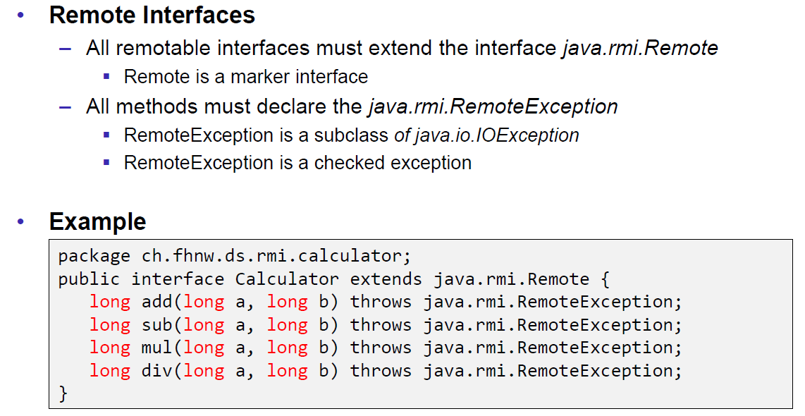

### 2.) Implementation

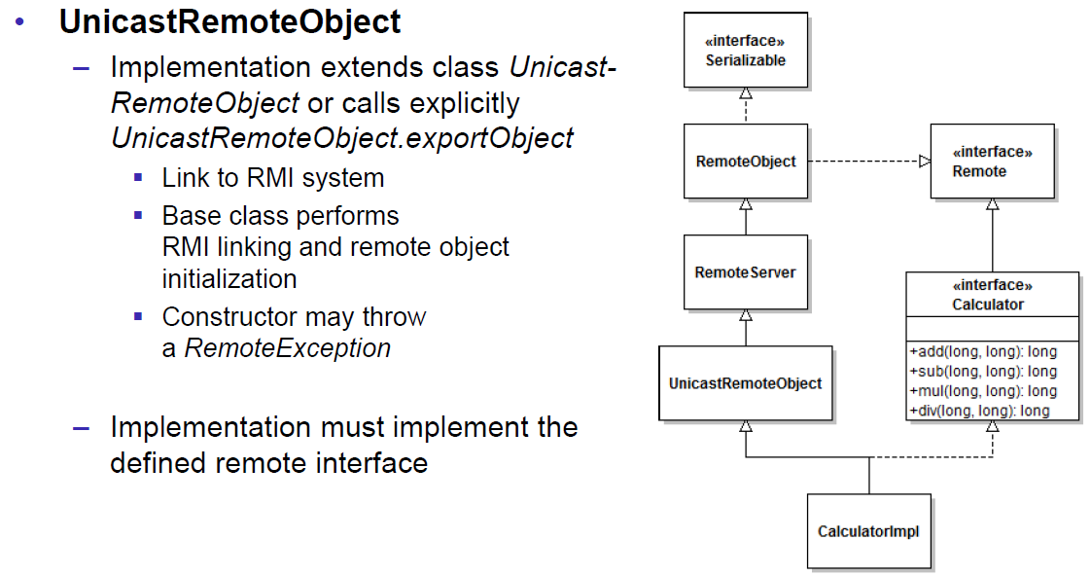

### 2.) Example

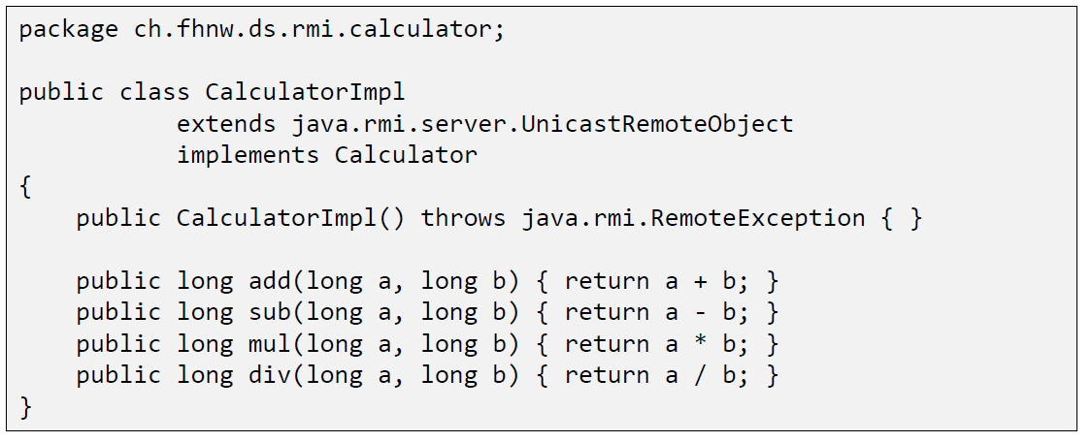

### 3.) Create Stubs and Skeletons (Deprecated)

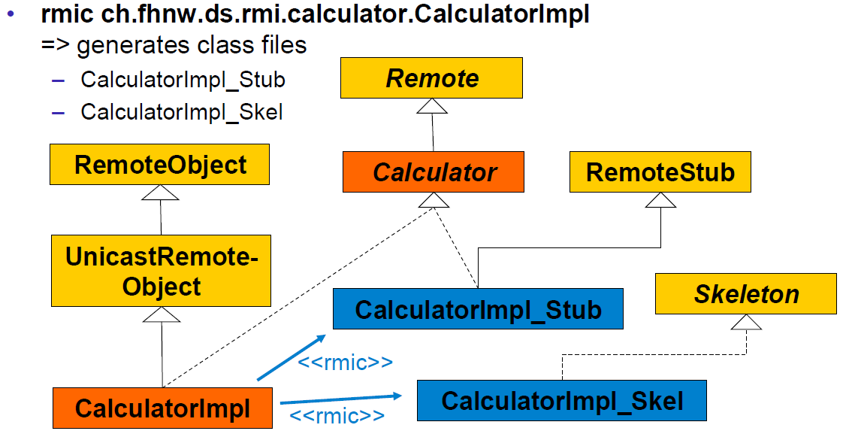

### 3.) Dynamic Stubs since Java 1.5

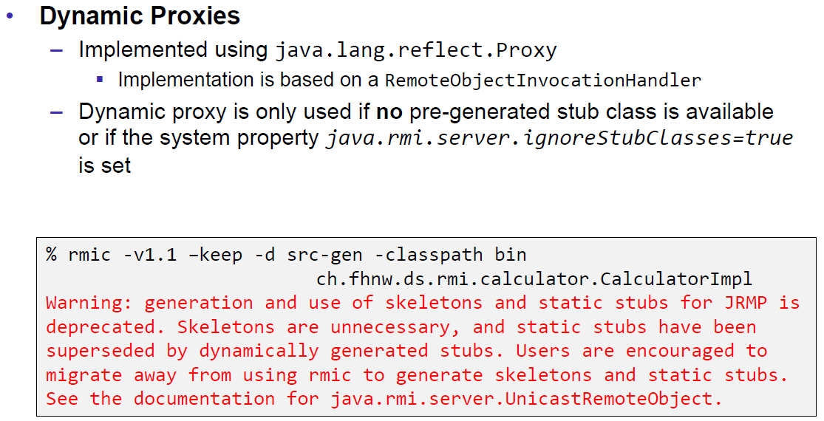

### 4.) Server

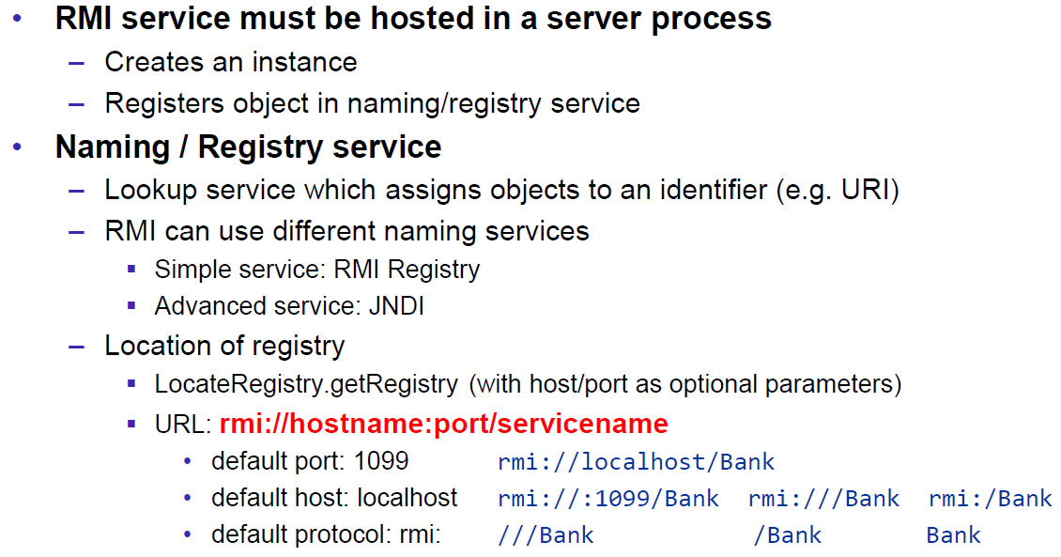

### 4.) Example

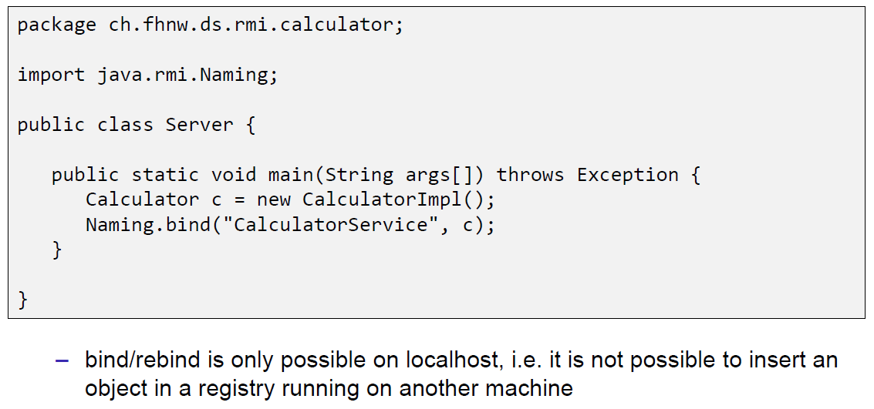

### 4.) and 5.) Naming/Registry

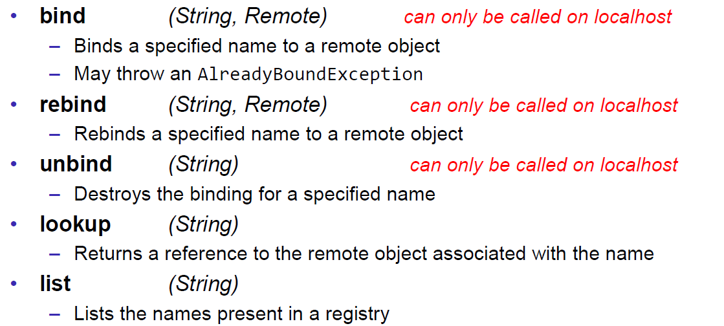

### 5.) Example

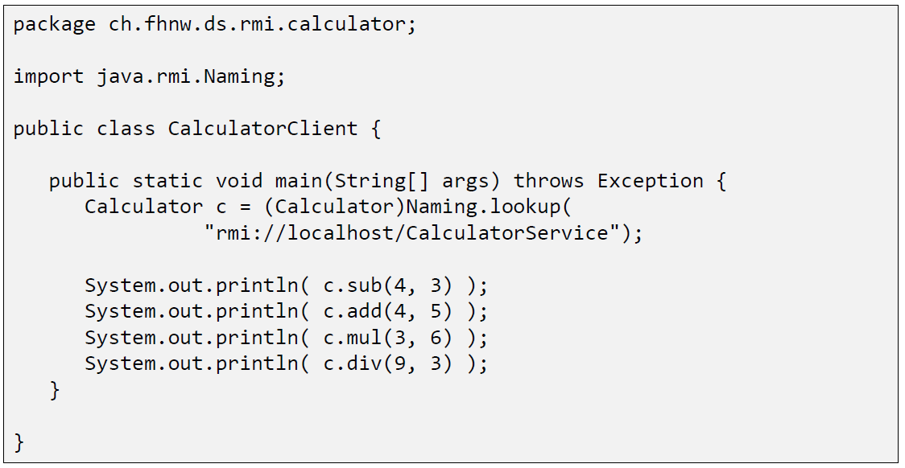

### 6.) Start of RMI Registry & Server

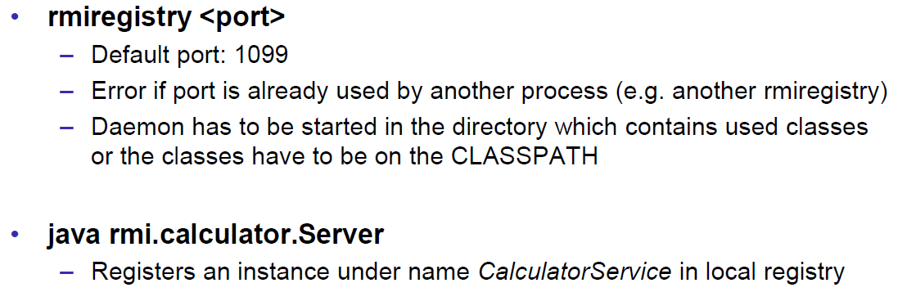

### 6.) Example

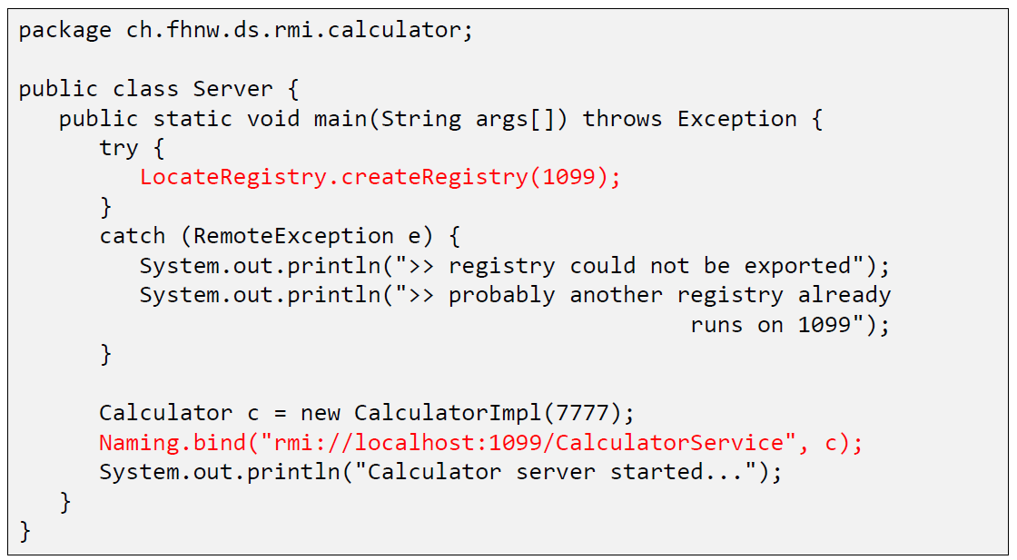

### Example: List of all registered objects

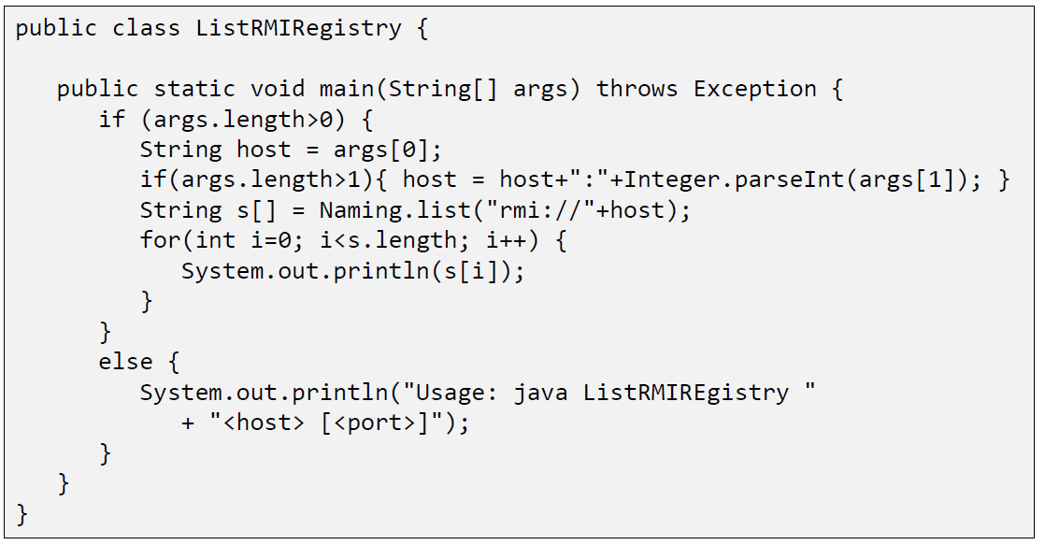

## RMI Marshalling

### Marshalling

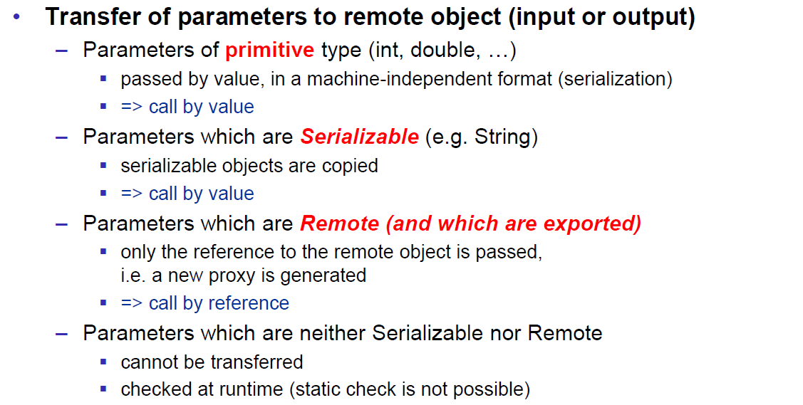

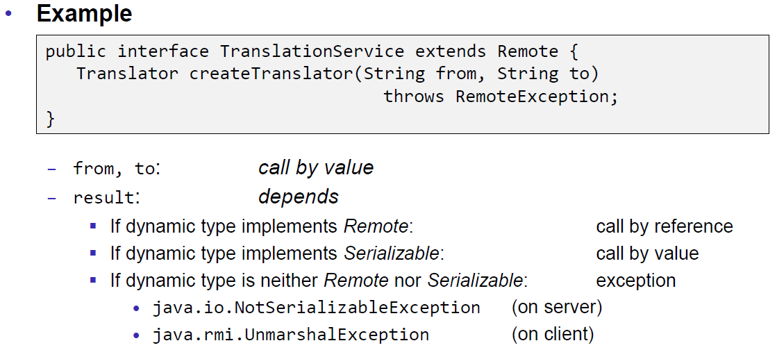

### RMI Stubs

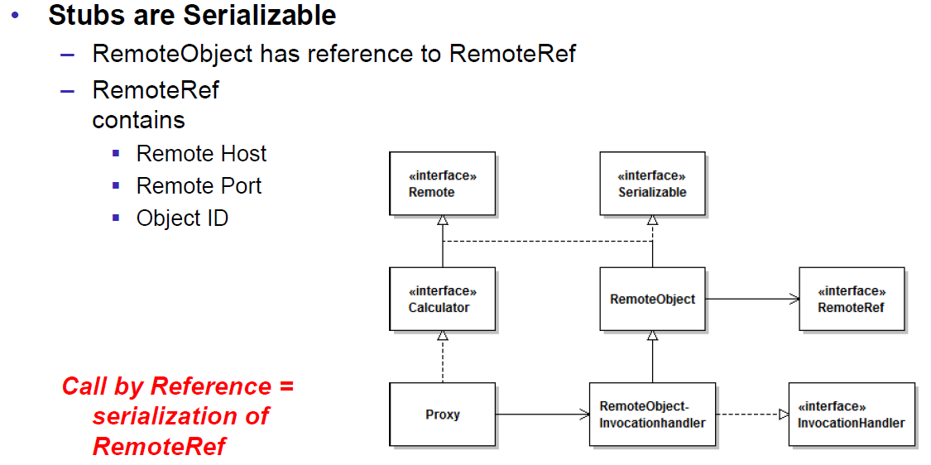

### Remote Reference Applications

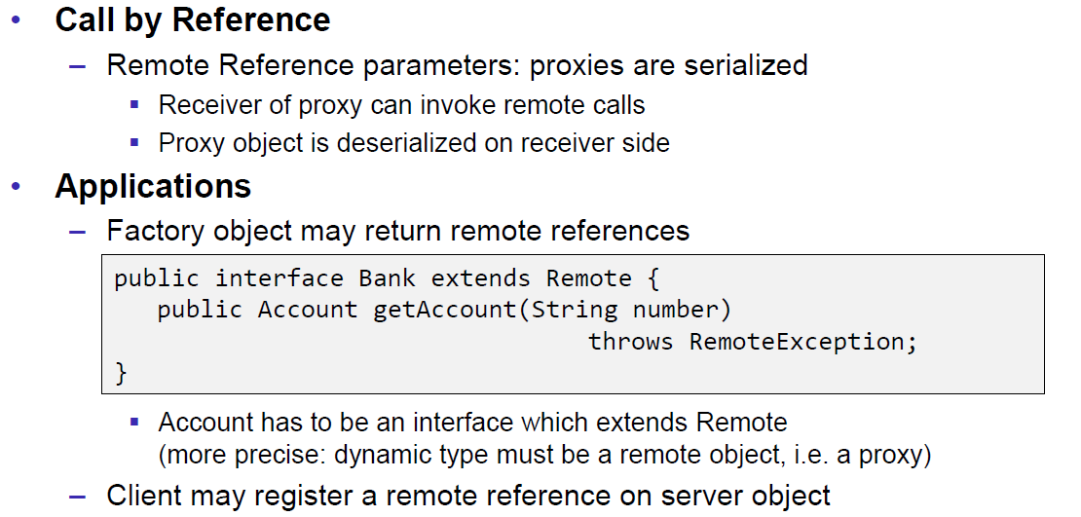

### Callback

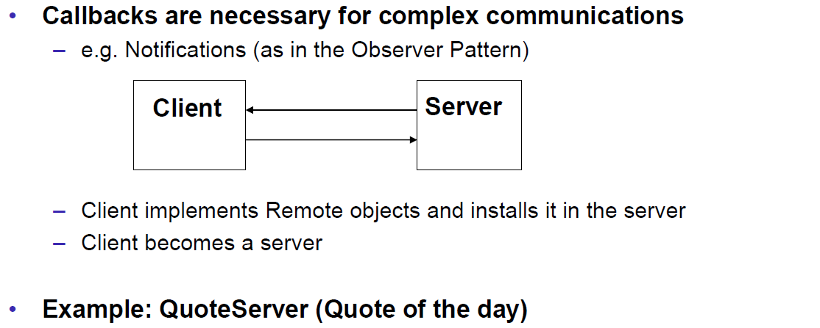

### Example: Quote Server

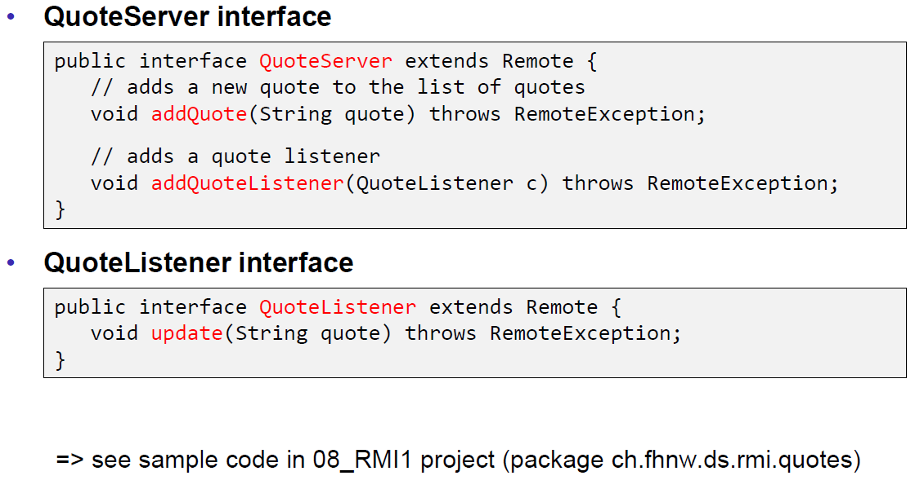

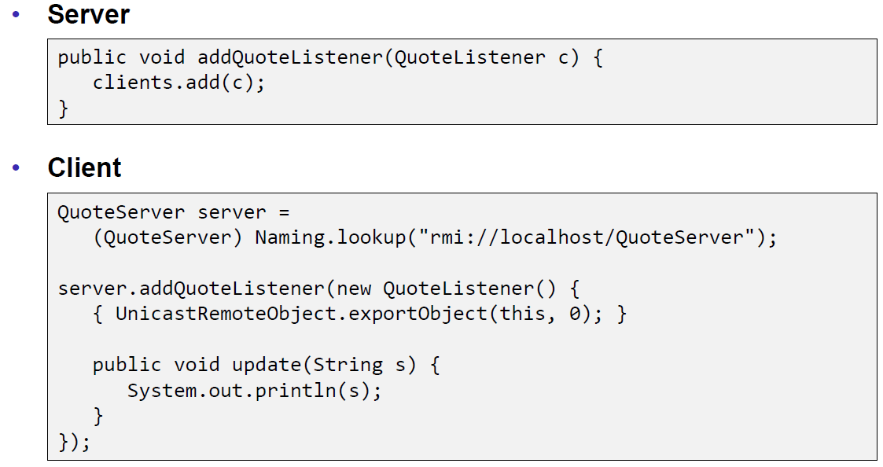

## RMI Architecture

### Summary of the RMI Architecture

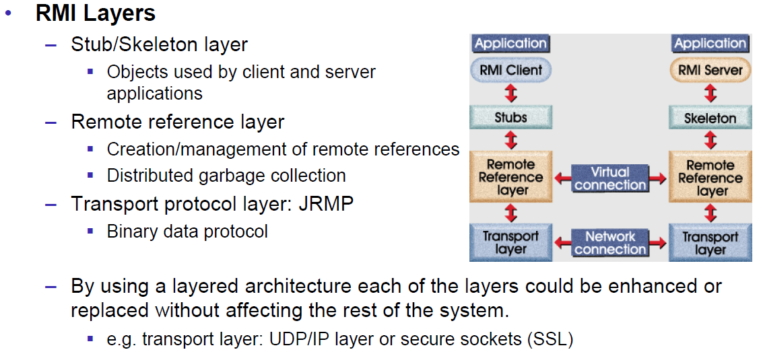

### Remote Reference Layer

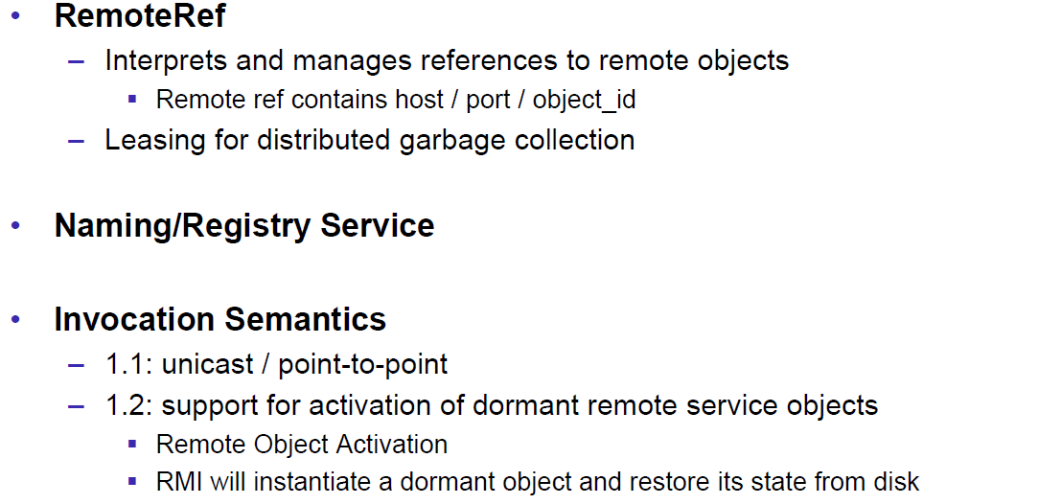

### Transport Layer

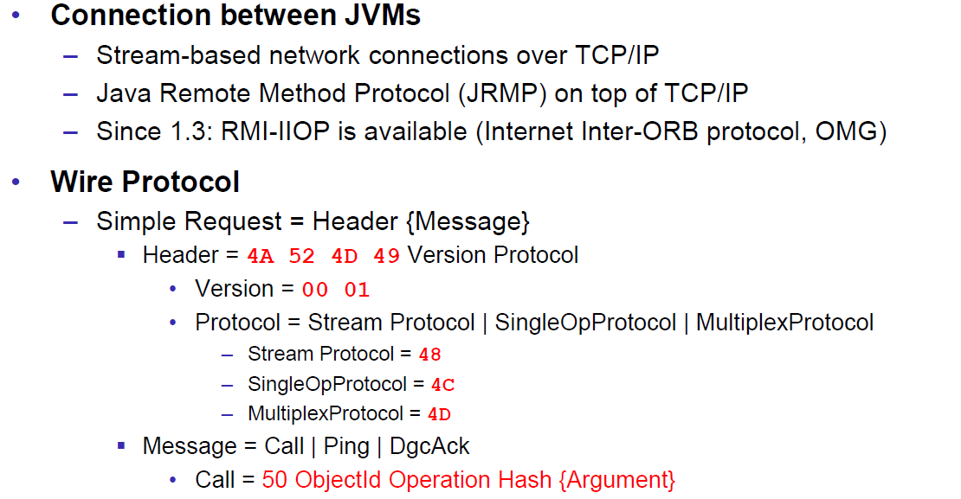

### RMI Server Properties

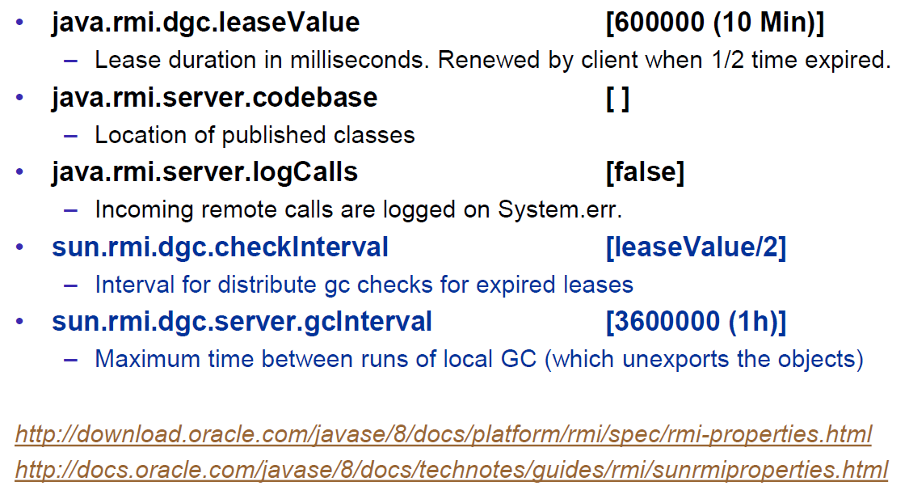

### Client behind a Router/NAT

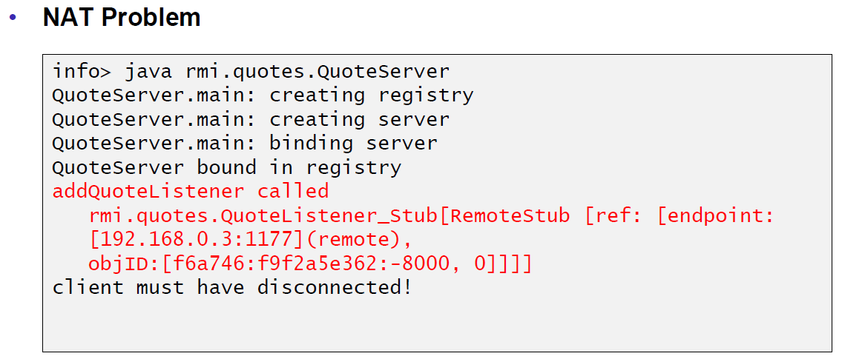

### Conclusion

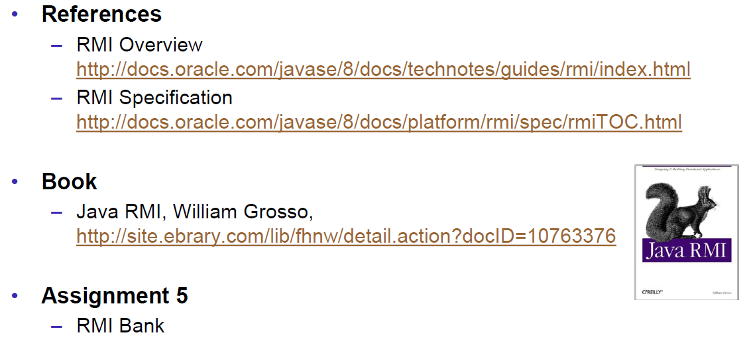

# Woche 9

## UnicastRemoteObject & Proxies

### RMI Object Implmentation Revisited

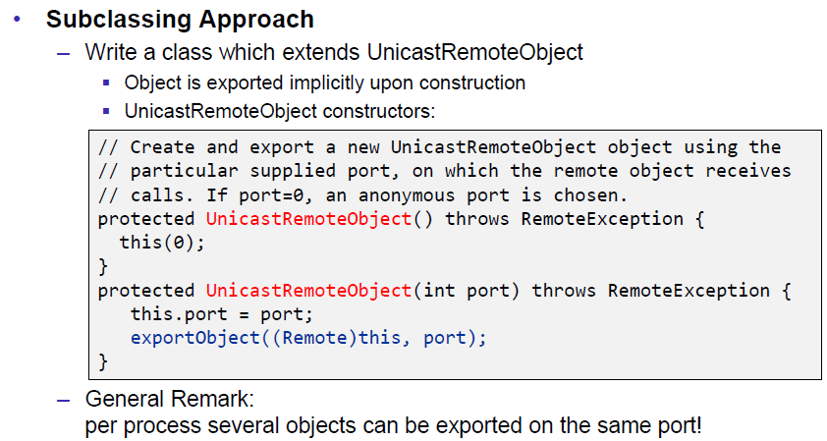

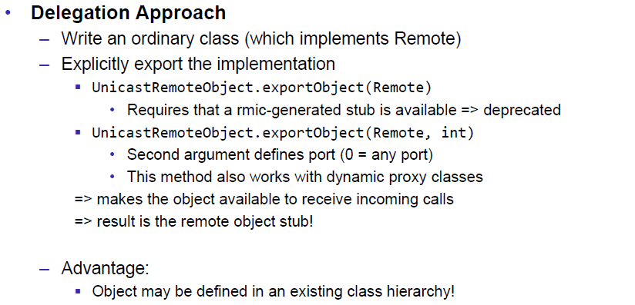

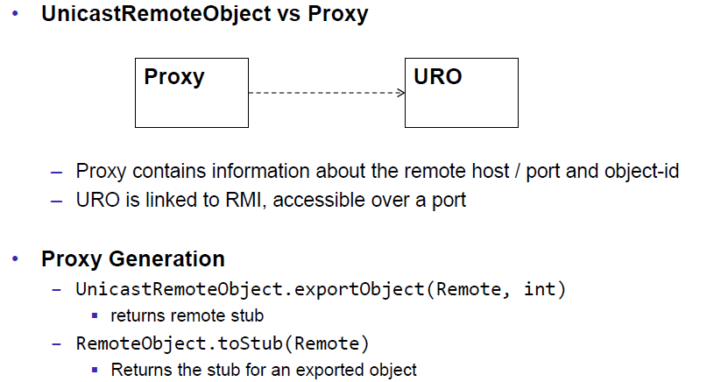

### FileRef Server

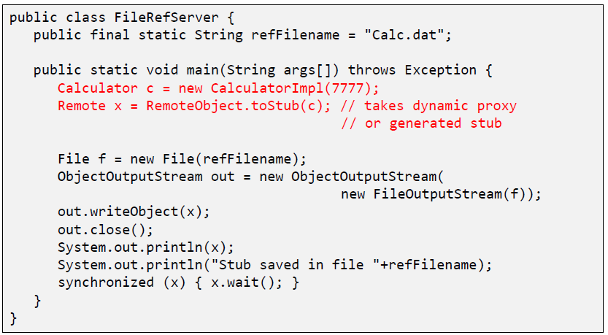

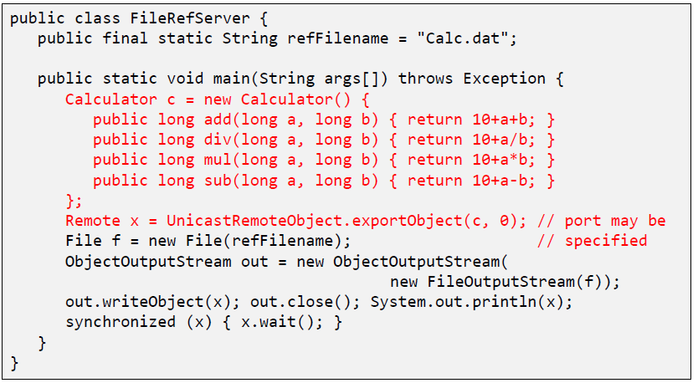

### FileRef Client

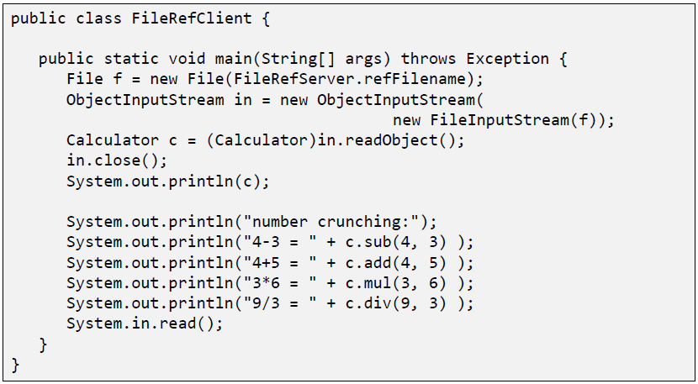

## Export and Unexport

### Exporting and Unexporting

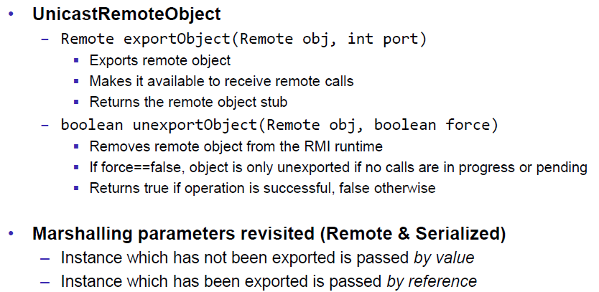

### Migrating Objects

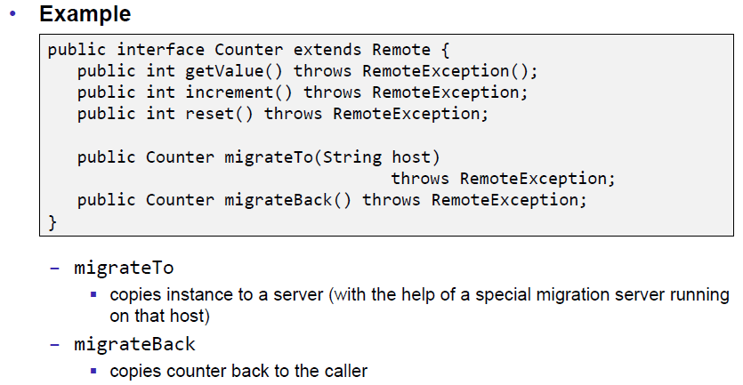

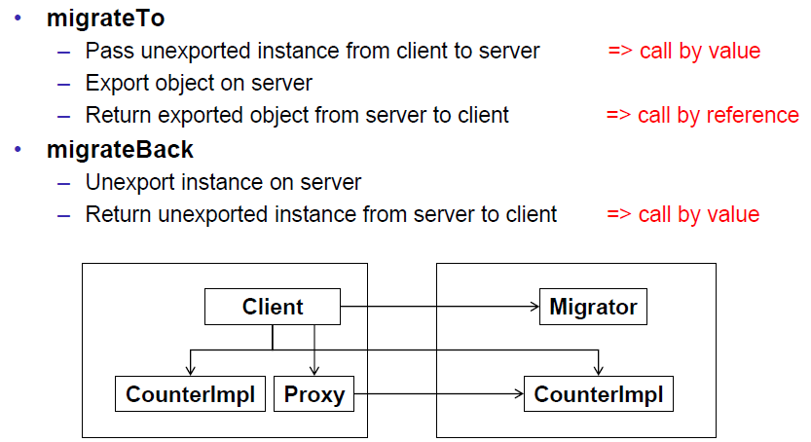

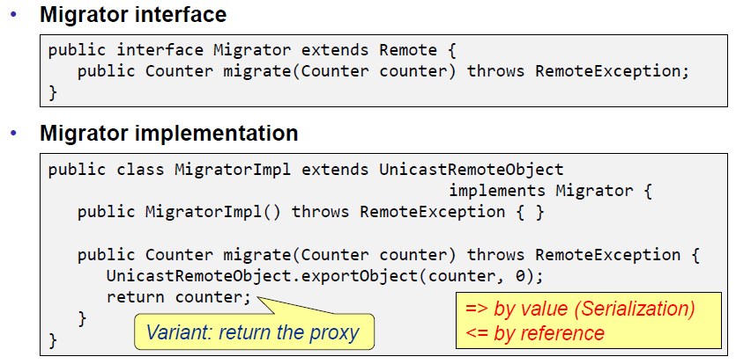

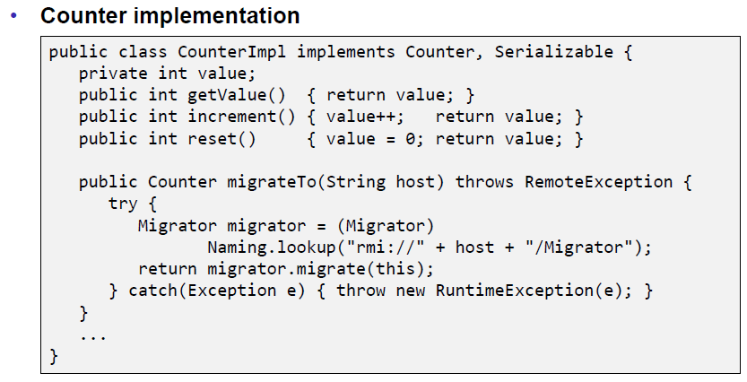

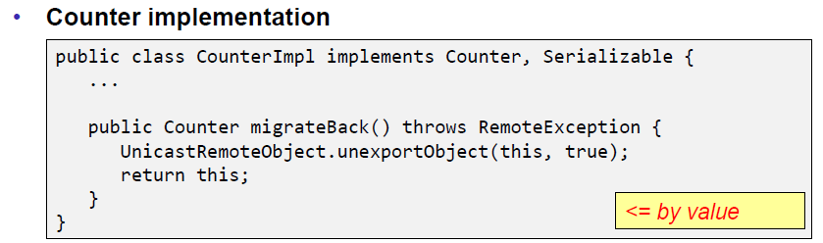

## RMI & Threading

### RMI & Threads

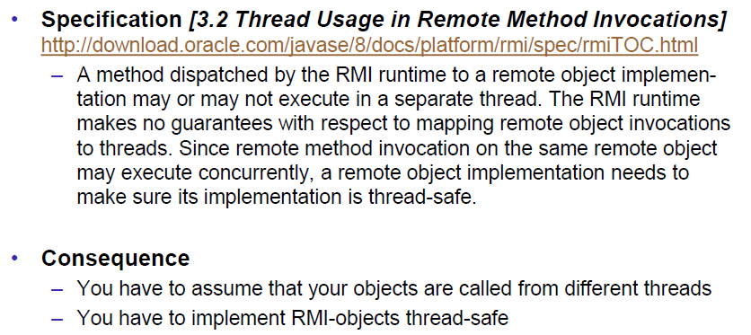

## Remote Class Loading

### Dynamically Loaded Classes

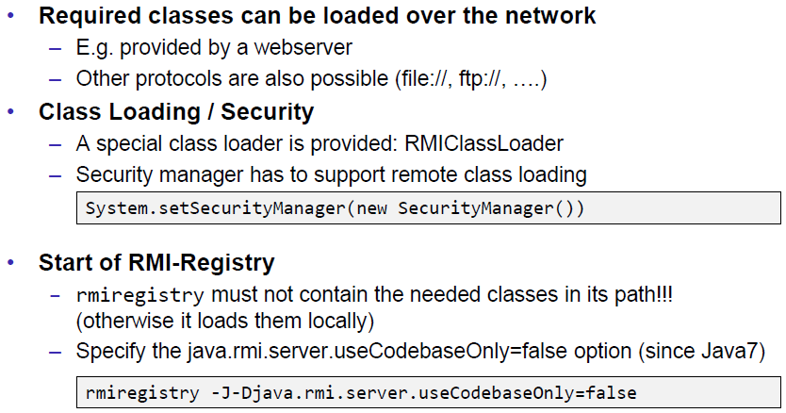

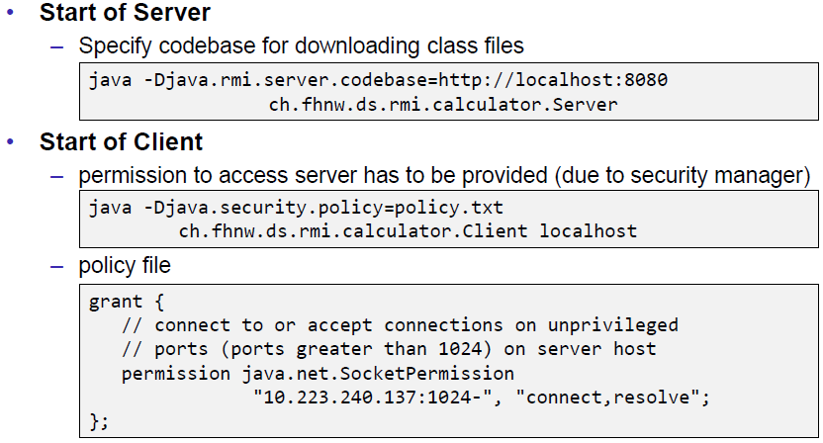

## Socket Factories

### Socket Factories

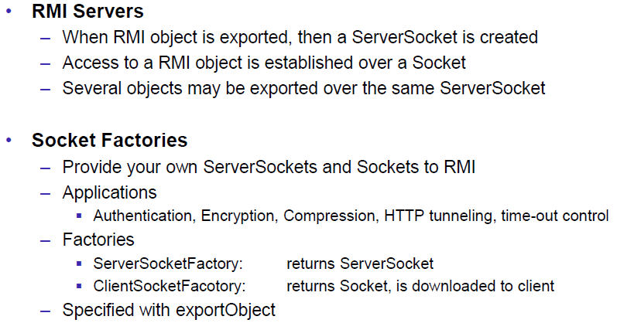

### Example of a Socket Factory

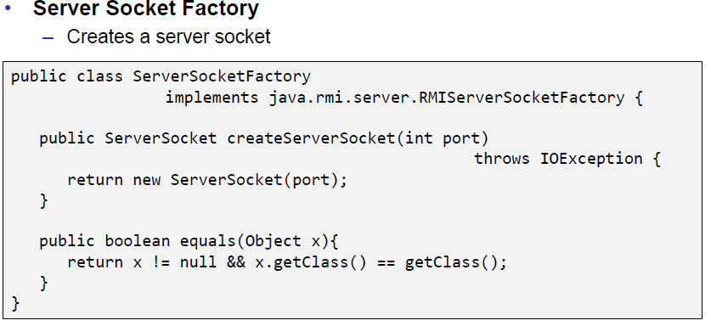

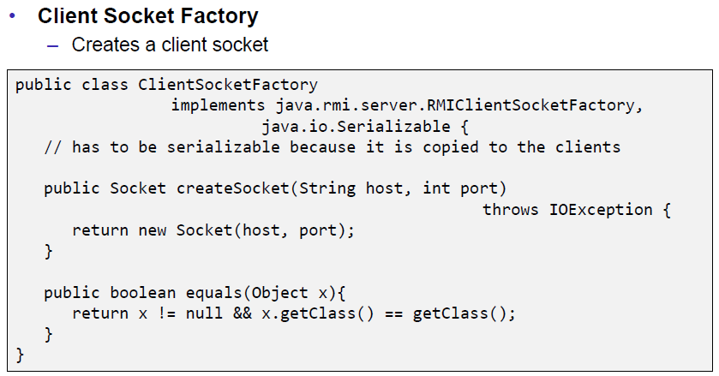

### Example of an XOR encoding

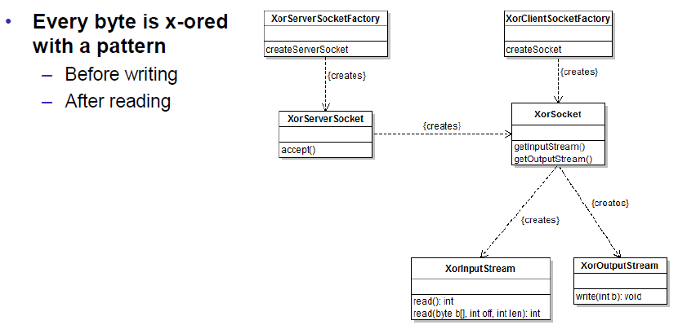

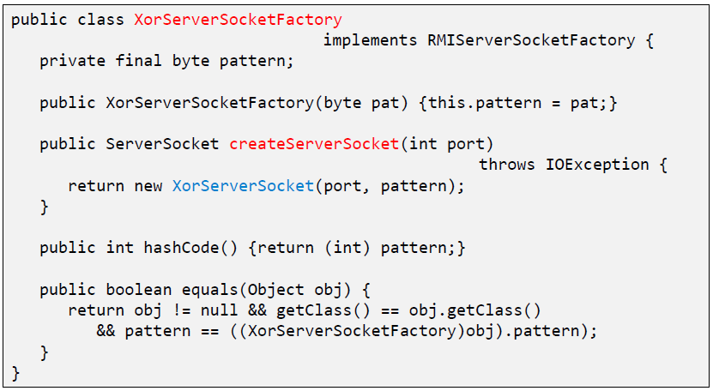

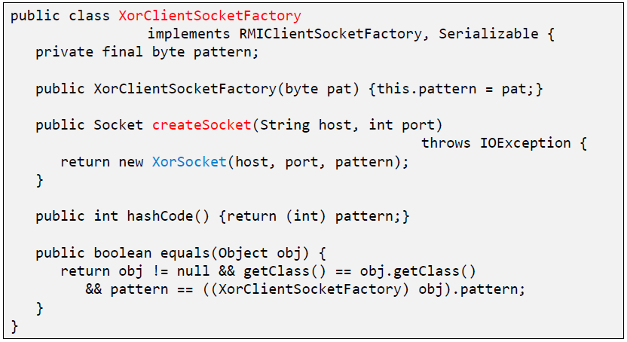

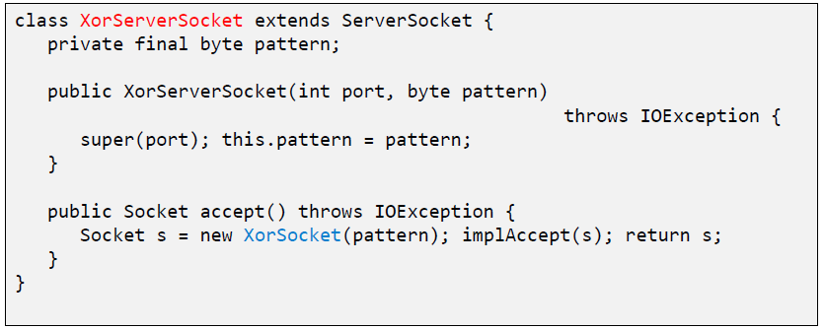

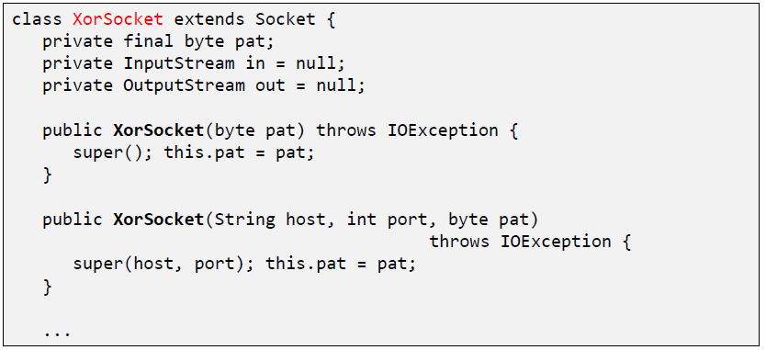

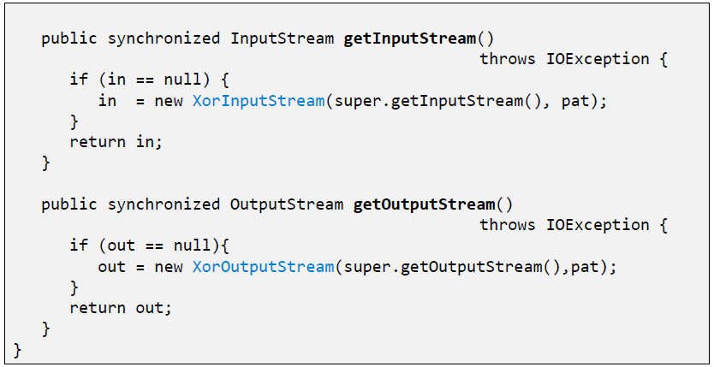

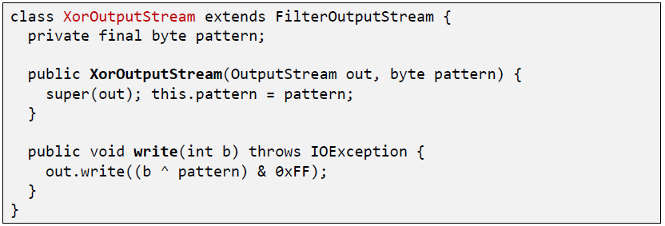

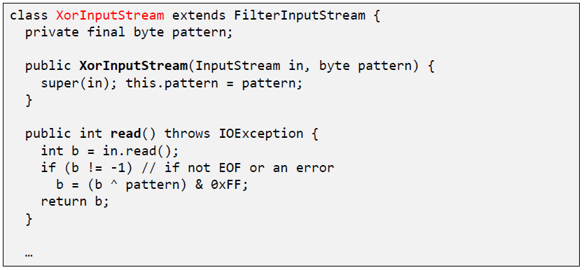

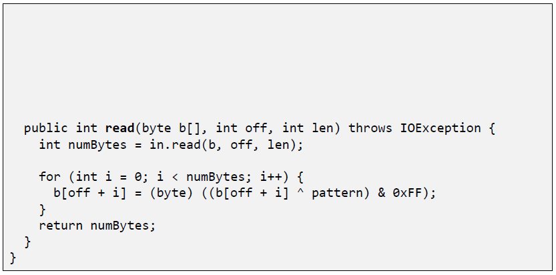

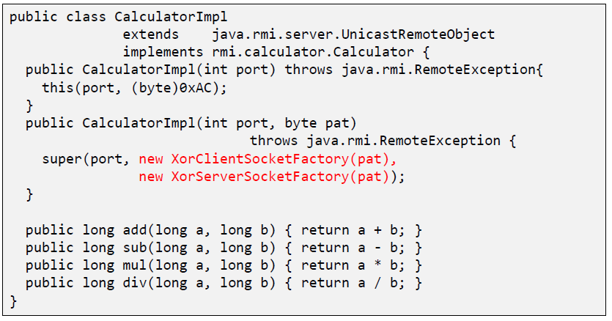

### RMI over SSL

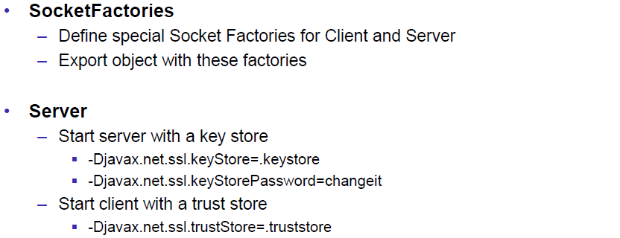

### RMI over SSL in JSE 5.0

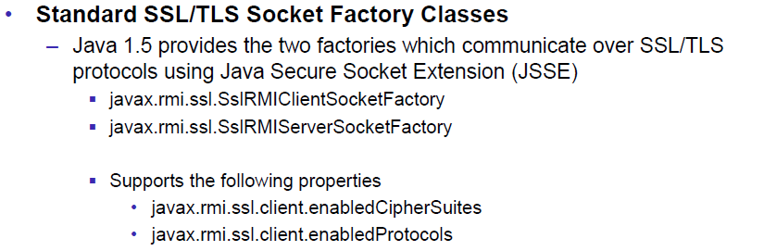

### Example of a SSLClientSocketFactory

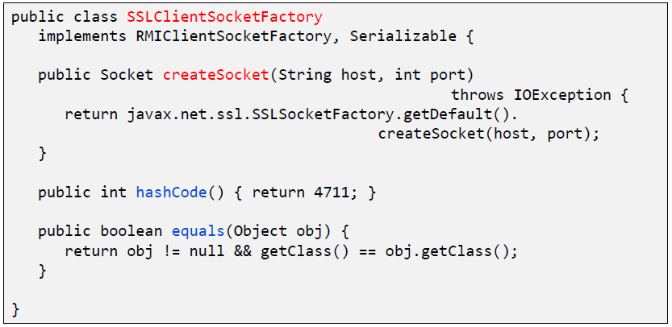

### Example of a SSLServerSocketFactory

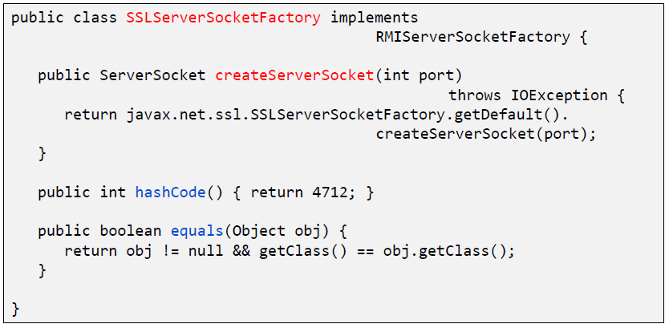

# Woche 10

In Woche 10 fand die Prüfung statt und somit fiel der Unterricht aus.

# Woche 11

In Woche 11 fand die Projektwoche statt und somit fiel der Unterricht aus.

# Woche 12

## Asynchronous Communication

### Asynchronous Communication

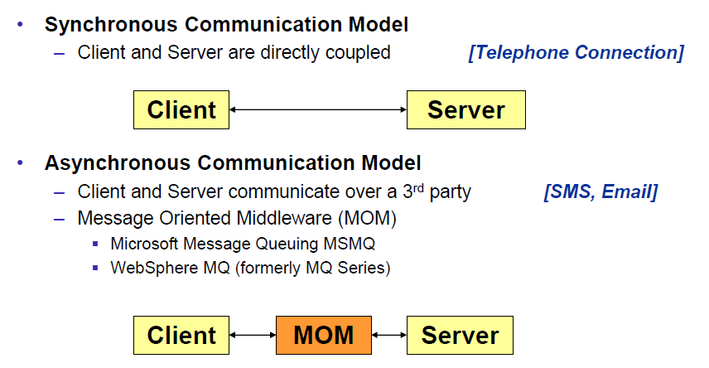

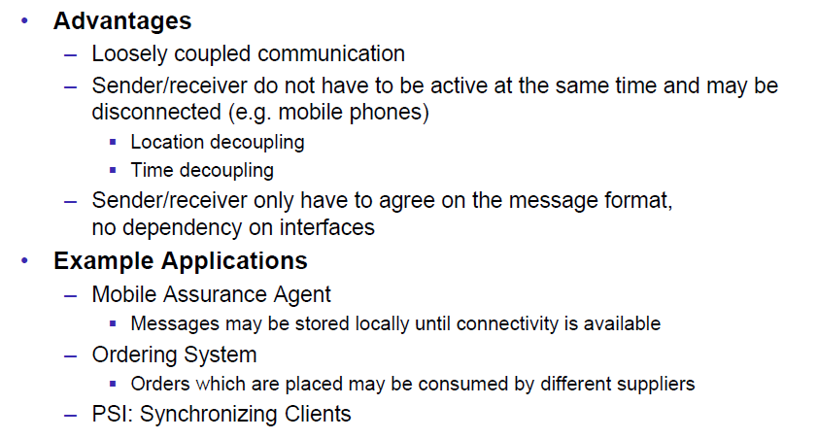

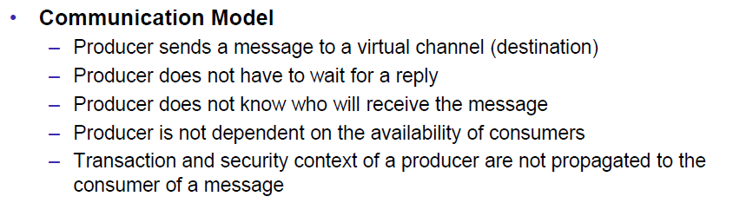

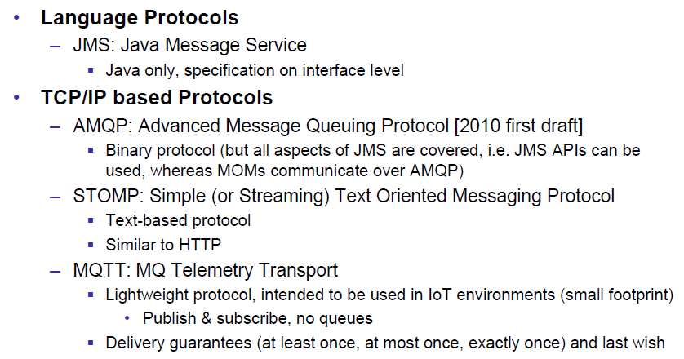

## Java Message Service

### Java Message Service API

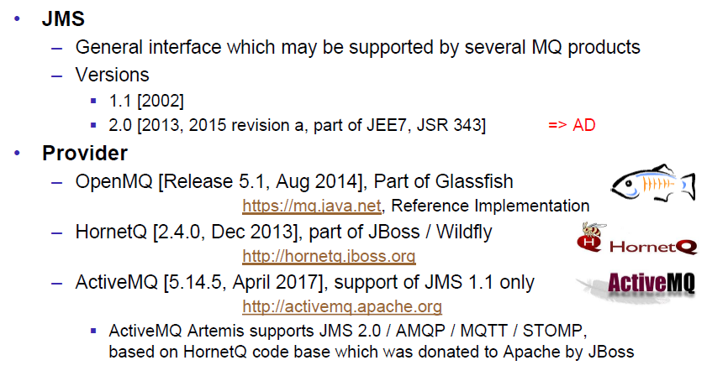

### Point to Point Messaging Domain

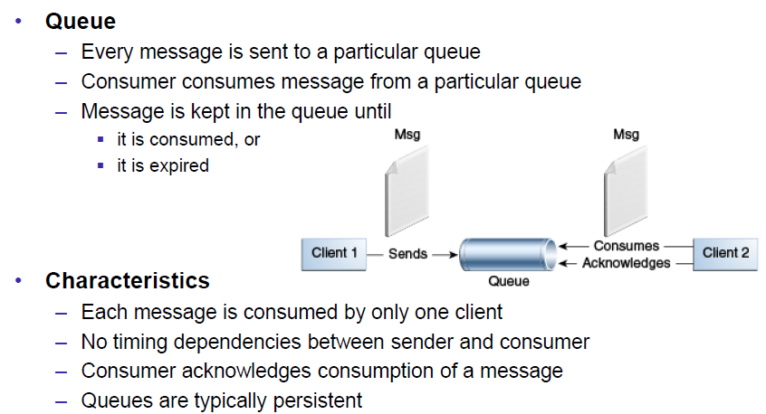

### Publish/Subscribe Messaging Domain

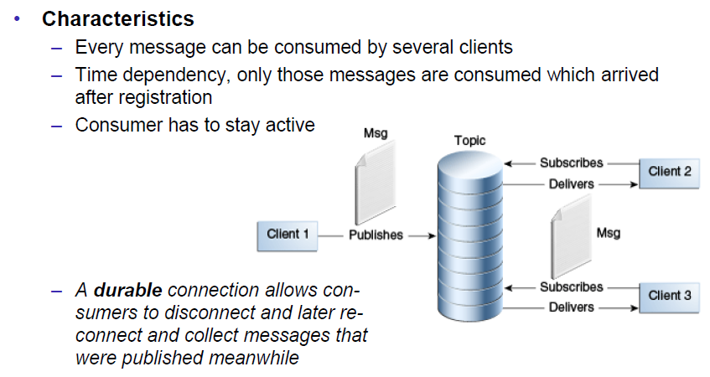

### JMS Destinations

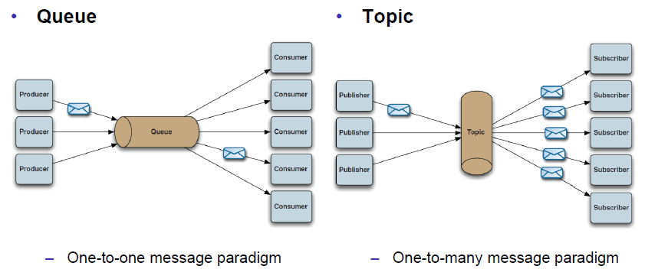

### JMS Architecture

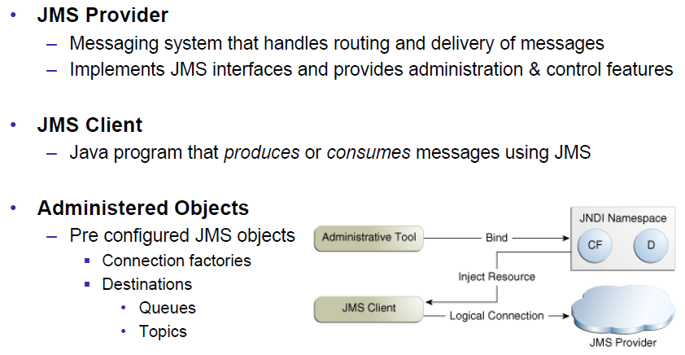

### JMS API: Destinations

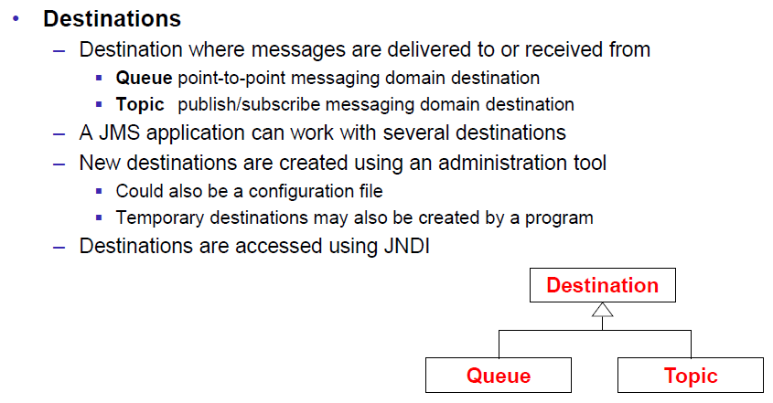

### JMS API: Overview & Programming Model

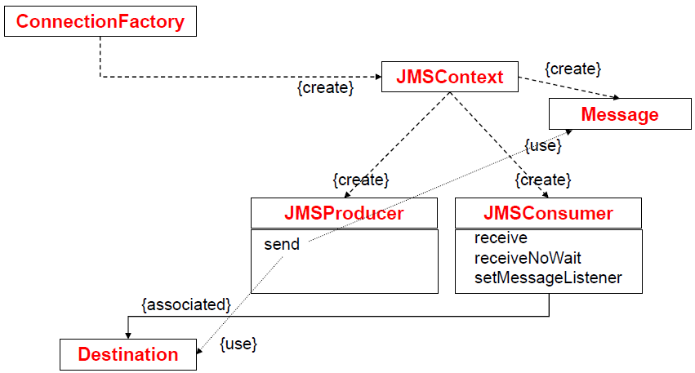

### JMS API: JMSContext

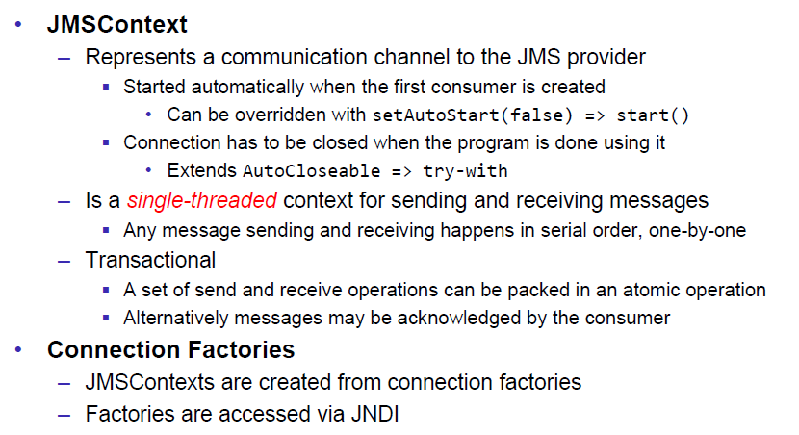

### JMS API: Producers & Consumers

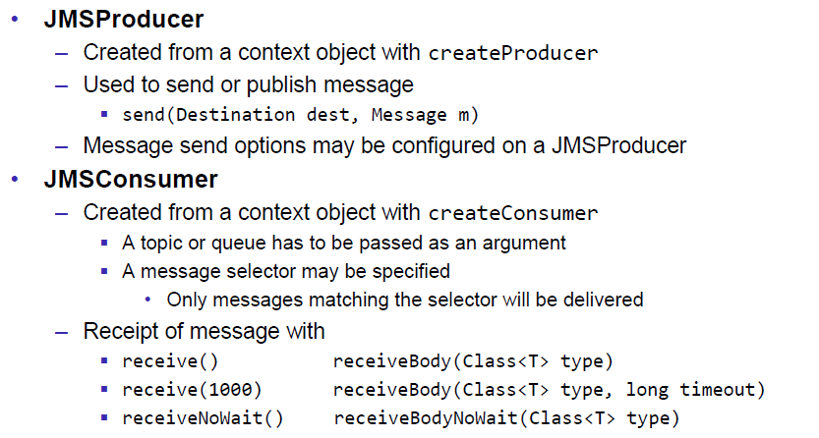

### Message Consumption

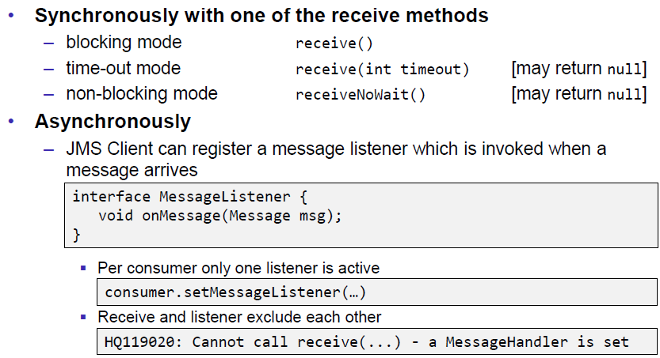

### JMS API: Messages

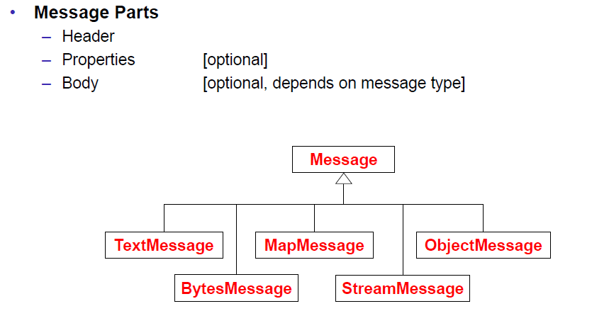

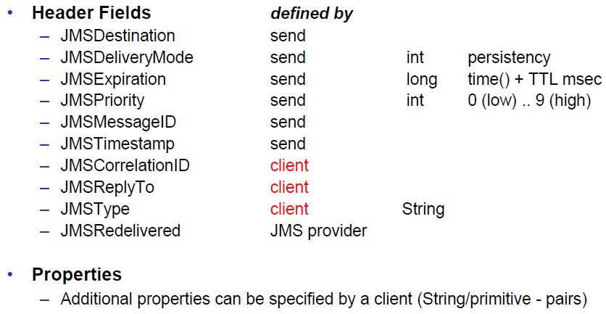

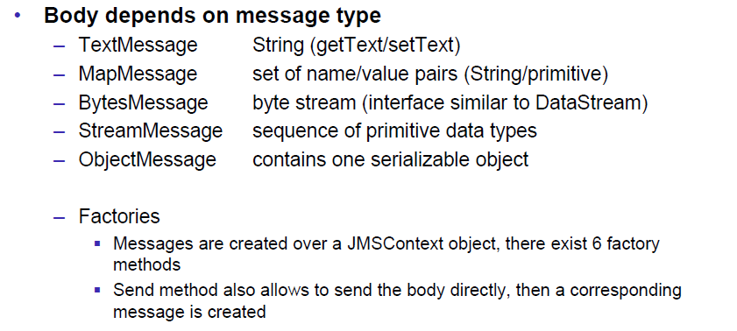

### Message Sending

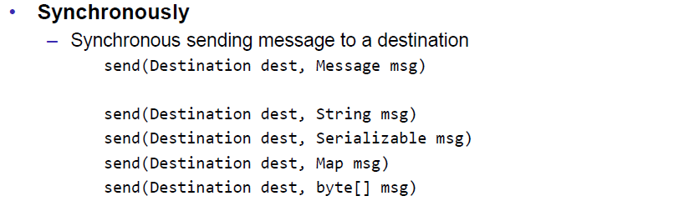

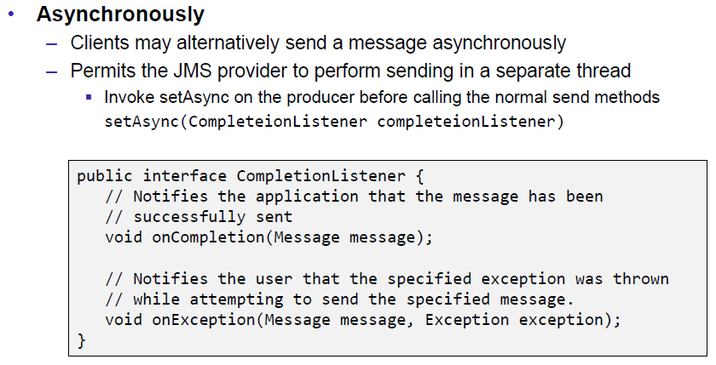

### JMS API: Overview & Programming Model

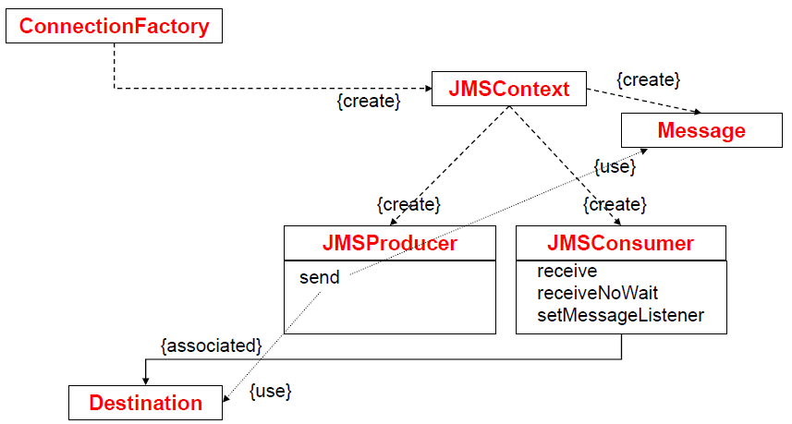

### Simple Example Sender

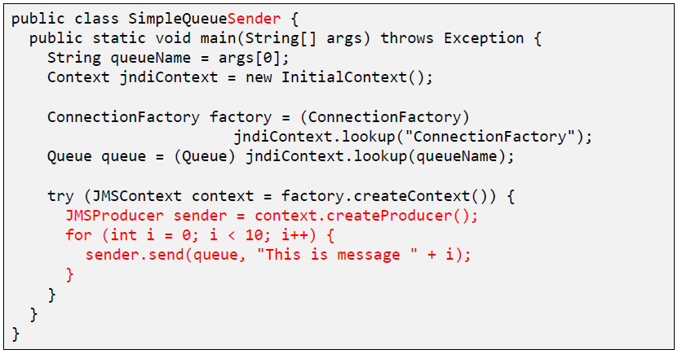

### Simple Example Receiver

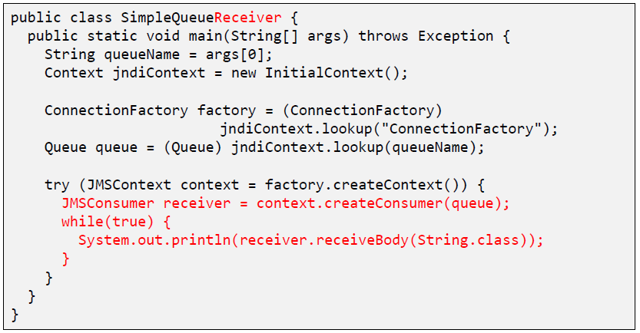

### Sending & Receiving a Message

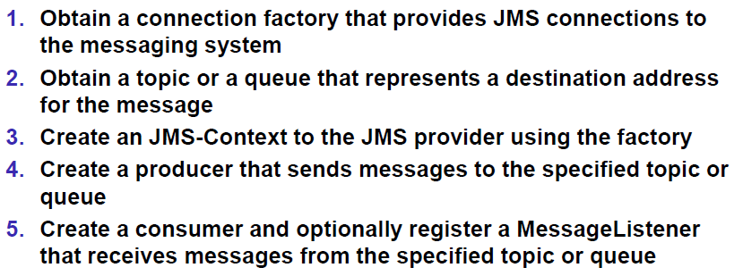

## HornetQ & Echo Example

### HornetQ

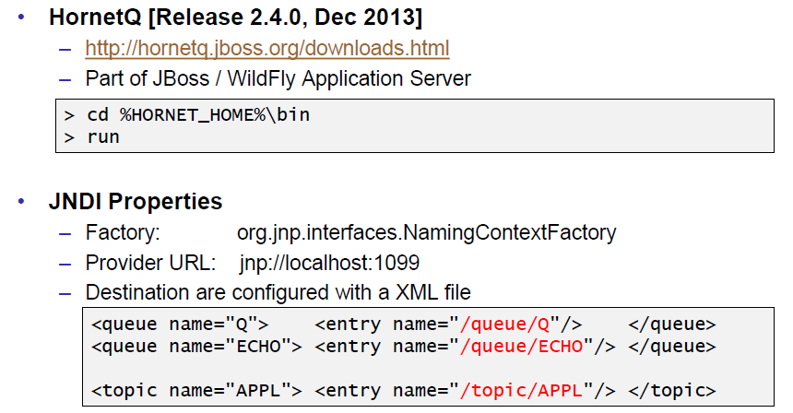

### Example: Echo

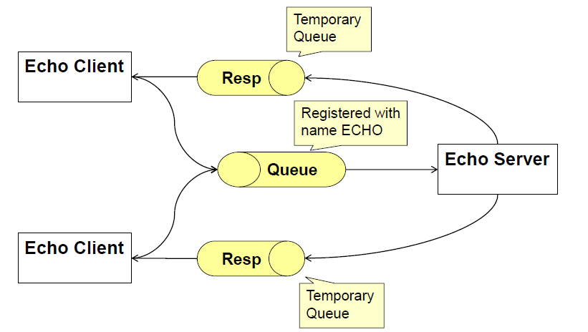

### Echo Client

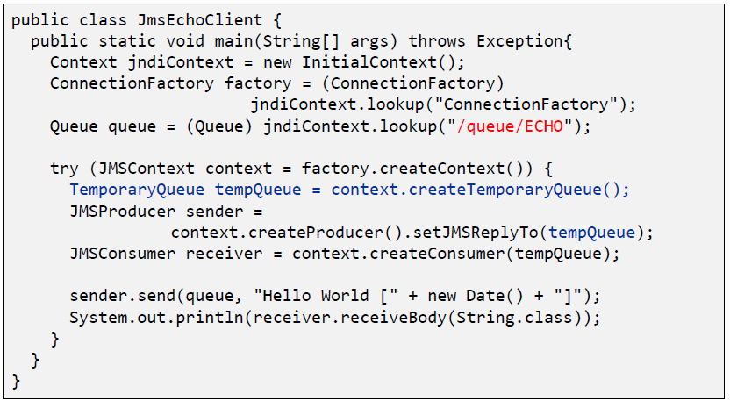

### Echo Server

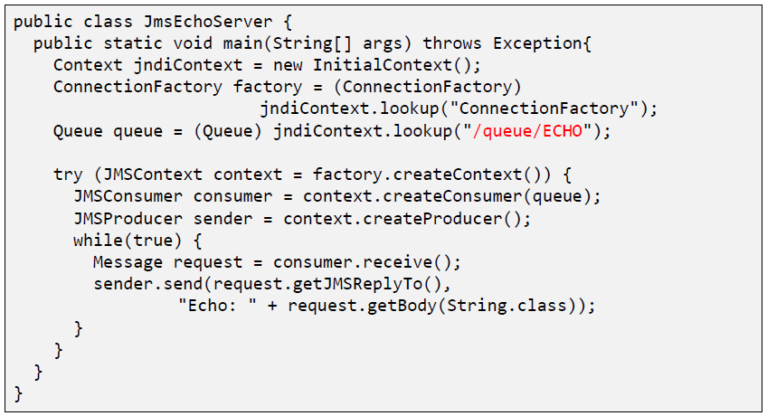

## Guaranteed Messaging and Transactions

### QoS Properties: Delivery Mode

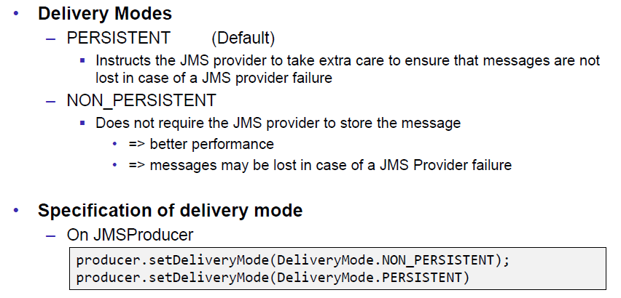

### QoS Properties: TTL and Delay

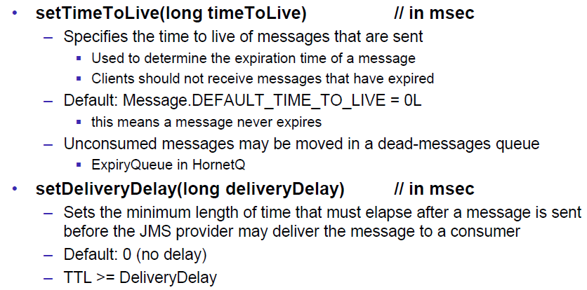

### QoS Properties: Priority

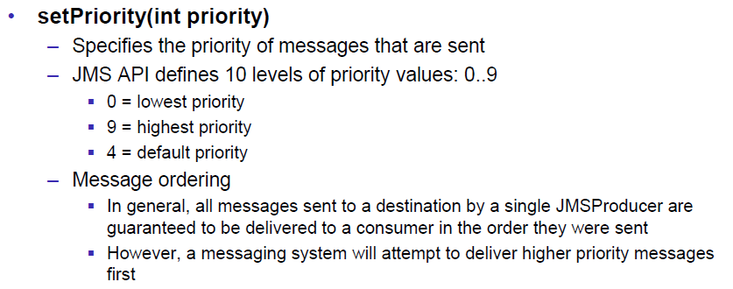

### Message Selection

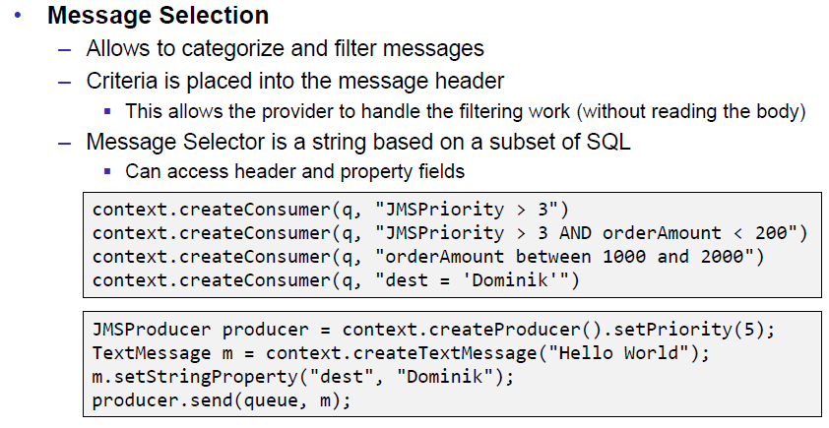

### Durable Consumers

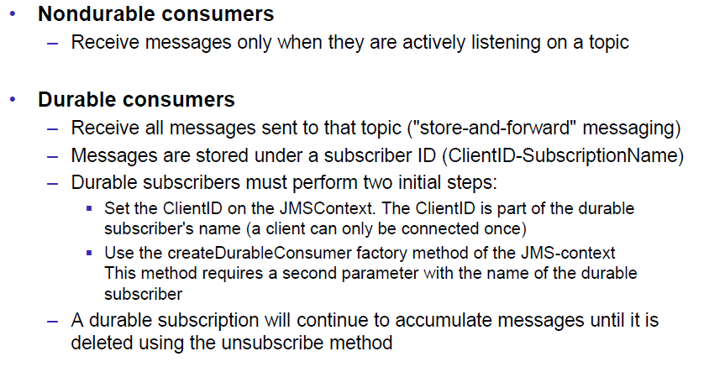

### Message Acknowledgement: Transacted

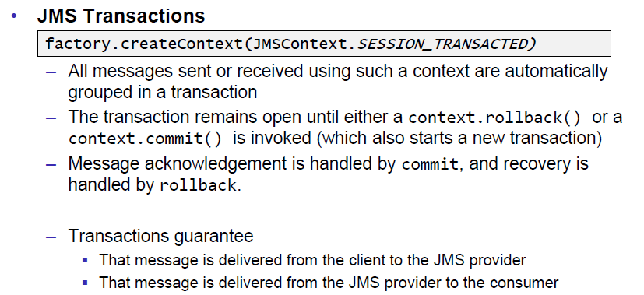

### Message Acknowledgement: Manually

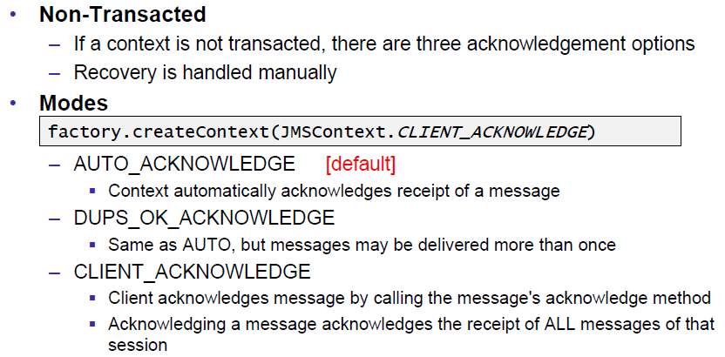

## References

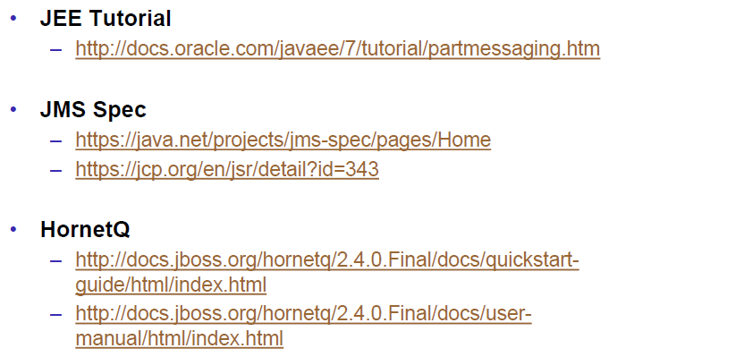

# Woche 13

## WebSockets Specification

### Web: Bidirectional Communication

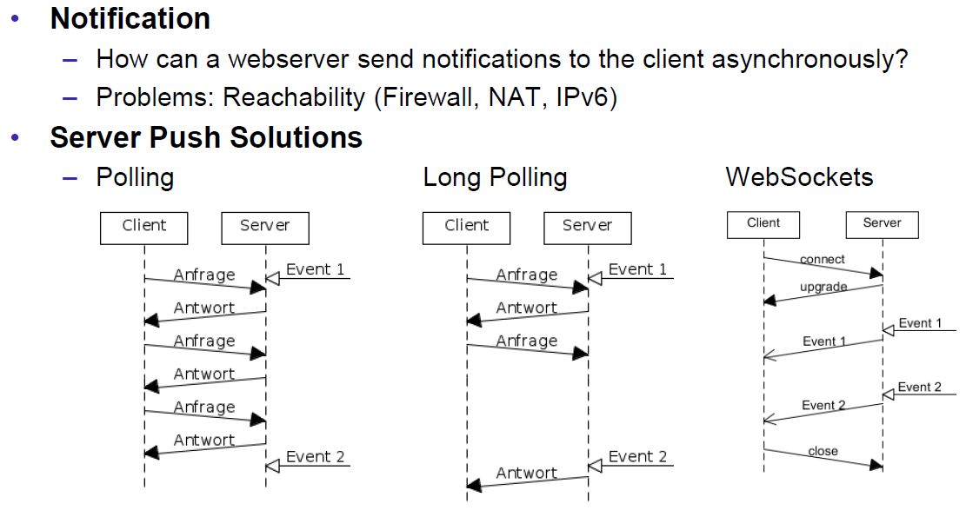

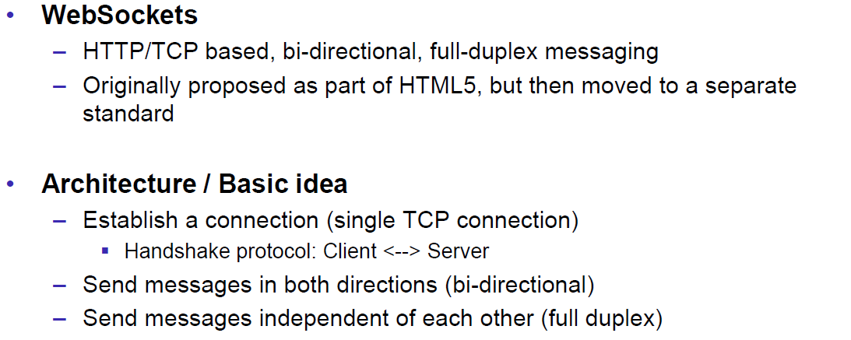

### WebSockets Specification

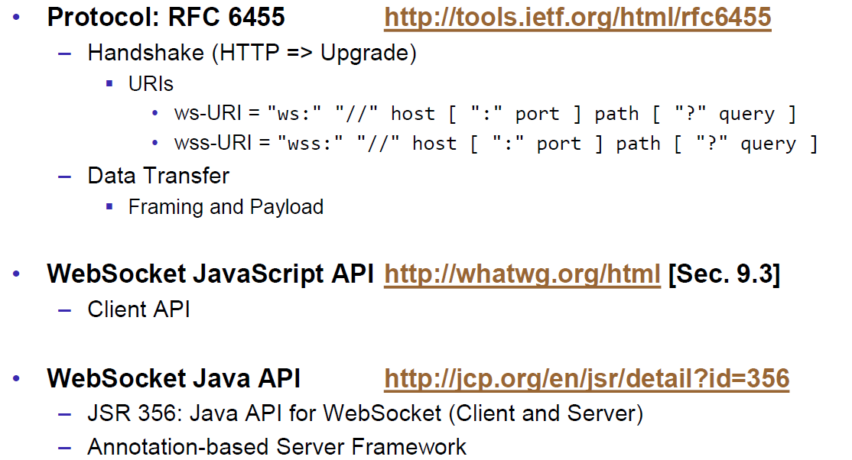

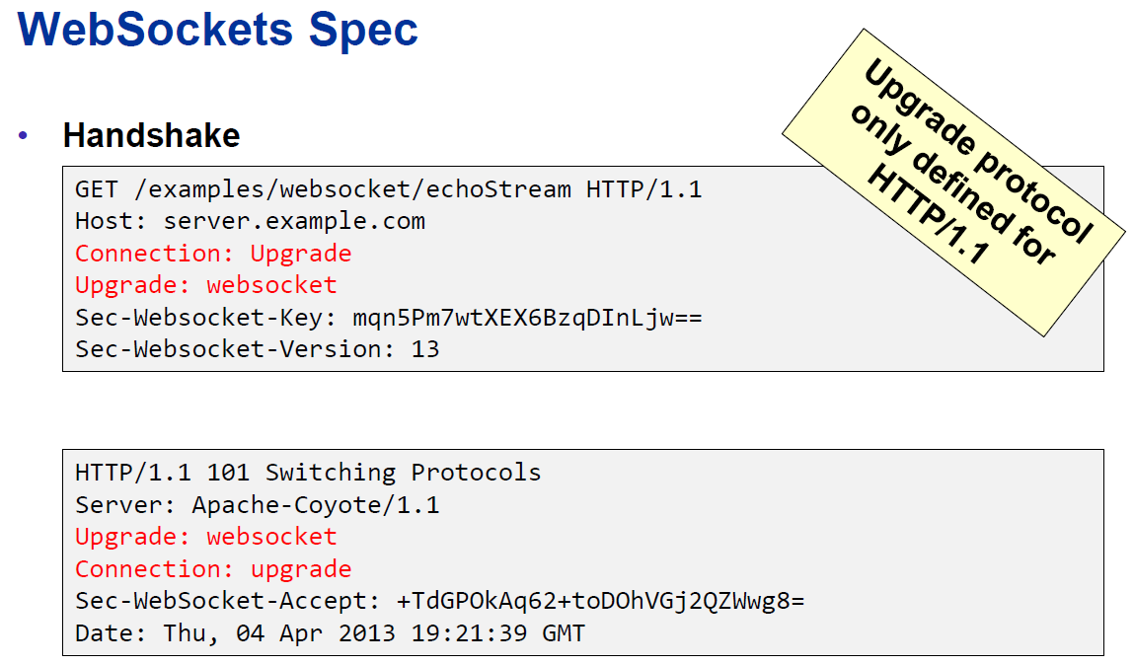

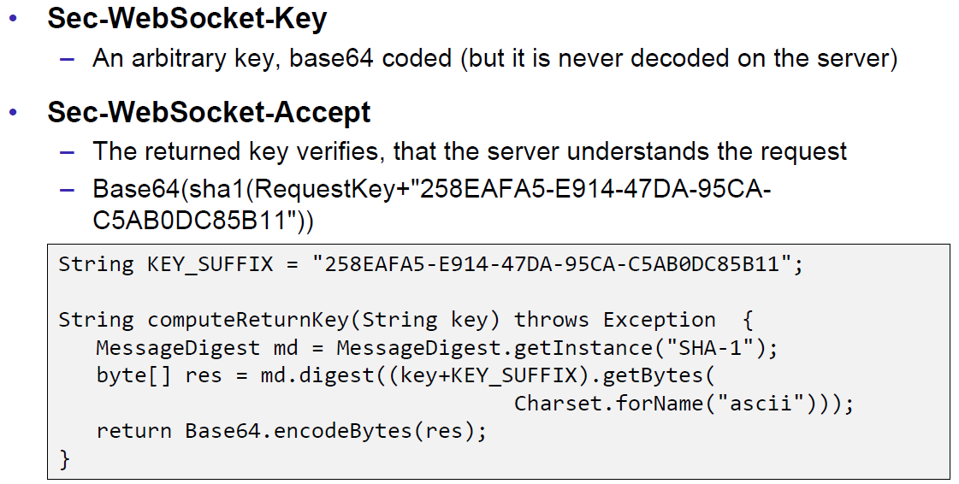

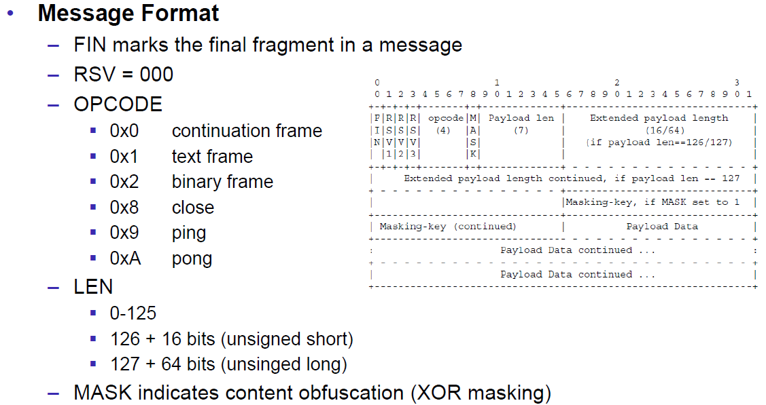

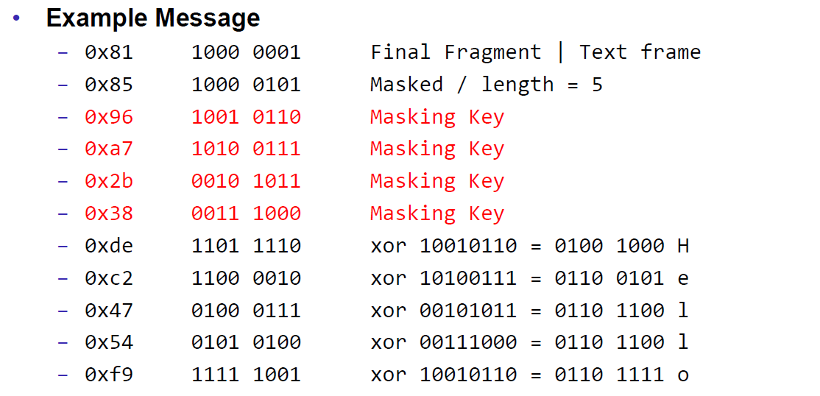

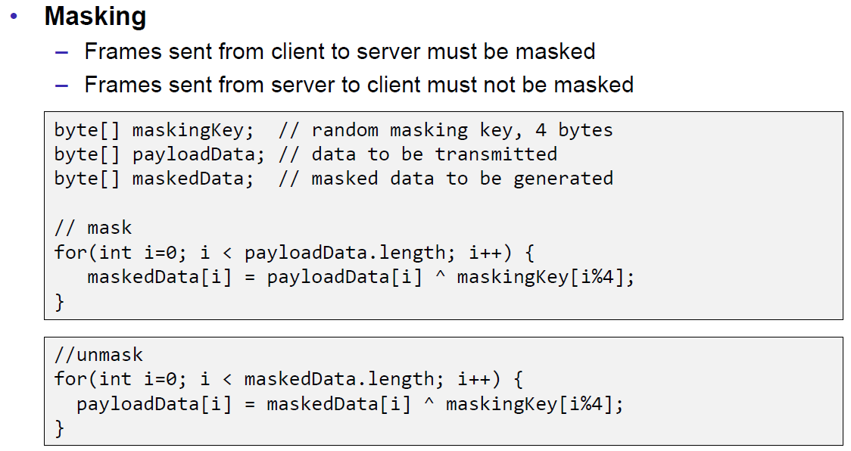

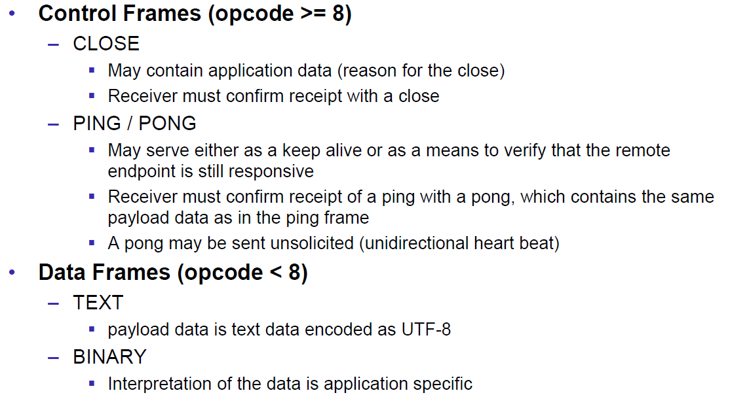

### WebSockets Subprotocols

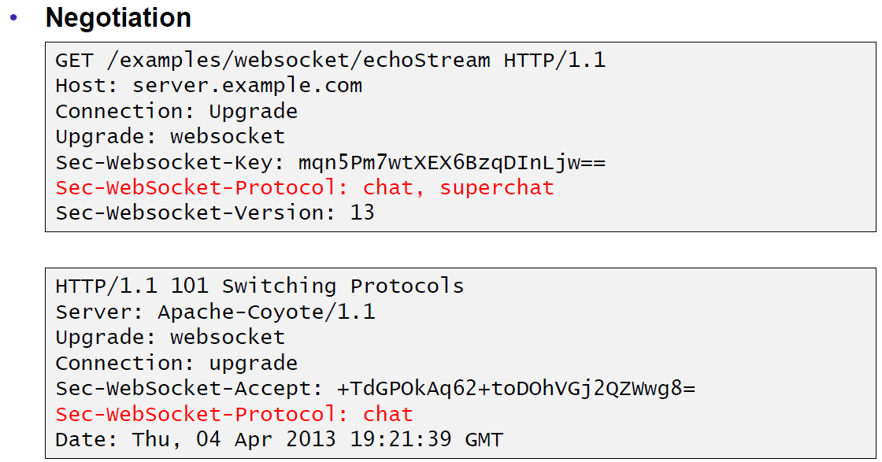

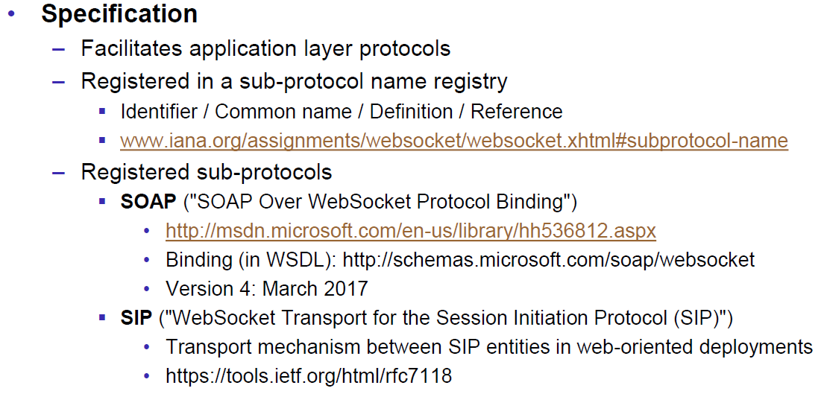

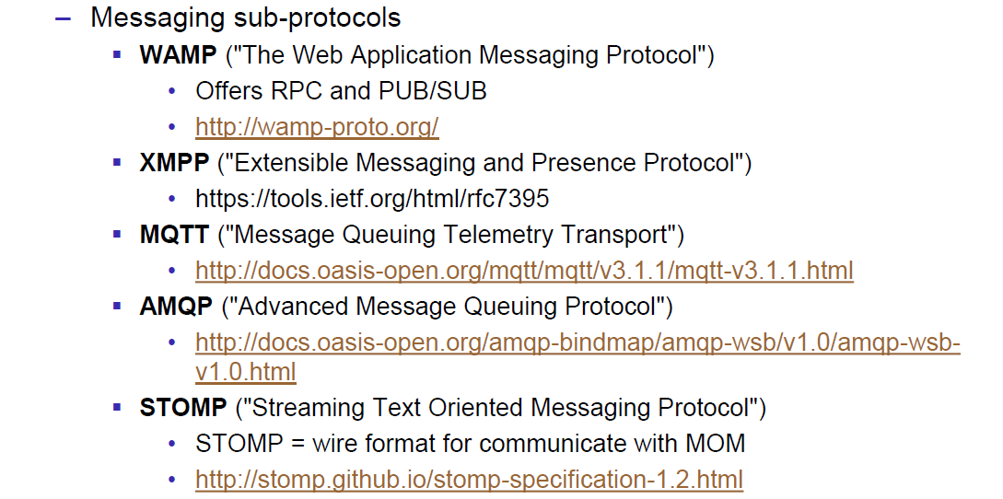

## WebSockets in Java

### JSR 356

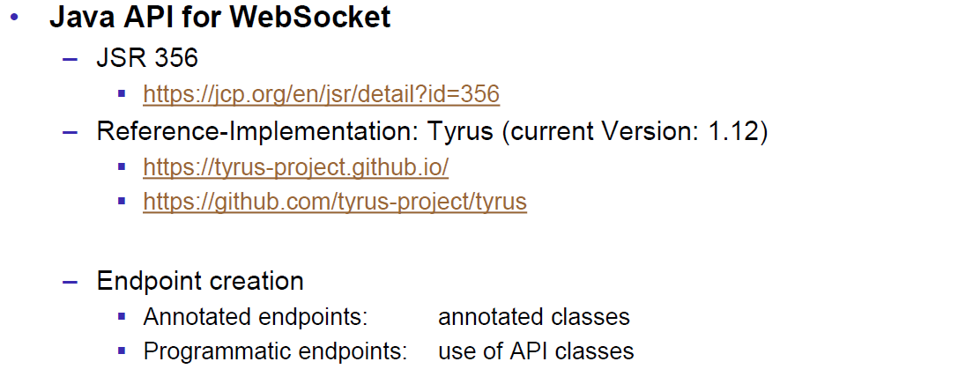

### Java WebSockets Server

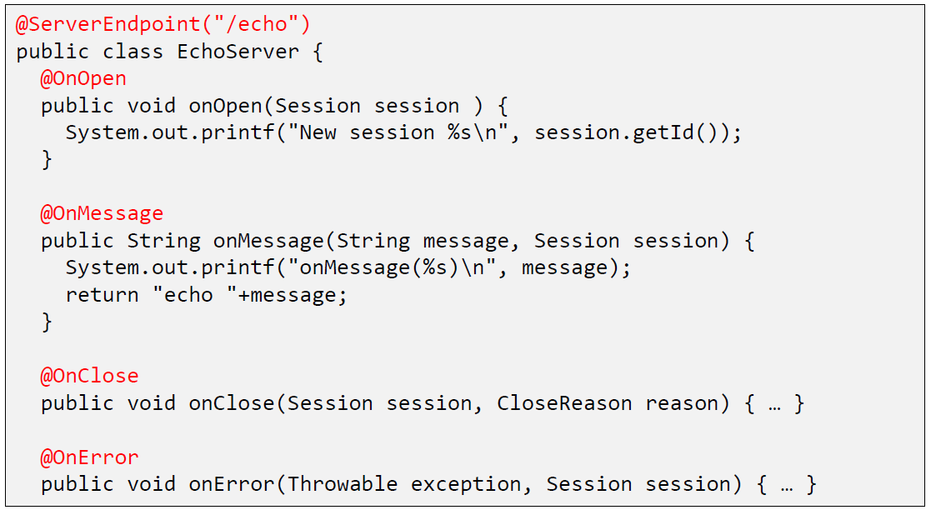

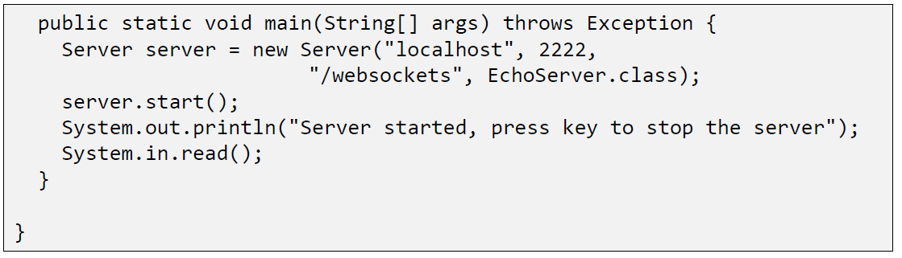

### Java WebSockets Client

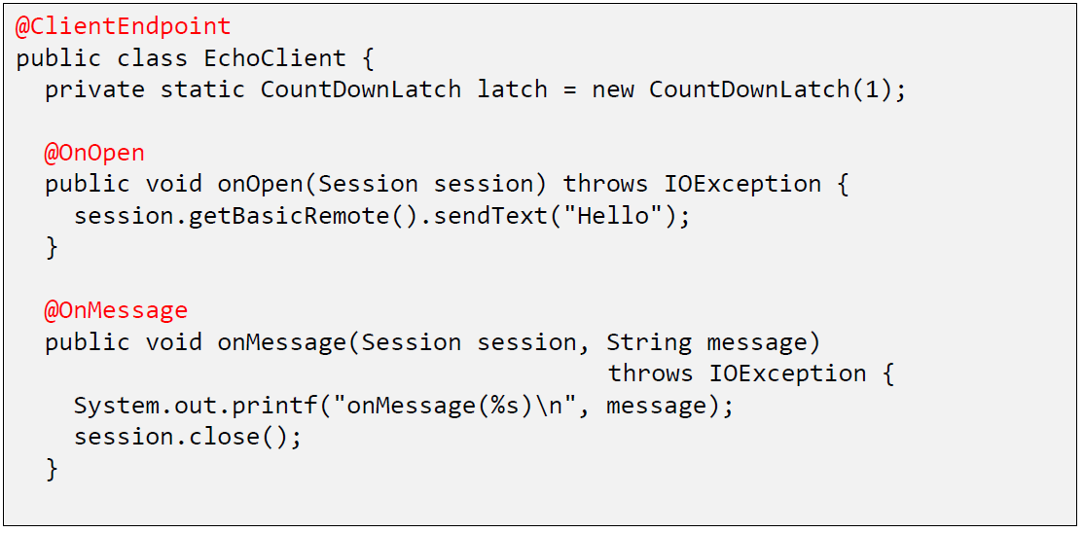

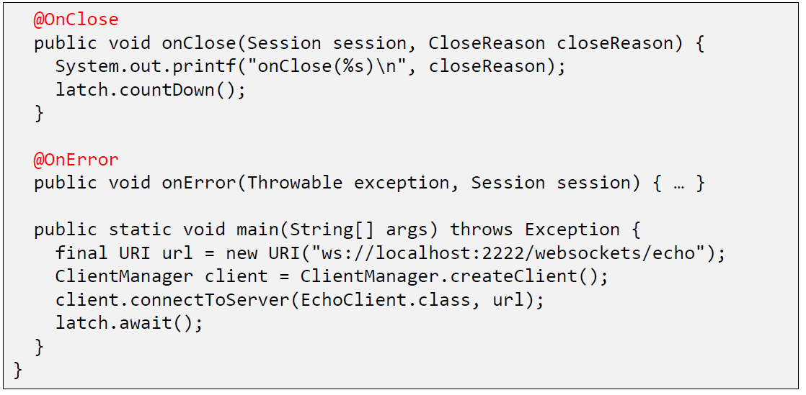

### Java WebSockets

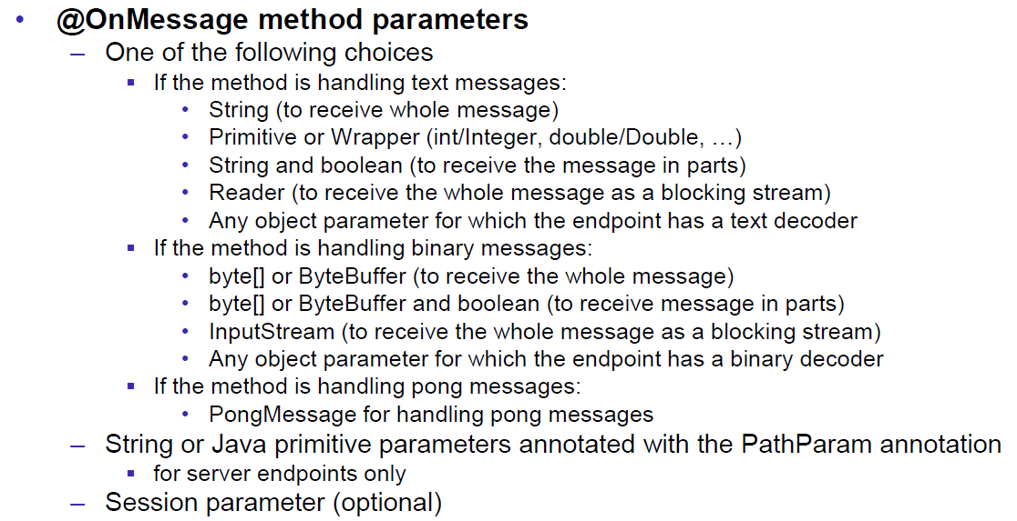

### Sending Messages (JSR 356)

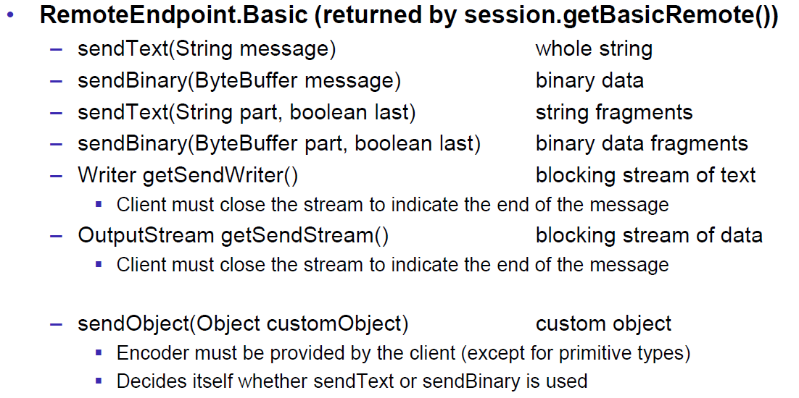

### Annotations (JSR 356)

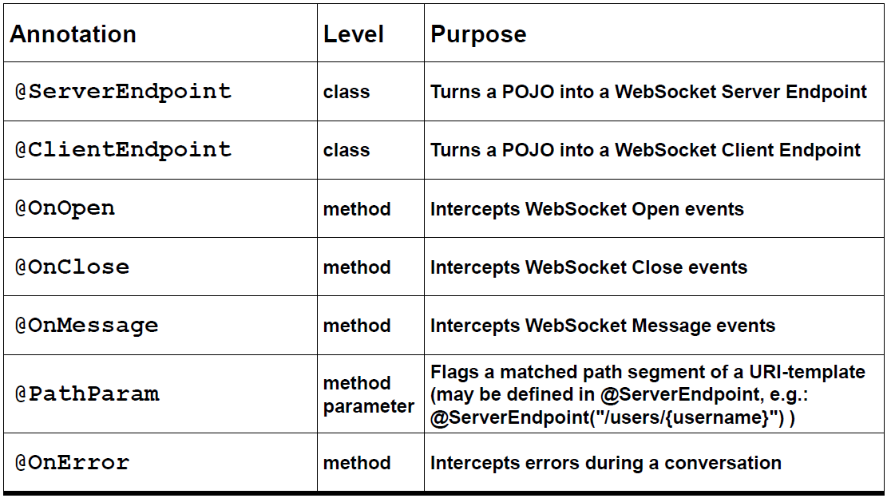

### Attributes for Annotation @ServerEndpoint

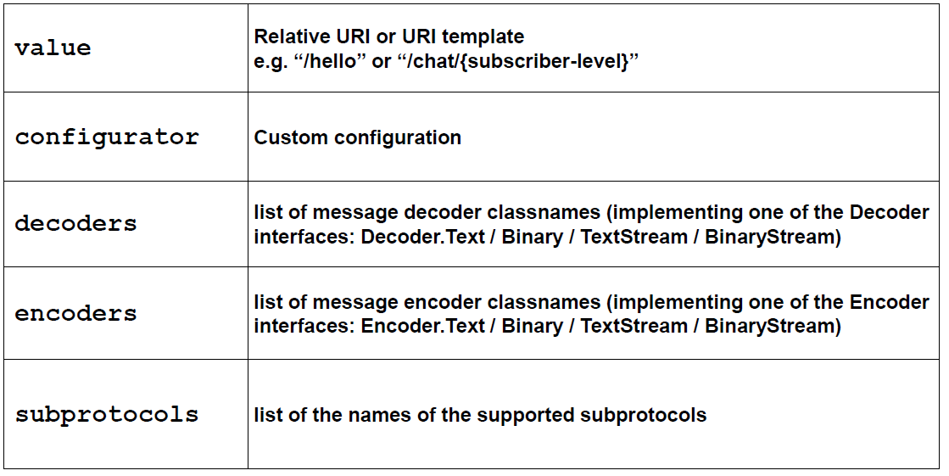

### Java WebSocket Server

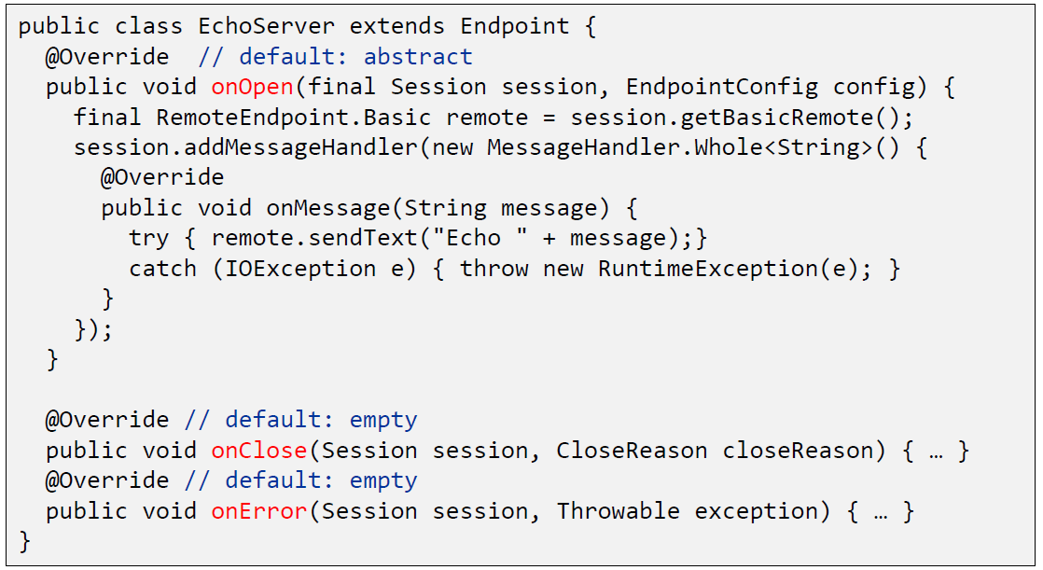

### Java WebSocket Client

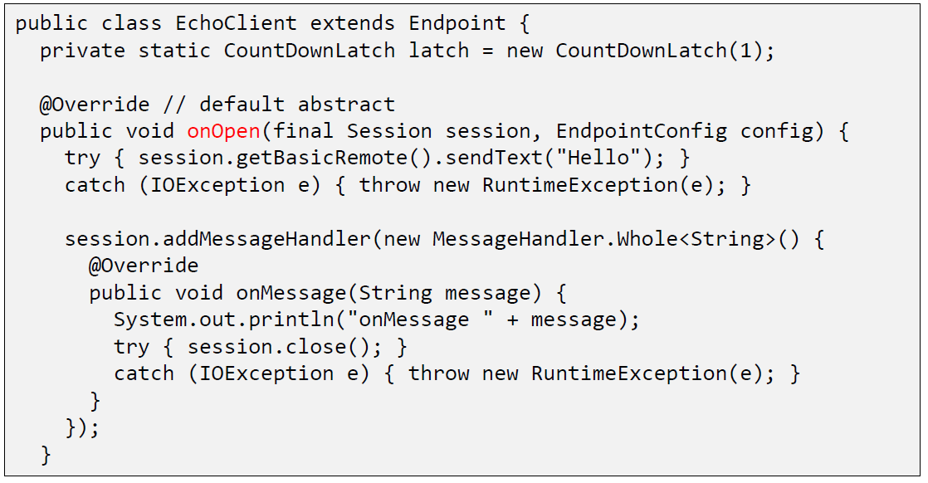

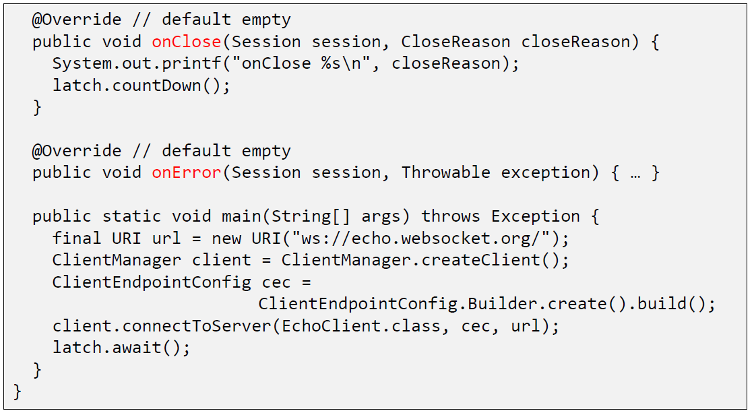

### Receiving Messages (JSR 356)

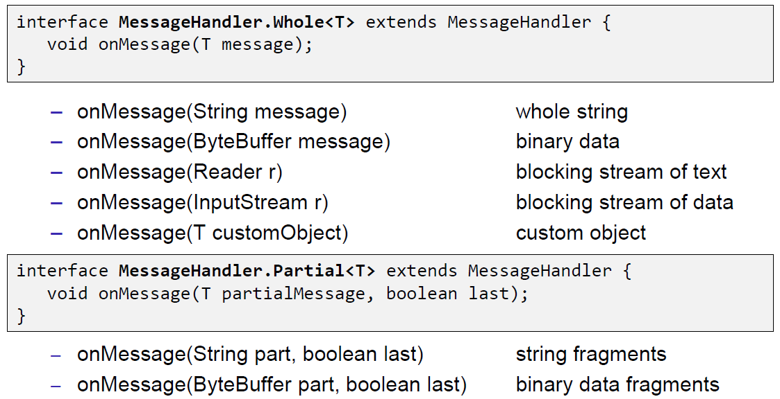

## WebSockets in JavaScript

### JavaScript Client Interface

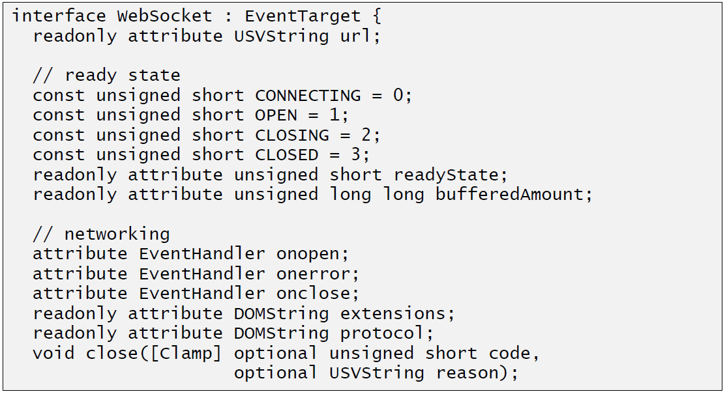

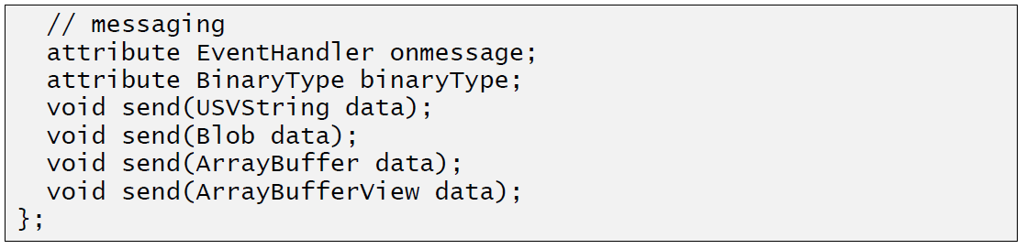

### JavaScript Echo Example

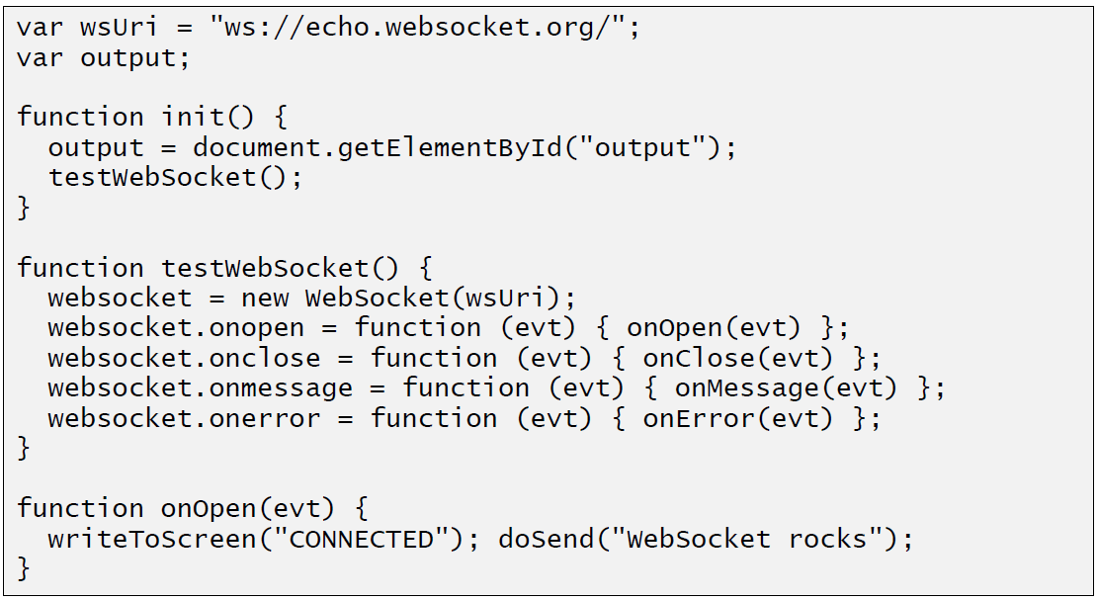

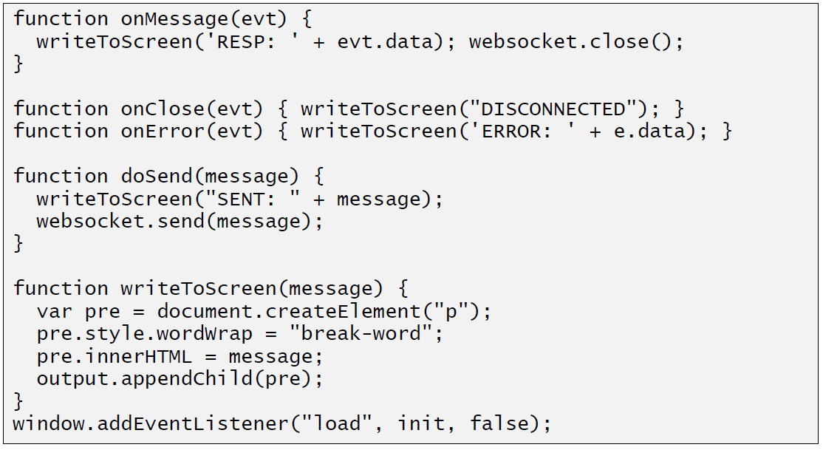

# Woche 14

## Actor Model

### Communication in Actor Systems

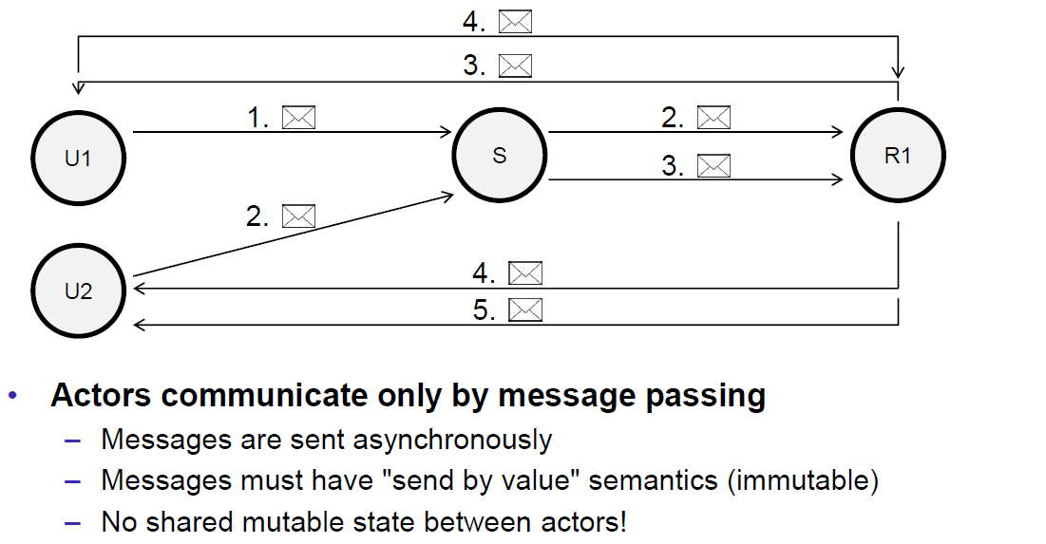

### Anatomy of an Actor

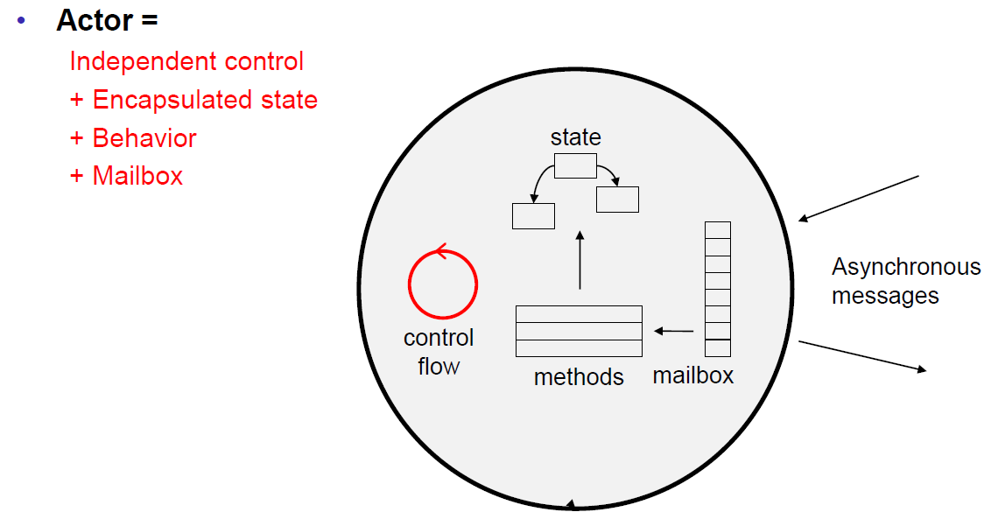

### Actor Model

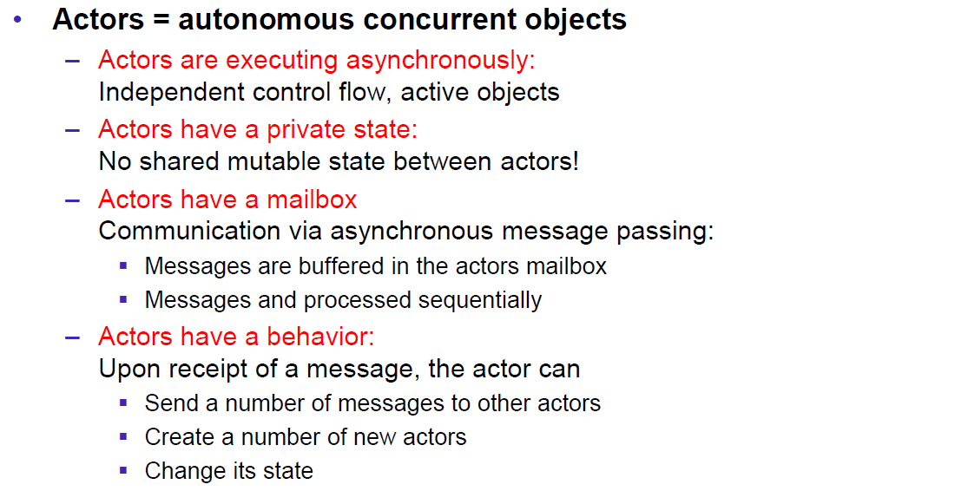

### Programming with Actors

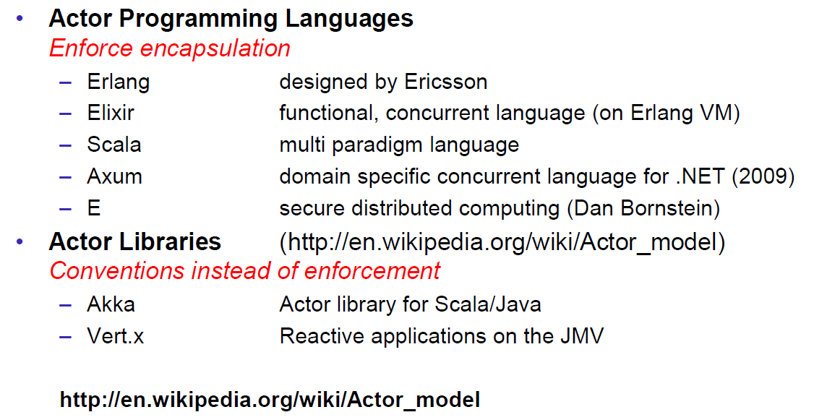

### Actor versus JMS

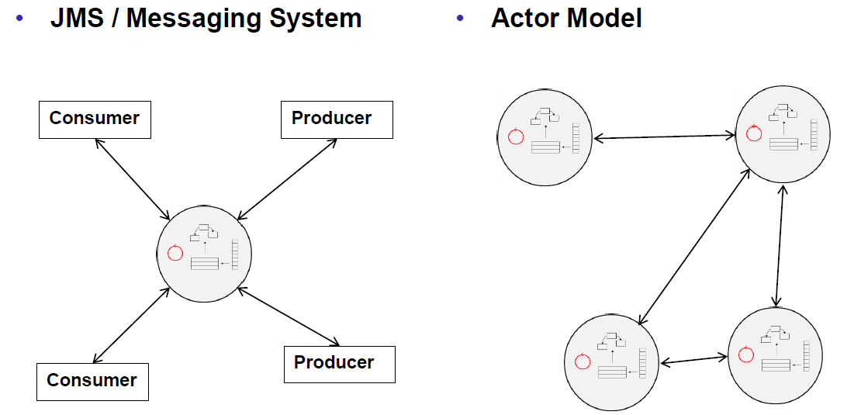

## Akka

### Simple Actor

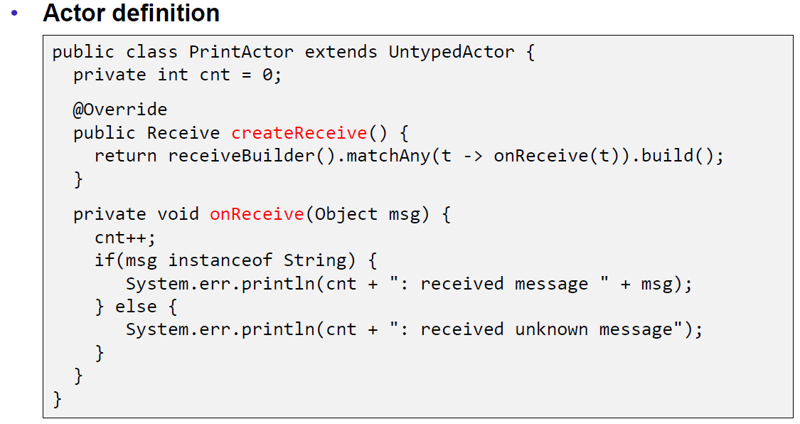

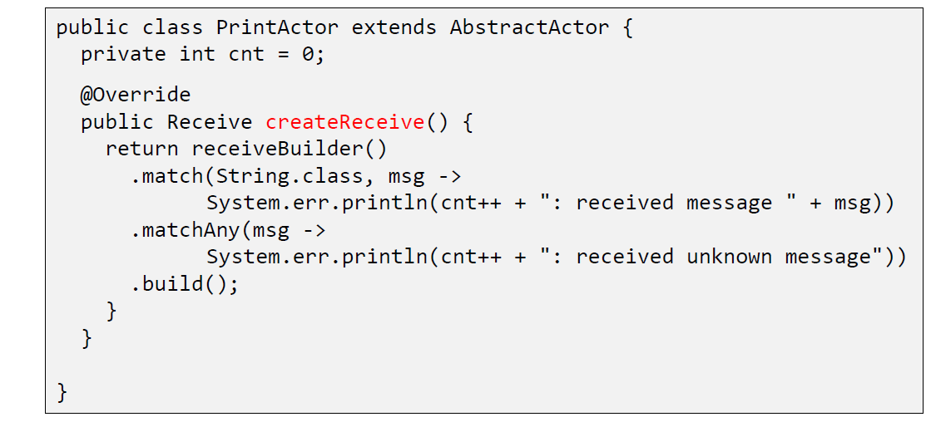

### Creating an Actor Instance

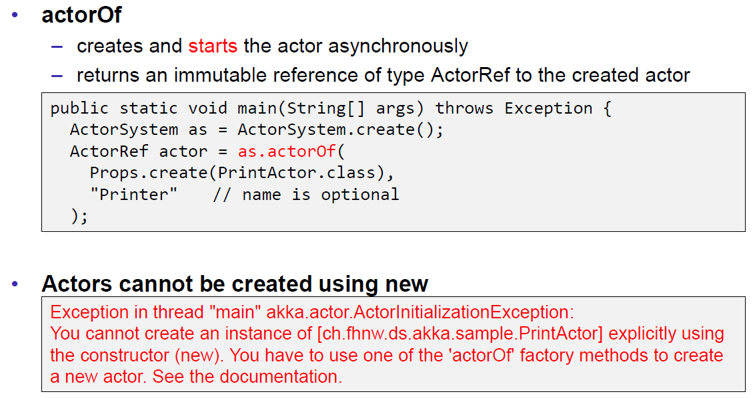

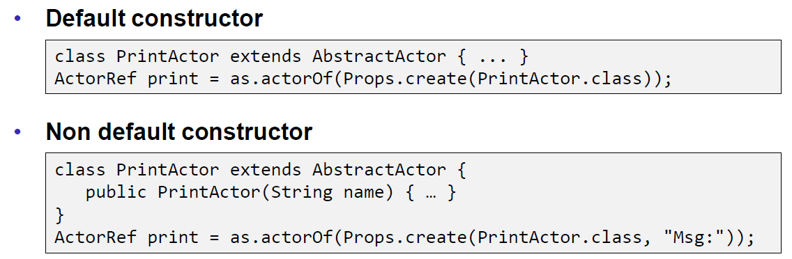

### Sending Messages (Fire-Forget)

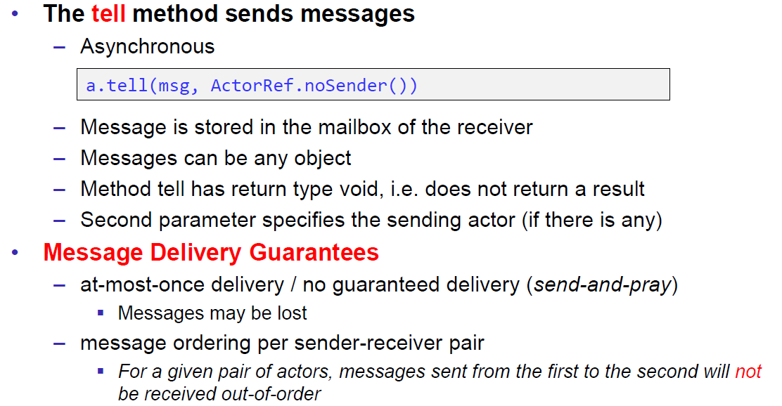

### Receiving Messages (Actor Methods)

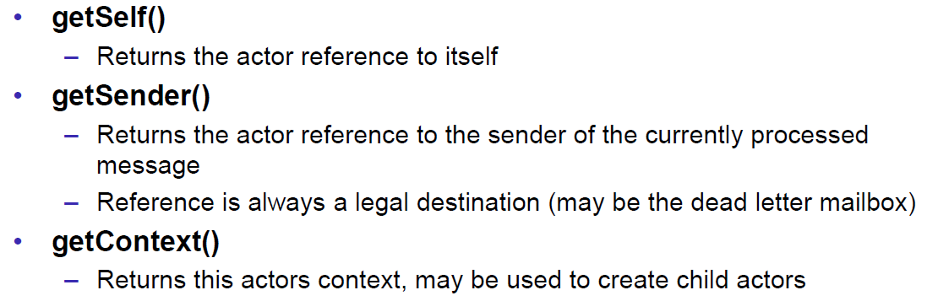

### Example: Chat Program

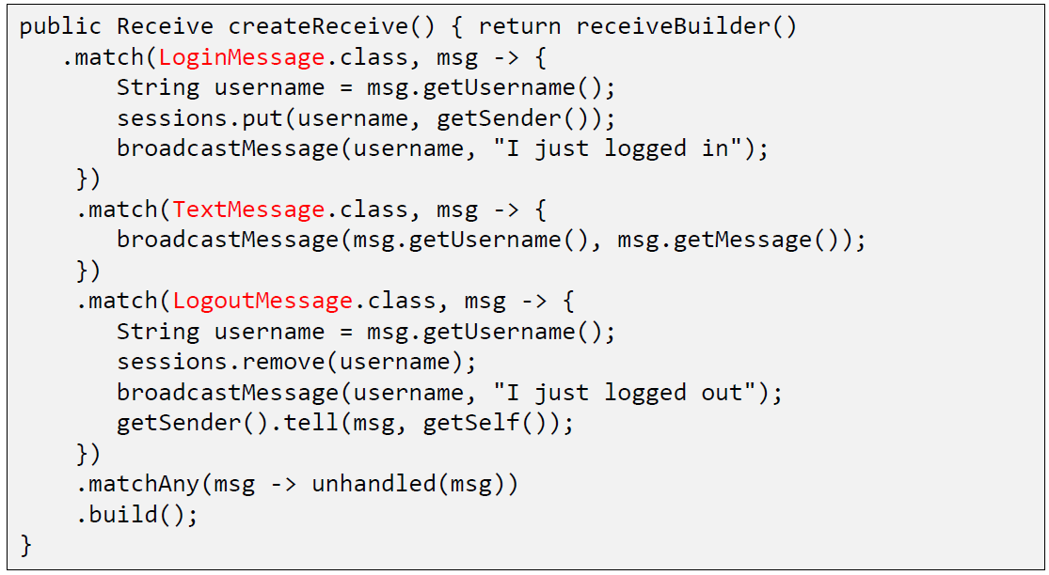

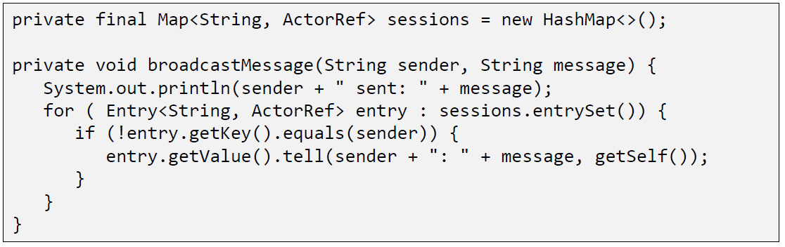

## Akka and Fault Tolerance

### Actor System Hierarchies

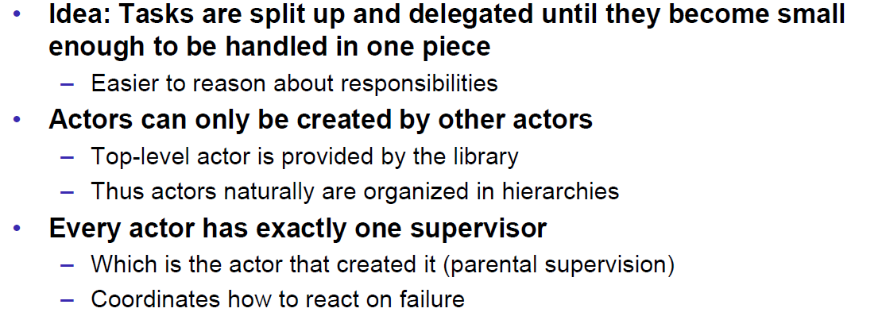

### Actor Lookup

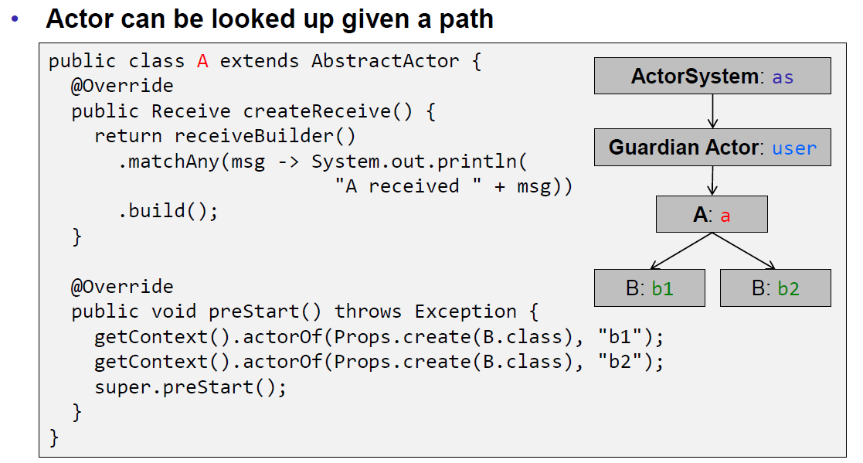

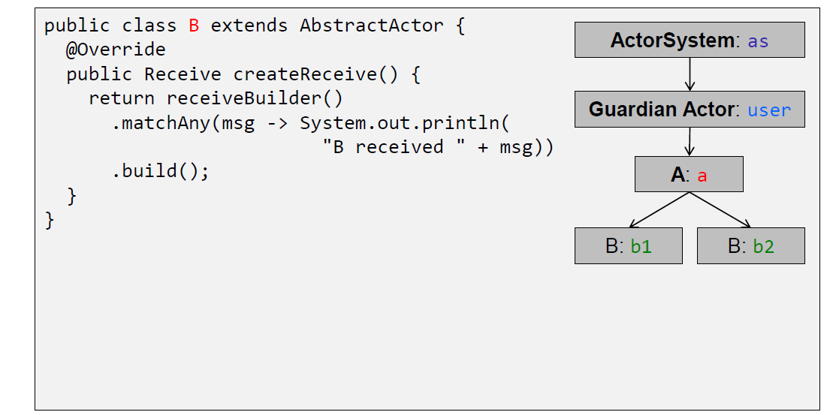

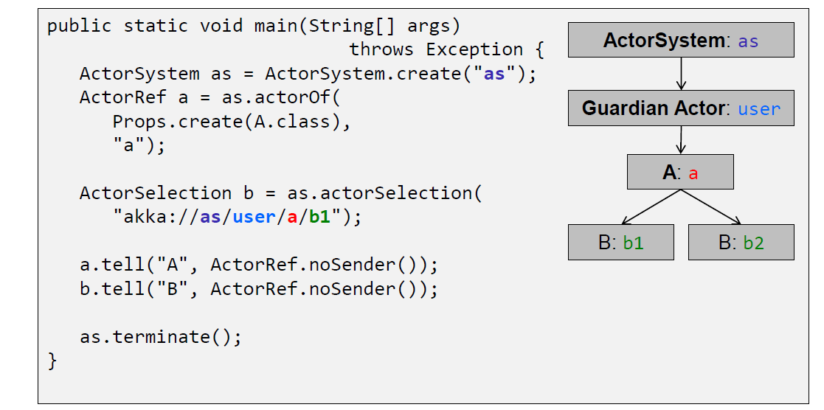

### Exceptions

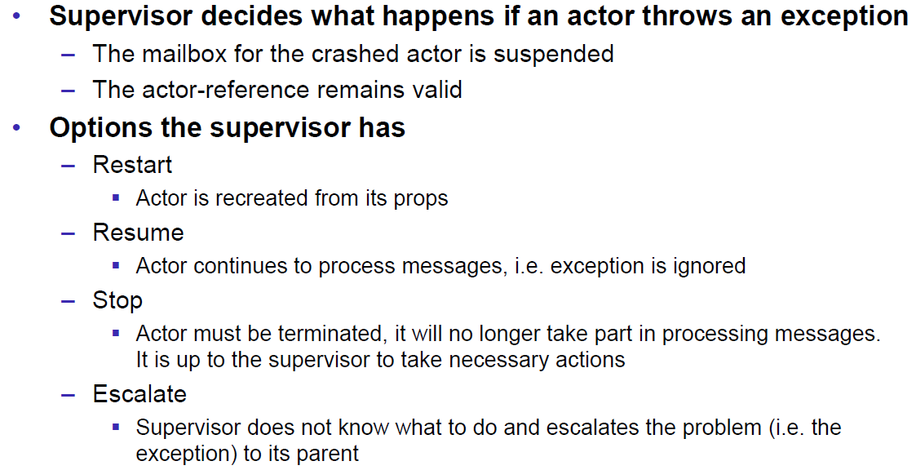

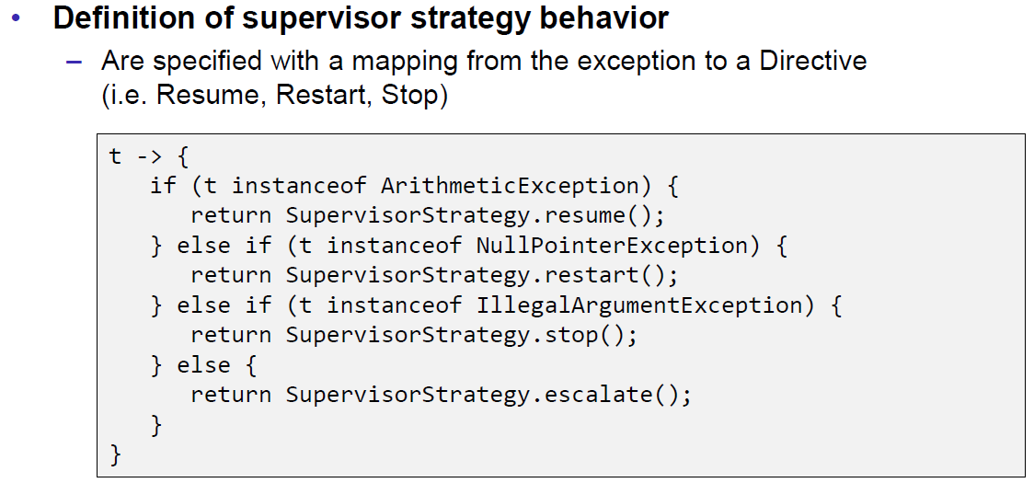

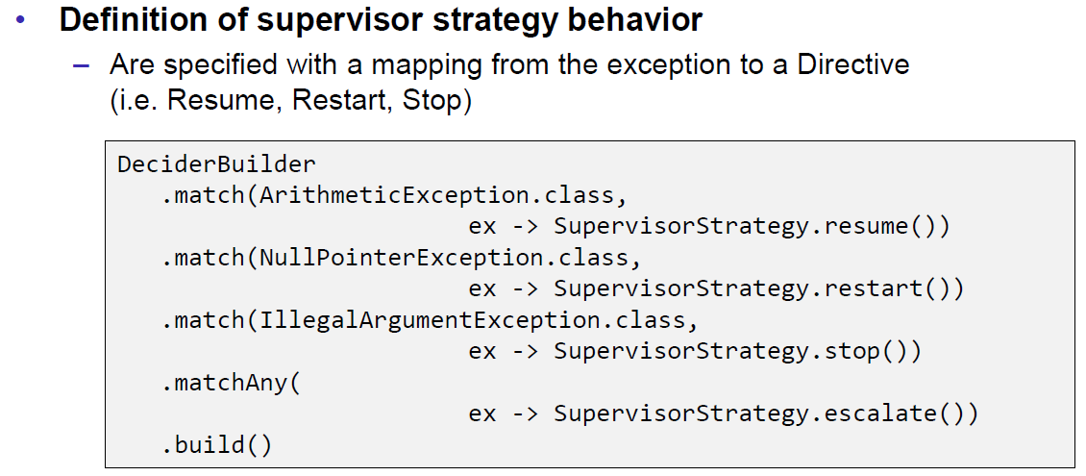

### Definition of a Supervisor Strategy

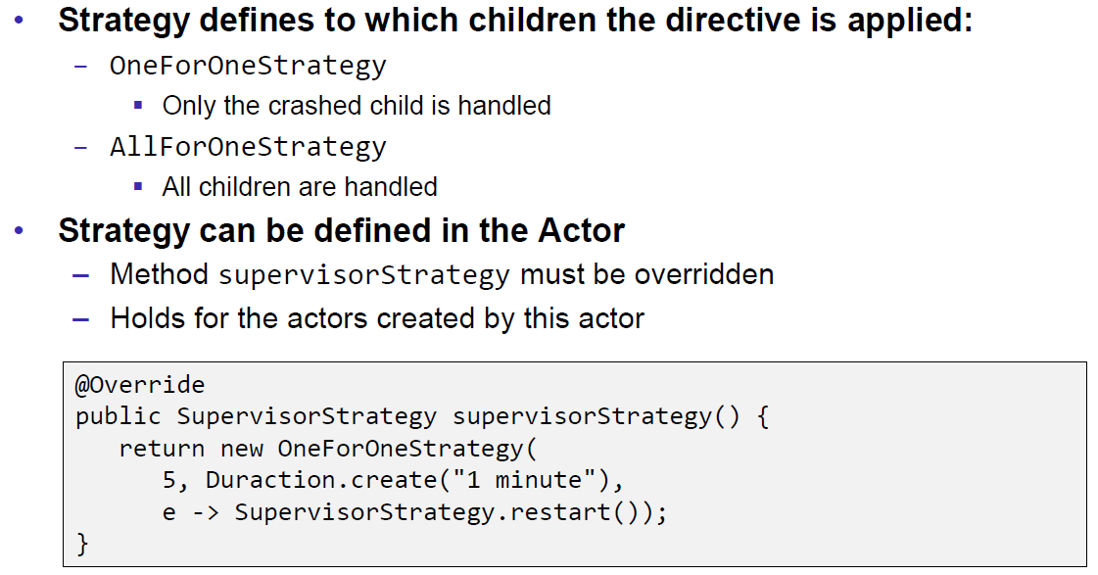

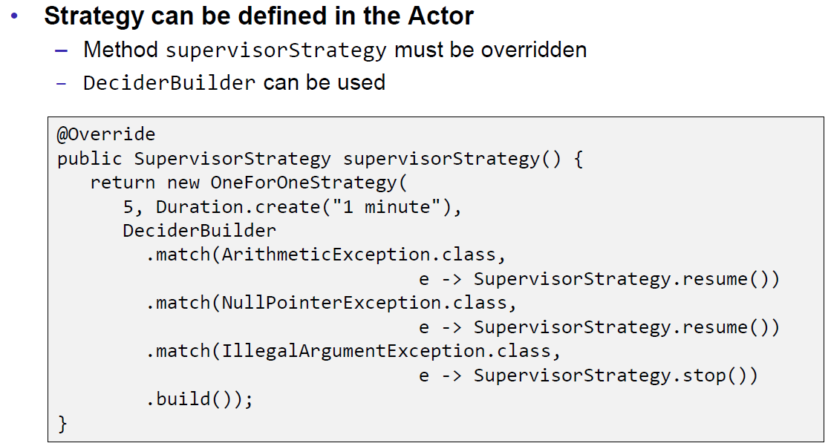

### Guardian Supervisor Strategy

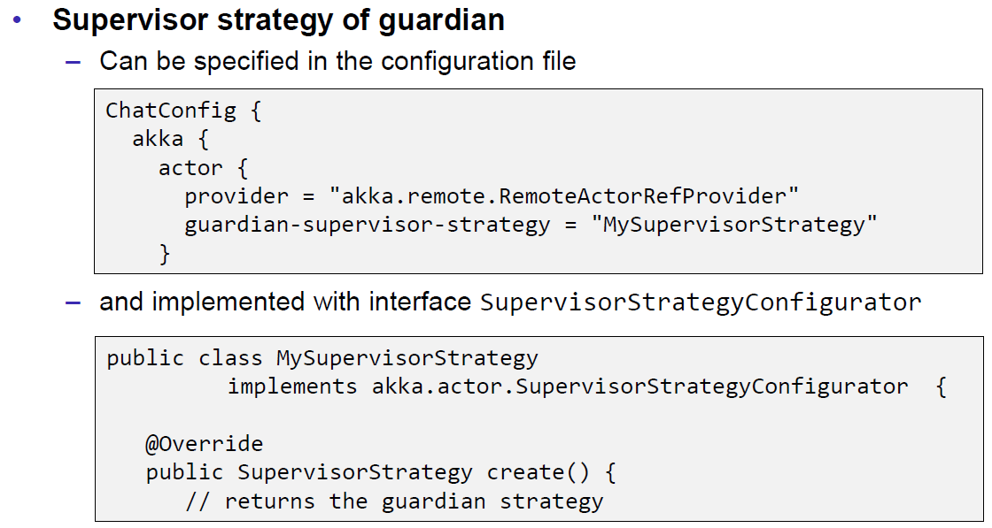

### Actor Lifecycle

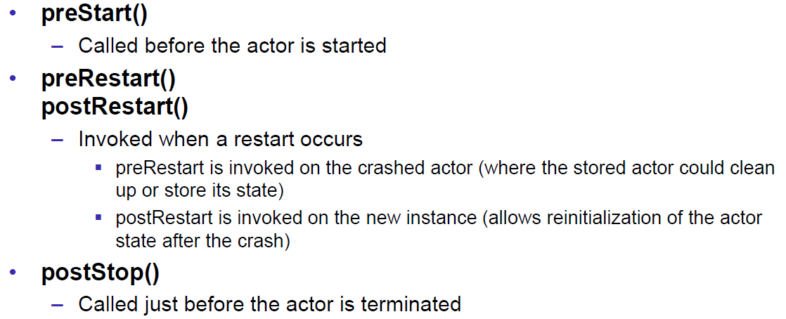

# Woche 15

In Woche 15 wurde die Unterrichtsevaluation besprochen.

# Woche 16

In Woche 16 fand kein Unterricht statt.